Microsoft Cloud Workshops

Onboarding Lab Guide

February2017

© 2017 Microsoft Corporation. All rights reserved. This document is confidential and proprietary to Microsoft. Internal use only. This document is for informational purposes only. MICROSOFT MAKES NO WARRANTIES, EXPRESS OR IMPLIED, IN THIS SUMMARY.

This document is provided "as-is." Information and views expressed in this document, including URL and other Internet Web site references, may change without notice. You bear the risk of using it.

Some examples are for illustration only and are fictitious. No real association is intended or inferred.

## Contents

Modern cloud apps hackathon 1

Modern cloud apps hackathon answers 32

Azure resource manager hackathon 156

Azure resource manager hackathon answers 165

Internet of Things (IoT) hackathon 212

Internet of Things hackathon answers 222

Big data and visualization hackathon 277

Big data and visualization hackathon answers 292

# Modern cloud apps hackathon

## Overview

The Modern cloud apps Hackathon is a hands-on exercise that will challenge you to implement an end-to-end scenario using a supplied sample that is based on Microsoft Azure App Services and related services. The scenario will include implementing compute, storage, security, and scale using various components of Microsoft Azure. The Hackathon can be implemented on your own, but it is highly recommended to pair up with other members at the Hackathon to model a real world experience much closer and to allow each member to share their expertise for the overall solution.

## Requirements

* Microsoft Azure subscription
* Local machine or a virtual machine configured with:
  + Visual Studio 2015 Community Edition Update 3
  + Azure SDK 2.9.+ for Visual Studio
    - <http://go.microsoft.com/fwlink/?linkid=518003&clcid=0x409>

## Lab structure

This lab has two sets of instructions. The first is a high-level set of instructions that is designed for attendees that have previous experience with managing and building .NET web apps. The second is a traditional hands-on lab guide that is designed for attendees that do not.

## Exercise 1: Environment setup

In this exercise, you will set up your environment for use for the rest of the exercises. This will involve downloading the sample application and creating a Visual Studio Online Team Project.

### Task 1: Setup a Development Environment

If you do not have a machine setup with Visual Studio 2015 Community and Azure SDK 2.9 complete this task.

1. Create a virtual machine in Azure using the Visual Studio Community 2015 Update 3 and SDK 2.9 on Windows Server 2012 R2 image.

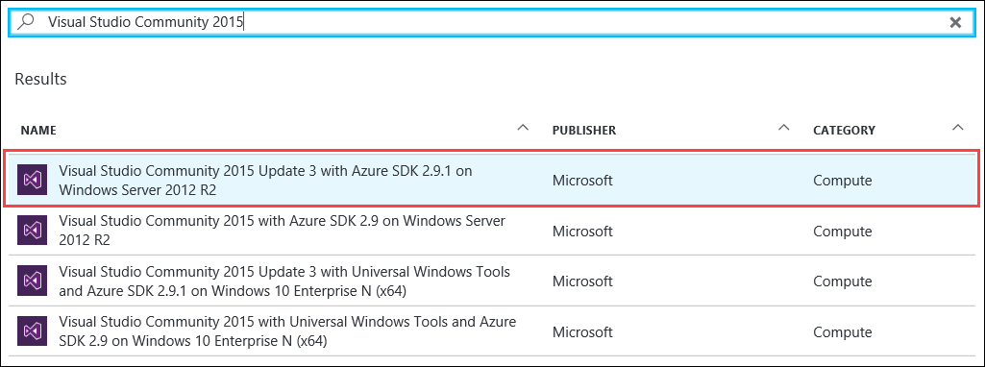

It is highly recommended to use a DS2 or D2 instance size for this VM.

### Task 2: Disable IE Enhanced Security

Note: Sometimes this image has IE ESC disabled, and sometimes it does not.

1. On the new VM you just created, click the **Server Manager** icon.



1. Click **Local Server**.

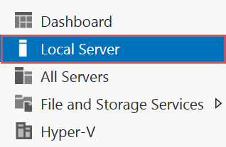

1. On the right side of the pane, click **On** by IE Enhanced Security Configuration.



1. Change to **Off** for Administrators and click **OK**.

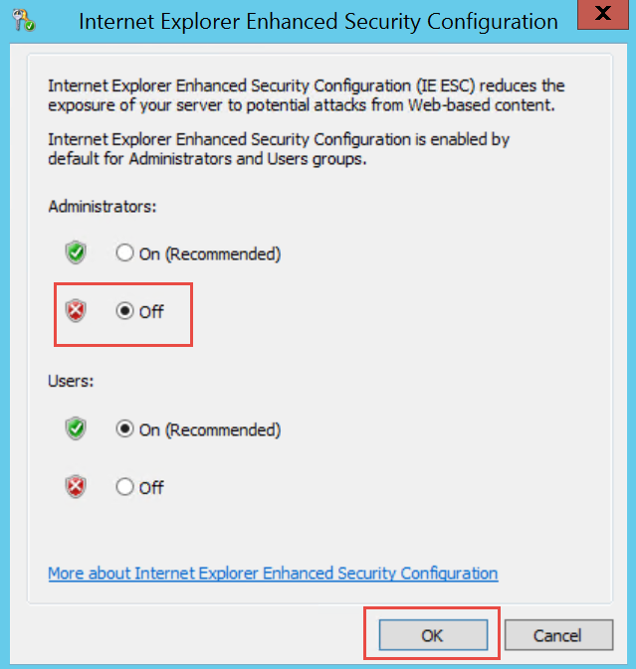

### Task 3: Install SQL Server Management Studio

1. On the new VM, download and install SQL Server Management Studio.  
   <https://msdn.microsoft.com/en-us/library/mt238290.aspx>

### Task 4: Validate Connectivity to Azure

1. From within the virtual machine, Launch Visual Studio 2015 and validate that you can login with your Microsoft Account when prompted.
2. Validate connectivity to your Azure subscription. Launch Visual Studio, open Server Explorer from the View menu, and ensure that you can connect to your Azure subscription.

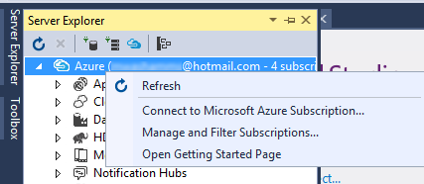

### Task 5: Download and explore the Contoso Sports League sample

1. Create a new folder on your C: drive named **Hackathon**.
2. Download the sample application from here: https://opsgilityweb.blob.core.windows.net/cebootcamp-feb-2017/Modern%20Cloud%20App%20Hackathon%20-%20Strudent%20Files.zip and extract to the **Hackathon** folder.

Note: The link above is case sensitive.

1. From the **Contoso Sports League** folder under **Hackathon**, open the Visual Studio Solution file: **Contoso.Apps.SportsLeague.sln**.
2. The solution contains the following projects:

|  |  |
| --- | --- |
| Contoso.Apps.SportsLeague.Web | Contoso Sports League e-commerce application |
| Contoso.Apps.SportsLeague.Admin | Contoso Sports League call center admin application |
| Contoso.Apps.SportsLeague.WorkerRole | Handles receipt generation for orders |
| Contoso.Apps.SportsLeague.Data | Data tier |
| Contoso.Apps.SportsLeague.Offers | API for returning list of available products |
| Contoso.Apps.PaymentGateway | API for payment processing |

### Task 6: Create a new Azure Resource Group

1. Within the Azure Management Portal, open the **Resource groups** tile and click **Add**.

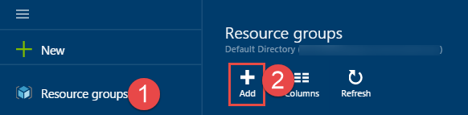

1. Specify the name of the resource group as **contososports**, and choose the Azure region you want to deploy the lab to. This resource group will be used throughout the rest of the lab. Click **Create** to create the resource group.

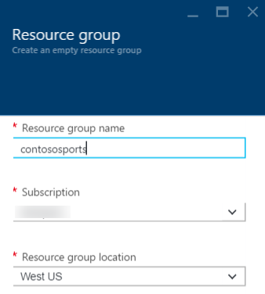

## Exercise 2: Proof of concept deployment

Contoso has asked you to create a proof of concept deployment in Microsoft Azure by deploying the web, database, and API applications for the solution and then validating that the core functionality of the solution works. Ensure all resources use the same resource group that was created in the beginning of the lab.

### Help references

|  |  |
| --- | --- |
| SQL firewall | https://azure.microsoft.com/en-us/documentation/articles/sql-database-configure-firewall-settings/ |
| Deploying a web app | https://azure.microsoft.com/en-us/documentation/articles/web-sites-deploy/ |
| Deploying an API app | https://azure.microsoft.com/en-us/documentation/articles/app-service-dotnet-deploy-api-app/ |
| Accessing an API app from a JavaScript client | https://azure.microsoft.com/en-us/documentation/articles/app-service-api-javascript-client/ |

### Task 1: Deploy the e-commerce website, SQL database, and storage

### Tasks to complete

* Create the resources in Microsoft Azure needed to deploy the e-commerce web app, database, and storage.
* Specify the configuration settings to connect to the resources in the e-commerce Web App’s Application Settings in Azure.
* Deploy the e-commerce application to Microsoft Azure.

### Exit criteria

* The web application should display locally. (Right-click the project and click **view in browser**.)
* The web application should display in Microsoft Azure by navigating to its [web app name]**.azurewebsites.net** URL.
* Click the **STORE** link to ensure that connectivity to the database is successful.

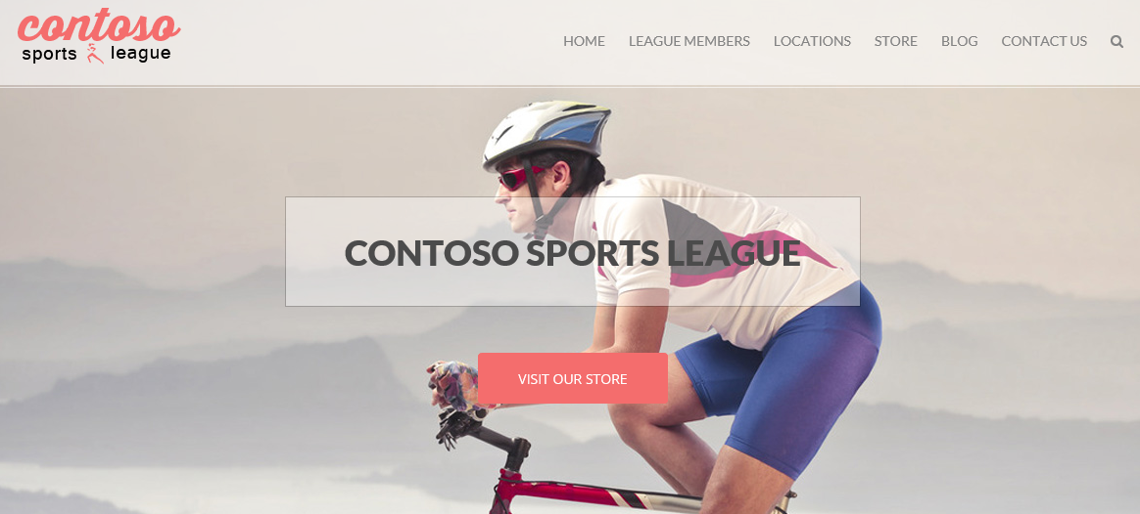

### Task 2: Setup SQL Database Geo-Replication

### Tasks to complete

* Configure Readable Geo-Replication for the SQL Database created in Task 1 by setting up a Secondary database in the other Azure Region in the pair.
* Force Failover to the Secondary database.
* Specify the connection string for the Secondary database in the e-commerce Web App’s Application Settings in Azure, and test the Web App.
* Revert the Failover test so the original database is Primary.

Manually forcing the Failover to the Secondary database is optional. The process of performing the Failover, testing it, and then reverting back to the Primary database can take up to 30 minutes to complete. If you have time, it is recommended that you complete these steps.

### Exit criteria

* The web application should display locally when connected to the Secondary database in the Failover test (Right-click the project and click **view in browser**.)
* Click the **STORE** link to ensure that connectivity to the Secondary database is successful.
* The web application should display locally when connected to the Primary database after the Failover test has been reverted.
* Click the **STORE** link to ensure that connectivity to the Primary database is successful.

### Task 3: Deploying the call center admin website

### Tasks to complete

* Create the resources in Microsoft Azure needs to deploy the call center admin website.
* Specify the configuration settings to connect to the resources in the call center admin Web App’s Application Settings in Azure.
* Deploy the call center admin website application to Microsoft Azure.

### Exit criteria

* The web application should display locally. (Right-click the project and click **view in browser**.)
* The web application should display in Microsoft Azure by navigating to its [web app name]**.azurewebsites.net** URL.

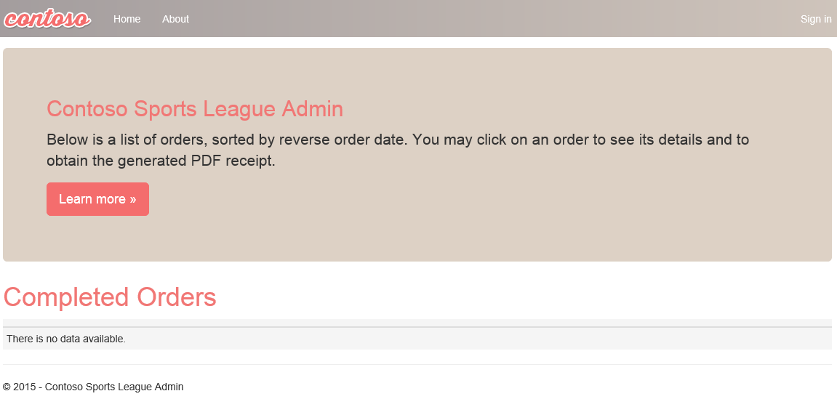

### Task 4: Deploying the payment gateway

### Tasks to complete

* Create the resources in Microsoft Azure and deploy the payment gateway API application.

### Exit criteria

* Please note the URL of the deployed API app for future reference.

### Task 5: Deploying the offers web API

### Tasks to complete

* Create the resources in Microsoft Azure and deploy the offers API application.
* Specify the configuration settings to connect to the created resources in the Web Apps Application Settings in Azure.

### Exit criteria

* Please note the URL of the deployed API app for future reference.

### Task 6: Update and deploy the e-commerce website

### Tasks to complete

* Update the e-commerce application to reference the new API applications.
* Deploy the updated e-commerce site to the Azure website.
* Verify the configuration by placing a test order on the e-commerce site and ensure the order appears on the admin site.

### Exit criteria

* The web application should display locally.
* The web application should display in Microsoft Azure by navigating to its [web app name]**.azurewebsites.net** URL.
* The home page should render a list of products with images underneath the Today’s Offers heading.
* The e-commerce application should render the products catalog without errors.
* A test order should be rendered in the call center admin application after being submitted through the e-commerce site.

## Exercise 3: Identity and security

The Contoso call center admin application will only be accessible by users of the Contoso Active Directory environment. You have been asked to create a new Azure AD Tenant and secure the application so only users from the tenant can log on.

### Help references

|  |  |
| --- | --- |
| What is Azure AD? | https://azure.microsoft.com/en-us/documentation/articles/active-directory-whatis/ |
| Azure Web Apps authentication | https://azure.microsoft.com/en-us/documentation/articles/active-directory-authentication-scenarios/ |
| View your access and usage reports | https://msdn.microsoft.com/en-us/library/azure/dn283934.aspx |
| Custom branding an Azure AD Tenant | https://msdn.microsoft.com/en-us/library/azure/Dn532270.aspx |

### Task 1: Provide the identity solution for the call center application

Note: Tasks 1, 2, and 4 are optional and require global admin permissions on the Azure AD Tenant. Task 3 is also optional, but does require the permission to create an app in the Azure AD tenant.

### Tasks to complete

1. Enable Azure AD Premium on your existing Azure AD Tenant
2. Create a new user in your Azure AD tenant
3. Enable Azure AD authentication with your existing Azure AD tenant on the call center admin web app and validate you can log in with the new user within that tenant.
4. Customize the branding by providing a banner and tile logo, a large illustration, and custom text, and then validate the branding is applied. The logo files can be found in the folder you extracted the starter files to.

### Exit criteria

* The call center application should only allow users that log in through the customized Azure AD form access to the application.
* The custom branding should be displayed on the logon page.

## Exercise 4: Load testing and monitoring

To validate the scalability of the application and to configure telemetry, you have been asked to configure Microsoft Azure Application Insights and perform a web load test using Visual Studio Online.

### Help references

|  |  |
| --- | --- |
| Run performance tests on your app | http://blogs.msdn.com/b/visualstudioalm/archive/2015/09/15/announcing-public-preview-for-performance-load-testing-of-azure-webapp.aspx |
| Application Insights Custom Events | https://azure.microsoft.com/en-us/documentation/articles/app-insights-api-custom-events-metrics/ |
| Enabling Application Insights | https://azure.microsoft.com/en-us/documentation/articles/app-insights-start-monitoring-app-health-usage/ |
| Detect failures | https://azure.microsoft.com/en-us/documentation/articles/app-insights-asp-net-exceptions/ |
| Monitor performance problems | https://azure.microsoft.com/en-us/documentation/articles/app-insights-web-monitor-performance/ |

### Task 1: Configure the application for telemetry

### Tasks to complete

* Configure a method to capture telemetry information for the application for the server and client side.
* Complete the implementation of the TrackException and TrackEvent method in Helpers\TelemetryHelper.cs.
* Republish the web application with telemetry enabled.

### Exit criteria

* Verify that when you browse to the website, the telemetry data appears.

### Task 2: Test the application

#### Tasks to complete

* Submit several test orders to verify that telemetry is capturing custom events.
* Simulate a load test of at least 250 users browsing the home page over a 5-minute time frame.

#### Exit criteria

* You should be able to view the average response time for the simulated load test.

### Task 3: Analyze the load test results

#### Tasks to complete

* Use the monitoring capabilities of your telemetry solution to identify failures from the test (if any).
* Use the monitoring capabilities of your telemetry solution to identify performance issues from the test.

#### Exit criteria

* The telemetry solution should show custom events captured by the application such as new orders.
* The telemetry solution should show performance numbers such as the number of sessions and average response time.

## Exercise 5: Automating backend processes

Contoso wants to automate the process of generating receipts in PDF format and alerting users when their orders have been processed.

### Help references

|  |  |
| --- | --- |
| Deploying WebJobs using Visual Studio | https://docs.microsoft.com/en-us/azure/app-service-web/websites-dotnet-deploy-webjobs |
| Creating a logic app | https://azure.microsoft.com/en-us/documentation/articles/app-service-logic-create-a-logic-app/ |
| Logic app connectors | https://azure.microsoft.com/en-us/documentation/articles/app-service-logic-connectors-list/ |

### Task 1: Enable receipt generation

#### Tasks to complete

* Configure and deploy Contoso’s existing receipt generation as a Web Job.
* Submit a test order and view receipt through the call center admin application.

#### Exit criteria

* Receipt should be downloadable from the call center application.

### Task 2: Order notifications

Note: Explicit instructions are given here due to the Logic App service being in constant change and in preview with limited documentation.

#### Subtask 1: Configure your Twilio trial account

1. If you do not have a Twilio account, sign up for one for free at the following URL:   
   [**https://www.twilio.com/try-twilio**](https://www.twilio.com/try-twilio).

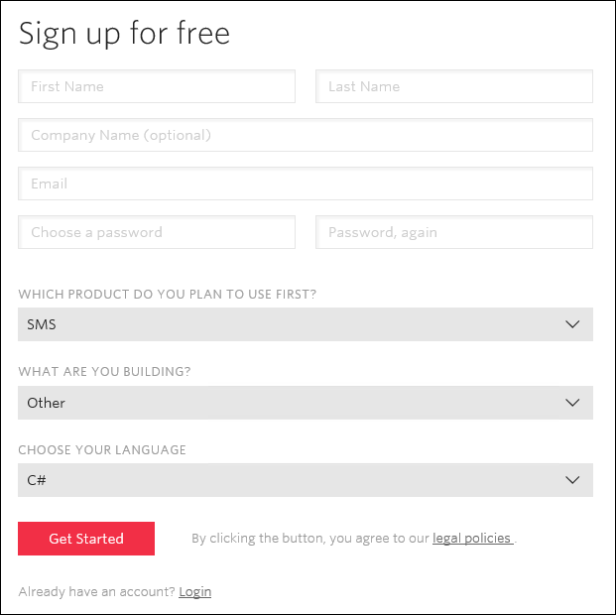

1. When you sign up for a free Twilio trial, you be asked to verify your personal phone number. This is an important security step that is mandatory for trying Twilio.  
   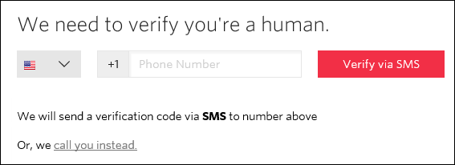
2. Click **All Products & Services**  
   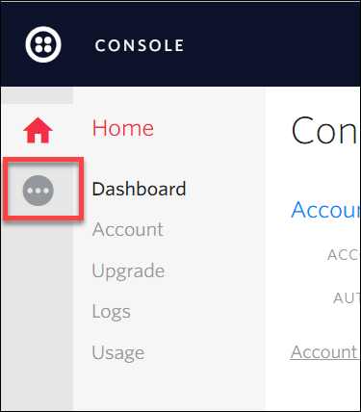
3. Click **Phone Numbers**.  
   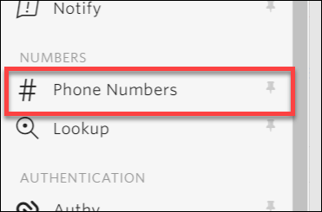
4. Click **Get Started**.  
   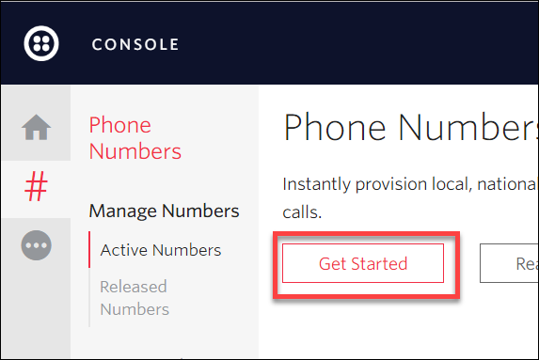
5. Click the **Get your first Twilio phone number** button.  
   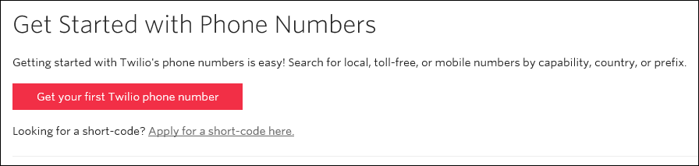
6. Record the **Phone Number**, then click the **Choose this Number** button on the Your first Twilio Phone Number prompt, and then click **Done**

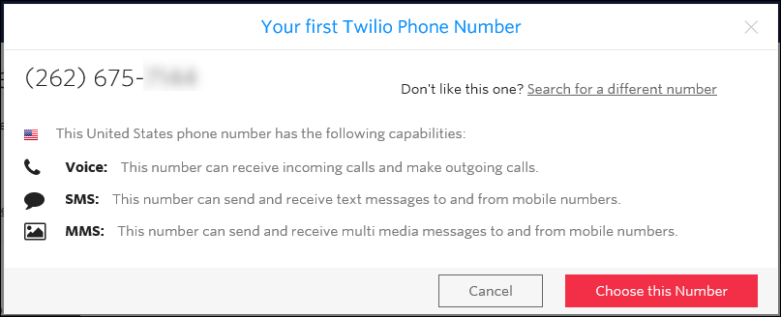

1. Click **Home**, and then record the **Account SID** and **Auth Token** for use when configuring the Twilio Connector.  
   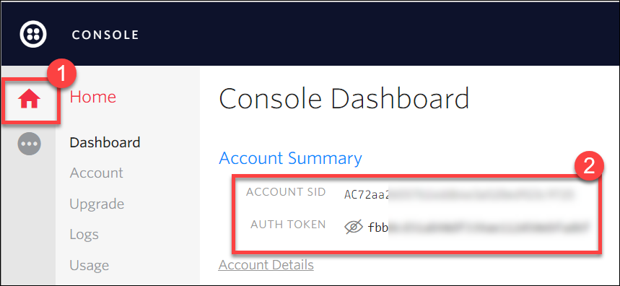

#### Subtask 2: Create a new logic app

1. Open **SQL Server Management Studio** and Connect to the SQL Database for the **ContosoSportsDB** database.  
   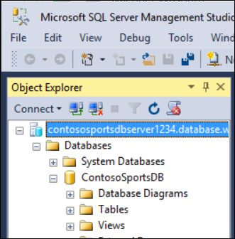
2. Under the **ContosoSportsDB** database, expand **Programmability**, right-click **Stored Procedures**, then click **New**, and **Stored Procedure…**  
   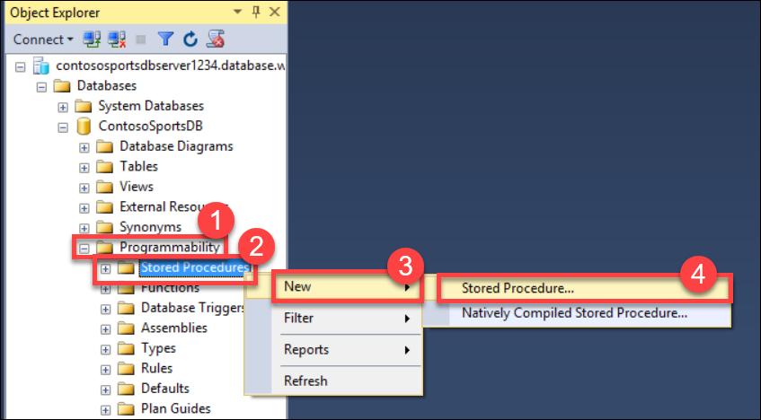
3. Replace the Stored Procedure Template code with the following:

CREATE PROCEDURE [dbo].[GetUnprocessedOrders]

AS

declare @returnCode int

SELECT @returnCode = COUNT(*) FROM [dbo].[Orders] WHERE PaymentTransactionId is not null AND PaymentTransactionId <> '' AND Phone is not null AND Phone <> '' AND SMSOptIn = '1' AND SMSStatus is null

return @returnCode

GO

1. Click **Execute** in the toolbar or press the **F5** key.  
   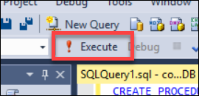
2. Delete the SQL script for the Stored Procedure from the code editor, and replace it with the following:

CREATE PROCEDURE [dbo].[ProcessOrders]

AS

SELECT * FROM [dbo].[Orders] WHERE PaymentTransactionId is not null AND PaymentTransactionId <> '' AND Phone is not null AND Phone <> '' AND SMSOptIn = '1' AND SMSStatus is null;

UPDATE [dbo].[Orders] SET SMSStatus = 'sent' WHERE PaymentTransactionId is not null AND PaymentTransactionId <> '' AND Phone is not null AND Phone <> '' AND SMSOptIn = '1' AND SMSStatus is null;

1. Click **Execute** in the toolbar or press the F5 key.  
   
2. Open the Azure Management Portal (<http://portal.azure.com>), click **+New**, then **Web + Mobile,** and then **Logic App.**

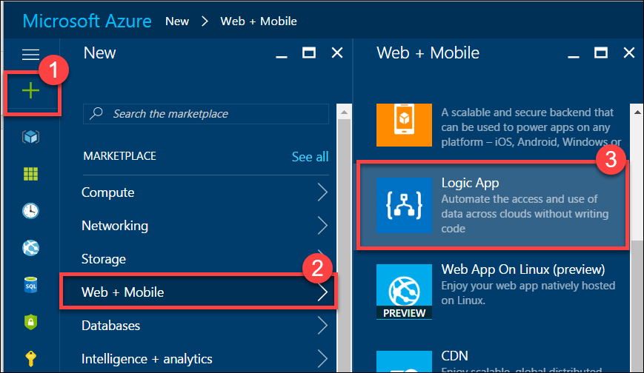

1. On the **Create logic app** blade, assign a value for **Name**, and set the **Resource Group** to **contososports**.

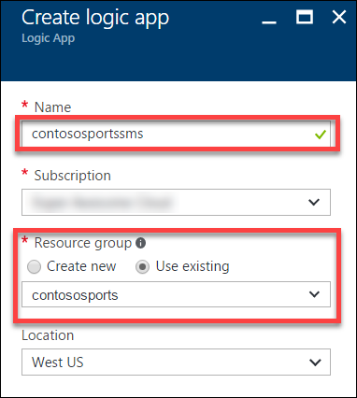

1. Open the Logic App by clicking **More services** > **Logic Apps**, and click the Logic App you just created.



1. Select the **Blank LogicApp** Template.  
   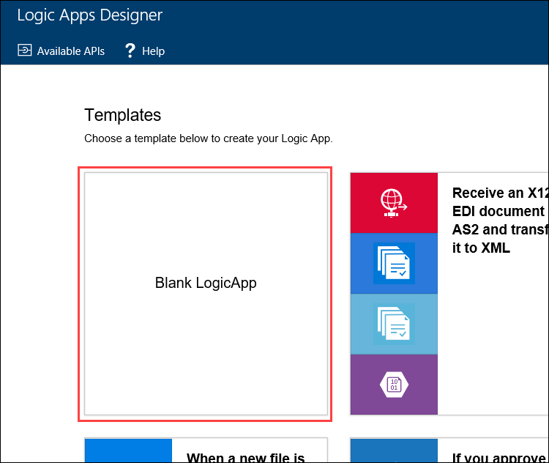
2. On the **Logic Apps Designer**, click **Recurrence**.

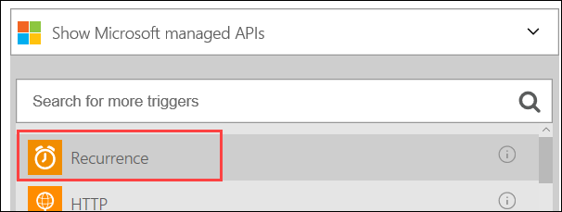

1. Set the **FREQUENCY** to **MINUTE**, and **INTERVAL** to 1.

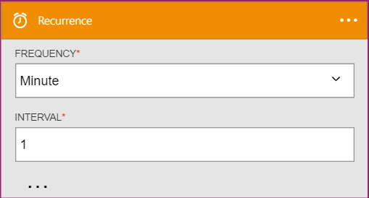

1. Click the **New Step**, and then click **Add an action**.

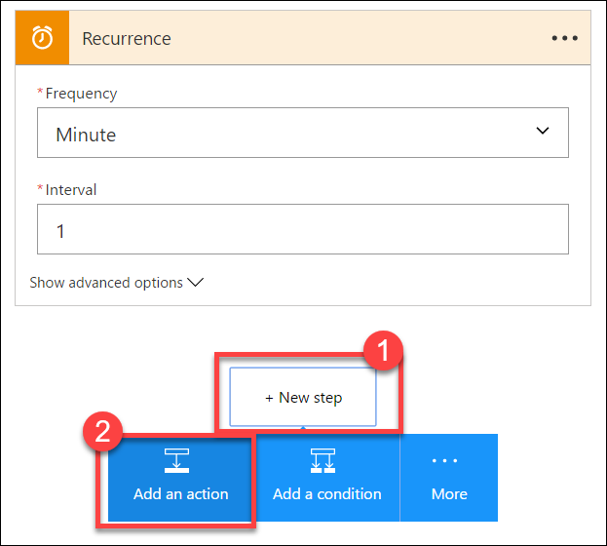

1. Type **SQL Server** into the filter box, and click the **SQL Server – Execute stored procedure** action.

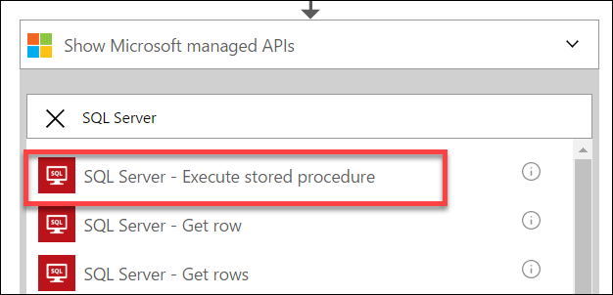

1. The first time you add a SQL action you will be prompted for the connection information. Name the connection **ContosoDB**, input the server and database details used earlier, and then click **Create**.   
   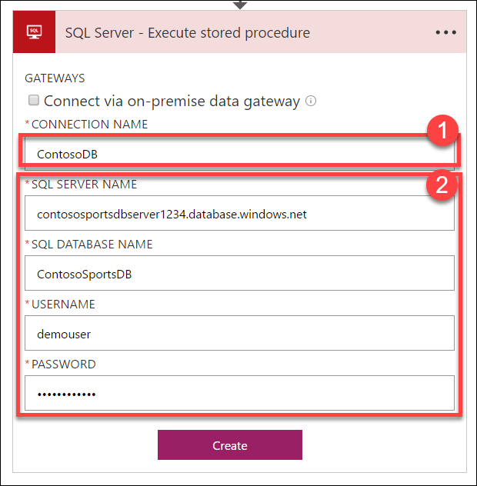
2. Select the **[dbo].[GetUnprocessedOrders]** stored procedure from the drop-down menu on the **Procedure Name** field.

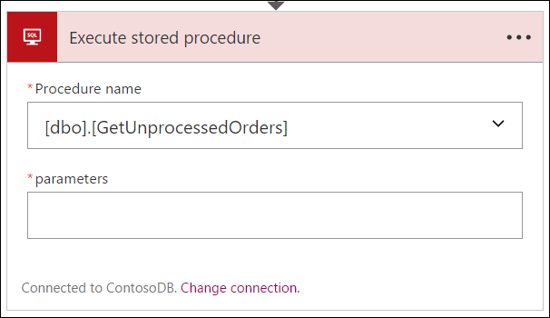

1. Click **New Step** and click the **Add a condition** link.

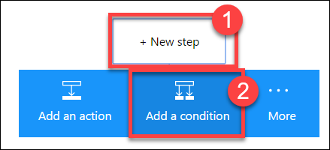

1. Specify **ReturnCode** for the OBJECT NAME, set the RELATIONSHIP to **is greater than**, and set the VALUE to **0**.

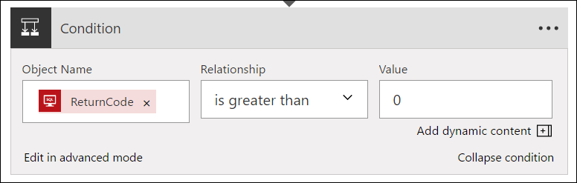

1. Click the **Add an action** link on the **If yes** condition.

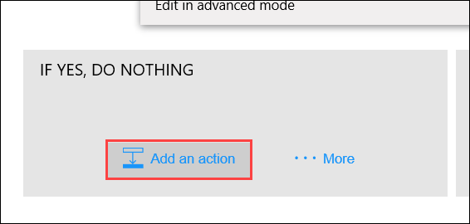

1. Type **SQL Server** into the filter box, then click the **SQL Server – Execute stored procedure** action.

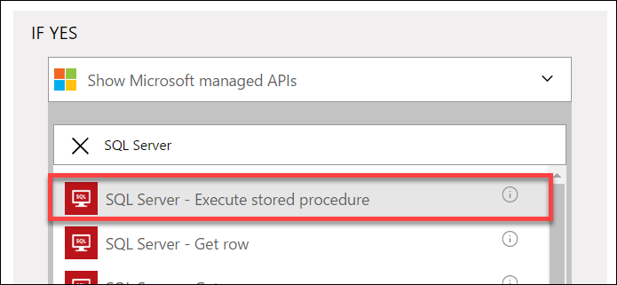

1. Select the **ProcessOrders** stored procedure in the Procedure name drop-down menu.

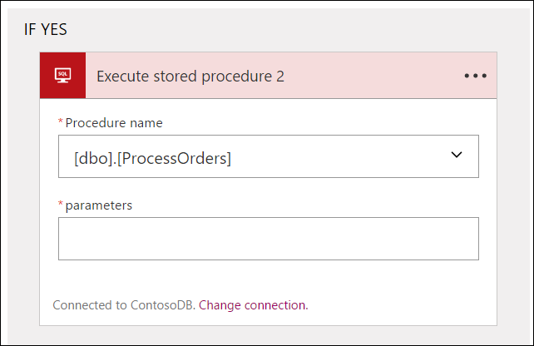

1. Click the **Add an action** link.

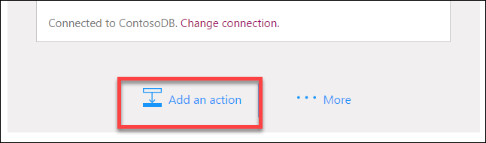

1. Type **Twilio** in the filter box, then click the **Twilio – Send Text Message (SMS)** connector.

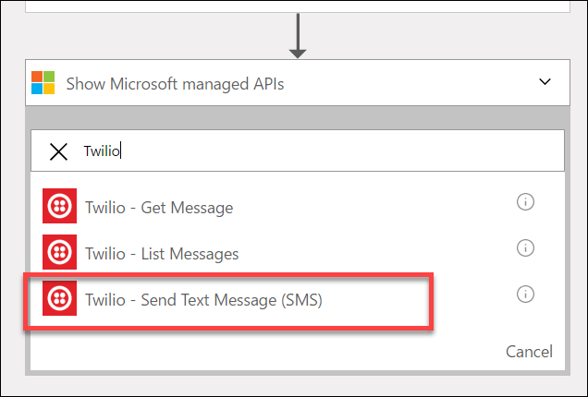

1. Set the **Connection Name** to **Twilio**, specify your Twilio **Account SID** and **Authentication Token**, and then click the **Create** button.

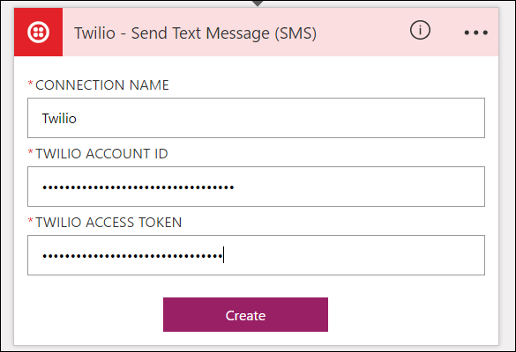

1. Using the drop-down menu, select your Twilio number for the **FROM PHONE NUMBER** field. Specify a placeholder phone number in the **TO PHONE NUMBER**, and a **TEXT** message.  
   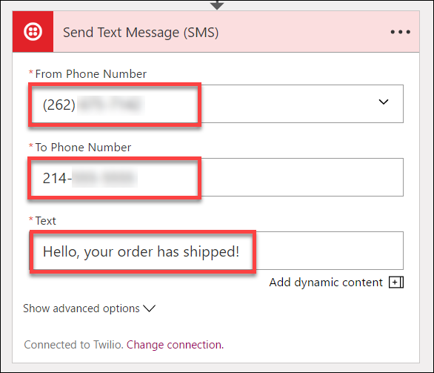
2. On the **Logic Apps Designer** toolbar, click the **Code View** button.

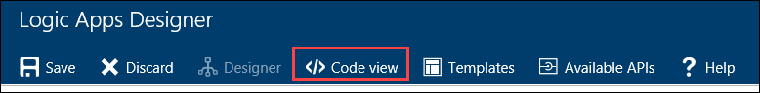

1. Find the **Send_Text_Message_(SMS)** action, then modify the body property of the Twilio action:

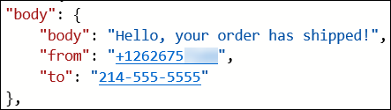

1. Add the following code between Hello and the comma.

**@{item()['FirstName']}**

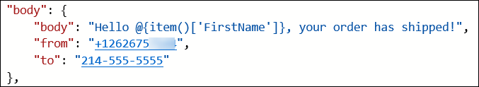

1. Modify the **to** property to pull the phone number from the item.

**@{item()['Phone']}**

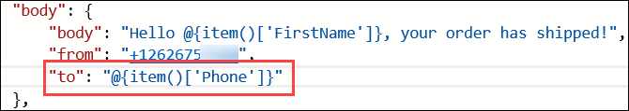

1. Immediately before the **Send_Text_Message_(SMS)** create a new line and add the following code:

"forEach_email": {

"type": "Foreach",

"foreach": "@body('Execute_stored_procedure_2')['ResultSets']['Table1']",

"actions": {

1. Remove the **runAfter** block from the **Send_Text_Message_(SMS)** action.  
   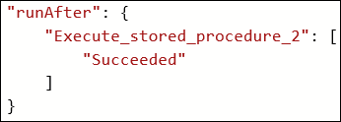
2. Locating the closing bracket of the **Send_Text_Message_(SMS)** action, then create a new line after it and add the following code:

},

"runAfter": {

"Execute_stored_procedure_2": [

"Succeeded"

]

}

}

1. After the code for the **Send_Text_Message_(SMS)** has been modified to be contained within the **forEach_email** action, it should look like the following:

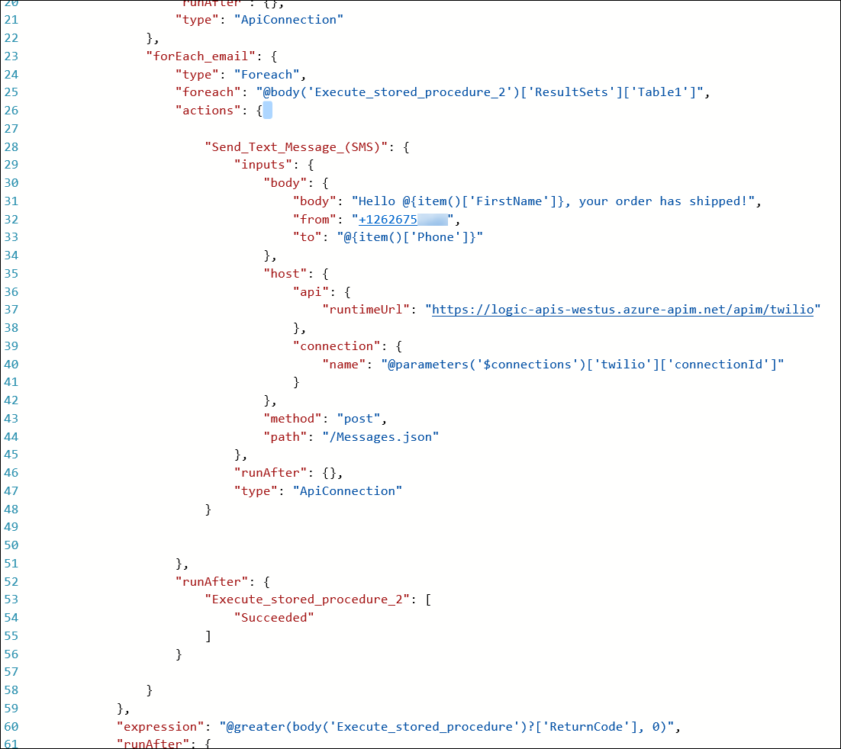

1. Click **Save** on the toolbar to enable the logic app.

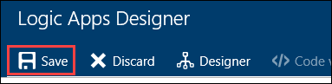

1. Your workflow should look like below, and you should receive a text for each order you have placed

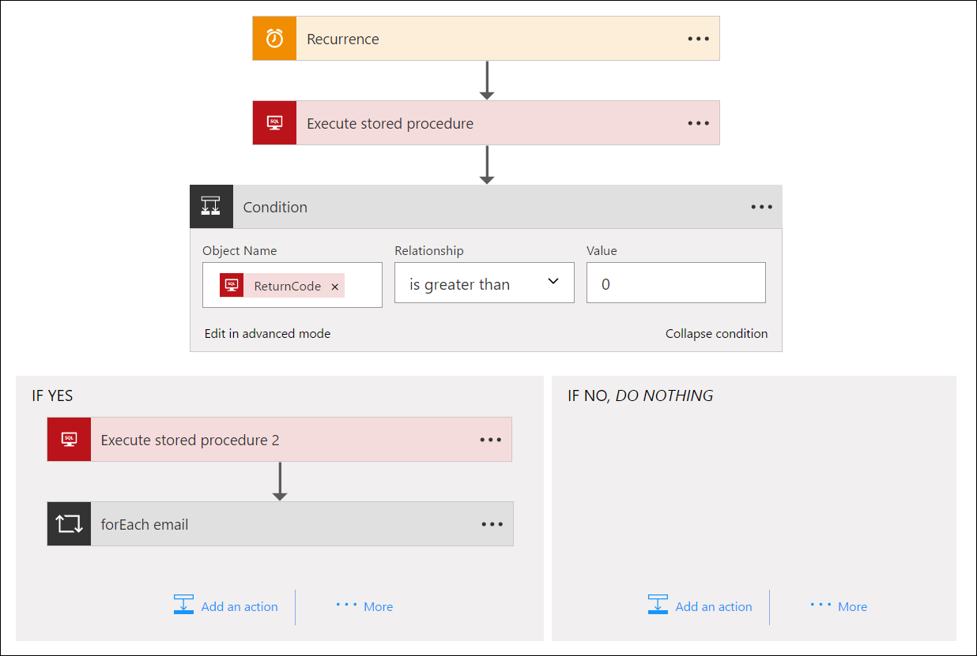

## Exercise 6: Create SQL Data Warehouse

Contoso wants to setup a SQL Data Warehouse in Microsoft Azure to enable data analytics capabilities.

### Help references

|  |  |
| --- | --- |
| Create an Azure SQL Data Warehouse | https://azure.microsoft.com/en-us/documentation/articles/sql-data-warehouse-get-started-provision/ |
| SQL Data Warehouse Migration Utility | https://azure.microsoft.com/en-us/documentation/articles/sql-data-warehouse-migrate-migration-utility/ |
| Introduction to Azure Data Factory Service | https://azure.microsoft.com/en-us/documentation/articles/data-factory-introduction/ |

### Task 1: Create SQL Data Warehouse

#### Tasks to complete

* Create the resources in Microsoft Azure for a SQL Data Warehouse
* Migrate the **Orders** and **OrderDetails** tables from the database into the SQL Data Warehouse using the Migration Utility

#### Exit criteria

* A SQL Data Warehouse has been provisioned in Microsoft Azure
* The **Orders** and **OrderDetails** tables schema and data has been migrated into the SQL Data Warehouse

### Task 2: Configure Azure Data Factory

#### Tasks to complete

* Create the resources in Microsoft Azure for a Data Factory
* Configure a **Copy data** Pipeline on the Azure Data Factory to continuously migrate data from the **Orders** and **OrderDetails** tables within the Azure SQL Database to the Azure SQL Data Warehouse.

#### Exit criteria

* The Data Factory Pipeline runs every 15 minutes to keep the SQL Data Warehouse **Orders** and **OrderDetails** tables continuously synchronized.

# Modern cloud apps hackathon answers

## Overview

This portion of the lab is designed to help *only* if you are blocked or do not have any experience with Azure developer tools or services.

## Exercise 1: Environment setup

In this exercise, you will set up an environment to use for the rest of the exercises.

### Task 1: Setup a Development Environment

If you do not have a machine setup with Visual Studio 2015 Community and Azure SDK 2.9 complete this task.

1. Create a virtual machine in Azure using the Visual Studio Community 2015 Update 3 and SDK 2.9 on Windows Server 2012 R2 image.



It is highly recommended to use a DS2 or D2 instance size for this VM

### Task 2: Disable IE Enhanced Security

Note: Sometimes this image has IE ESC disabled, and sometimes it does not.

1. On the new VM you just created, click the **Server Manager** icon.



1. Click **Local Server**.



1. On the right side of the pane, click **On** by IE Enhanced Security Configuration.



1. Change to **Off** for Administrators and click **OK**.



### Task 3: Install SQL Server Management Studio

1. On the new VM, download and install SQL Server Management Studio.  
   <https://msdn.microsoft.com/en-us/library/mt238290.aspx>

### Task 4: Validate Connectivity to Azure

1. From within the virtual machine, Launch Visual Studio 2015 and validate that you can login with your Microsoft Account when prompted.
2. Validate connectivity to your Azure subscription. Launch Visual Studio, open Server Explorer from the View menu, and ensure that you can connect to your Azure subscription.



### Task 5: Download and explore the Contoso Sports League sample

1. Create a new folder on your C: drive named **Hackathon**.
2. Download the sample application from here: https://opsgilityweb.blob.core.windows.net/cebootcamp-feb-2017/Modern%20Cloud%20App%20Hackathon%20-%20Strudent%20Files.zip and extract to the **Hackathon** folder.

Note: The link above is case sensitive.

1. From the **Contoso Sports League** folder under **Hackathon**, open the Visual Studio Solution file: **Contoso.Apps.SportsLeague.sln**.
2. The solution contains the following projects:

|  |  |
| --- | --- |
| Contoso.Apps.SportsLeague.Web | Contoso Sports League e-commerce application |
| Contoso.Apps.SportsLeague.Admin | Contoso Sports League call center admin application |
| Contoso.Apps.SportsLeague.WorkerRole | Handles receipt generation for orders |
| Contoso.Apps.SportsLeague.Data | Data tier |
| Contoso.Apps.SportsLeague.Offers | API for returning list of available products |
| Contoso.Apps.PaymentGateway | API for payment processing |

### Task 6: Create a new Azure Resource Group

1. Within the Azure Management Portal, open the **Resource groups** tile and click **Add**.

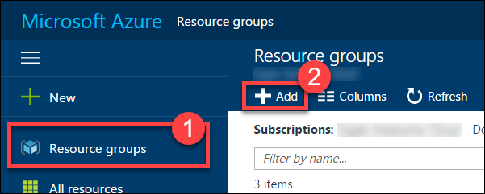

1. Specify the name of the resource group as **contososports**, and choose the Azure region you want to deploy the lab to. This resource group will be used throughout the rest of the lab. Click **Create** to create the resource group.

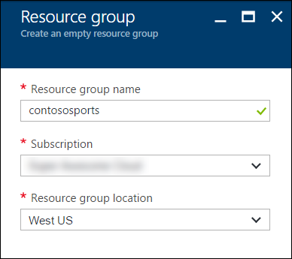

## Exercise 2: Proof of concept deployment

### Overview

Contoso has asked you to create a proof of concept deployment in Microsoft Azure by deploying the web, database, and API applications for the solution and then validating that the core functionality of the solution works. Ensure all resources use the same resource group that was created for the App Service Environment.

### Help references

|  |  |
| --- | --- |
| SQL firewall | https://azure.microsoft.com/en-us/documentation/articles/sql-database-configure-firewall-settings/ |
| Deploying a web app | https://azure.microsoft.com/en-us/documentation/articles/web-sites-deploy/ |
| Deploying an API app | https://azure.microsoft.com/en-us/documentation/articles/app-service-dotnet-deploy-api-app/ |
| Accessing an API app from a JavaScript client | https://azure.microsoft.com/en-us/documentation/articles/app-service-api-javascript-client/ |
| SQL Database Geo-Replication overview | https://azure.microsoft.com/en-us/documentation/articles/sql-database-geo-replication-overview/ |

### Task 1: Deploy the e-commerce website, SQL database, and storage

In this exercise, you will provision a website via the Azure Web App + SQL template using the Microsoft Azure Portal. You will then edit the necessary configuration files in the starter project and deploy the e-commerce website.

#### Subtask 1: Create the web app and SQL database instance

1. From the Azure Management portal <http://portal.azure.com>, using a new tab or instance, navigate to create **Web App + SQL**.
2. Click **New**, and in the Marketplace search text box enter **“Web App + S”**. Click the **Web App + SQL** item in the search results.

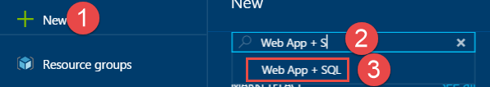

1. On the **Everything** blade select **Web App + SQL**.

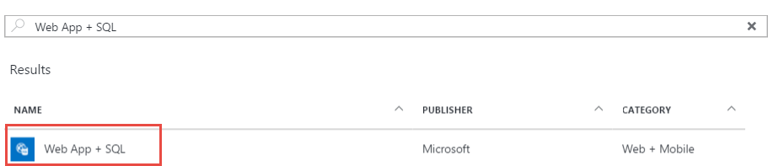

1. Check the box to pin to the dashboard, and then click **Create**.

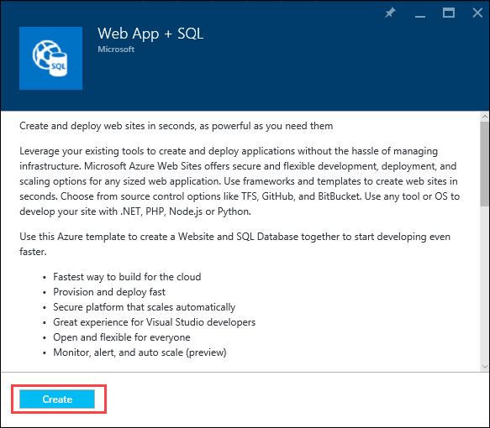

1. On the **Web App + SQL** blade select **App Service plan/Location, *Configure required settings***.

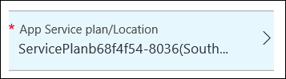

1. On the Web App blade specify the following configuration:
   1. Specify a unique and valid URL (until the green check mark appears)
   2. Specify the **contososports** resource group.
   3. Specify the name **ContosoSportsPlan** as the App Service plan and choose the same location as the Resource Group.

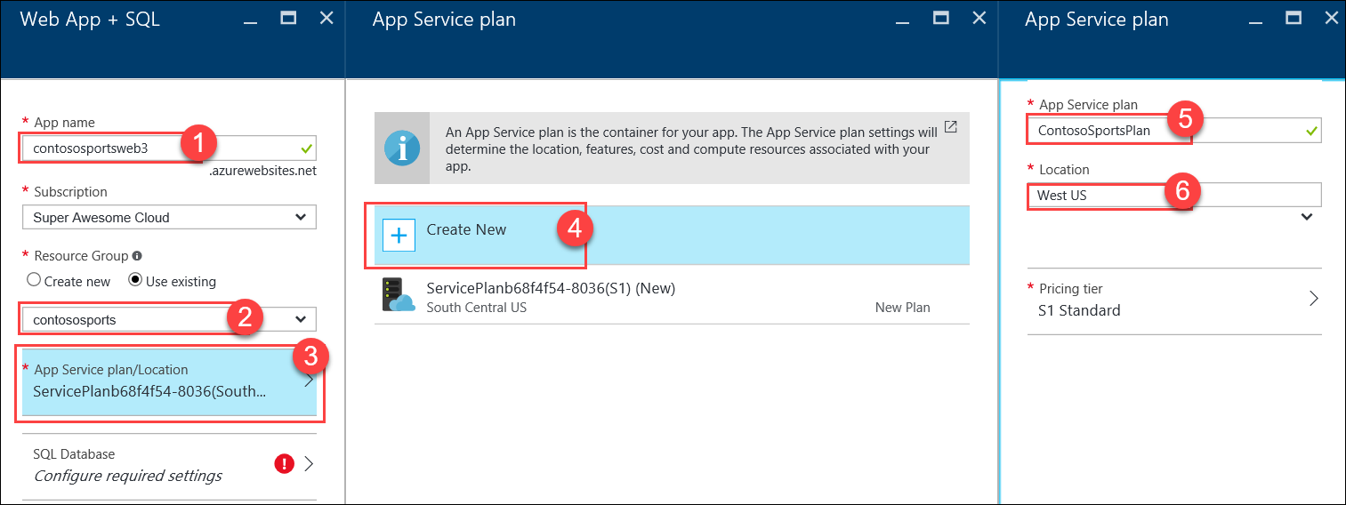

1. Click **OK** to save the configuration.

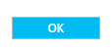

1. Select **SQL Database *Configure required settings***., then click **Create a new database**

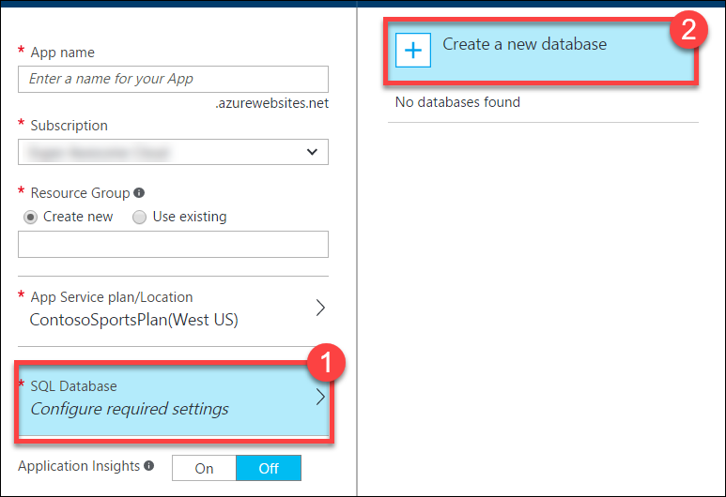

1. On the **SQL Database** blade, specify **ContosSportsDB** as the database name.

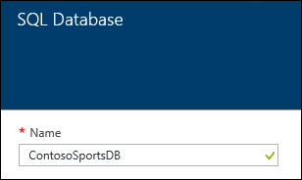

1. On the **SQL Database** blade, select **Target** **Server *Configure required settings***.

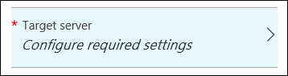

1. On the **New server** blade, specify the following configuration:
   1. Server name: a unique value (ensure the green checkmark appears)
   2. Server admin login: **demouser**
   3. **Password** and **Confirm Password**: demo@pass123
   4. Ensure the **Location** is the same region as the web app.

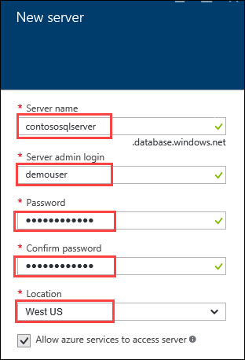

1. Once the values are accepted in the **New server** blade, click **Select**.



1. On the **SQL Database** blade, click **Select**.



1. After the values are accepted, click **Create**.



This may take a couple minutes to provision the Web App and SQL Database resources.

1. After the Web App and SQL Database are provisioned, click **More services**, **SQL databases**, and then click the name of the SQL Database you just created.

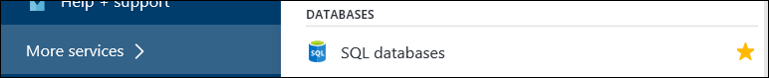

1. On the **SQL Database** blade, click the **Show database connection strings** link.

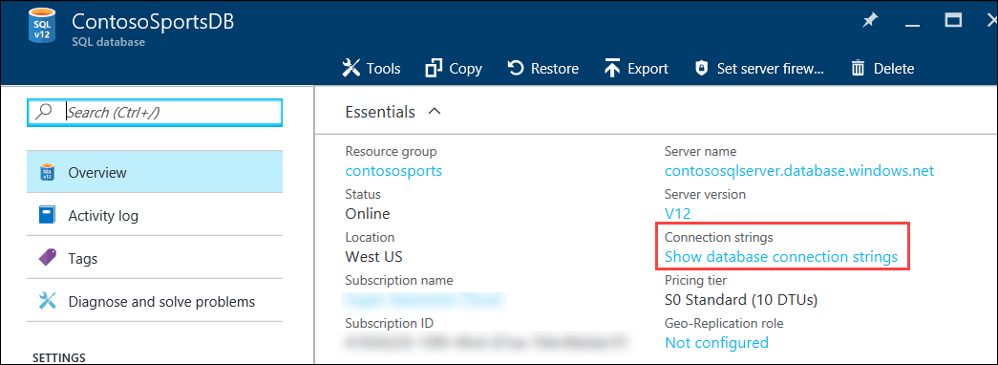

1. On the **Database connection strings** blade, select and copy the **ADO.NET** connection string, then save it in Notepad for use later.  
   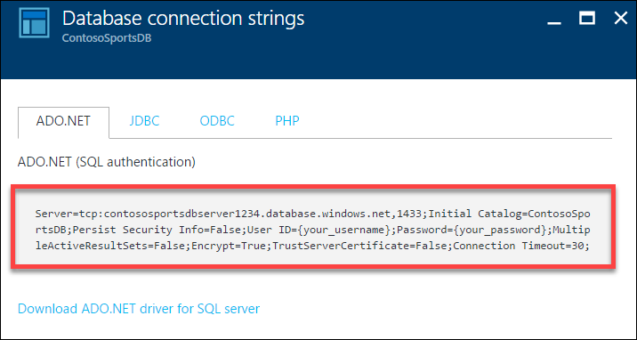
2. Click the SQL Database server name link.

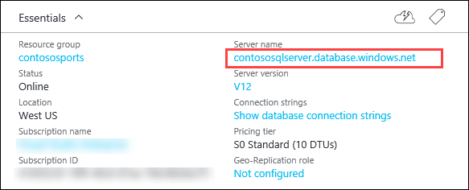

1. On the **SQL Server** blade under **Firewall**, click **Show firewall settings**.

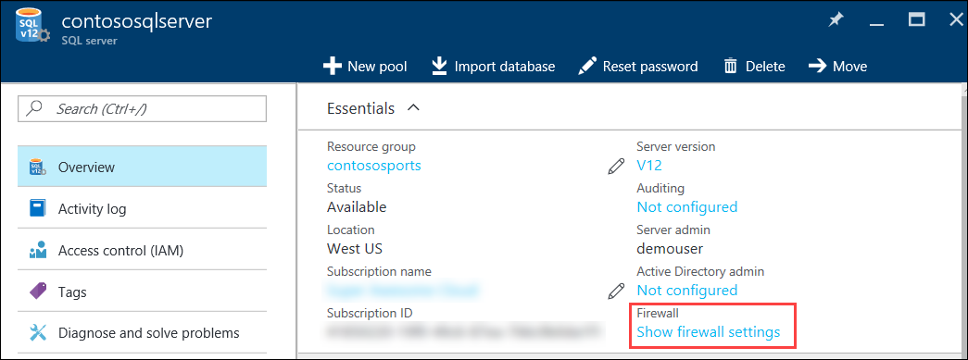

1. On the **Firewall Settings** blade, specify a new rule named **ALL**, with START IP **0.0.0.0**, and END IP **255.255.255.255**.

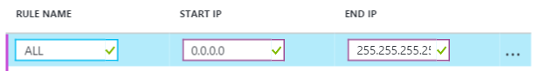

This is only done to make the lab easier to do. In Production, you do not want to open up your SQL Database to all IP Addresses this way. In Production, you will want to specify just the IP Addresses you wish to allow through the Firewall.

1. Click **Save**.

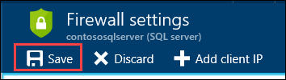

1. On the **Success!** dialog box click **OK**.

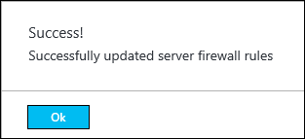

1. Close all configuration blades.

#### Subtask 2: Provision the storage account

1. Using a new tab or instance of your browser navigate to the Azure Management portal <http://portal.azure.com>.
2. Click **+New, Storage,** and **Storage account.**

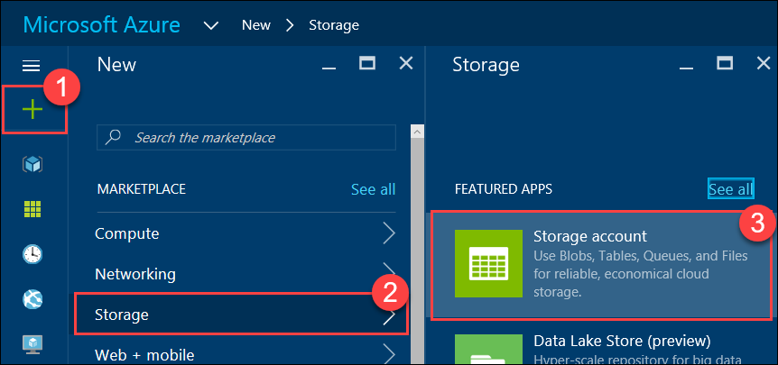

1. On the Create storage account blade specify the following configuration options:
   1. Name: unique value for the storage account (ensure the green check mark appears)
   2. Specify the Resource Group **contososports**
   3. Specify the same **Location** as the resource group.

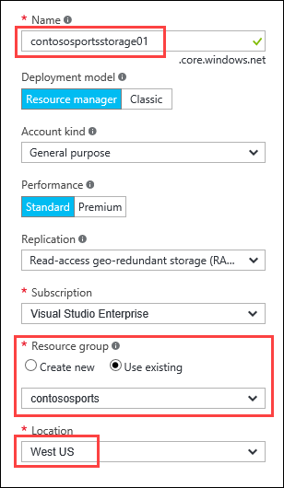

1. Click **Create**.

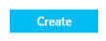

1. After the storage account has completed provisioning, open the storage account by clicking **More services** > **Storage accounts**, and then click the storage account name.

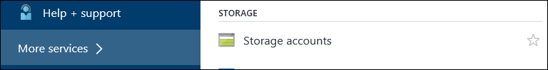

1. On the **Storage account** blade, click **All** **settings**.

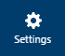

1. On the **Storage** account blade, scroll down to and select the **Access keys** option.

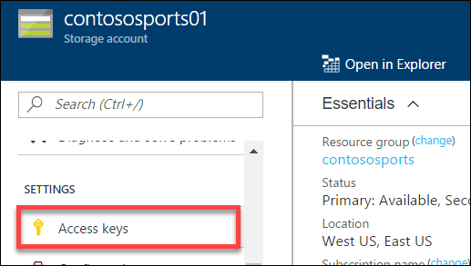

1. On the **Access keys** blade, click the ellipsis button by **key1**.

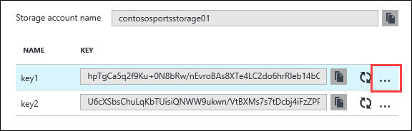

Then click **View Connection String**, and copy the value to the clipboard by selecting the value and pressing **CTRL-C**. Put the value in notepad for later reference.

#### Subtask 3: Update the configuration in the starter project

1. In the Azure Portal, click **Resource Groups**, and then click the **contososports** resource group.   
   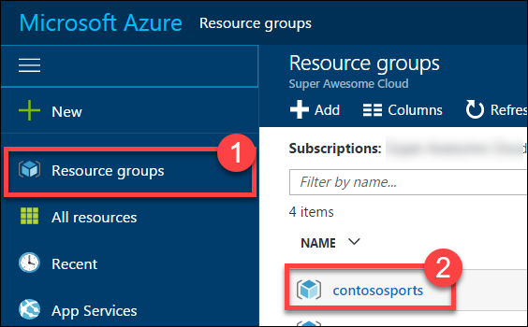
2. Click the **Web App** that was just created in a previous step.
3. On the **App Service** blade, scroll down in the left pane and click **Application settings**.  
   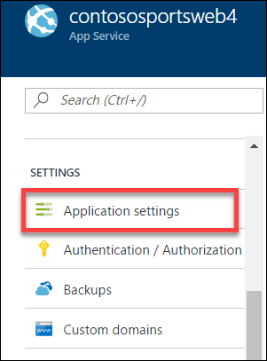
4. Scroll down and locate the **App settings** section.  
   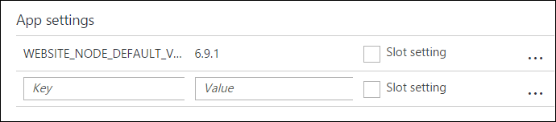
5. Add a new **App setting** with the following values:
   1. Key: **AzureQueueConnectionString**
   2. Value: **enter the Connection String for the Azure Account that was just created**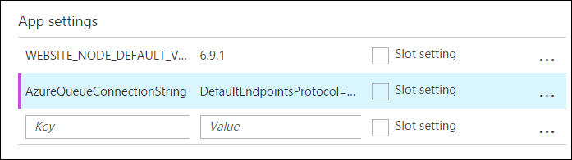
6. Locate **Connection Strings** below App settings.  
   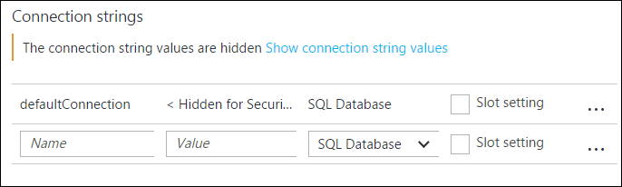
7. Add a new **Connection String** with the following values:
   1. Name: **ContosoSportsLeague**
   2. Value: **enter the Connection String for the SQL Database that was just created**
   3. Type: **SQL Database**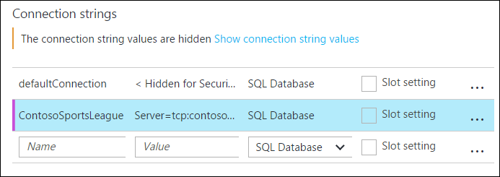

Ensure you replace the string placeholder values {your_username} {your_password_here} with the username and password respectively you setup during creation (demouser AND demo@pass123).



1. Click **Save**  
   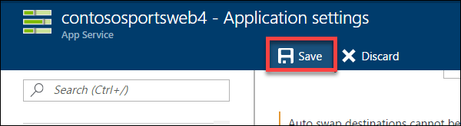

#### Subtask 4: Deploy the e-commerce web app from Visual Studio

1. Navigate to the **Contoso.Apps.SportsLeague.Web** project located in the **Web** folder using the **Solution Explorer** of Visual Studio.

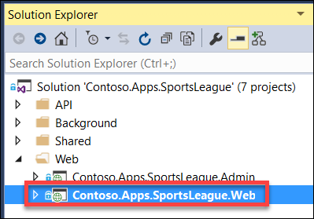

1. Right-click the **Contoso.Apps.SportsLeague.Web** project and click **Publish**.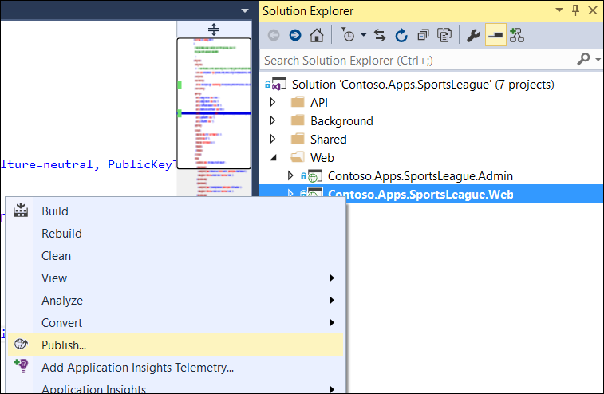  
   Choose **Microsoft Azure App Service** as the publish target.

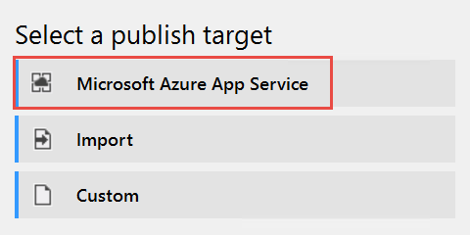

1. Log on with your credentials and ensure the subscription you published earlier is selected.

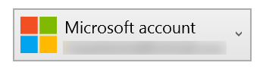

1. Select the Contoso Sports Web App.

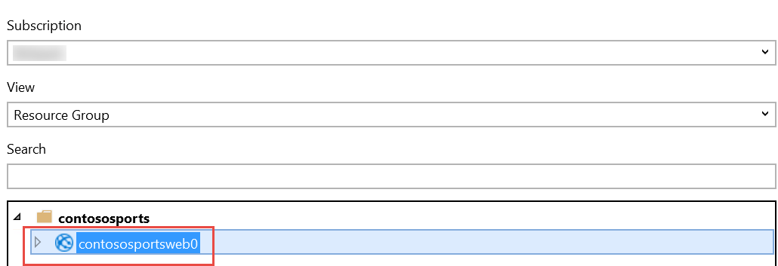

1. Click **OK**, and then click **Publish** to publish the web application.
2. In the Visual Studio **Output** view, you will see a status that indicates the web app was published successfully.

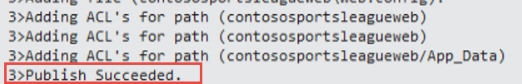

1. Validate the website by clicking the **Store** link on the menu. As long as products return, the connection to the database is successful.



### Task 2: Set up SQL Database Geo-Replication

In this exercise, the attendee will provision a secondary SQL Database and configure Geo-Replication using the Microsoft Azure Portal.

#### Subtask 1: Add secondary database

1. Using a new tab or instance of your browser navigate to the Azure Management Portal <http://portal.azure.com>
2. Click **More services,** then **SQL databases**, and then click the name of the SQL Database you created previously.  
   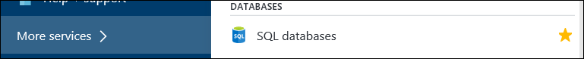
3. Under **Settings**, click **Geo-Replication**.  
   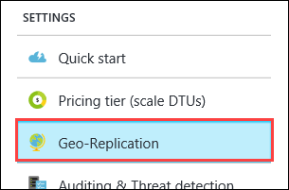
4. Select the Azure Region to place the Secondary within.  
   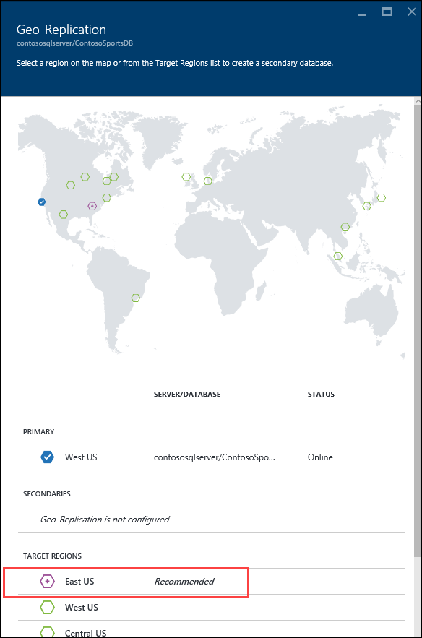

The Secondary Azure Region should be the Region Pair for the region the SQL Database is hosted in. The portal suggests the Region Pair to use by labeling it as “Recommended.”

1. On the **Create secondary** blade, select **Secondary Type** as **Readable**.
2. Select **Target server *Configure required settings***.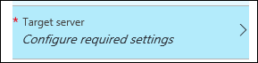
3. On the **New server** blade, specify the following configuration:
   1. Server name: a unique value (ensure the green checkmark appears)
   2. Server admin login: **demouser**
   3. Password and Confirm Password: **demo@pass123**

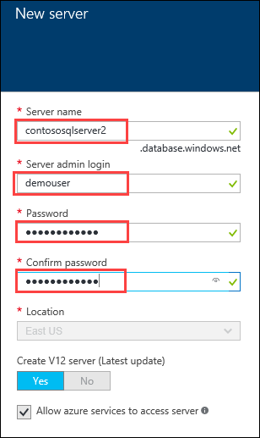

1. Once the values are accepted in the **New server** blade, click **Select**.  
   
2. On the **Create secondary** blade click **OK**.
3. After the Geo-Replication has finished provisioning, click **More services, SQL databases**.  
   
4. Click the name of the Secondary SQL Database you just created.  
   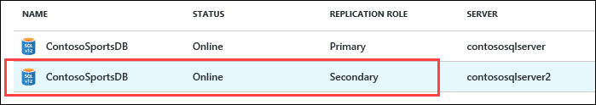
5. On the **SQL Database** blade, click the **Show database connection strings link**.  
   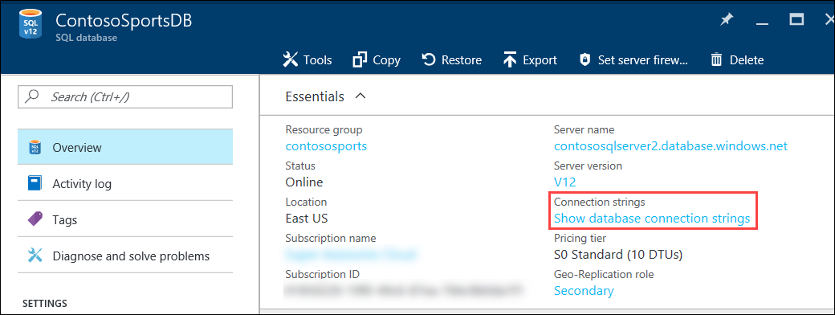
6. On the **Database connection strings** blade, select and copy the **ADO.NET** connection string, then save it in Notepad for use later.  
   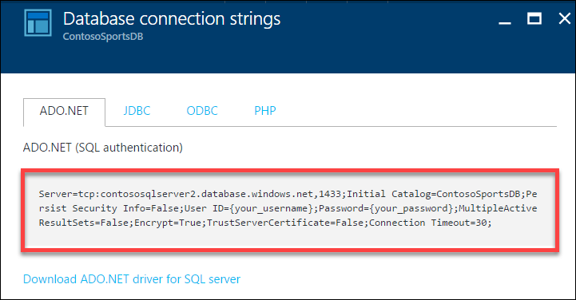  
   Click the SQL Database server name link.  
   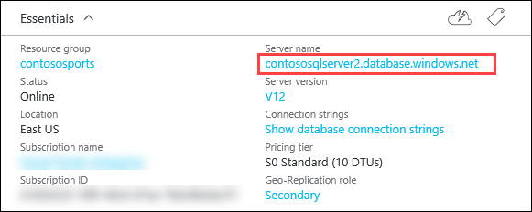
7. On the **SQL Server** blade, under **Firewall**, click **Show firewall settings**.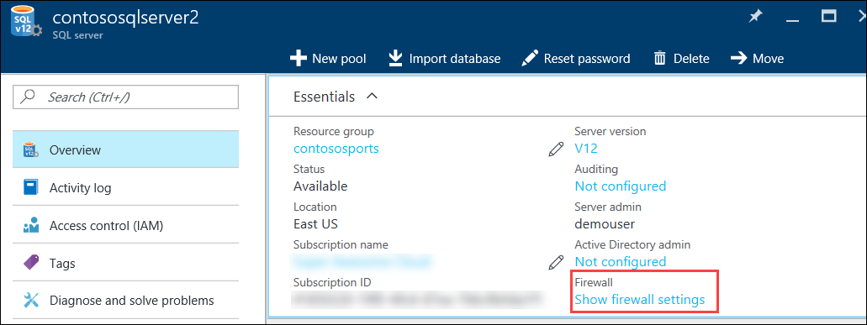
8. On the **Firewall Settings** blade, specify a new rule named **ALL**, with START IP **0.0.0.0**, and END IP **255.255.255.255**.  
   
9. Click **Save**.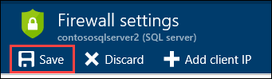
10. On the **Success!** dialog box click **OK**.  
    
11. Close all configuration blades.

#### Subtask 2: Failover secondary SQL database – OPTIONAL

Since the Replication and Failover process can take anywhere from 10 to 30 minutes to complete, you have the choice to skip Subtask 2 through 5, and skip directly to Task 3. However, if you have the time, it is recommended that you complete these steps.

1. Using a new tab or instance of your browser, navigate to the Azure Management Portal <http://portal.azure.com>.
2. Click **More services,** then **SQL databases**, and then click the name of the SQL Database you created previously.  
   
3. On the **Settings** blade, click **Geo-Replication**.  
   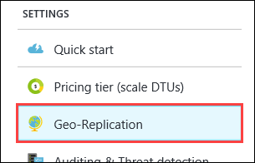
4. On the **Geo-Replication** blade, selectthe Secondary database.  
   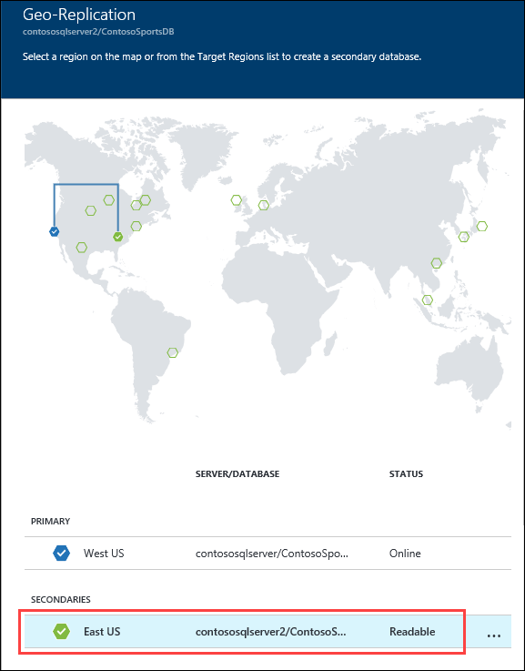
5. Click the **Failover** button.  
   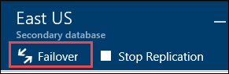
6. On the **Failover** prompt, click **Yes**.  
   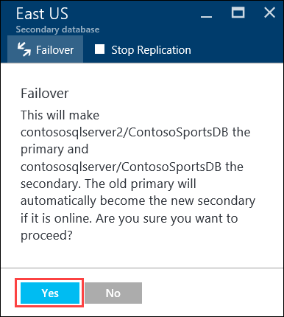

The Failover may take a few minutes to complete. You can continue with the next Subtask to modify the Web App to point to the Secondary SQL Database while the Failover is pending.

#### Subtask 3: Test e-commerce web app after Failover

1. In the Azure Portal, click **Resource Groups**, and then click the **contososports** resource group.   
   
2. Click the **Web App** that was just created in a previous step.
3. On the **App Service** blade, scroll down in the left pane and click **Application settings**.  
   
4. Scroll down and locate the **Connection strings** section.
5. Update the **ContosoSportsLeague** Connection String to the value of the Connection String for the **Secondary SQL Database.**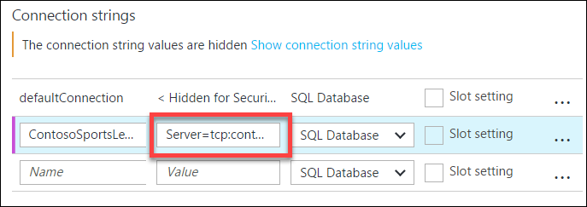

Ensure you replace the string placeholder values {your_username} {your_password_here} with the username and password respectively you setup during creation (demouser AND demo@pass123).



1. Click **Save**
2. On the **App Service** blade, click **Overview**.  
   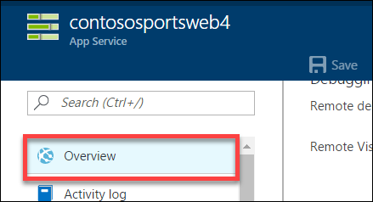
3. On the **Overview** pane, click the **URL** for the Web App to open it in a new browser tab.  
   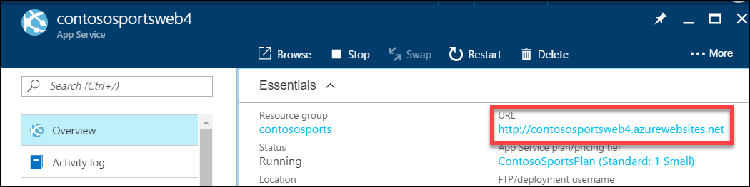
4. After the e-commerce web app loads in Internet Explorer, click **STORE** in the top navigation bar of the website.  
   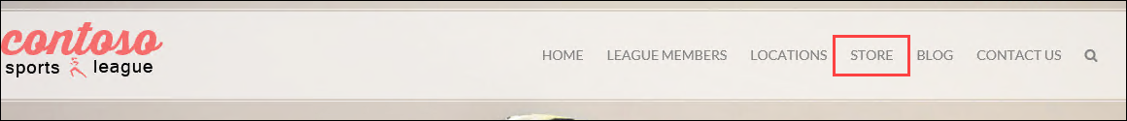
5. Verify the product list from the database displays  
   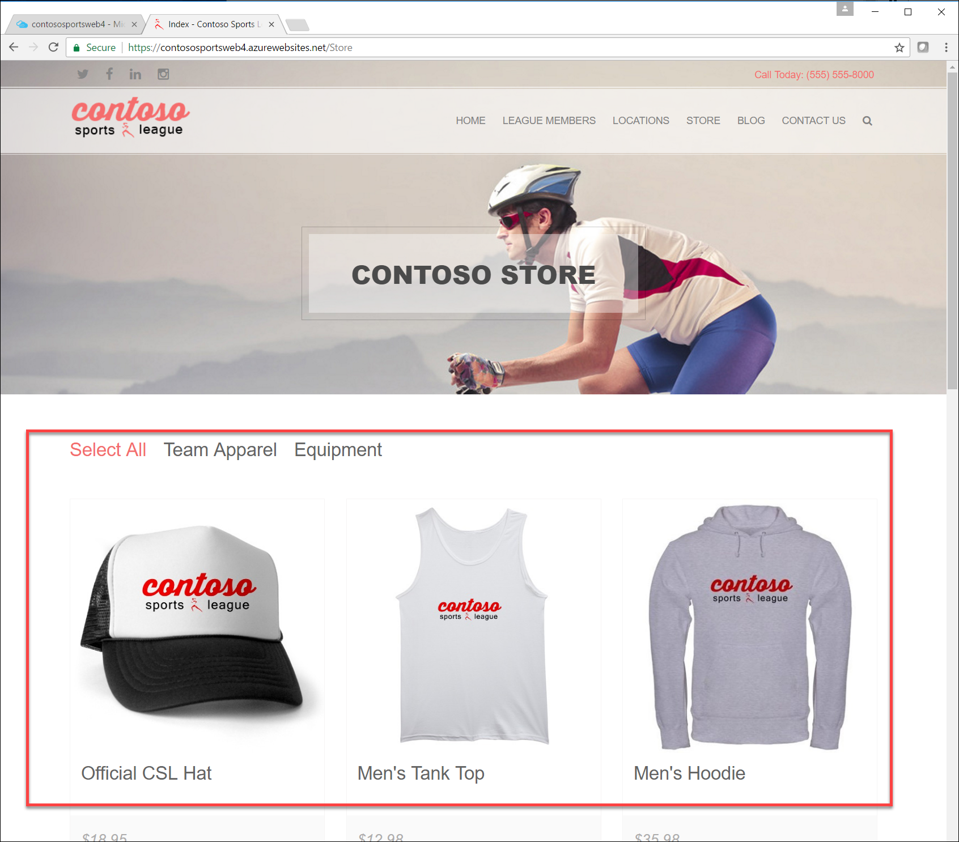

#### Subtask 4: Revert Failover back to Primary database

1. Using a new tab or instance of your browser navigate to the Azure Management Portal <http://portal.azure.com>
2. Click **More services,** then **SQL databases**, and then click the name of the SQL Database you created previously  
   
3. On the **Settings** blade, click **Geo-Replication**.  
   
4. On the **Geo-Replication** blade, selectthe Secondary database.  
   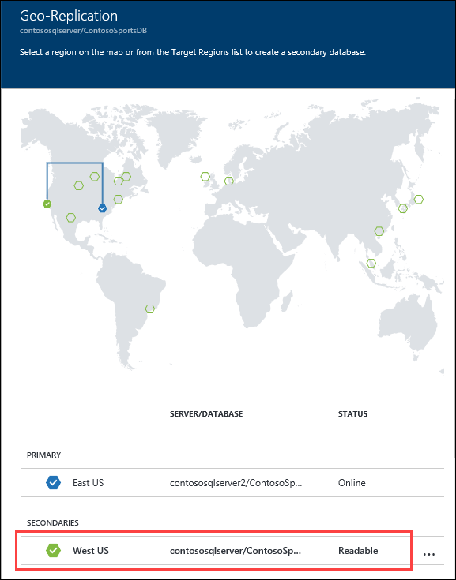
5. Click the **Failover** button.  
   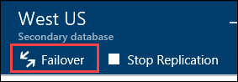
6. On the **Failover** prompt, click **Yes**.  
   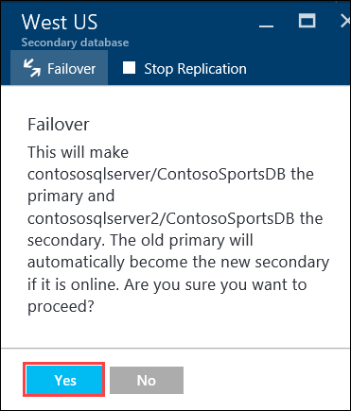

The Failover may take a few minutes to complete. You can continue with the next Subtask modifying the Web App to point back to the Primary SQL Database while the Failover is pending.

#### Subtask 5: Test e-commerce web app after reverting Failover

1. In the Azure Portal, click **Resource Groups**, and then click the **contososports** resource group.  
   
2. Click the **Web App** that was just created in a previous step.
3. On the **App Service** blade, scroll down in the left pane and click **Application settings**.  
   
4. Scroll down and locate the **Connection strings** section.
5. Update the **ContosoSportsLeague** Connection String to the value of the Connection String for the **Primary SQL Database**.

Ensure you replace the string placeholder values {your_username} {your_password_here} with the username and password, respectively, you set up during creation (demouser and demo@pass123).



1. Click **Save**.
2. On the **App Service** blade, click **Overview**.  
   
3. On the **Overview** pane, click the **URL** for the Web App to open it in a new browser tab.  
   
4. After the e-commerce web app loads in Internet Explorer, click **STORE** in the top navigation bar of the website.  
   

Verify the product list from the database displays.  


### Task 3: Deploying the call center admin website

In this exercise, the attendee will provision a website via the Azure Web App template using the Microsoft Azure Portal. The attendee will then edit the necessary configuration files in the Starter Project and deploy the call center admin website.

#### Subtask 1: Provision the call center admin web app

1. Using a new tab or instance of your browser navigate to the Azure Management portal <http://portal.azure.com>.
2. Click **New**, **Web + mobile**, and then click **Web App** 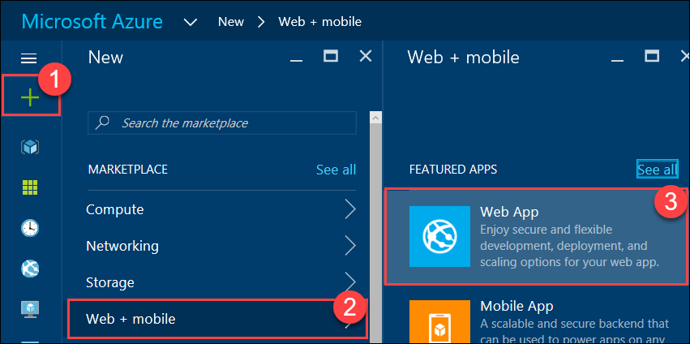
3. Specify a **unique URL** for the web app, and ensure the **same App Service Plan**, and **resource group** that you have used throughout the lab are selected.

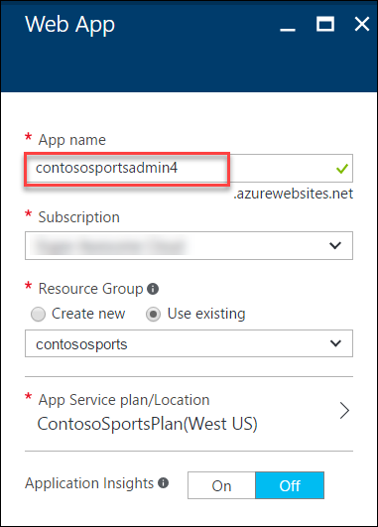

1. Click **App Service plan/Location** and select the **ContosoSportsPlan** that is used by the front-end Web App.  
   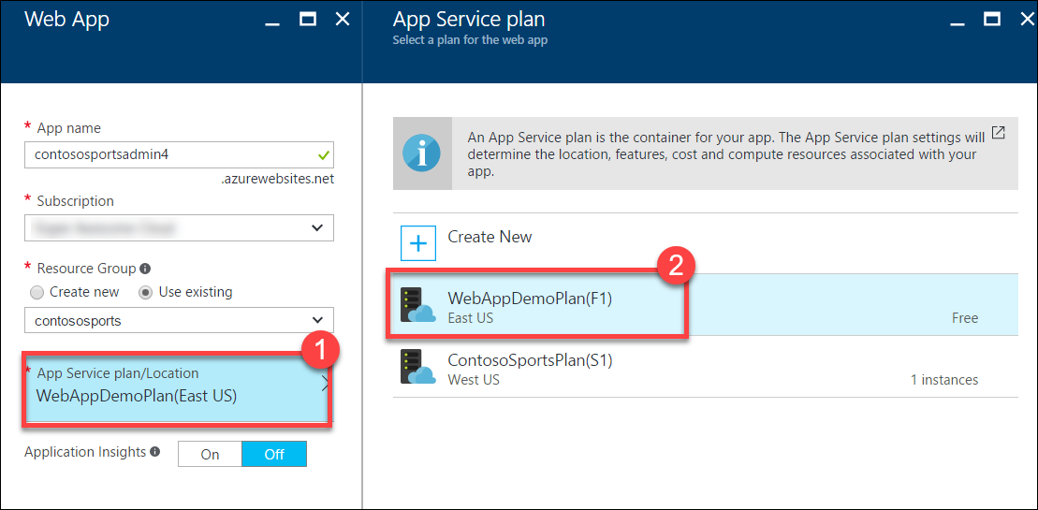
2. After the values are accepted click **Create**.



#### Subtask 2: Update the configuration in the starter project

1. Navigate to the **App Service** blade for the Call Center Admin app that was just provisioned.  
   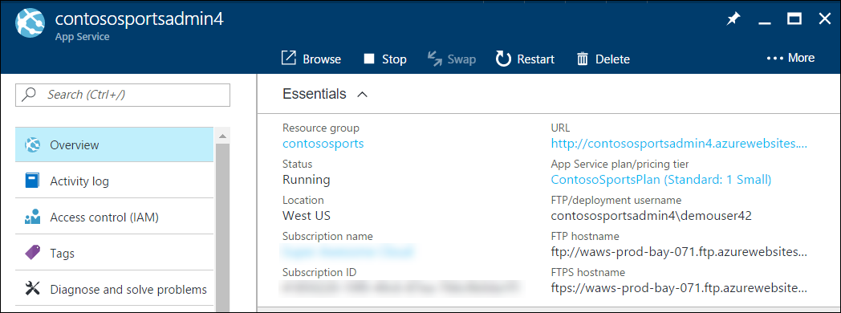
2. On the **App Service** blade, click **Application settings** in the left pane.

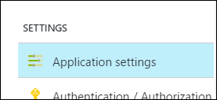

1. Scroll down and locate the **Connection strings** section.

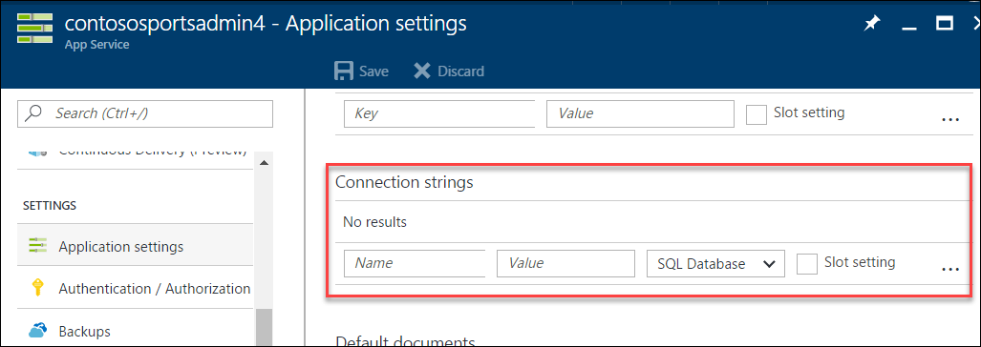

1. Add a new **Connection string** with the following values:
   1. Name: **ContosoSportsLeague**
   2. Value: **enter the Connection String for the SQL Database that was created**
   3. Type: **SQL Database**

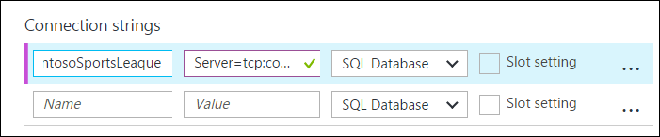

Ensure you replace the string placeholder values {your_username} {your_password_here} with the username and password respectively you setup during creation (demouser AND demo@pass123).



Click **Save**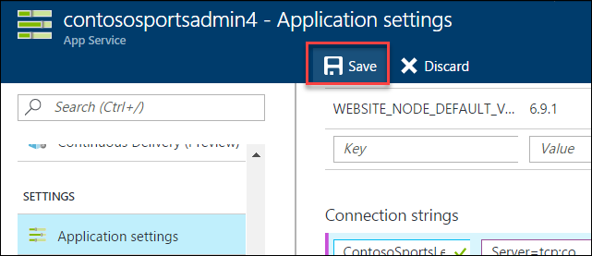

#### Subtask 3: Deploy the call center admin web app from Visual Studio

1. Navigate to the **Contoso.Apps.SportsLeague.Admin** project located in the **Web** folder using the **Solution Explorer** in Visual Studio.

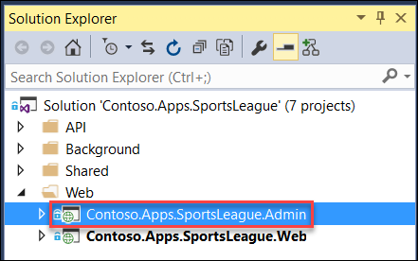

1. Right-click the **Contoso.Apps.SportsLeague.Admin** project and click **Publish**.

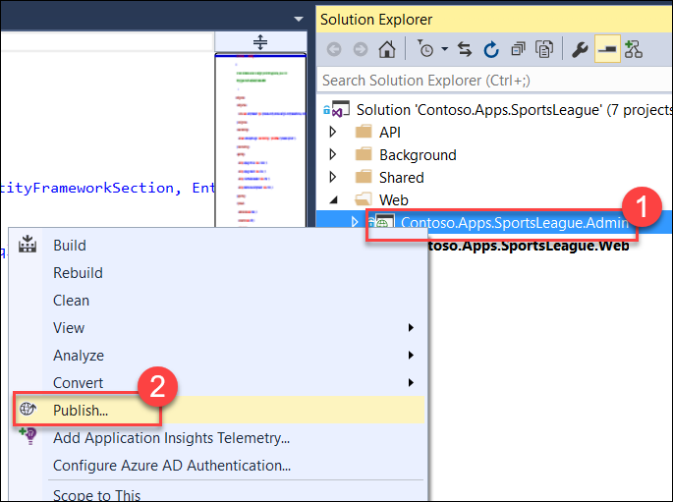

1. Choose **Microsoft Azure App Service** as the publish target.



1. Select the **Web App** for the Call Center Admin App.

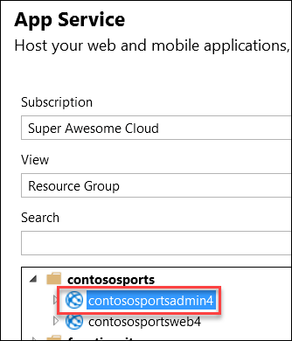

1. Click **OK**, and then click **Publish** to deploy the site.
2. The website should load and display the following:

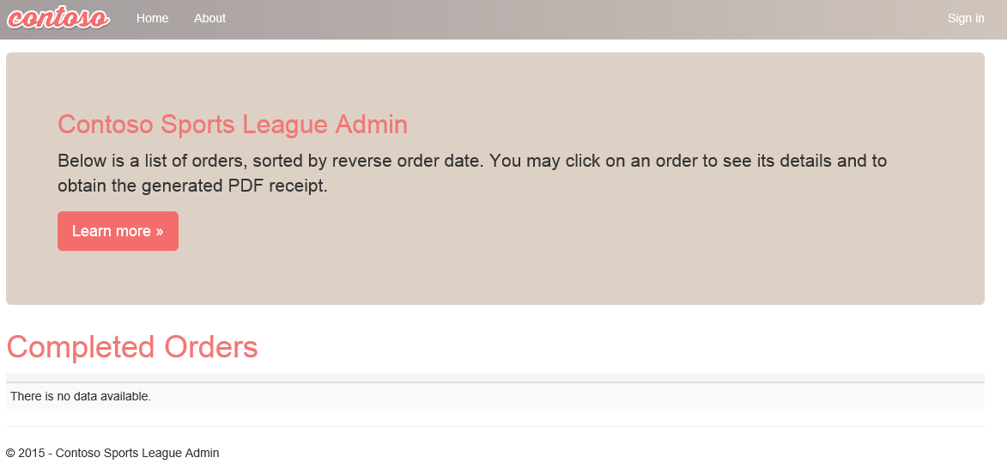

### Task 4: Deploying the payment gateway

In this exercise, the attendee will provision an Azure API app template using the Microsoft Azure Portal. The attendee will then deploy the payment gateway.

#### Subtask 1: Provision the payment gateway API app

1. Using a new tab or instance of your browser navigate to the Azure Management Portal <http://portal.azure.com>.
2. Click **+New**, then type **API App** into the **Search the marketplace** box, and press **Enter**.

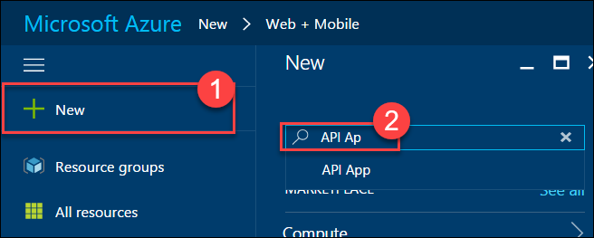

1. Click **API App** in the search results list.  
   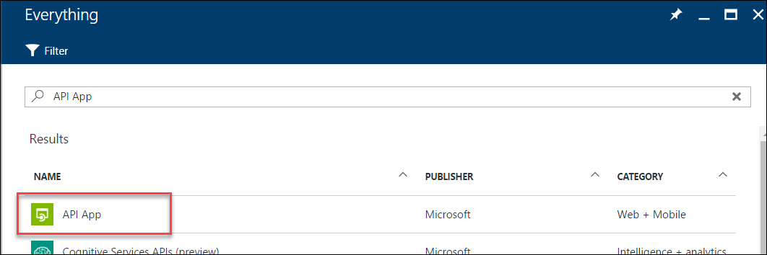
2. Click **Create**.  
   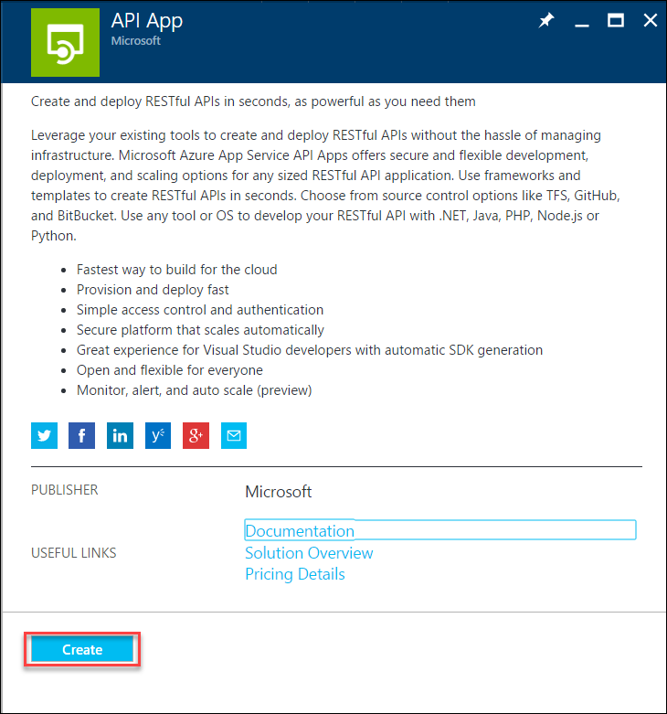
3. On the new **API App** blade, specify a unique name for the App Service Name, and ensure the previously used Resource Group and App Service Plan is selected.  
   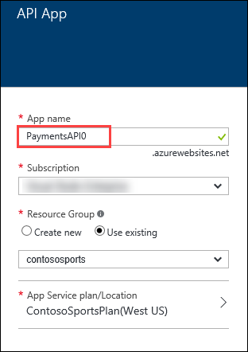
4. Click **App Service plan/Location** and select the same App Service Plan used for the other Web App services.  
   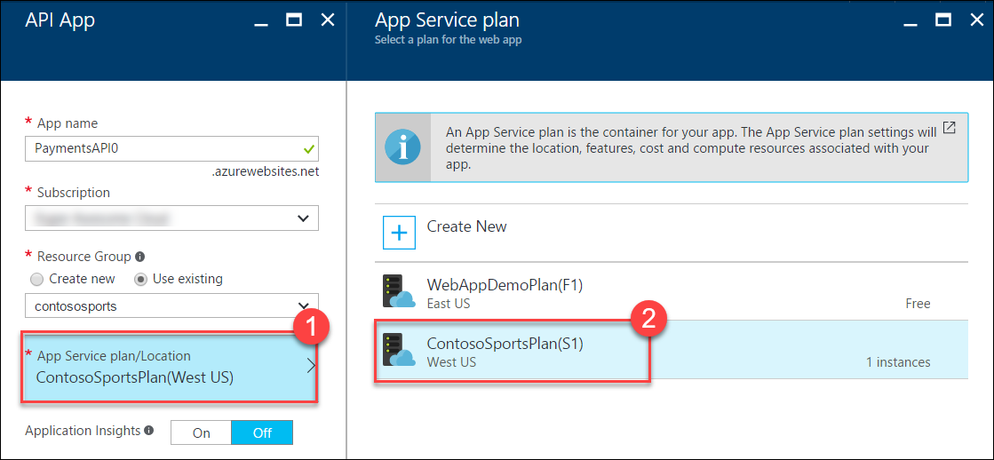
5. After the values are accepted click **Create**.  
   

#### Subtask 2: Deploy the Contoso.Apps.PaymentGateway project in Visual Studio

1. Navigate to the **Contoso.Apps.PaymentGateway** project located in the **APIs** folder using the **Solution Explorer** in Visual Studio.

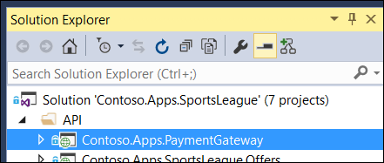

1. Right-click the **Contoso.Apps.PaymentGateway** project and click **Publish**.

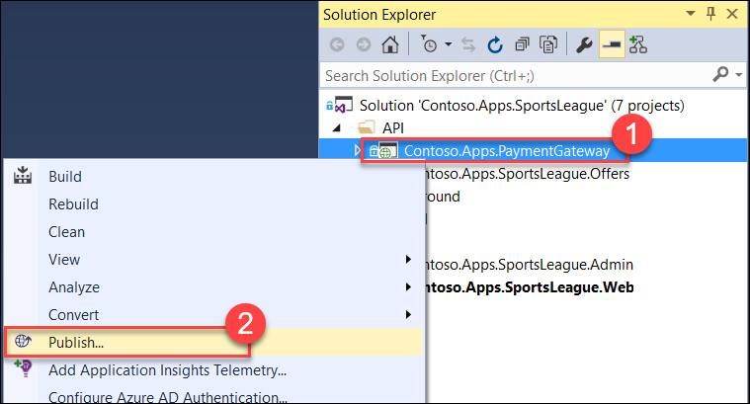

1. On the **Publish Web** dialog box,click **Microsoft Azure App Service**.

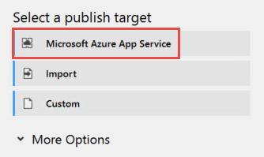

1. Select the Payment Gateway API app created earlier, click **OK**, and then **Publish**.

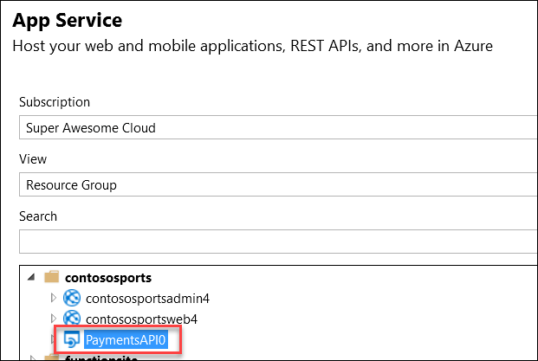

1. In the Visual Studio **Output** view you will see a status that indicates the web app was published successfully.



1. Record the value of the deployed **API App URL** for later use.

### Task 5: Deploying the offers Web API

In this exercise, the attendee will provision an Azure API app template using the Microsoft Azure Portal. The attendee will then deploy the offers Web API.

#### Subtask 1: Provision the offers Web API app

1. Using a new tab or instance of your browser navigate to the Azure Management Portal (<http://portal.azure.com>).
2. Click **+New**, then type **API App** into the Search the marketplace box, and press Enter.



1. Click **API App** in the search results list.  
   
2. Click **Create**.  
   
3. On the new **API App** blade, specify a unique name for the App Service Name, and ensure the previously used Resource Group and App Service Plan is selected.

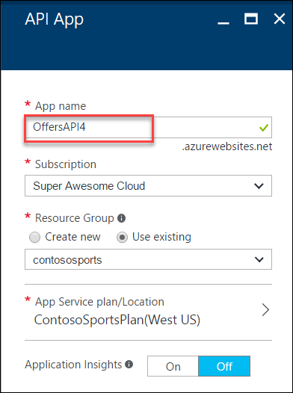

1. Click **App Service plan/Location** and select the same App Service Plan used for the other Web App services.  
   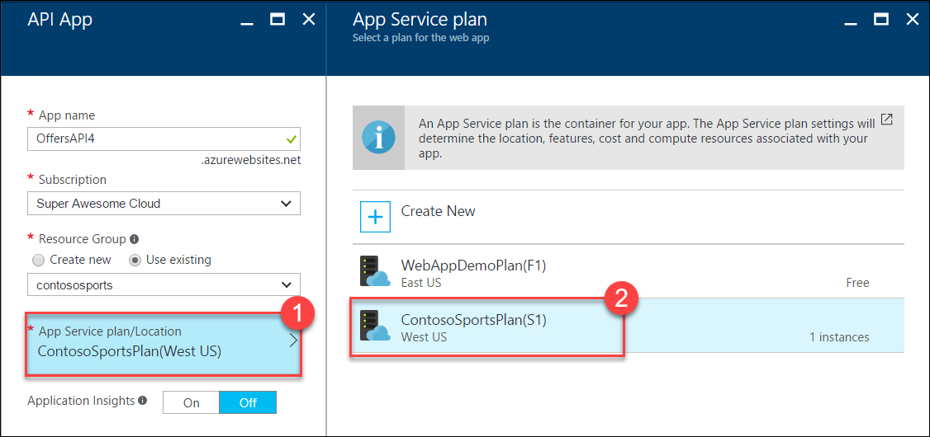
2. After the values are accepted click **Create**.  
   
3. When the web app template has completed provisioning, open the new API App by clicking **More services** > **App Services** > and then click the **Offers API** that was just created.

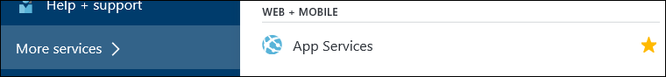

#### Subtask 2: Configure cross-origin resource sharing (CORS)

1. On the **App Service** blade, scroll down and click **CORS** within the API section of the left pane.

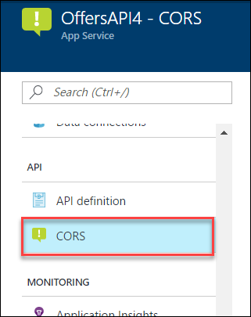

1. In the **ALLOWED ORIGINS** text box specify **\***, and click **Save**. 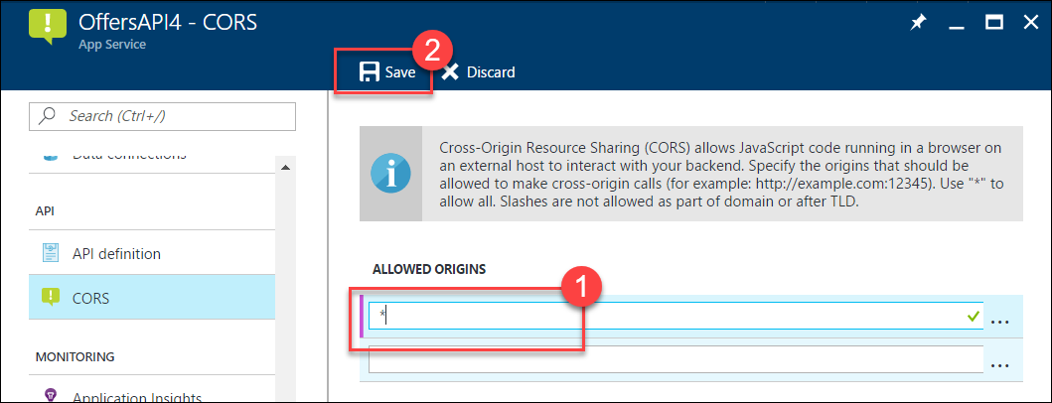

#### Subtask 3: Update the configuration in the starter project

1. On the **App Service** blade for the Offers API click **Application settings**.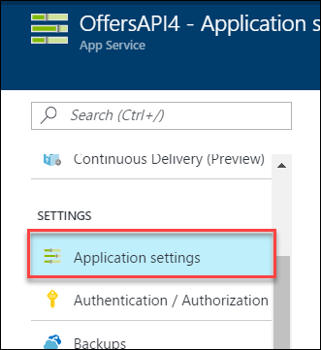
2. Scroll down and locate the **Connection strings** section.  
   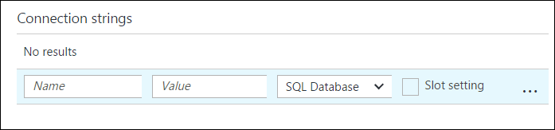
3. Add a new **Connection string** with the following values:
   1. Name: **ContosoSportsLeague**
   2. Value: **enter the Connection String for the SQL Database that was created**
   3. Type: **SQL Database**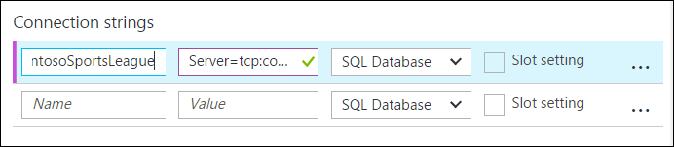

Ensure you replace the string placeholder values {your_username} {your_password_here} with the username and password respectively you setup during creation (demouser AND demo@pass123).



1. Click **Save**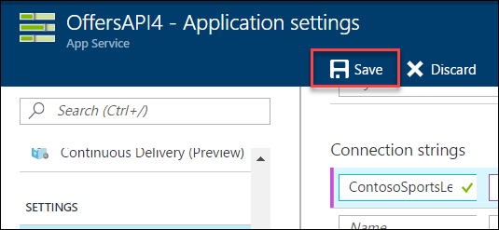

#### Subtask 4: Deploy the Contoso.Apps.SportsLeague.Offers project in Visual Studio

1. Navigate to the **Contoso.Apps.SportsLeague.Offers** project located in the **APIs** folder using the **Solution Explorer** in Visual Studio.

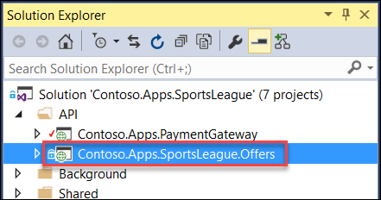

1. Right-click the **Contoso.Apps.SportsLeague.Offers** project and select **Publish**.

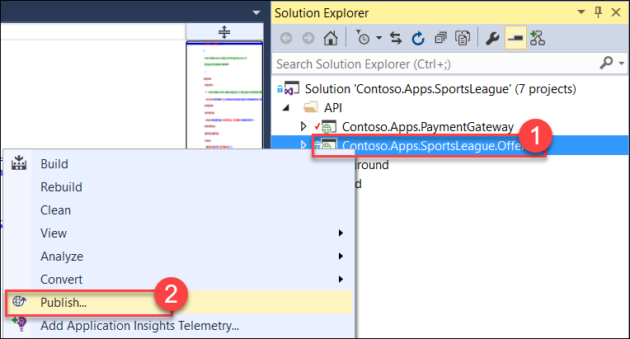

1. On the **Publish Web** dialog box,click **Microsoft Azure App Service**.



1. Select the Offers API app created earlier, click **OK**, and then **Publish**.

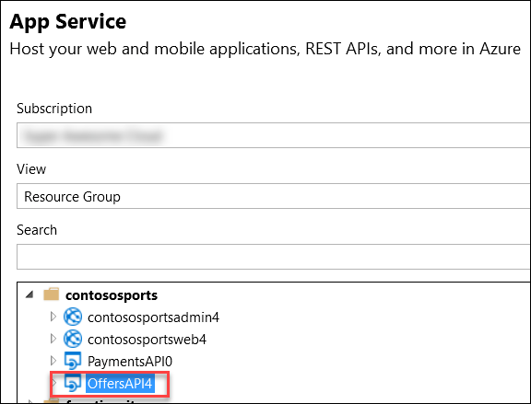

1. In the Visual Studio **Output** view you will see a status that the API app was published successfully.
2. Record the value of the deployed API app URL for later use.

\

### Task 6: Update and deploy the e-commerce website

#### Subtask 1: Update the Application Settings for the Web App that hosts the Contoso.Apps.SportsLeague.Web project

1. Using a new tab or instance of your browser navigate to the Azure Management Portal <http://portal.azure.com>.
2. Click **Resource groups**, then the **contososports** resource group.  
   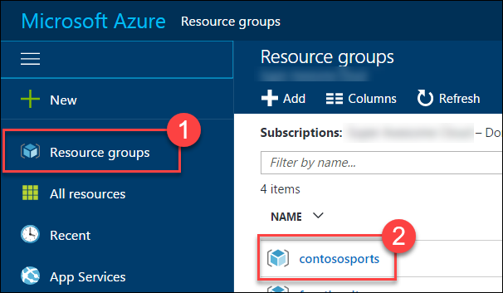
3. Click the **App Service Web App** for the front-end Web Application.   
   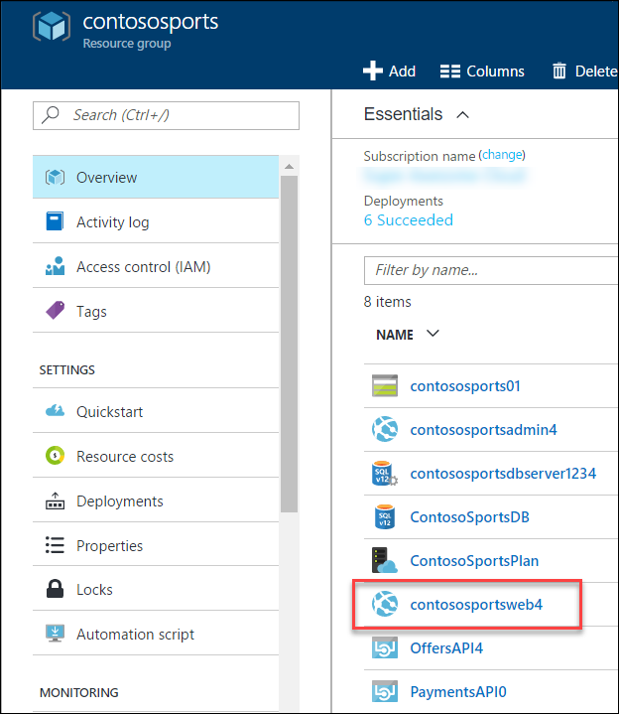
4. On the **App Service** blade, scroll down and click **Application settings** in the left pane.

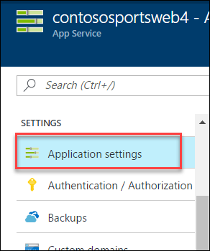

1. Scroll down and locate the **App settings** section  
   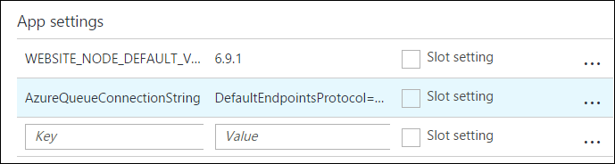
2. Add a new **App Setting** with the following values:
   1. Key: **paymentsAPIUrl**
   2. Value: enter the **HTTPS** URL for the Payments API App with **/api/nvp** appended to the end. Ex: https://paymentsapi0.azurewebsites.net/api/nvp  
      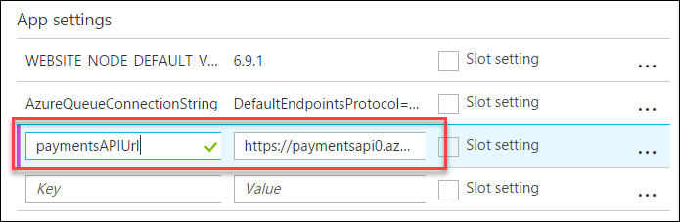
3. Add a new **App Setting** with the following values:
   1. Key: **offersAPIUrl**
   2. Value: enter the **HTTPS** URL for the Offers API App with **/api/get** appended to the end. Ex: https://offersapi4.azurewebsites.net/api/get  
      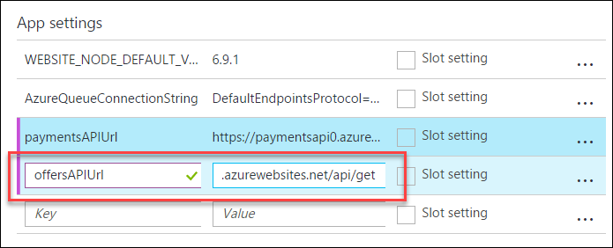
4. Click **Save**.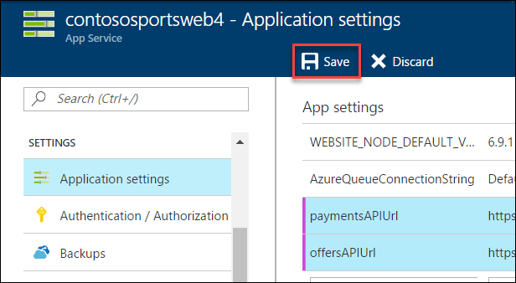

Note: Ensure that the API URLs both are using SSL (https://) or you will see a CORS errors.

#### Subtask 2: Validate App Settings are correct

1. On the **App Service** blade, click Overview.  
   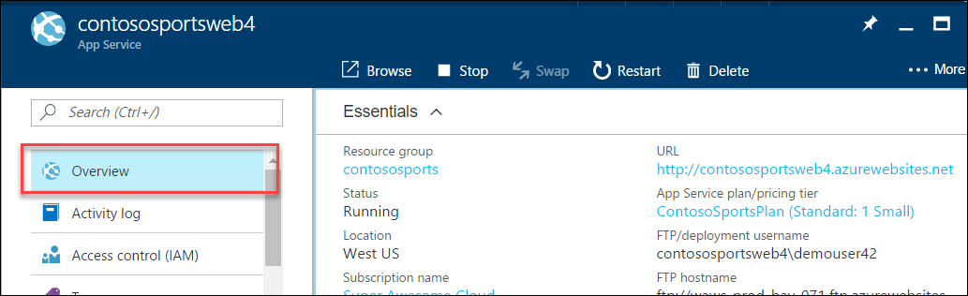
2. In the **Overview** pane, click the **URL** for the Web App to open it in a new browser tab.  
   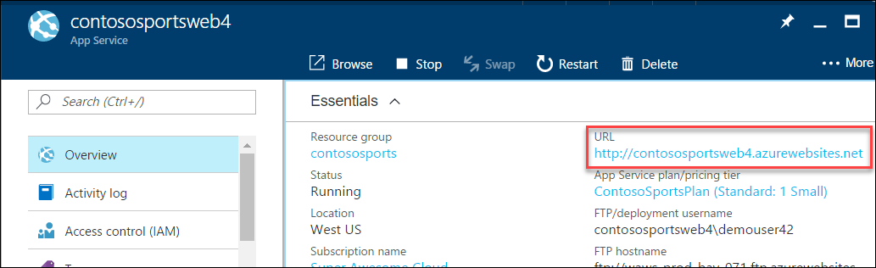
3. On the homepage, you should see the latest offers populated from the offers API.

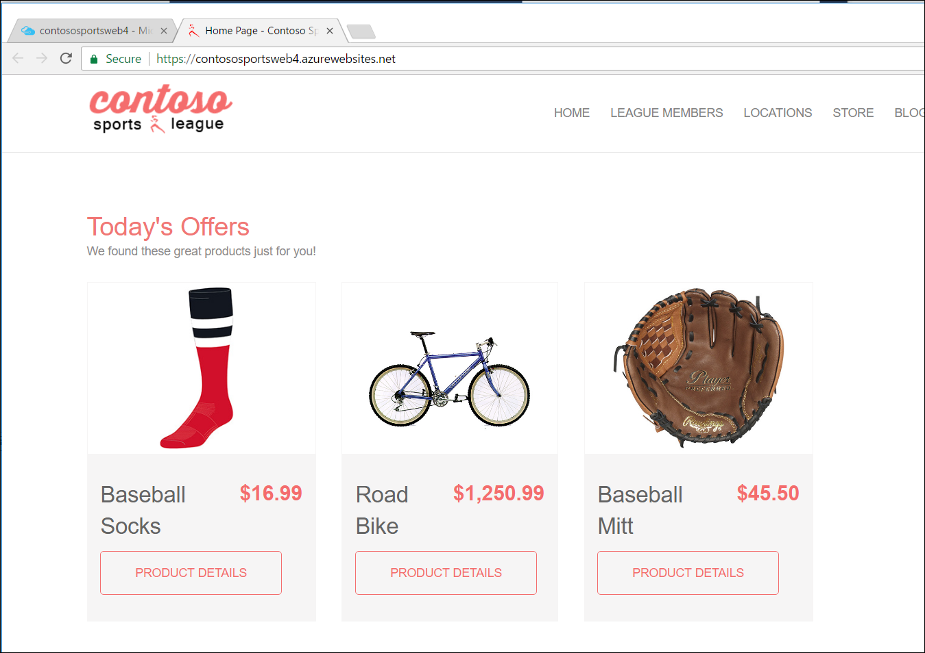

1. Submit several test orders to ensure that all pieces of the site are functional.

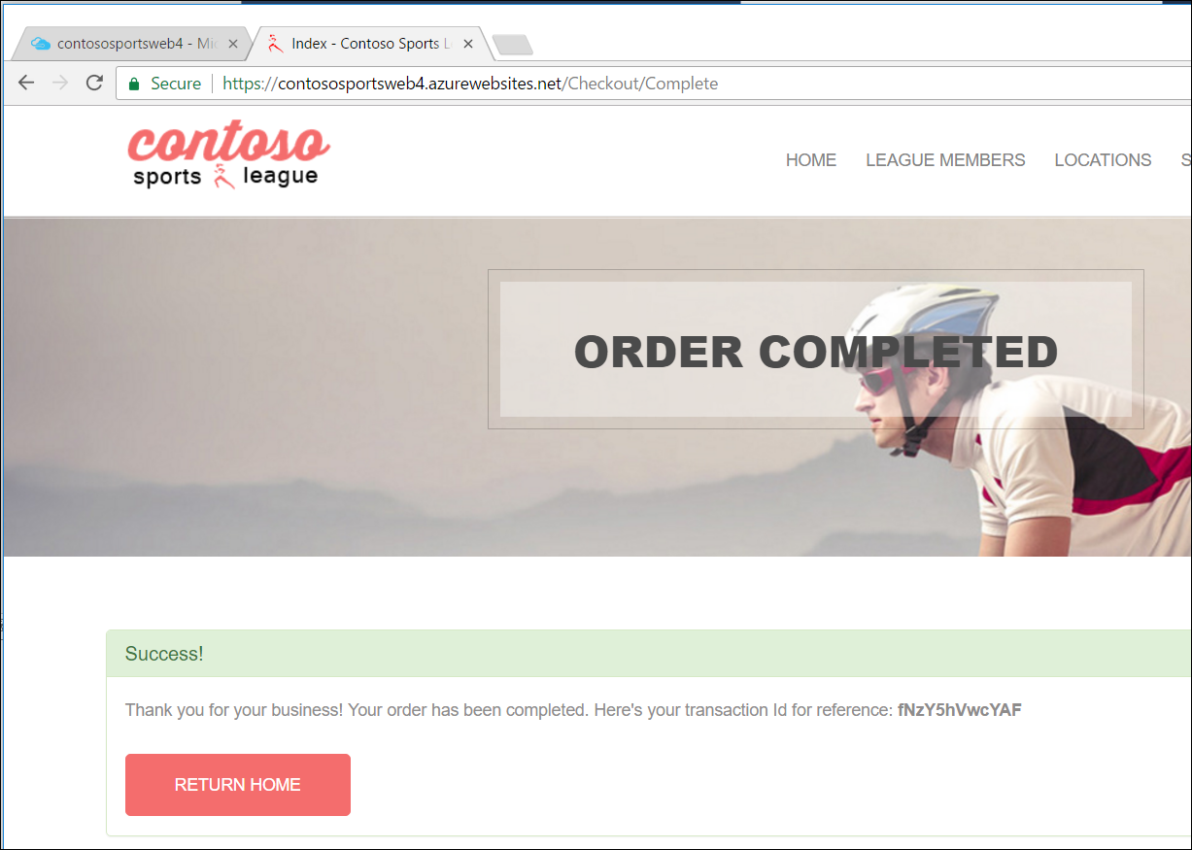

Proctor Note: If the attendee is still experiencing CORS errors, ensure the URLs to the web app in Azure local host are exact.

## Exercise 3: Identity and security

### Overview

The Contoso call center admin application will only be accessible by users of the Contoso Active Directory environment. You have been asked to create a new Azure AD Tenant and secure the application so only users from the tenant can log on.

### Help references

|  |  |
| --- | --- |
| What is Azure AD? | <https://azure.microsoft.com/en-us/documentation/articles/active-directory-whatis/> |
| Azure Web Apps authentication | <http://azure.microsoft.com/blog/2014/11/13/azure-websites-authentication-authorization/> |
| View your access and usage reports | <https://msdn.microsoft.com/en-us/library/azure/dn283934.aspx> |
| Custom branding an Azure AD Tenant | <https://msdn.microsoft.com/en-us/library/azure/Dn532270.aspx> |

Note: Tasks 1, 2, and 4 are optional and require global admin permissions on the AzureAD Tenant. Task 3 is also optional, but does require the permission to create an app in the Azure AD tenant.

### Task 1: Enable Azure AD Premium Trial

Note: this task is optional and is valid only if you are a global administrator on the Azure AD tenant associated with your subscription.

1. From the Azure Management portal <http://portal.azure.com>, using a new tab or instance
2. Click **More services** then **Azure Active Directory** under the SECURITY + IDENTITY section.  
   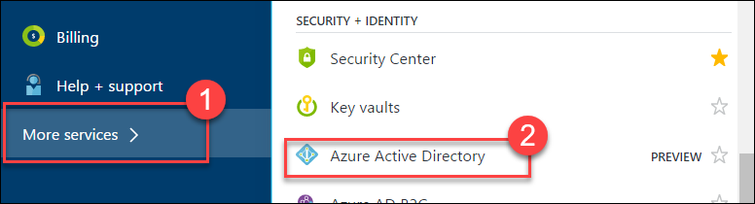
3. On the **Azure Active Directory** blade, locate and click the **Company branding** option.  
   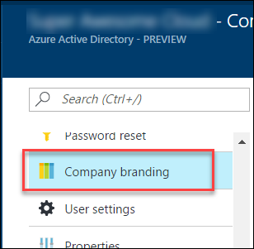
4. Click the option to **Get a free Premium trial**.  
   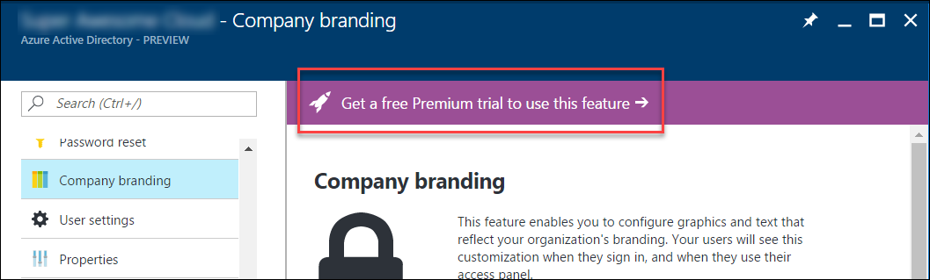

If you already have a Premium Azure Active Directory, then skip to Task 2.

1. On the **Activate** blade, click the **Free Trial** link within the AZURE AD PREMIUM box.  
   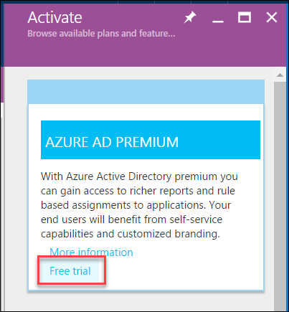
2. On the **Active Azure AD Premium trial** blade, click the **Activate** button.  
   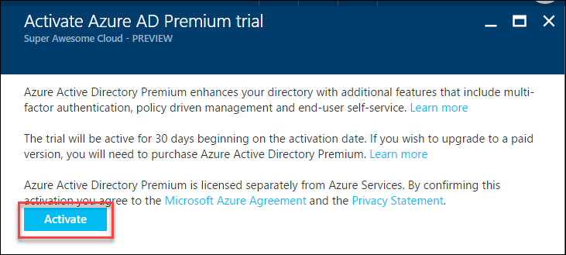
3. Close the **Azure Active Directory** blades.

### Task 2: Create a new Contoso user

Note: this task is optional and is valid only if you are a global administrator on the Azure AD tenant associated with your subscription.

1. From the Azure Management portal <http://portal.azure.com>, using a new tab or instance
2. Click **More services** then **Azure Active Directory** under the SECURITY + IDENTITY section.  
   
3. On the **Azure Active Directory** blade, click **Domain** names.  
   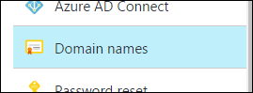
4. Copy the **Domain Name** for your Azure AD Tenant.  
   It will be in the format: *[your tenant].onmicrosoft.com*This will be used for creating the new user’s the Username.  
   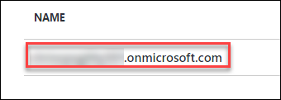
5. On the **Azure Active Directory** blade, click **Users and groups**, then **All users**.  
   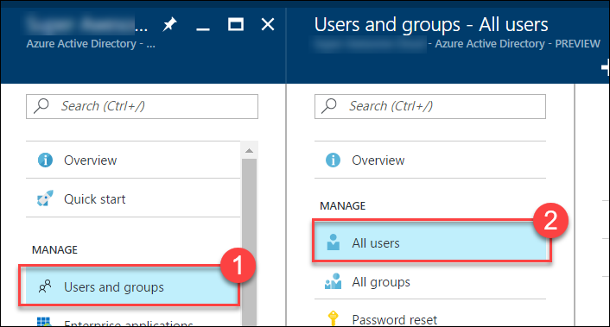
6. Click **+Add** to add a new user.  
   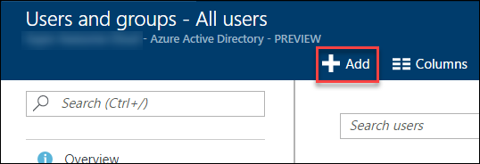
7. On the **User** blade, specify a user’s **Name** and **Username**.  
   Specify the **Username** to be at the domain name for your Azure AD Tenant.  
   For example: *tbaker@[your tenant].onmicrosoft.com*  
   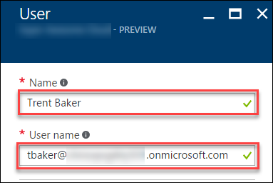
8. Click the **Show Password** check box, and make a note of the Password for use later.  
   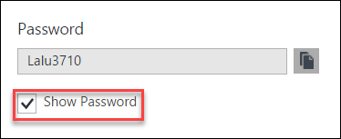
9. Click **Create**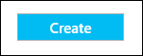

### Task 3: Configure access control for the call center administration web application

Note: this task is optional and is valid only if you have the right to create applications in your Azure AD Tenant.

#### Subtask 1: Enable Azure AD Authentication

1. On the left navigation of the Azure Portal, click **App Services** (or click **More services** and then click **App Services**.



1. On the **web apps** page select the **call center administration web app**.

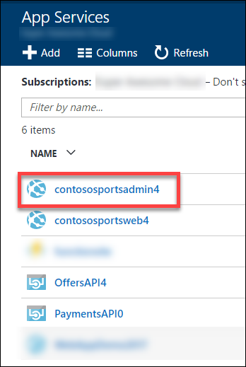

1. Click the **Authentication / Authorization** tile.

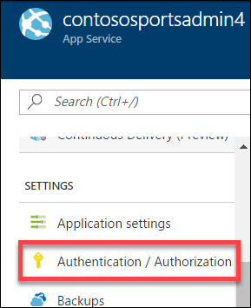

1. Change **App Service Authentication** to **On**, change the drop-down menu to **Log in with Azure Active Directory**

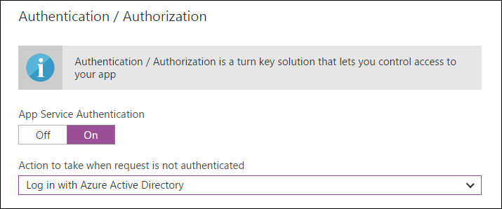

1. Click the **Azure Active Directory**.  
   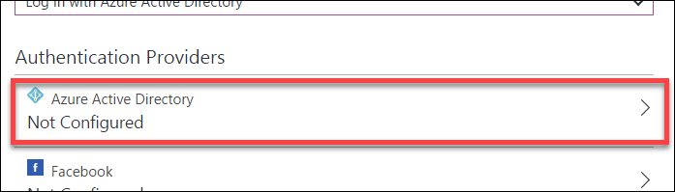
2. On the **Azure Active Directory Settings** blade, change **Management mode** to **Express**

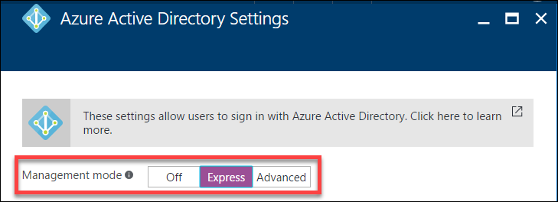

1. Click **OK**  
   
2. In the **Authentication / Authorization** blade click **Save**.

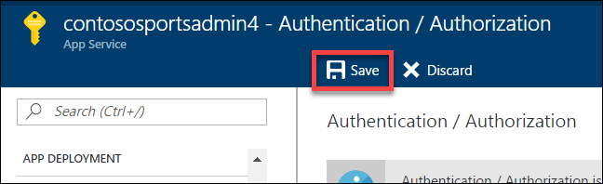

#### Subtask 2: Verify the call center administration website uses the access control logon

1. Close your browser (or use an alternative) and launch a browser is InPrivate or Incognito mode. Navigate to the **call center administration** website.
2. The browser will redirect to the non-branded Access Control logon URL. You can log on with your Microsoft account or the **Contoso test user** you created earlier.

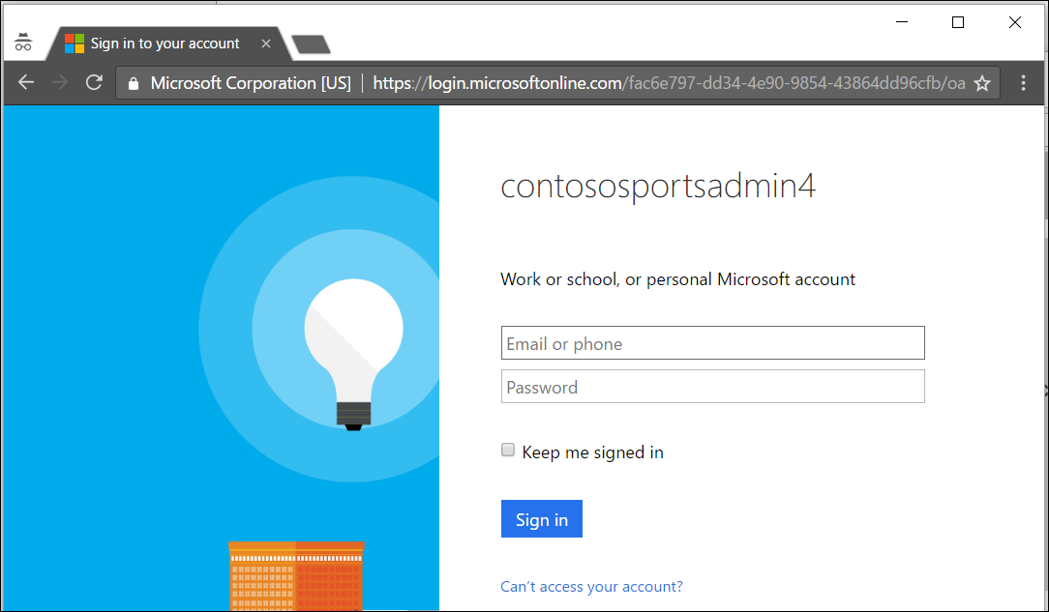

1. After you log on, your browser will be redirected to the Contoso Sports League Admin web page.

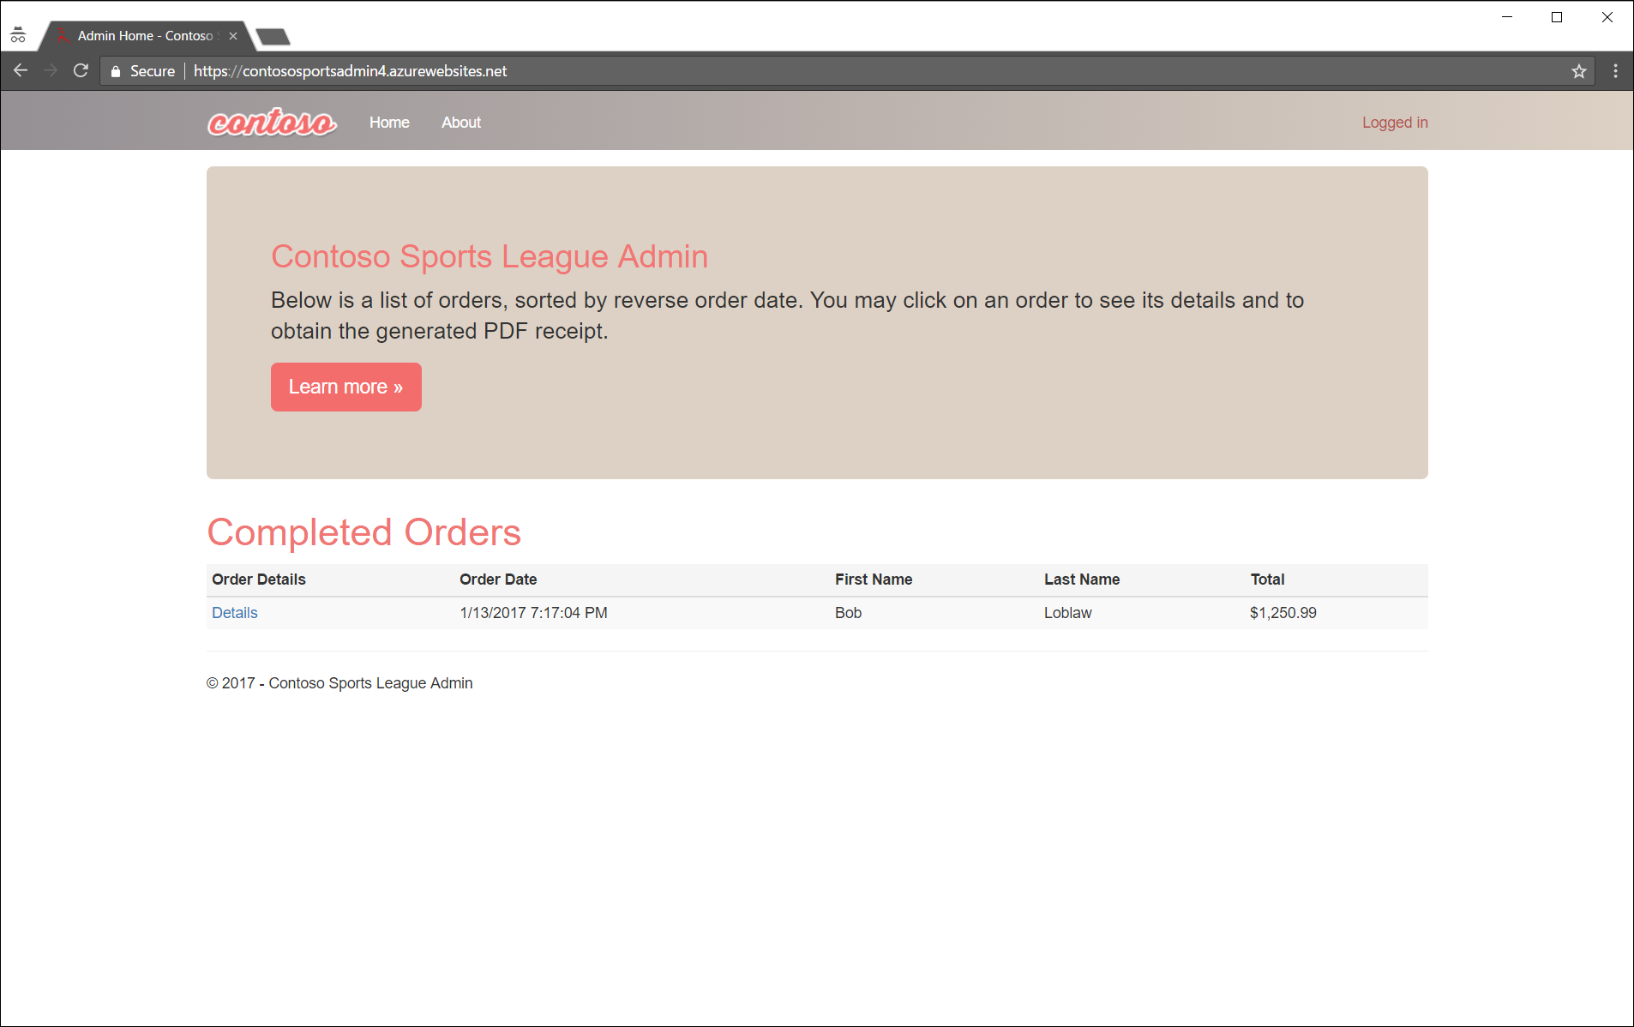

1. Verify that in the upper-right corner you see the link **Logged In**. If it is not configured you will see **Sign in**.

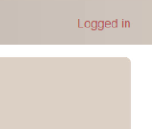 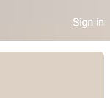

### Task 4: Apply custom branding for the Azure Active Directory logon page

Note: this task is optional and is valid only if you are a global administrator on the Azure AD tenant associated with your subscription and you completed the Enabling Azure AD Premium exercise.

1. From the Azure Management portal <http://portal.azure.com>, using a new tab or instance
2. Click **More services** then **Azure Active Directory** under the SECURITY + IDENTITY section.  
   
3. On the **Azure Active Directory** blade, click **Company branding**.  
   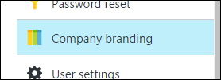
4. Click the **Configure company branding now** link.  
   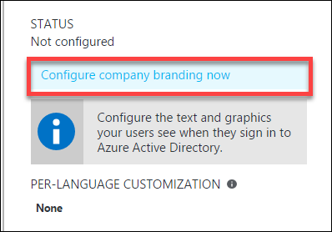
5. On the **Configure company branding** blade, select the **default_signin_illustration.jpg** image file from **C:\hackathon** for the **Sign-in page image**.  
   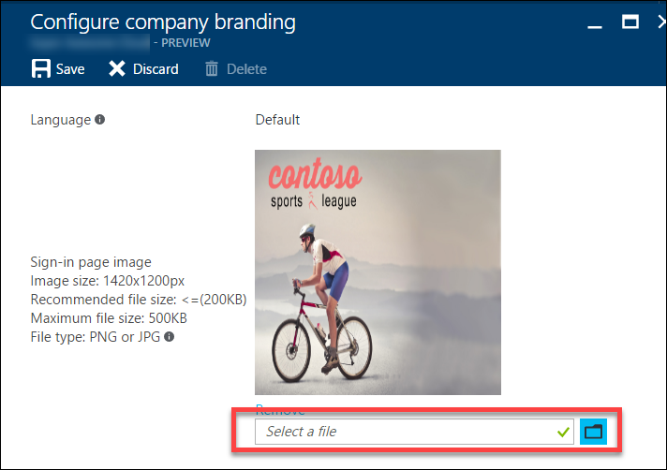
6. Select the **logo-60-280.png** image file from **C:\hackathon** for the **Banner image**  
   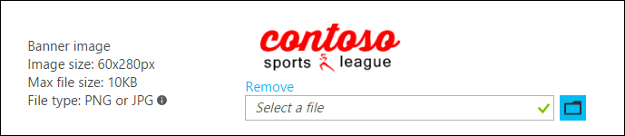

Click **Save**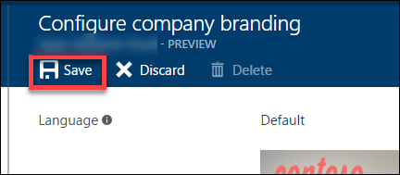

#### Subtask 2: Verify the branding has been successfully applied to the Azure Active Directory logon page

1. Close any previously authenticated browser sessions to the call center administration website, reopen using InPrivate or Incognito mode, and then navigate to the **call center administration** website.
2. The browser will redirect to the branded access control logon URL.

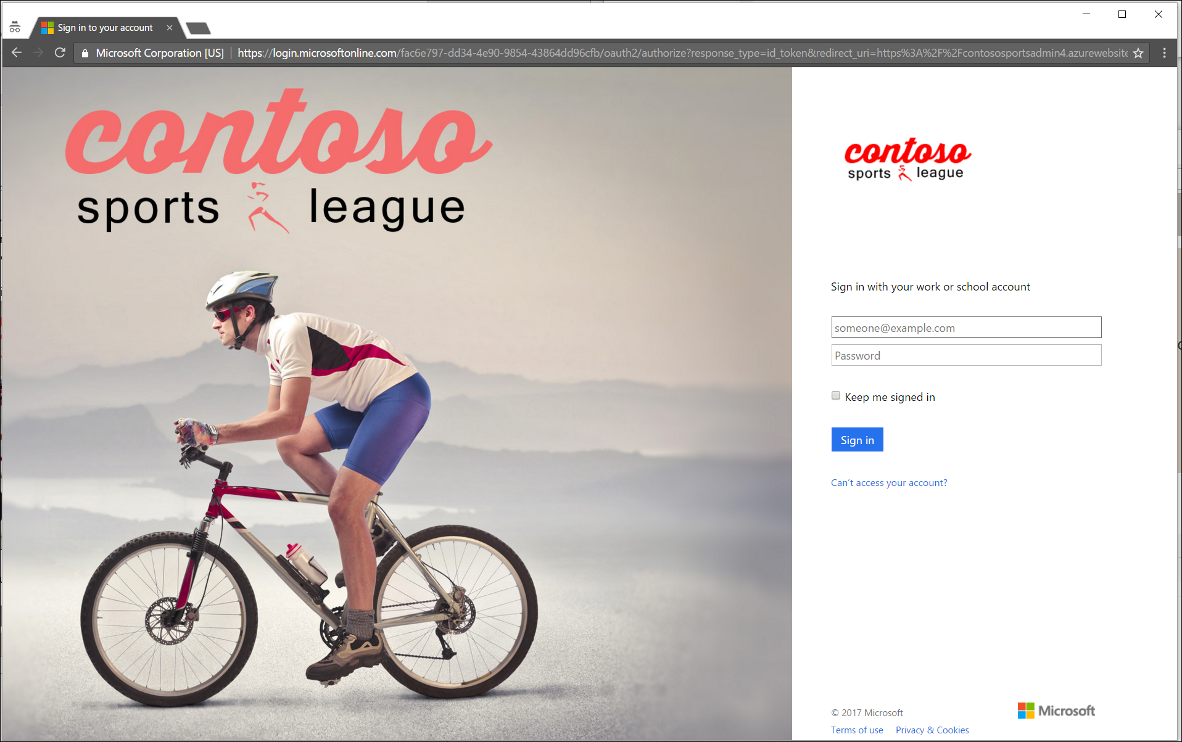

1. After you log on your browser will be redirected to the Contoso Sports League Admin web page.



1. Verify that in the upper-right corner you see the link **Logged in**.



## Exercise 4: Enabling Telemetry with Application Insights

### Overview

To configure the application for logging and diagnostics, you have been asked to configure Microsoft Azure Application Insights and add some custom telemetry.

### Help references

|  |  |
| --- | --- |
| Run performance tests on your app | http://blogs.msdn.com/b/visualstudioalm/archive/2015/09/15/announcing-public-preview-for-performance-load-testing-of-azure-webapp.aspx |
| Application Insights Custom Events | https://azure.microsoft.com/en-us/documentation/articles/app-insights-api-custom-events-metrics/ |
| Enabling Application Insights | https://azure.microsoft.com/en-us/documentation/articles/app-insights-start-monitoring-app-health-usage/ |
| Detect failures | https://azure.microsoft.com/en-us/documentation/articles/app-insights-asp-net-exceptions/ |
| Monitor performance problems | https://azure.microsoft.com/en-us/documentation/articles/app-insights-web-monitor-performance/ |

### Task 1: Configure the application for telemetry

#### Subtask 1: Add Application Insights Telemetry to the e-commerce website project

1. Open the Solution **Contoso.Apps.SportsLeague** in Visual Studio.
2. Navigate to the **Contoso.Apps.SportsLeague.Web** project located in the **Web** folder using the **Solution Explorer** in Visual Studio.

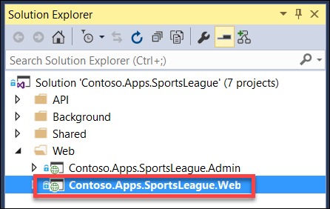

1. Right-click the **Contoso.Apps.SportsLeague.Web** project and select **Add Application Insights Telemetry**.

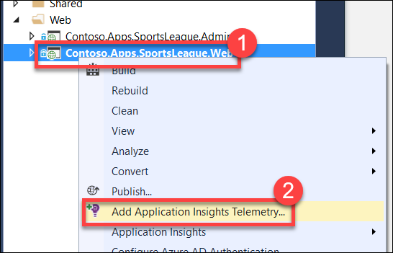

1. On the **Application Insights** dialog box, click the **Configure settings…** button

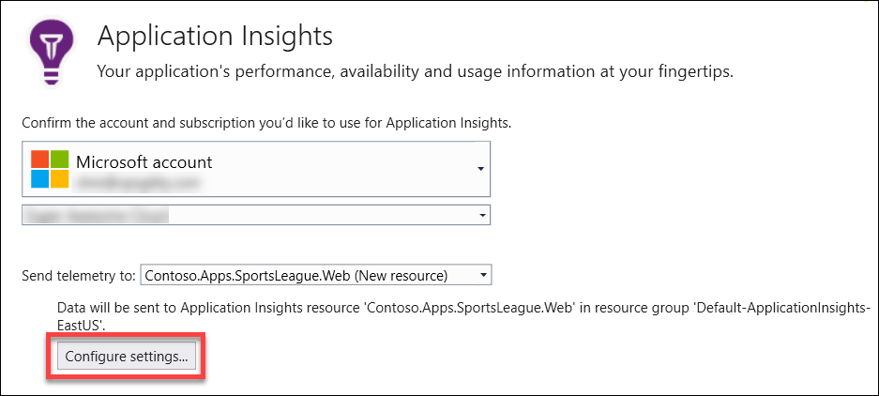

1. On the **Application Insights Configuration** dialog box, change the **Resource Group** to the **contososports** resource group that is used to host the Web App, and then click **OK**.  
   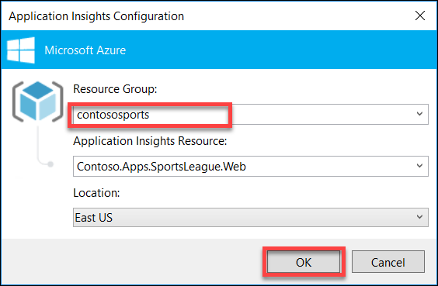
2. Click **Add**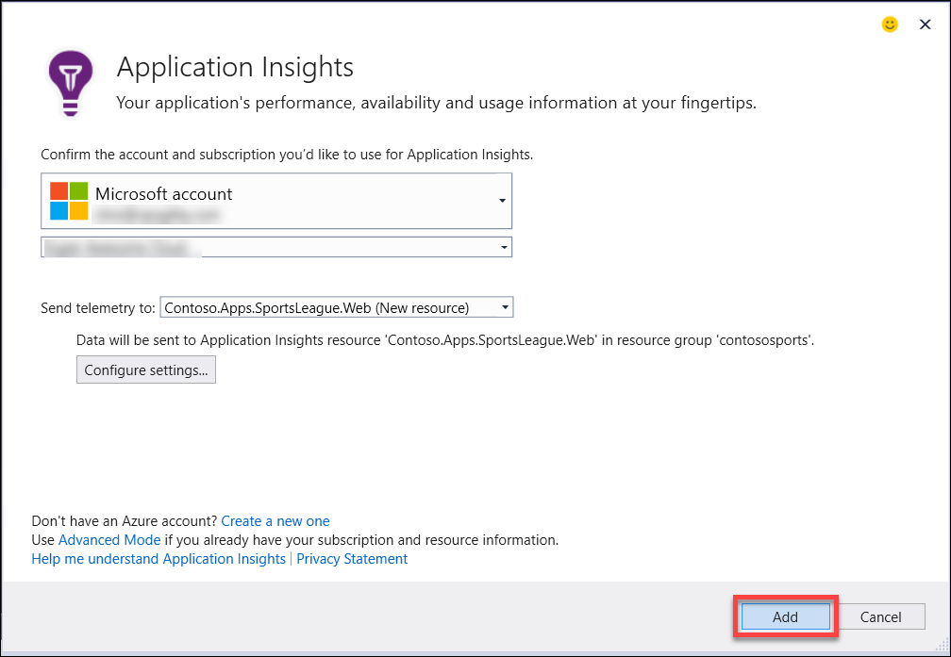
3. Once it completes, it displays the following Output and opens a new browser window

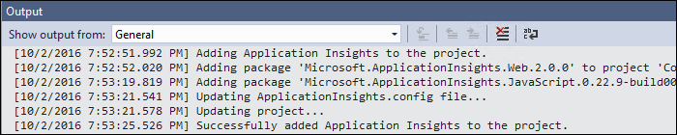

1. Open the file **\Helpers\TelemetryHelper.cs** located in the **Contoso.Apps.SportsLeague.Web** project.
2. Add the following using statement to the top of the file:

using Microsoft.ApplicationInsights;

1. Add the following code to the **TrackException** method to instantiate the telemetry client and track exceptions.

var client = new TelemetryClient();

client.TrackException(new Microsoft.ApplicationInsights.DataContracts.ExceptionTelemetry(exc));

1. Add the following code to the **TrackEvent** method to instantiate the telemetry client and track event data.

var client = new TelemetryClient();

client.TrackEvent(eventName, properties);

1. Save the **TelemetryHelper.cs** file.

#### Subtask 2: Enable client side telemetry

1. Open the Azure Management Portal (<http://portal.azure.com>). Click **More services**, and then click **Application Insights**.

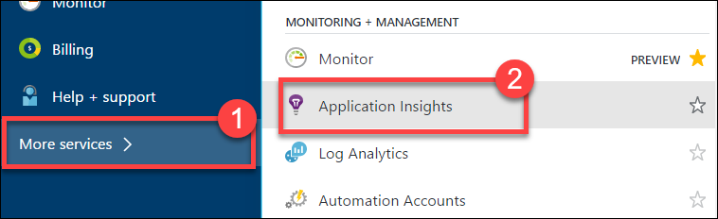

1. Click the Application Insights instance associated with the Contoso E-Commerce Site.

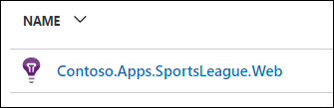

1. In settings menu click **Getting Started**.

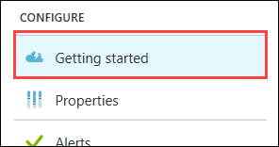

1. Next, click the **MONITOR AND DIAGNOSE CLIENT SIDE APPLICATION** arrow.**🡪**This will open the **Client application monitoring and diagnosis** blade.  
   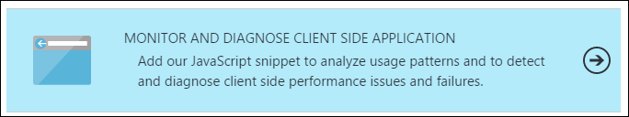
2. Select and copy the full contents of the JavaScript on the **Client application monitoring and diagnosis** blade.

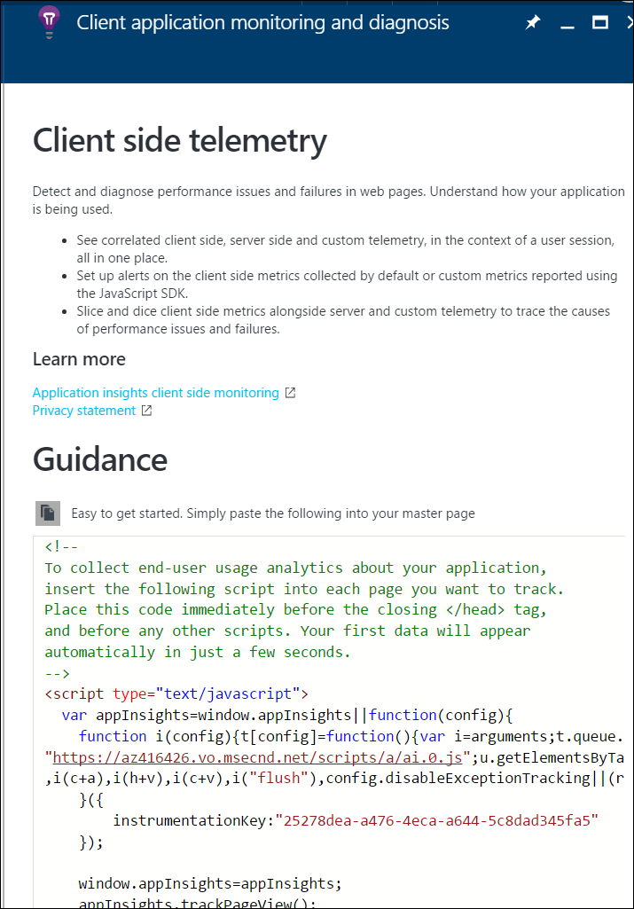

1. Navigate to the **Contoso.Apps.SportsLeague.Web** project located in the **Web** folder using the **Solution Explorer** in Visual Studio.
2. Open **Views** > **Shared** > **_Layout.cshtml**.

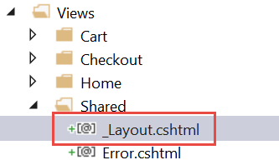

1. Paste in the code before the **</head>** tag.

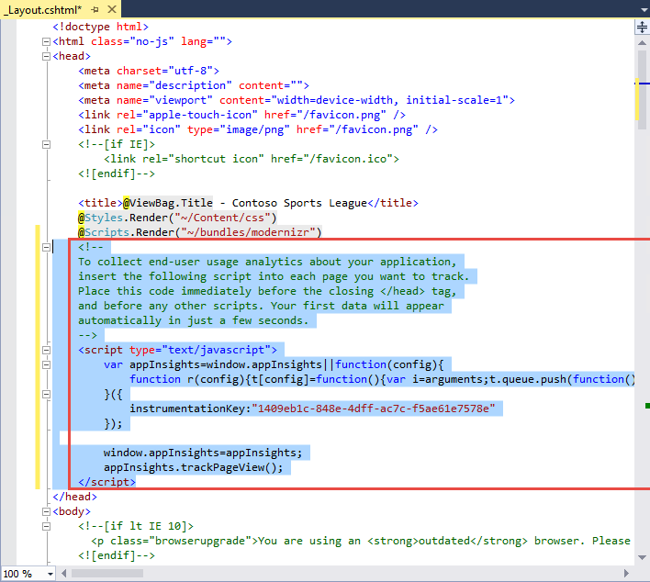

1. Save the **_Layout.cshtml** file.

#### Subtask 3: Deploy the e-commerce web app from Visual Studio

1. Navigate to the **Contoso.Apps.SportsLeague.Web** project located in the **Web** folder using the **Solution Explorer** in Visual Studio.

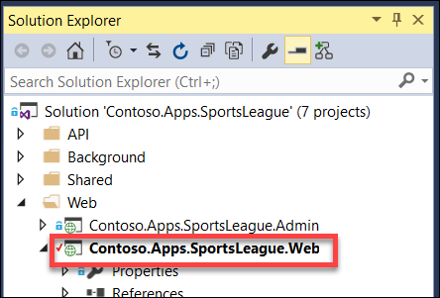

1. Right-click the **Contoso.Apps.SportsLeague.Web** project and select **Publish**.  
   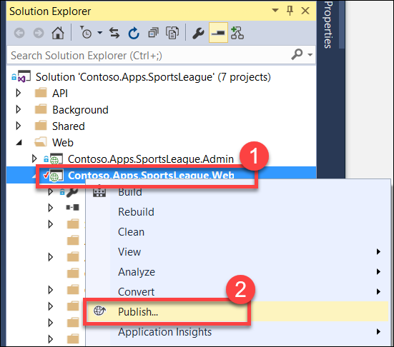
2. Click **Publish** again when the Publish dialog appears.
3. Click a few links on the published E-Commerce web site and submit several orders to generate some sample telemetry.

### Task 2: Creating the web performance test and load test

#### Subtask 1: Create the load test

1. Open the Azure Management Portal (<http://portal.azure.com>). Click **More services**, and then click **Application Insights**.

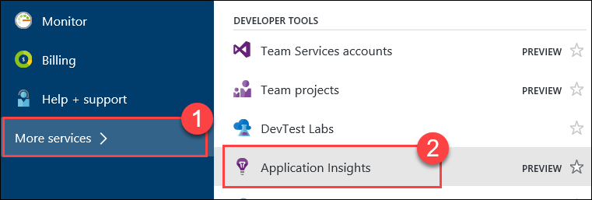

1. Click the Application Insights instance associated with the Contoso E-Commerce Site.

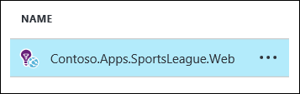

1. Click **Performance Testing**.

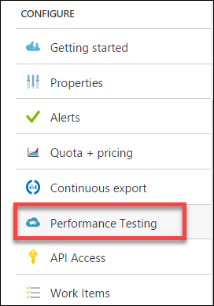

1. Click the Set Account button to associate/create a Visual Studio Team Services account.

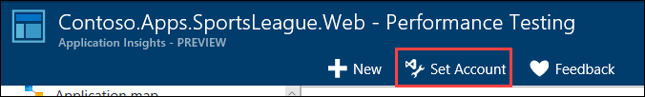

1. On the Account tile, click **Or Create New**.

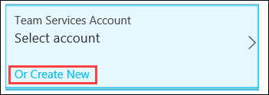

1. Specify a unique name for the account and select a region. Note the region may differ from the region you have deployed your resources.

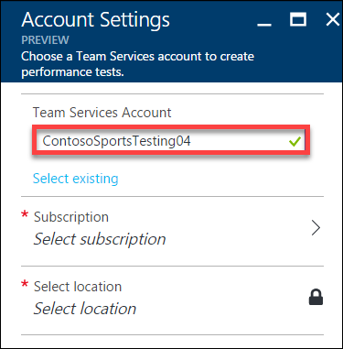

1. Click **Subscription**, and then select **your Subscription**.  
   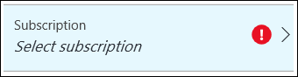
2. Click **Select location**, and then select a Location.  
   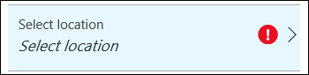
3. Click **OK**.

The VSTS account creation will take a minute to complete.

1. Click **New**.

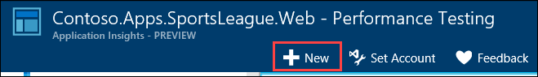

1. Click **Configure Test Using**.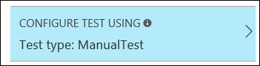
2. Specify the **URL** to the Contoso E-Commerce site, and then click **Done**.  
   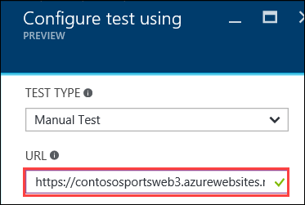
3. Name the test **ContosoSportsTest**, then click the **Run test** button.

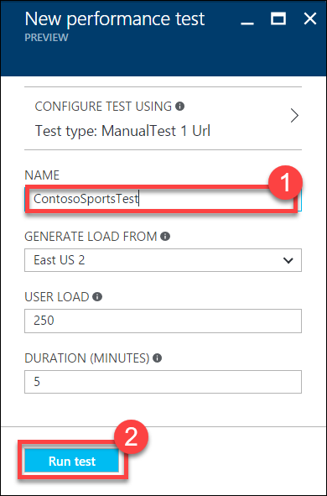

1. Wait until the load test has completed.

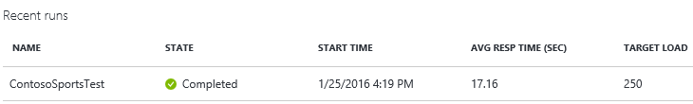

#### Subtask 2: View the Application Insights logs

1. Using a new tab or instance of your browser navigate to the Azure Management portal <http://portal.azure.com>.
2. On the left menu area, click **More services**.
3. On the **More services** blade select **Application Insights**.
4. On the **Application Insights** blade select, the Application Insights configuration you created for the e-commerce website.

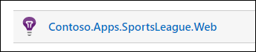

1. View the performance timeline to see the overall number of requests and page load time.

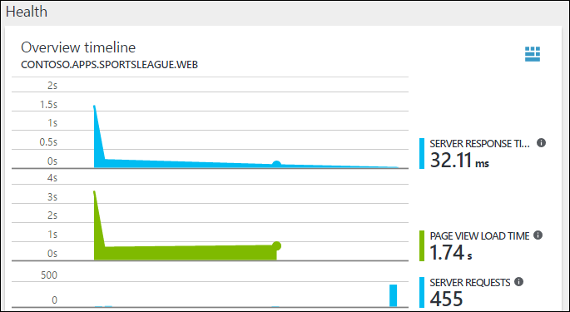

1. Under Investigate, click **Usage**.

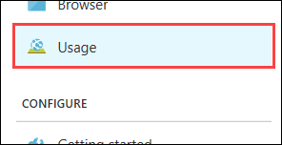

1. After several minutes you should see several Custom events from your previous order testing. This is reported through the TelemetryClient’s TrackEvent method.

Note: If you do not see data here come back later after the lab is complete.

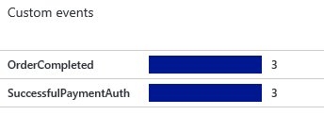

Drilling into the OrderCompleted events provides you with more detail about the specific order.

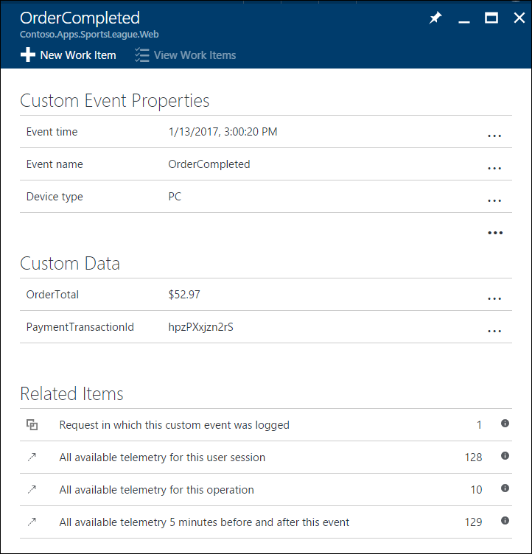

## Exercise 5: Automating backend processes

### Overview

Contoso wants to automate the process of generating receipts in PDF format and alerting users when their orders have been processed.

### Help references

|  |  |
| --- | --- |
| Deploying WebJobs using Visual Studio | https://docs.microsoft.com/en-us/azure/app-service-web/websites-dotnet-deploy-webjobs/ |
| Creating a Logic App | https://azure.microsoft.com/en-us/documentation/articles/app-service-logic-create-a-logic-app/ |
| Logic app connectors | https://azure.microsoft.com/en-us/documentation/articles/app-service-logic-connectors-list/ |

### Task 1: Enable receipt generation

#### Subtask 1: Provision Web App for Background Service Web Job

1. Using a new tab or instance of your browser navigate to the Azure Management portal <http://portal.azure.com>.
2. Click **New**, **Web + mobile**, and then click **Web App** 
3. Specify a **unique URL** for the web app, and ensure the **same App Service Plan**, and **resource group** that you have used throughout the lab are selected.  
   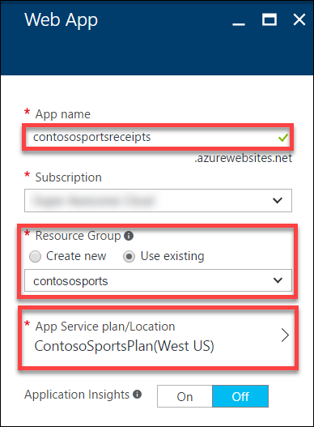
4. After the values are accepted click **Create**.  
   

#### Subtask 2: Update Application Settings configuration for Web Job

1. Click **Resource Groups**, then the **contososports** resource group, and then click the **Web App** that was just created.  
   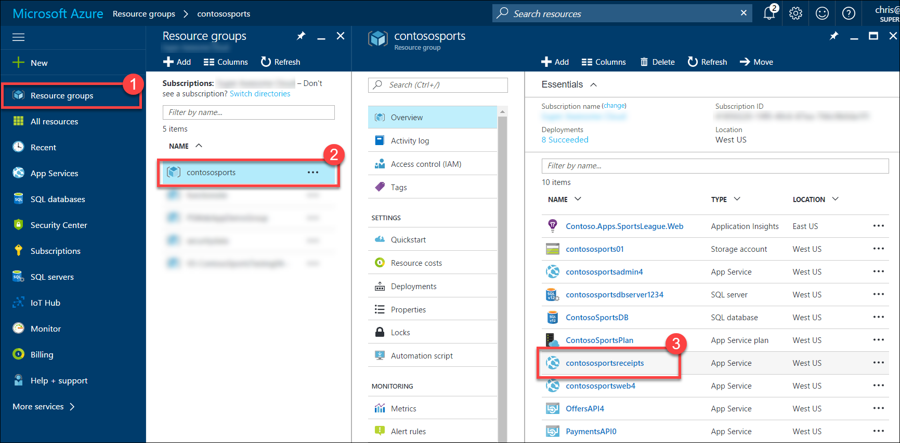
2. On the **App Service** blade, scroll down and click **Application settings** in the left pane.  
   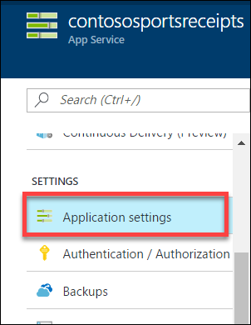
3. Scroll down and locate the **Connection Strings** section.  
   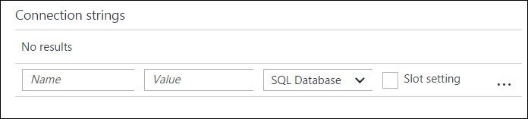
4. Add a new **Connection String** with the following values:
   1. Name: **WebJobsStorage**
   2. Value: **enter the Connection String for the Azure Storage Account that was copied earlier**
   3. Type: **Custom**  
      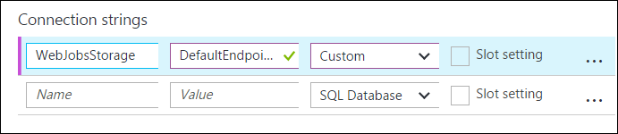
5. Add a new **Connection String** with the following values:
   1. Name: **ContosoSportsLeague**
   2. Value: **enter the** **Connection String for the SQL Database**
   3. Type: **SQL Database**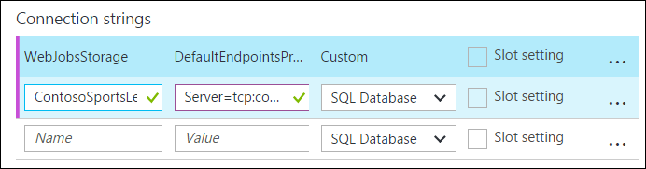
6. Click **Save**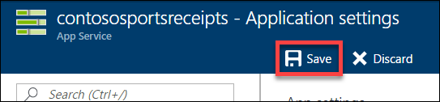
7. ?
8. ?

#### Subtask 3: Deploy the receipt generation Web Job

1. Open the **Contoso.Apps.SportsLeague** solution in Visual Studio.
2. Navigate to the **Contoso.Apps.SportsLeague.ReceiptProcessor** project located in the **Background** folder using the **Solution Explorer** in Visual Studio.  
   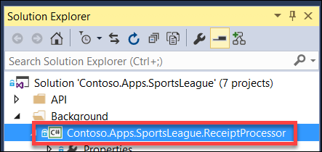
3. Right-click the **Contoso.Apps.SportsLeague.ReceiptProcessor** project and click **Publish as Azure Web Job…**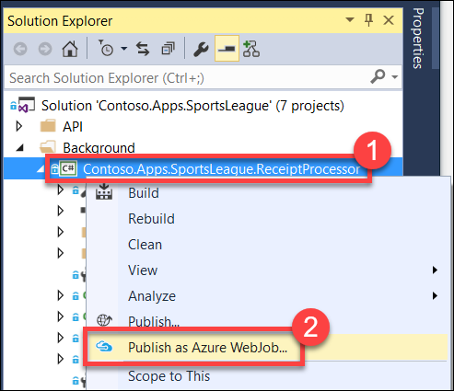
4. On the **Add Azure WebJob** dialog, change the **WebJob name** to **ReceiptProcessor**, then click **OK**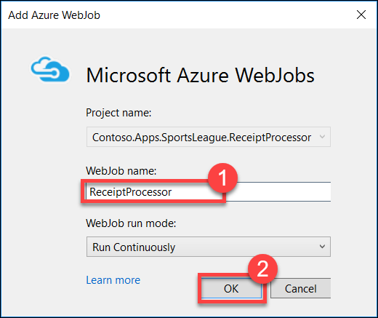
5. On the **Publish** dialog, select **Microsoft Azure App Service** as the Publish Target  
   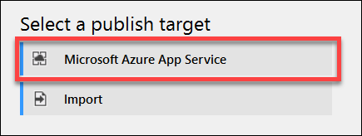
6. Expand the **contososports** resource group, then select the **Web App** that was just created, then click **OK**  
   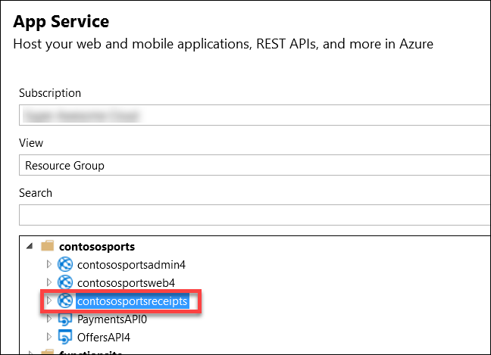
7. Click **Publish**
8. After the receipt generation service has been deployed, log in to the Call Center Admin site. Click **Details**.

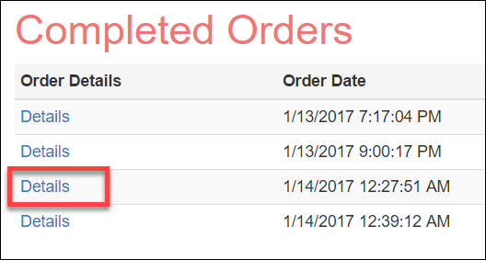

1. Verify that clicking on **Download receipt**, opens a *.pdf file of the receipt.

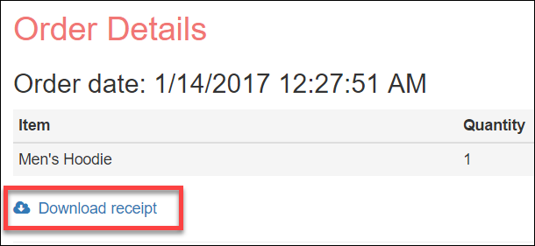

### Task 2: Order Notifications

#### Subtask 1: Configure your Twilio trial account

1. If you do not have a Twilio account, sign up for one for free at the following URL:   
   [**https://www.twilio.com/try-twilio**](https://www.twilio.com/try-twilio).



1. When you sign up for a free Twilio trial, you be asked to verify your personal phone number. This is an important security step that is mandatory for trying Twilio.  
   
2. Click **All Products & Services**.  
   
3. Click **Phone Numbers**.  
   
4. Click **Get Started**.  
   
5. Click the **Get your first Twilio phone number** button.  
   
6. Record the **Phone Number**, then click the **Choose this Number** button on the Your first Twilio Phone Number prompt, and then click **Done**  
   
7. Click **Home**, and then record the **Account SID** and **Auth Token** for use when configuring the Twilio Connector.  
   

#### Subtask 2: Create a new logic app

1. Open **SQL Server Management Studio** and Connect to the SQL Database for the **ContosoSportsDB** database.  
   
2. Under the **ContosoSportsDB** database, expand **Programmability**, right-click **Stored Procedures**, then click **New**, and **Stored Procedure…**  
   
3. Replace the Stored Procedure Template code with the following:

CREATE PROCEDURE [dbo].[GetUnprocessedOrders]

AS

declare @returnCode int

SELECT @returnCode = COUNT(*) FROM [dbo].[Orders] WHERE PaymentTransactionId is not null AND PaymentTransactionId <> '' AND Phone is not null AND Phone <> '' AND SMSOptIn = '1' AND SMSStatus is null

return @returnCode

GO

1. Click **Execute** in the toolbar or press the **F5** key.  
   
2. Delete the SQL script for the Stored Procedure from the code editor, and replace it with the following:

CREATE PROCEDURE [dbo].[ProcessOrders]

AS

SELECT * FROM [dbo].[Orders] WHERE PaymentTransactionId is not null AND PaymentTransactionId <> '' AND Phone is not null AND Phone <> '' AND SMSOptIn = '1' AND SMSStatus is null;

UPDATE [dbo].[Orders] SET SMSStatus = 'sent' WHERE PaymentTransactionId is not null AND PaymentTransactionId <> '' AND Phone is not null AND Phone <> '' AND SMSOptIn = '1' AND SMSStatus is null;

1. Click **Execute** in the toolbar or press the **F5** key.  
   
2. Open the Azure Management Portal (<http://portal.azure.com>), click **+New**, then **Web + Mobile,** and then **Logic App.**



1. On the **Create logic app** blade, assign a value for **Name**, and set the Resource Group to **contososports**.



1. Open the Logic App by clicking **More services > Logic Apps**, and click the Logic App just created.



1. Select the **Blank LogicApp** Template.  
   
2. On the **Logic Apps Designer**, click **Recurrence**.



1. Set the **FREQUENCY** to **MINUTE**, and **INTERVAL** to 1.



1. Click the **New Step**, and then click **Add an action**.



1. Type **SQL Server** into the filter box, and click the **SQL Server – Execute stored procedure** action.



1. The first time you add a SQL action you will be prompted for the connection information. Name the connection **ContosoDB**, and input the server and database details used earlier, and then click **Create**.   
   
2. Select the **[dbo].[GetUnprocessedOrders]** stored procedure from the drop-down menu on the **Procedure Name** field.



1. Click **New Step** and click the **Add a condition** link.



1. Specify **ReturnCode** for the OBJECT NAME, set the RELATIONSHIP to **is greater than**, and set the VALUE to **0**.



1. Click the **Add an action** link on the **If yes** condition.



1. Type **SQL Server** into the filter box, then click the **SQL Server – Execute stored procedure** action.



1. Select the **ProcessOrders** stored procedure in the **Procedure Name** drop-down menu.



1. Click the **Add an action** link.



1. Type **Twilio** in the filter box, then click the **Twilio – Send Text Message (SMS)** connector.



1. Set the **Connection Name** to **Twilio**, then specify your Twilio **Account SID** and **Authentication Token**, and then click the **Create** button.



1. Using the drop-down menu, select your Twilio number for the **FROM PHONE NUMBER** field. Specify a placeholder phone number in the **TO PHONE NUMBER**, and a **TEXT** message.  
   
2. On the **Logic Apps Designer** toolbar, click the **Code View** button.



1. Find the **Send_Text_Message_(SMS)** action, then modify the body property of the Twilio action:



1. Add the following code between Hello and the comma.

**@{item()['FirstName']}**



1. Modify the **to** property to pull the phone number from the item.

**@{item()['Phone']}**



1. Immediately before the **Send_Text_Message_(SMS)** create a new line and add the following code:

"forEach_email": {

"type": "Foreach",

"foreach": "@body('Execute_stored_procedure_2')['ResultSets']['Table1']",

"actions": {

1. Remove the **runAfter** block from the **Send_Text_Message_(SMS)** action.  
   
2. Locating the closing bracket of the **Send_Text_Message_(SMS)** action, then create a new line after it and add the following code:

},

"runAfter": {

"Execute_stored_procedure_2": [

"Succeeded"

]

}

}

1. After the code for the **Send_Text_Message_(SMS)** has been modified to be contained within the **forEach_email** action, it should look like the following:



1. Click **Save** on the toolbar to enable the logic app.



Your workflow should look like below, and you should receive a text for each order you have placed



## Exercise 6: SQL Data Warehouse

### Overview

Contoso wants to setup a SQL Data Warehouse in Microsoft Azure to enable data analytics capabilities.

### Help references

|  |  |
| --- | --- |
| Create an Azure SQL Data Warehouse | https://azure.microsoft.com/en-us/documentation/articles/sql-data-warehouse-get-started-provision/ |
| SQL Data Warehouse Migration Utility | https://azure.microsoft.com/en-us/documentation/articles/sql-data-warehouse-migrate-migration-utility/ |
| Introduction to Azure Data Factory Service | https://azure.microsoft.com/en-us/documentation/articles/data-factory-introduction/ |

### Task 1: Create SQL Data Warehouse

In this exercise, you will provision a SQL Data Warehouse using the Microsoft Azure Portal.

#### Subtask 1: Create SQL Data Warehouse

1. Navigate to the Azure Management Portal <http://portal.azure.com>, using a new tab or browser instance.
2. Click **+New**, select **Databases**, then **SQL Data Warehouse**.  
   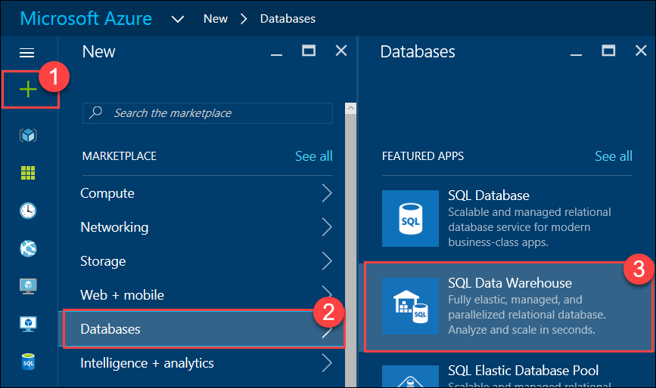
3. On the **SQL Data Warehouse** blade, specify the following configuration:
   1. Specify **ContosoSportsDWDB** as the Database name
   2. Specify the **contososports** Resource group.
   3. Specify **100 DWU** for the Performance  
        
      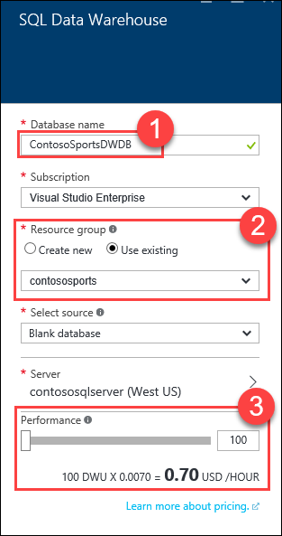
4. Click **Server**, then click **Create a new server**.  
   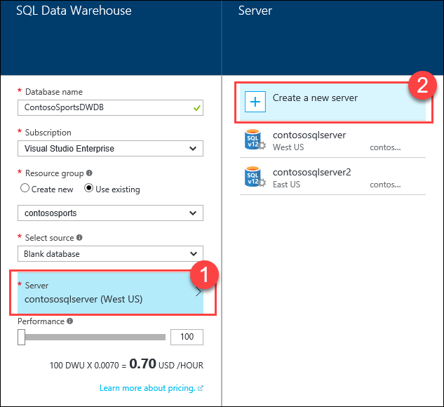
5. On the **New server** blade, specify the following configuration:
   1. Server name: a unique value (ensure the green checkmark appears)
   2. Server admin login: **demouser**
   3. **Password** and  **Confirm Password**: demo@pass123
   4. Ensure the **Location** is the same region as the SQL Database for the Web App  
        
      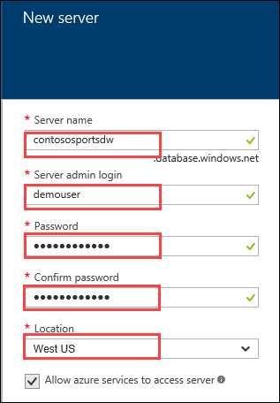
6. Click **Select**.
7. On the **SQL Data Warehouse** blade, click **Create**.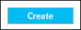
8. Click **More services**, and then **SQL data warehouses**.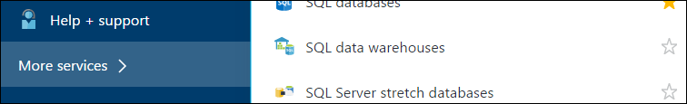
9. Click the SQL Data Warehouse that was just created, and click the **Server name** on the SQL Data Warehouse blade.  
   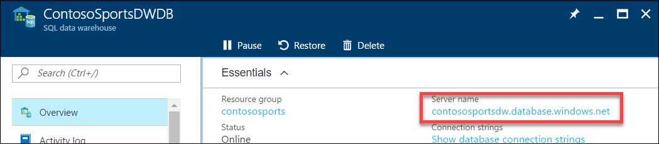
10. On the **SQL Server** blade, click **Show firewall settings**.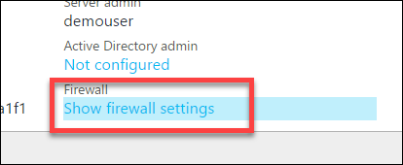
11. Click the **Add client IP** button.  
    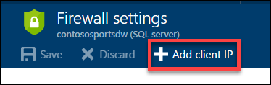
12. Click **Save.**  
    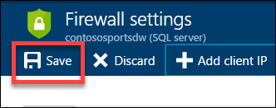

#### Subtask 2: Initialize SQL Data Warehouse database

1. Download and Install the Data Warehouse Migration Utility  
   <https://www.microsoft.com/en-us/download/details.aspx?id=49100>
2. Run the Data Warehouse Migration Utility (DataSourceMigrationEngine.exe)

The utility is installed into the following folder:  
*C:\Program Files (x86)\Data Warehouse Migration Utility*

Also, an Icon to run the utility will be placed on the Desktop.  
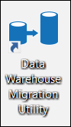

1. In the Migration Utility specify the **Azure SQL Database** Source Type, and click **Next**.  
     
   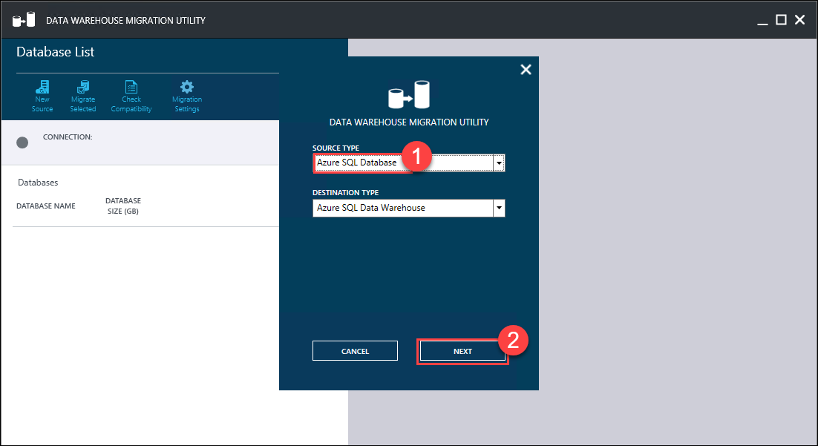
2. In the **Migration Source** step, specify the following configuration:
   1. Specify the **Server name** of the Azure SQL database server; this needs to be the full server DNS name: *{server name}.database.windows.net*
   2. Specify the **User Name** to login to the server: demouser
   3. Specify the **Password** to login to the server: demo@pass123  
        
      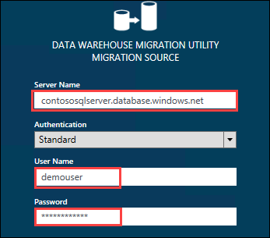
3. Click **CONNECT**
4. Select the database, then click the **Migrate Selected** button  
   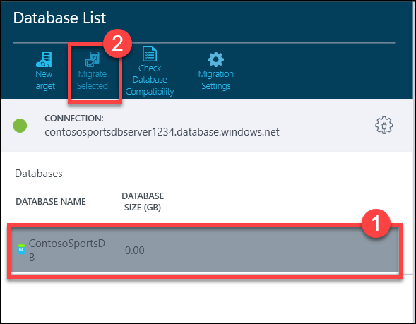
5. In the **Migrate Database** pane, select the **dbo.Orders** and **dbo.OrderDetails** tables.  
   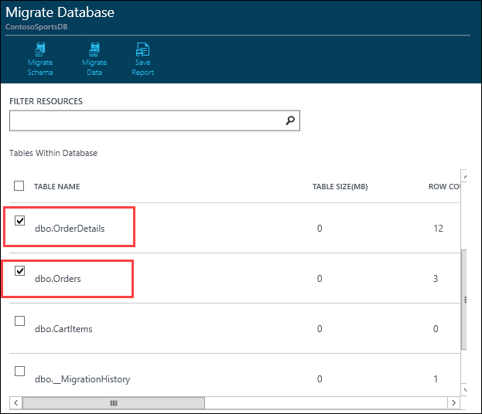
6. Click the **Migrate Schema** button  
   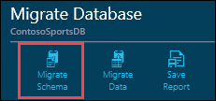
7. On the **Migrate** Schema pane, click the **Run Script** button  
   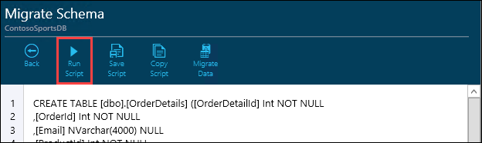
8. In the **Migration Destination** dialog, specify the following configuration:
   1. Specify the **Server name** of the Azure SQL Data Warehouse server; this needs to be the full server DNS name: {server name}.database.windows.net
   2. Specify the **User Name** to login to the server: demouser
   3. Specify the **Password** to login to the server: demo@pass123  
        
      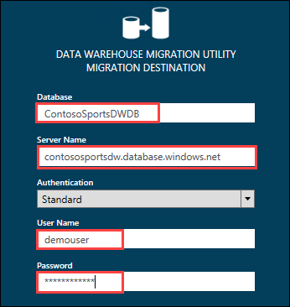
9. Click **OK**
10. Click **OK** on the **Script Applied Successfully** prompt  
    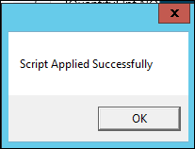
11. Click the **Migrate Data** button  
    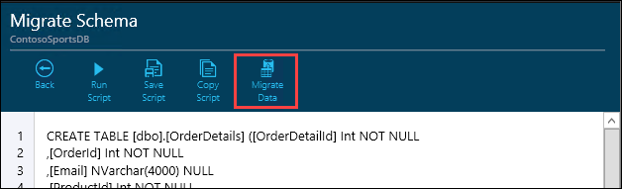
12. Click the **Run Migration** button  
    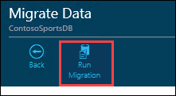
13. On the **Data Warehouse Migration Utility** dialog, Change the **Package Path** to a folder within **C:\hackathon**, click **Next**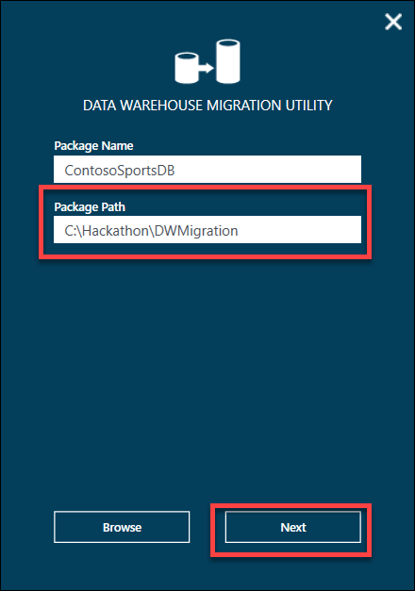
14. Click the **Generate** button  
    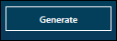
15. Click **OK** on the **Package(s) Generated Successfully** prompt  
    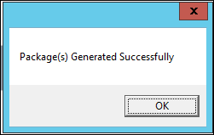

This will generate two .bat scripts for exporting the data and then importing it into the SQL Data Warehouse using BCP.

1. Open a **Command Prompt** window and change location to the **Package Path** folder that was uses where the packages were generated.  
   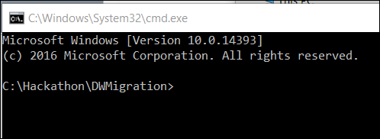
2. Run the **ContosoSportsDB_Export.bat** script  
   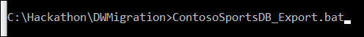
3. Run the **ContosoSportsDB_Import.bat** script  
   

### Task 2: Configure Azure Data Factory

In this exercise, you will provision an Azure Data Factory using the Microsoft Azure Portal. You will then configure a Pipeline to archive data from the applications SQL Database into the SQL Data Warehouse you created previously.

#### Subtask 1: Create Azure Data Factory

1. Navigate to the Azure Management Portal <http://portal.azure.com>, using a new tab or browser instance
2. Click **+New**, select the **Intelligence + analytics**, then **Data Factory**  
   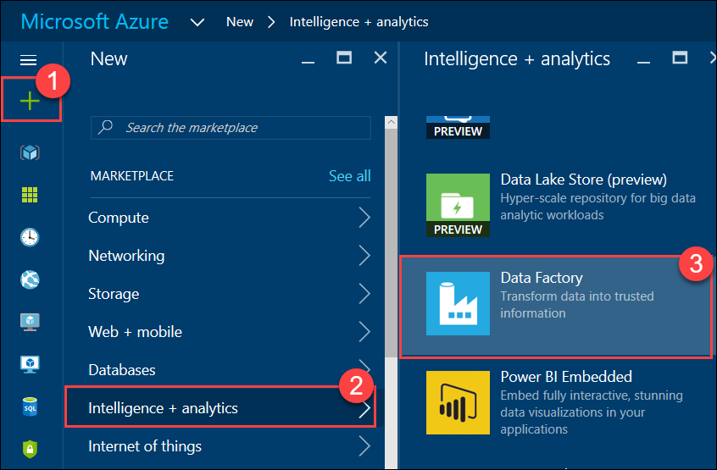
3. On the **New data factory** blade, specify the following configuration:
   1. Specify **ContosoSportsDataFactory** as the Name
   2. Specify the **contososports** Resource group
   3. Ensure the **Location** is the same region as the SQL Data Warehouse  
        
      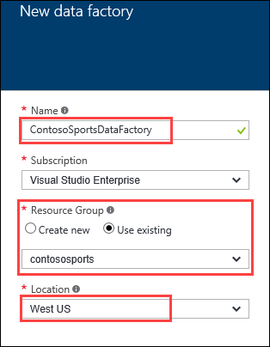

Currently, Data Factory is only available in a few regions. If it is not available in your desired Azure Region, then choose the region closest to the region SQL Data Warehouse is located instead.

1. Click **Create**

#### Subtask 2: Configure Pipeline

1. Navigate to the Azure Management Portal <http://portal.azure.com>, using a new tab or browser instance
2. Click **More services**, **Data factories**, and then click the name of the Data Factory you created previously
3. On the **Data factory** blade, click **Copy data**.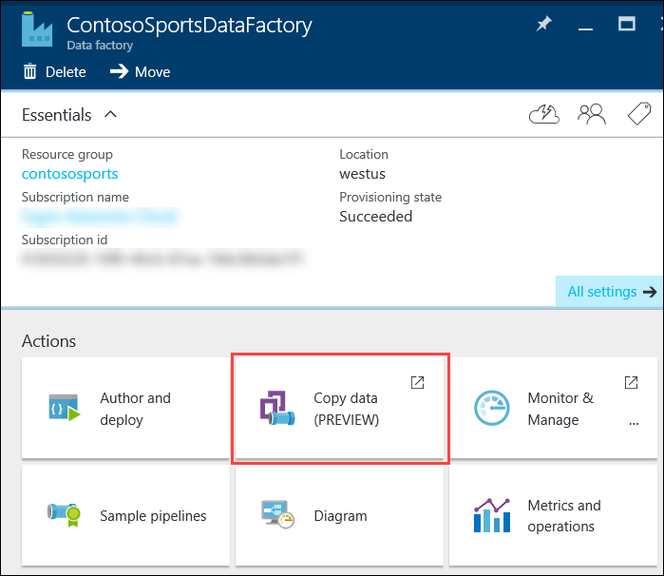

Clicking on Copy data will open up the Data Factory tool in a new browser tab.

1. Update the **Recurring pattern** to run every 15 minutes, and click **Next**  
   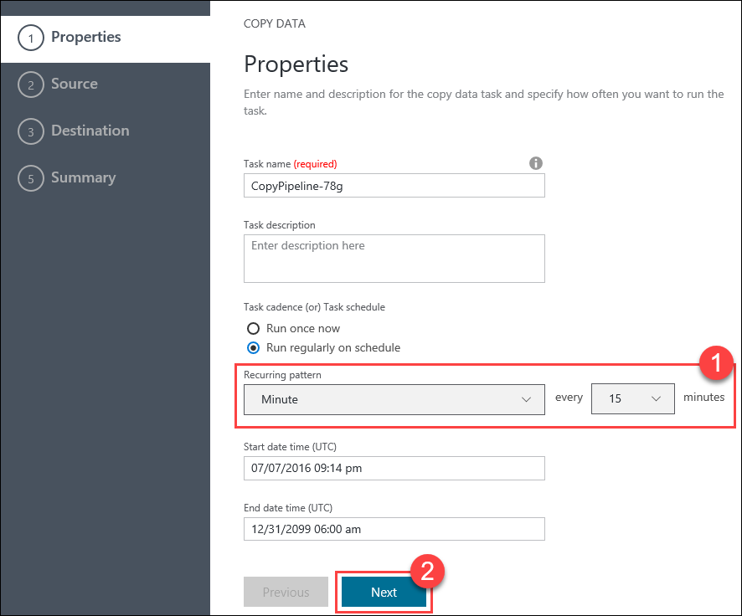
2. Select the **Azure SQL Database** data source, and click **Next**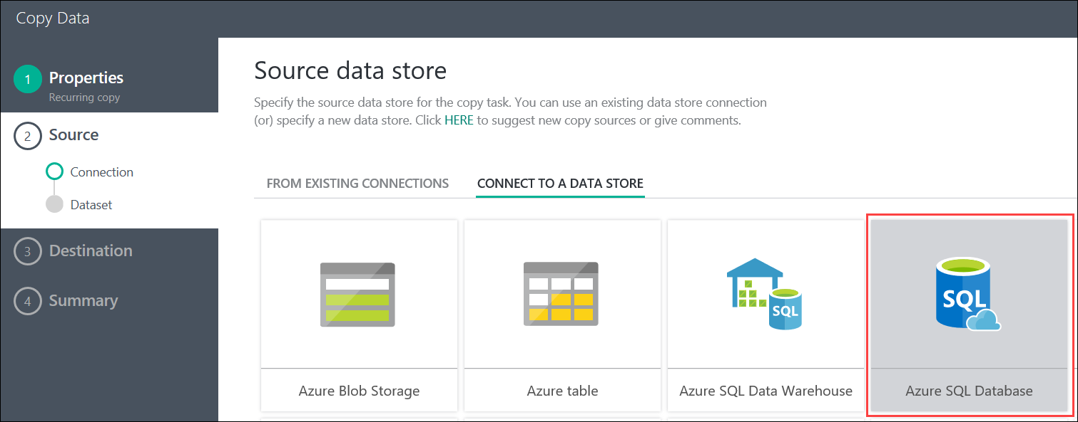
3. On the **Specify the Azure SQL database** step, specify the following configuration:
   1. Specify the **SQL Database Server** that contains the SQL database for the Web App
   2. Specify the **ContosoSportsDB** database
   3. Specify the User name for the database server: demouser
   4. Specify the Password for the database server: demo@pass123

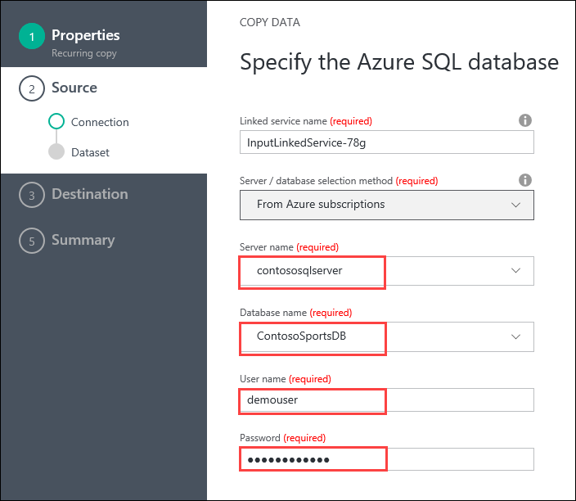

1. Click **Next**



1. Select the **Orders** and **OrderDetails** tables in the list of Existing Table, then click **Next**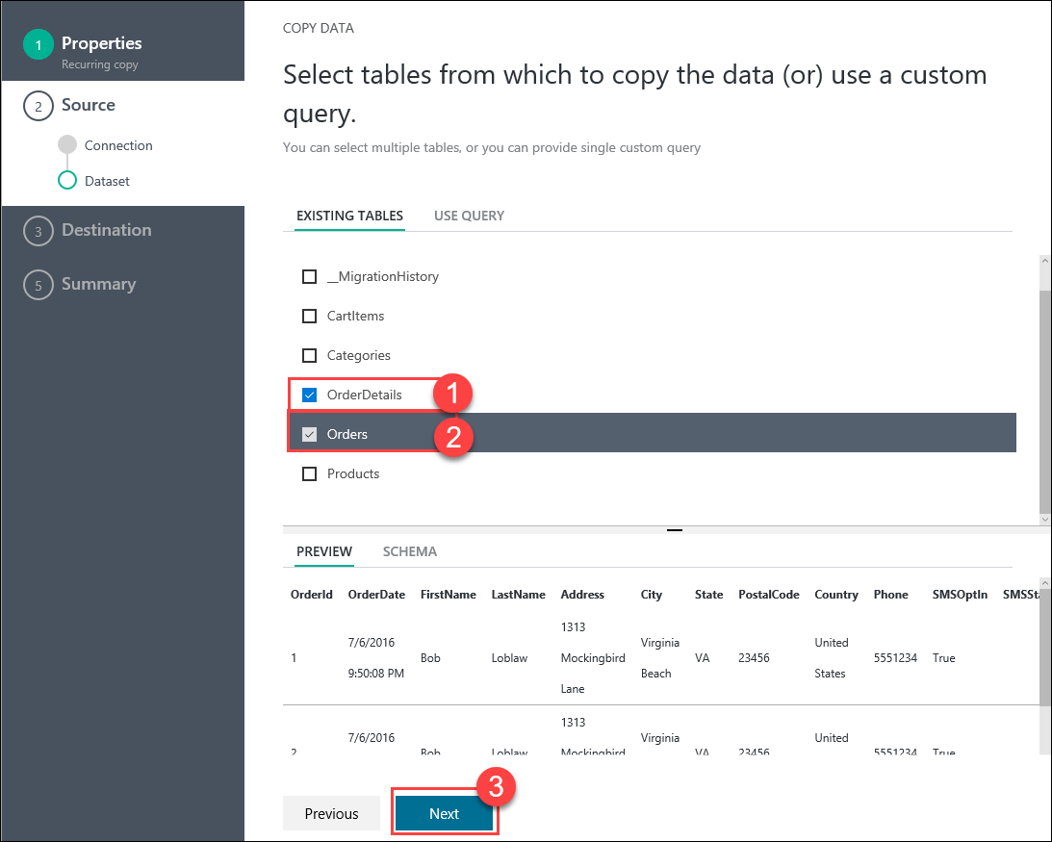
2. On the **Apply filter** step, set the **Orders** filter to **None**, andclick **Next**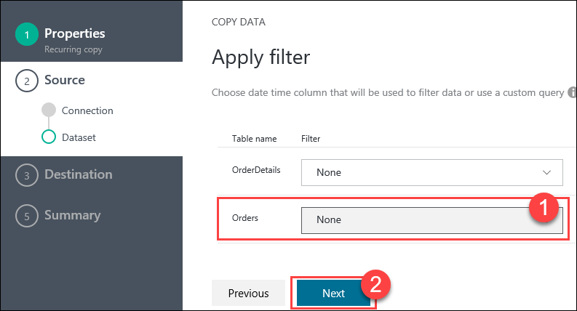
3. On the **Destination data store** step, select **Azure SQL Data Warehouse**, then click **Next**  
   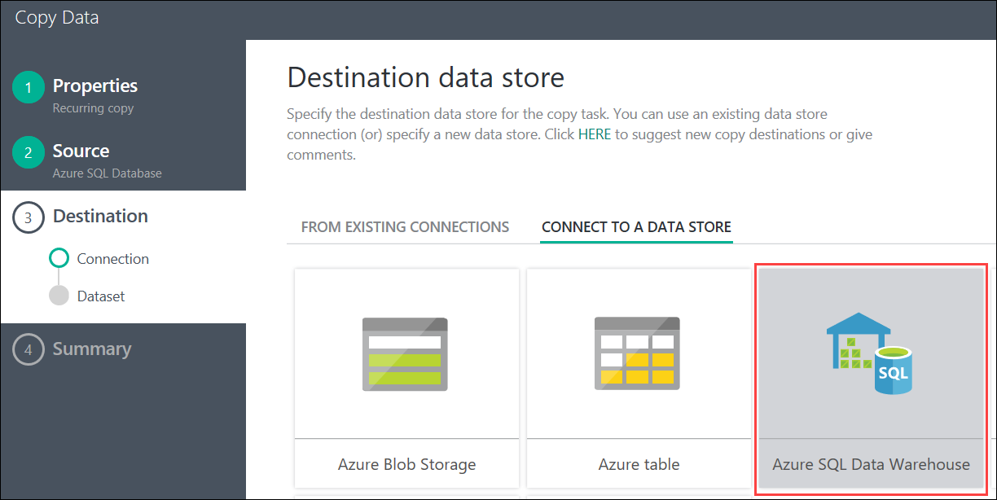
4. Specify the following configuration for the Azure SQL Data Warehouse:
   1. Specify the **Server name** for the SQL Data Warehouse
   2. Specify the **ContosoSportsDWDB** database
   3. Specify the User name for the Data Warehouse server: demouser
   4. Specify the Password for the Data Warehouse server: demo@pass123  
      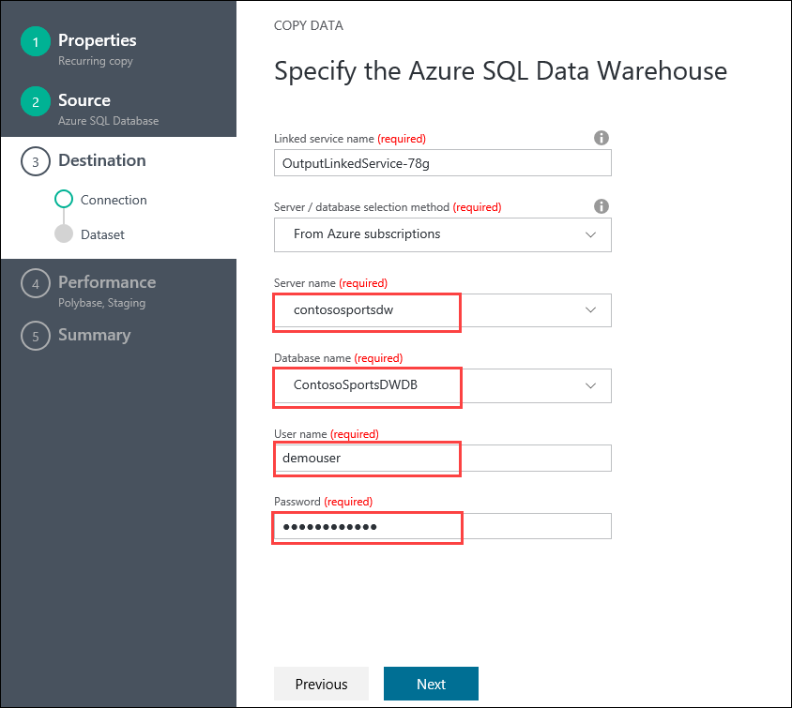
5. Click **Next**
6. On the **Destination Table Mapping** step, specify the following configuration:
   1. Specify the source OrderDetails to map to the **OrderDetails** destination table
   2. Specify the source Orders to map to the **Orders** destination table  
        
      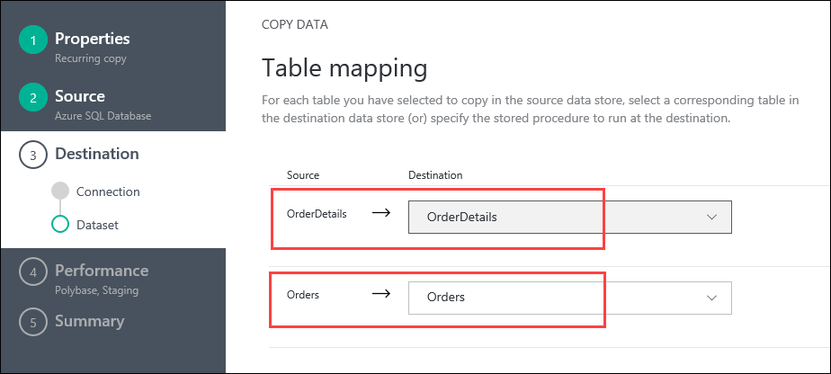
7. Click **Next**
8. On the **Destination Schema mapping** step, select the **OrderDetails** mappings and enter the following configuration:
   1. Set the Method to **Custom script**
   2. Set the Custom script to the following:

delete from OrderDetails

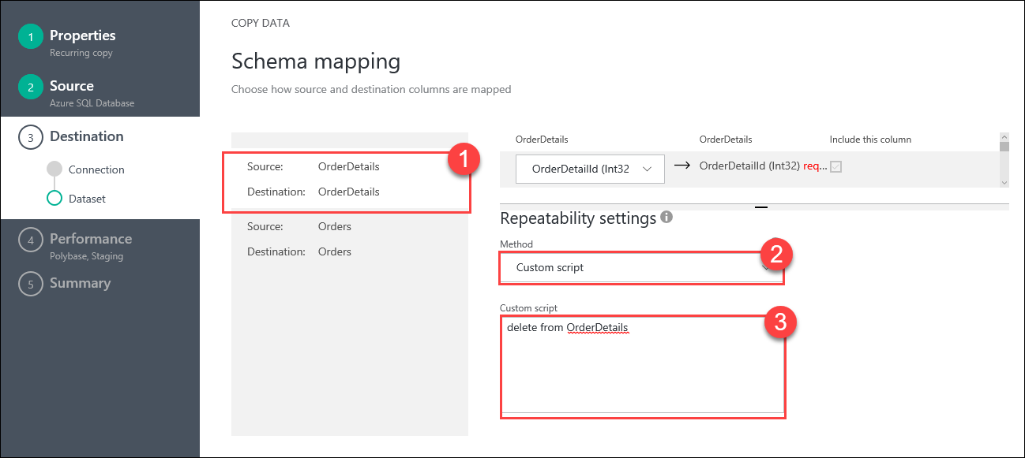

1. Select the **Orders** mappings and enter the following configuration:
   1. Set the Method to **Custom script**
   2. Set the Custom script to the following:

delete from Orders

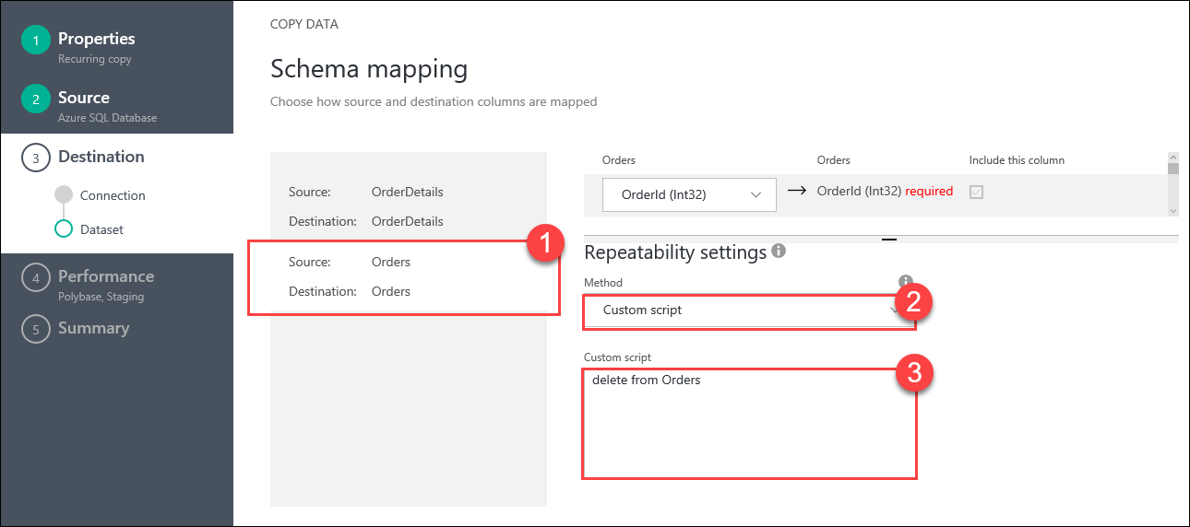

Note: These two DELETE custom scripts will ensure all previous row are deleted from the tables in the SQL Data Warehouse before data is copied over from the SQL Database each time the Pipeline runs.

1. Click **Next**
2. On the **Performance settings** step, expand **Advanced settings**, then **uncheck** the **Allow polybase** check box  
   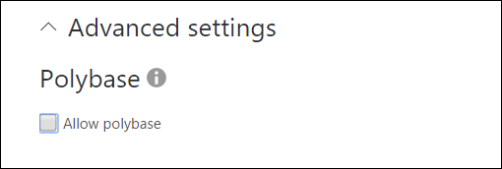

Note: The check box must be unchecked. With the current database schema in the web app, if Polybase is allowed then the Pipeline will error that the length of row exceeds maximum allowed for the Orders table data migration.

1. Set the **User staging account** to **New connection**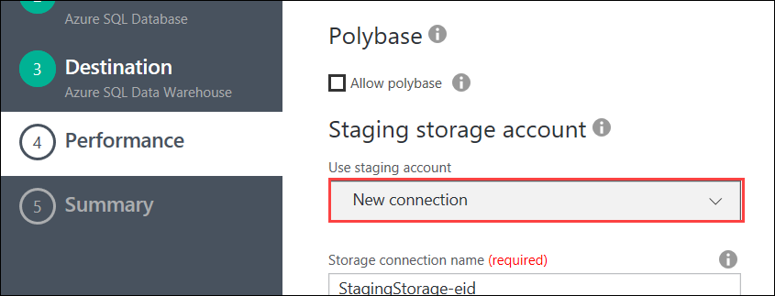
2. For **Staging storage account**, set the **Storage account name** to the Azure Storage Account that was previously created for Web App  
   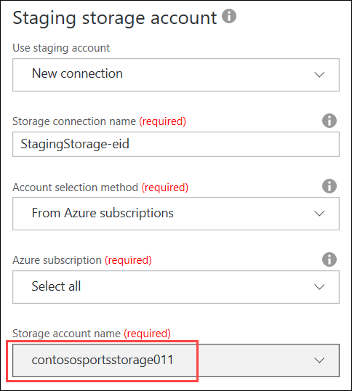
3. Click **Next**  
   
4. On the **Summary** step, click **Finish**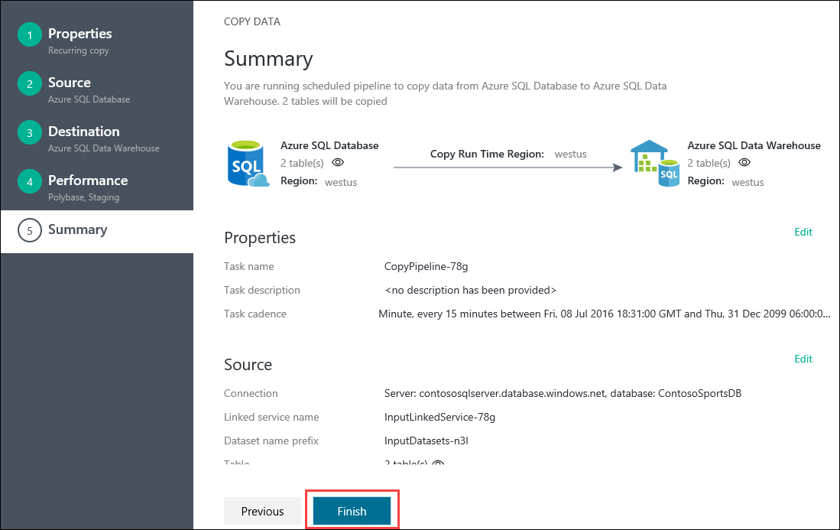
5. Once deployment is complete the deployment steps will show all green checkmarks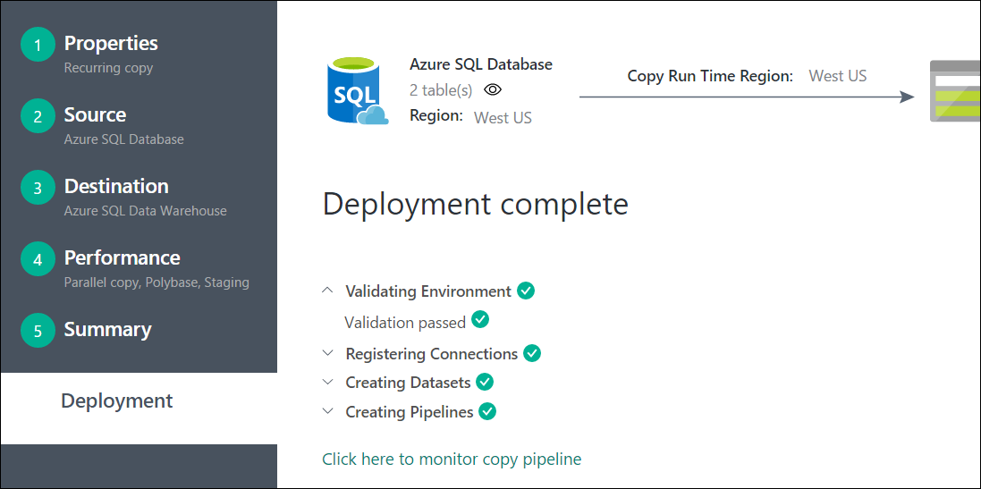

# Azure resource manager hackathon

## Overview

Contoso has asked you to define an Azure Resource Manager template that can deploy their application CloudShop and its associated database using Azure Virtual Machines.

## Requirements

* Microsoft Azure subscription
* Local machine or a virtual machine configured with:
  + Visual Studio 2015 Community Edition
  + Azure SDK 2.9+ for Visual Studio
    - <https://www.microsoft.com/en-us/download/details.aspx?id=51657>
  + Azure PowerShell (installed as part of Azure SDK)
  + Reboot after installing the Azure SDK

## Lab structure

This lab has two sets of instructions. The first is a high-level set of instructions that is designed for students that have previous experience authoring templates in Azure. The second is a traditional hands-on lab guide that is designed for users that are new to Azure Resource Manger template authoring.

## Help references

|  |  |
| --- | --- |
| Authoring ARM Templates | <https://azure.microsoft.com/en-us/documentation/articles/resource-group-authoring-templates/> |
| Azure Resource Manager templates with VS 2015 | <http://blogs.msdn.com/b/kaevans/archive/2015/07/06/azure-resource-manager-templates-with-visual-studio-2015.aspx> |
| Virtual Machine Scale Set Samples | <https://github.com/gbowerman/azure-myriad> |
| Azure Quick Start Templates | <https://github.com/Azure/azure-quickstart-templates> |
| Network Security Groups | <https://azure.microsoft.com/en-us/documentation/articles/virtual-networks-nsg/> |

## Exercise 0: Environment setup

### Overview

In this lab, you will create a developer environment and download the required files for this course if you do not already have one that meets the requirements.

### Prerequisites

* Microsoft Azure subscription: <http://azure.microsoft.com/en-us/pricing/free-trial/>
* Client computer with Windows 10 or later with Visual Studio 2015 - SDK 2.9.6+
  + Ensure you reboot after installing the SDK or Azure PowerShell will not work correctly

#### Task 1: Configure a Development Environment

If you do not have a machine setup with Visual Studio 2015 Community and Azure SDK 2.9.6+ complete this task.

1. Create a virtual machine in Azure using the Visual Studio Community 2015 Update 3 and SDK 2.9 on Windows Server 2012 R2 image.

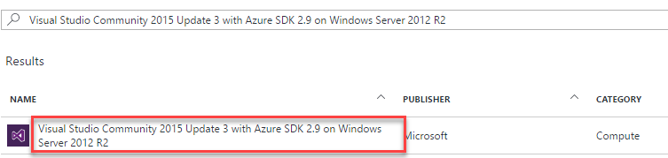

It is highly recommended to use a DS2_V2 or D2_V2 instance size for this VM

#### Task 2: Disable IE Enhanced Security

Note: Sometimes this image has IE ESC disabled. Sometimes it does not.

1. On the new VM you just created, click the Server Manager icon.



Click Local Server



1. On the right side of the pane, click **On** by IE Enhanced Security Configuration.



1. Change to **Off** for Administrators and click **OK**.



#### Task 3: Validate Connectivity to Azure

1. From within the virtual machine, Launch Visual Studio 2015 and validate that you can login with your Microsoft Account when prompted.
   1. Note: You will have to search for “Visual Studio”, after clicking the Start Button.

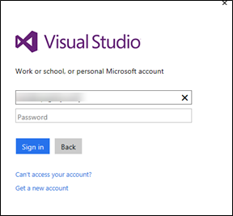

1. Validate connectivity to your Azure subscription. Launch Visual Studio, open Server Explorer from the View menu, and ensure that you can connect to your Azure subscription.



**Download the exercise files**

1. Download the exercise files for the training (from within the virtual machine).
   1. Create a new folder on your computer named **C:\Hackathon**
   2. Download the support files (.zip format), <https://opsgilityweb.blob.core.windows.net/cebootcamp-feb-2017/Lift%20and%20Shift%20ARM%20Hackathon%20-%20Student%20Files.zip> to the new folder.
   3. Extract the contents to the same folder.

Tip: In the labs when adding resources to the Azure Resource Manager template, ensure there are no spaces at the end of the resource names. Visual Studio will include the space in all of the code it generates.

## Summary

In this lab, you created a developer environment and downloaded the required files for this course.

### Exercise 1: Configure Automation Account

Contoso has asked you to create an Azure Resource Manager template that will configure the network for a proof of concept deployment of their new application CloudShop. Before creating the ARM Template, you must first create and configure an Azure Automation account using the Azure Portal.

#### Task 1: Create Azure Automation Account

*Tasks to complete*

* Create Automation Account in Azure portal
* Upload the Web and SQL .ps1 files
* Compile the files so they are available to virtual machines that check-in

*Exit criteria*

* You log into the portal and verify creation of the Azure Automation account, taking note of the Registration URL, Registration Keys, and the names of the nodes you compiled.

### Exercise 2: Define the network foundation

Contoso has asked you to create an Azure Resource Manager template that will configure the network for a proof of concept deployment of their new application CloudShop.

#### Task 1: Define the network foundation

##### Tasks to complete

* Create a new Azure Resource Manager template that creates a virtual network.
* Validate the JSON file with <http://jsonlint.com>.
* Deploy the virtual network to an Azure subscription.

##### Exit criteria

* You navigated to <http://jsonlint.com>, pasted the contents of your azuredeploy.json file into the text box, and clicked **Validate**.

Note: In future lab steps if you have errors deploying a template, repeat this process and check for validation errors.

* A template deployed to your Azure subscription that has the following virtual network characteristics.
  + Address space: 10.0.0.0/16
  + Subnet: FrontEndNet – 10.0.0.0/24
  + Subnet: DatabaseNet – 10.0.1.0/24

### Exercise 3: Extend with compute

The next task is to update the template by adding a storage account, a public IP, and virtual machines for the web server(s) and a SQL server. The servers will be automatically configured using a PowerShell DSC script supplied to you by the infrastructure team.

#### Task 1: Add storage and a location parameter

##### Tasks to complete

* Add a new storage account to the template. All virtual machines in the template will use this storage account.
* Create a location parameter for the template that all resources in the template use. Update the existing virtual network to use this parameter and as you add new resources to the template that require a location, update them to reference this parameter.
* Deploy the updated template.

##### Exit criteria

* A new storage account in the template.
* A location parameter that defines the list of regions the template can deploy to.
* The new storage account should be deployed to your subscription after deployment.

#### Task 2: Add a virtual machine for the web server

##### Tasks to complete

* Add the following resources to the template
  + A Windows virtual machine for the web front end
  + Public IP with a unique DNS name linked to the NIC of the web VM.
  + Azure DSC Extension
    - DSC Extension named **hackathonDSC** for the web servers that use the CloudShopWeb.WebServer configuration node of your Automation account.

##### Exit criteria

* The template should accept parameters for the Registration URL, Registration Key, and Configuration Node name(s) of the Automation account.
  + The scripts for the DSC Configurations are located in C:\Hackathon
* The web site should load when you browse the DNS name for the public IP.

#### Task 3: Add a virtual machine for the SQL Server

##### Tasks to complete

* Add the following resources to the template
  + A Windows virtual machine
  + Azure DSC Extension
    - DSC Extension named **hackathonDSCSql** for the SQL database that configures the SQL Server and restores the AdventureWorks database.
    - The scripts for the DSC Configurations are located in C:\Hackathon
    - Add a dependency on the DSC extension for the web tier to the DSC extension for the SQL server. This allows the virtual machines to be provisioned in parallel but the customizations to be orchestrated.

##### Exit criteria

* SQL Server virtual machine
  + Should have a parameter that specifies the size of the virtual machine. The default value should be Standard_D2.
    - Standard_D1, Standard_D2, Standard_D3, Standard_D4, Standard_D5
  + Should accept a parameter named **hackathonSqlVMSKU** that allows the user to specify the SQL Server SKU using one of the following values. The default value should be Web.
    - Web, Standard, Enterprise
  + The image configuration should use the following:
    - Image Publisher: MicrosoftSQLServer
    - Image Offer: SQL2014-WS2012R2
  + The virtual machine should have 4 x 1 TB disks attached to it formatted a 4 TB volume using Windows Storage Spaces.
  + The SQL Server should have the default path for data, logs, and backup referring to the F: drive and the database should be restored to the F: drive.
  + SQL Server should be in mixed authentication mode.

### Exercise 4: Lock down the environment

In this portion of the exercise, you will deploy a network security group to restrict the network attack surface for the deployment.

#### Task 1: Restrict traffic to the web server

##### Tasks to complete

* Create and deploy a network security group that allows the following traffic on the FrontEndNet subnet.
  + Source: INTERNET, Destination port: 80

##### Exit criteria

* Validate restrictions by connecting to the web server using a web browser. Traffic should be allowed in and the site should load. Attempt to connect using remote desktop, click **Connect** in the portal. This connection should fail.

#### Task 2: Update the network security group to allow Windows Remote Desktop

##### Tasks to complete

* Update the network security group on the deployed resources to allow the remote desktop protocol (port 3389).

##### Exit Criteria

* Access to the web front end should be successful by clicking **Connect** in the Azure Preview Portal.

### Exercise 5: Scale out the deployment

In this portion of the exercise, you will use the Azure Virtual Machine Scale Sets feature to scale out the web front end and the storage sub system.

Note: This is an *advanced* configuration based on a new feature (scale sets). It is recommended that unless you have configured scale sets before that you jump to the answers section of the lab to complete this exercise.

#### Task 1: Parameterize the size of the environment and add load balancing

##### Tasks to complete

* Add a new parameter called instanceCount to the template. This variable should define how many web servers should be created.
* Add a new resource that can create up to five storage accounts.
* Add a load balancer resource and associate it with the public IP.
* Add the virtual machine scale set configuration that will use the storage accounts and creates a number of virtual machines based on the instanceCount parameter.
* Remove the existing virtual machine and network adapter because they are replaced by the scale set.

##### Exit criteria

* The scale set should provision the number of virtual machines based on the instanceCount parameter.
* The virtual machines provisioned by the scale set should execute the same DSC script used in the initial web server configuration.

# Azure resource manager hackathon answers

## Overview

This portion of the lab is designed to help you if you are blocked or have limited experience with Azure Resource Manager.

## Exercise 1: Configure Automation Account

### Overview

In this exercise, you will create and configure an Azure Automation account in the Azure Portal before configuring and deploying the resources of your ARM template.

### Task1: Create Automation Account

1. Browse to the Azure Portal and authenticate at <https://portal.azure.com/>
2. Click **+New** and type **Automation** in the search box. Choose **Automation** from the results.  
   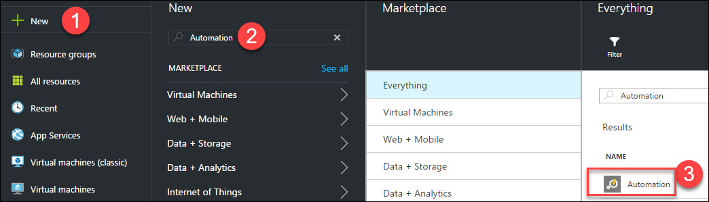
3. Click **Create** on the Automation blade so that the **Add Automation Account** blade is displayed. Specify the following information and click **Create**.  
     
   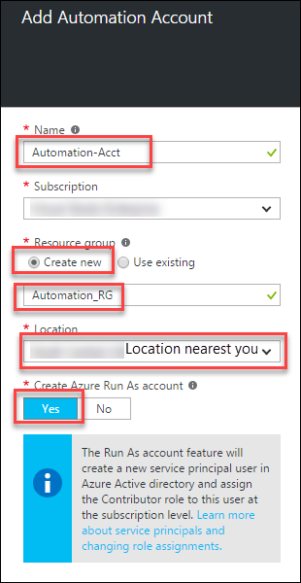

### Task 2: Upload DSC Configurations into Automation account

1. Click **Resource groups > Automation_RG > Automation-Acct** and click the **DSC Configuration** tile  
   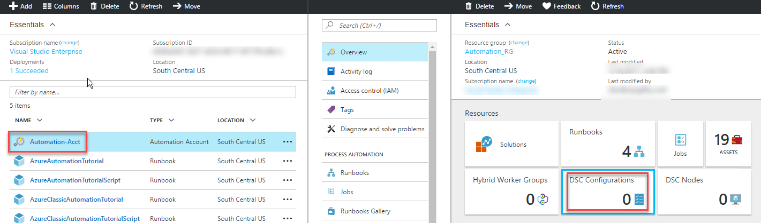
2. Click Add a configuration to upload **C:\Hackathon\CloudShopSQL.ps1** and **C:\Hackathon\CloudShopWeb.ps1**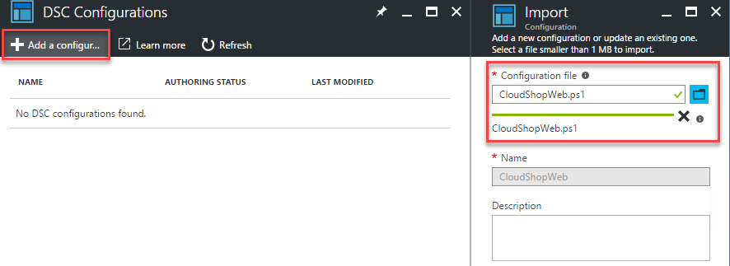
3. After importing the .ps1 files, click the **CloudShopSQL** DSC Configuration and click **Compile** on the toolbar (*click* ***Yes*** *on the overwrite prompt*). Do the same for **CloudShopWeb**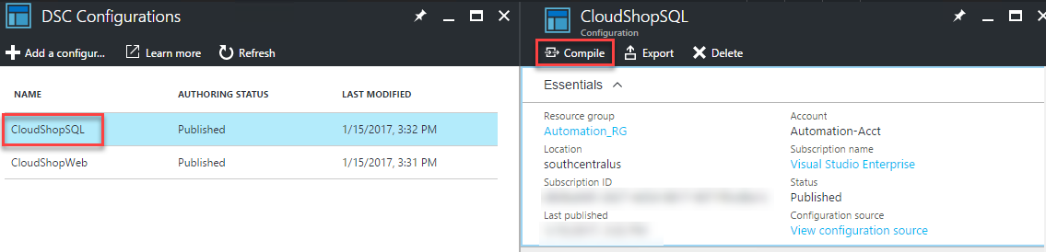

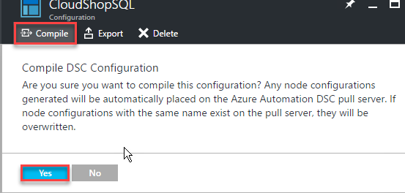

### Summary

In this exercise, you configured an Automation account, and configured DSC configuration scripts that will be leveraged by the virtual machine resources.

## Exercise 2: Define the network foundation

### Overview

Your first ARM template task is to create a virtual network template using Visual Studio and deploy it to your Azure account.

### Task 1: Deploy a virtual network with a template

1. Open Visual Studio. The shortcut should be available on the desktop.
2. Choose **File**, **New Project**, and then choose **Cloud**, and then **Azure Resource Group**.

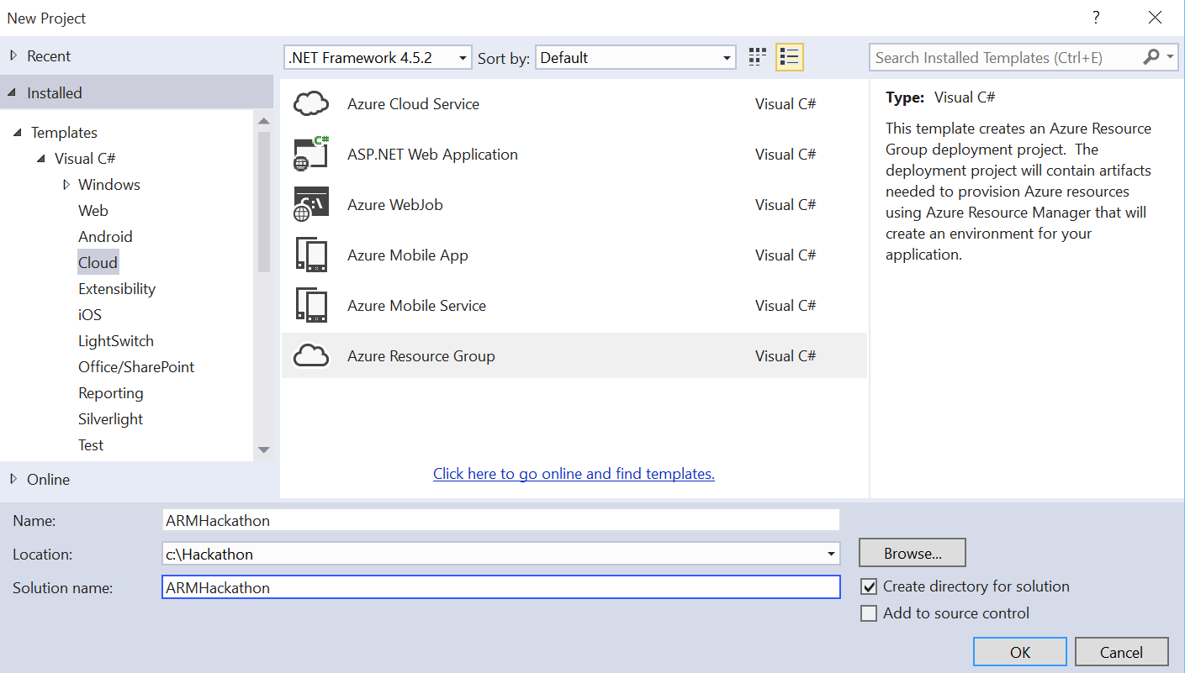

1. Name the project **ARMHackathon**,specify **C:\Hackathon** for the location, and click **OK**.
2. On the Select Azure Template dialog box, choose **Blank Template** and click **OK**. 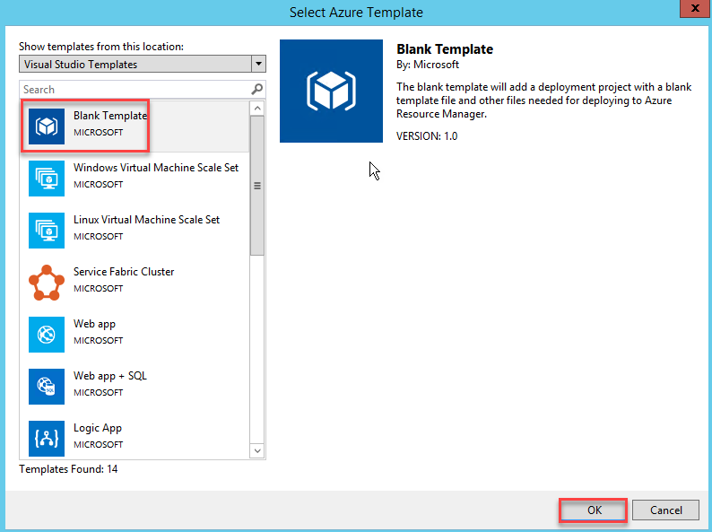
3. In the **Solution Explorer**, open the **azuredeploy.json** file from the **Templates** folder.

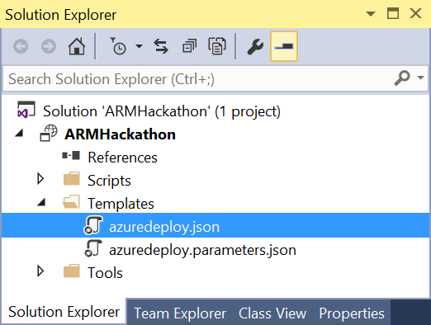

1. The file should contain four different sections: parameters, variables, resources, and outputs. On the left side, a new window called **JSON Outline** should have been opened as well. If this was not the case, go to the **View** menu, select **Other Windows**, and choose **JSON Outline**. The window should look like the following image.

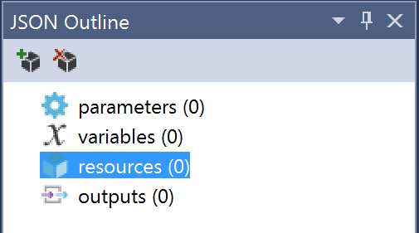

1. On the **JSON Outline** window, click **Add Resource** in the upper-left corner or right-click the **resources** and choose **Add New Resource**.

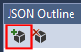

1. On the **Add Resource** dialog box, choose **Virtual Network**, enter **hackathonVnet** in the **Name** field, and click **Add**.

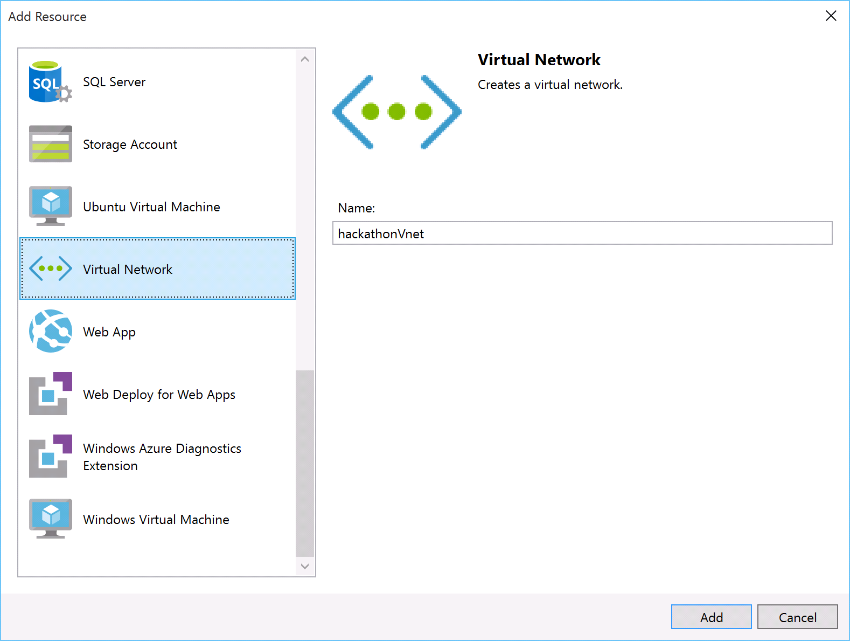

1. Go to the **azuredeploy.json** file, and inspect its content. Review the **variables** section. It should look like the following file.

"variables": {

    "hackathonVnetPrefix": "10.0.0.0/16",

    "hackathonVnetSubnet1Name": "Subnet-1",

    "hackathonVnetSubnet1Prefix": "10.0.0.0/24",

    "hackathonVnetSubnet2Name": "Subnet-2",

    "hackathonVnetSubnet2Prefix": "10.0.1.0/24"

}

1. Change the name of **Subnet-1** to **FrontEndNet**, and the name of **Subnet-2** to **DatabaseNet**.

"hackathonVnetSubnet1Name": "FrontEndNet",

"hackathonVnetSubnet2Name": "DatabaseNet",

1. Launch a browser and navigate to <http://jsonlint.com>. Copy the entire contents of **azuredeploy.json**, paste it in the text box, and click **Validate**.

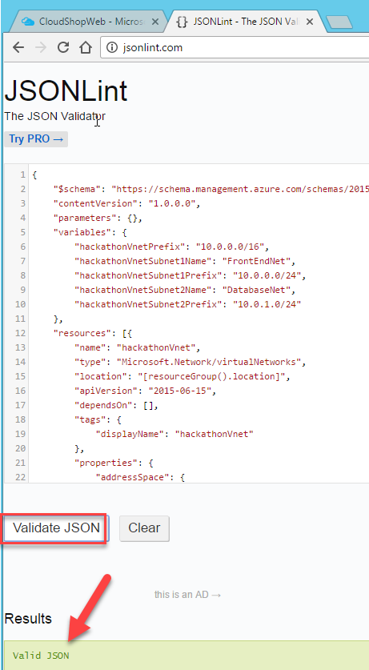

Note: In future lab steps if you have errors deploying a template, repeat this process and check for validation errors.

1. Deploy the template by right-clicking the **ARMHackathon** project, and choosing **Deploy** **>** **New Deployment**.

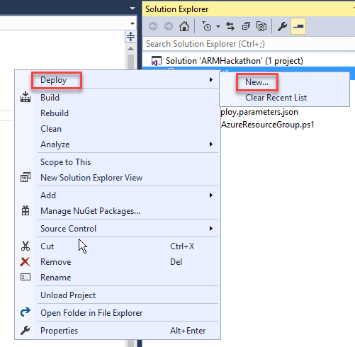

1. If you did not sign in to your Microsoft Azure account already, you will be asked to do so now.
2. Fill in the email address associated with the Azure account and click **Continue**.

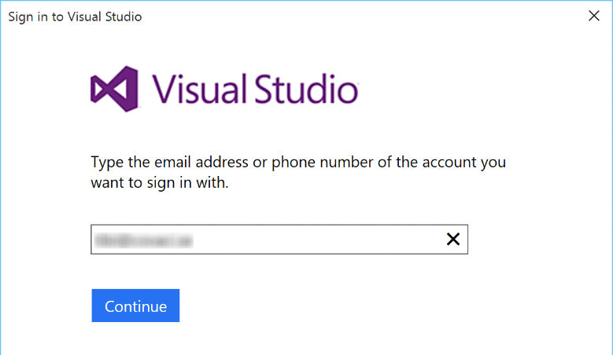

1. You might have to choose between a Work/School account and a Microsoft account. Microsoft account refers to a LiveId account. Depending on what kind of account you have, you should choose one or the other.
2. Enter your password and click **Sign In**.

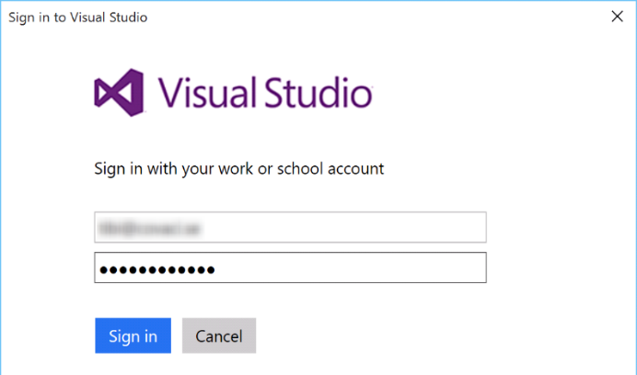

1. If you have several subscriptions, choose the one that you want your VNet to be deployed to, and on the Resource group choose **Create New**.

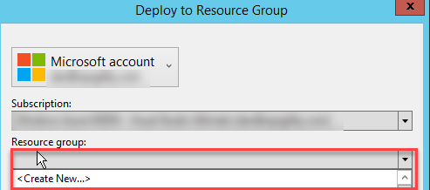

1. On the Create Resource Group dialog box, accept the default value for the name; and for the location, choose the **closest location to you**, and click **Create**.

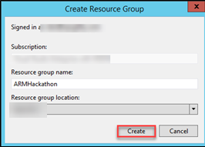

1. When you are back on the Deploy to Resource Group dialog box, click **OK**. After about a minute, your virtual network will be deployed to Azure.

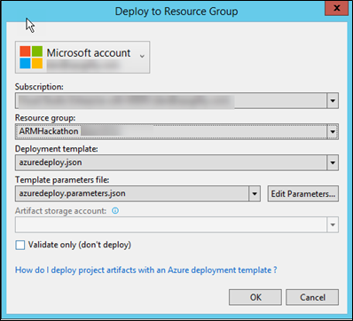

1. View the created resource group and virtual network in the Azure Management Portal by clicking **Resource Groups** and clicking the **ARMHackathon**.

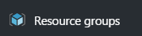

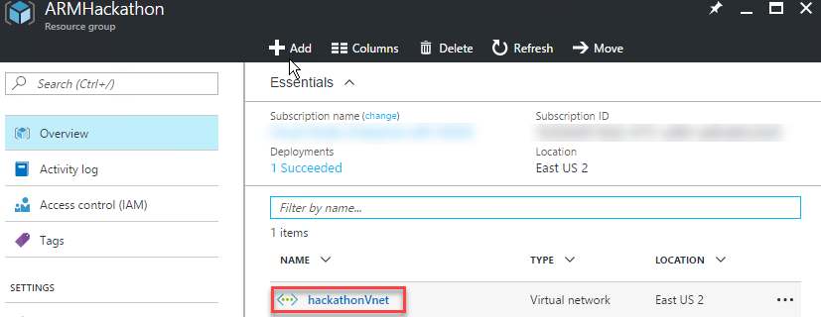

### Summary

In this exercise, you have created a new virtual network with two different subnets. To verify this, sign in to the **Microsoft Azure** portal and go to **Virtual Networks**. Your new network should be listed there.

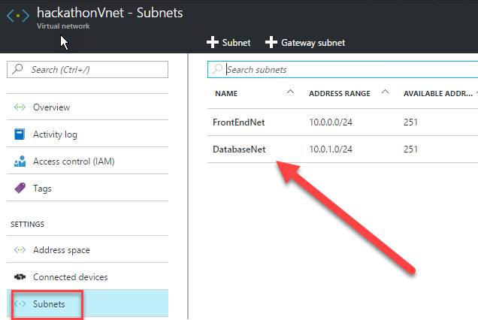

## Exercise 3: Extend with Compute

### Overview

In this task you will continue the work you started in the previous task by creating a storage account and adding virtual machines for the web application and for the database, and then configuring the machines for the roles.

### Task 1: Add an Azure storage account

1. On the **JSON Outline** window, click **Add Resource** in the upper-left corner, or right-click the **resources** and choose **Add New Resource**.



1. Add a new **Storage Account** resource to the template named ***hackstorage***.

Note: The template generated in the Azure SDK appends a unique value (13 characters in length) to the storage account name. Ensure the name specified is 11 characters or less in length.

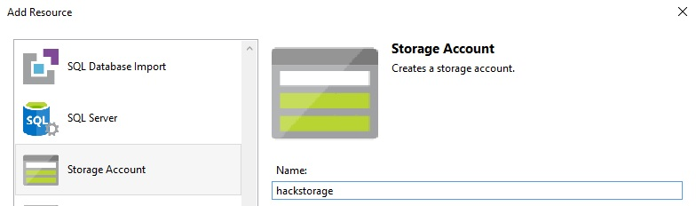

### Task 2: Add a virtual machine and configure as a web server

1. Add a new **Windows Virtual Machine** called **hackathonVM** and choose ***hackstorage*** as the Storage Account and **FrontEndNet** subnet as the Virtual network/subnet. The **FrontEndNet** is the value of **hackathonVnetSubnet1Name** variable.

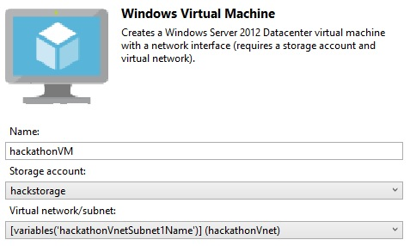

1. A **Network Interface** named ***hackathonVMNic*** was automatically added to the configuration when the virtual machine resource was added to connect the virtual machine to the virtual network. Add a public IP address called ***ok*** to the **hackathonVMNic**. This will allow you to connect to the machine using remote desktop client, or to access the web server.

Next you will add the PowerShell DSC Extension to the **azuredeploy.json** file. This will register the VM with Azure Automation DSC Extension

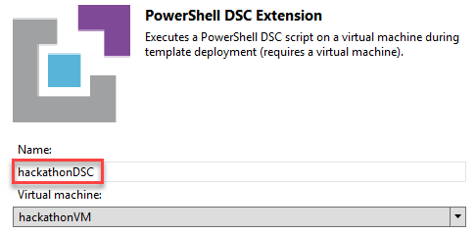

1. Change the Type Handler from 2.9 to 2.19 and make sure that autoUpgradeMinorVersion is true.

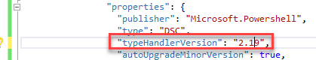

1. Find the settings code within the PowerShell DSC section you just added and replace it with this code:

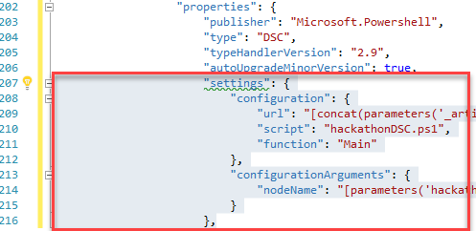

"settings": {

"modulesUrl": "https://opsgilityweb.blob.core.windows.net/20160629-arm-hackathon/RegistrationMetaConfigV2.zip",

"configurationFunction": "RegistrationMetaConfigV2.ps1\\RegistrationMetaConfigV2",

"Properties": [

{

"Name": "RegistrationKey",

"Value": {

"UserName": "PLACEHOLDER_DONOTUSE",

"Password": "PrivateSettingsRef:registrationKeyPrivate"

},

"TypeName": "System.Management.Automation.PSCredential"

},

{

"Name": "RegistrationUrl",

"Value": "[parameters('registrationUrl')]",

"TypeName": "System.String"

},

{

"Name": "NodeConfigurationName",

"Value": "[parameters('nodeConfigurationName')]",

"TypeName": "System.String"

},

{

"Name": "ConfigurationMode",

"Value": "[parameters('configurationMode')]",

"TypeName": "System.String"

},

{

"Name": "ConfigurationModeFrequencyMins",

"Value": "[parameters('configurationModeFrequencyMins')]",

"TypeName": "System.Int32"

},

{

"Name": "RefreshFrequencyMins",

"Value": "[parameters('refreshFrequencyMins')]",

"TypeName": "System.Int32"

},

{

"Name": "RebootNodeIfNeeded",

"Value": "[parameters('rebootNodeIfNeeded')]",

"TypeName": "System.Boolean"

},

{

"Name": "ActionAfterReboot",

"Value": "[parameters('actionAfterReboot')]",

"TypeName": "System.String"

},

{

"Name": "AllowModuleOverwrite",

"Value": "[parameters('allowModuleOverwrite')]",

"TypeName": "System.Boolean"

},

{

"Name": "Timestamp",

"Value": "[parameters('timestamp')]",

"TypeName": "System.String"

}

]

},

1. Next in the protectedSettings section delete the “configurationUrlSasToken” line; replacing it with this code.

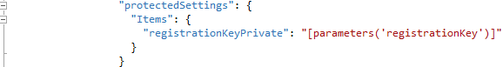

"Items": {

"registrationKeyPrivate": "[parameters('registrationKey')]"

}

1. You will now append the following parameters to your json template (*after the* ***hackathonPublicIPDnsName*** *parameter*)  
     
   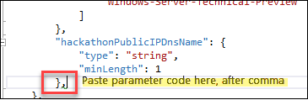  
     
   "registrationKey": {

"type": "string",

"metadata": {

"description": "Registration key of Automation account"

}

},

"registrationUrl": {

"type": "string",

"metadata": {

"description": "Registration URL of Automation account"

}

},

"nodeConfigurationName": {

"type": "string",

"metadata": {

"description": "Name of configuration to apply"

}

},

"rebootNodeIfNeeded": {

"type": "bool",

"metadata": {

"description": "Reboot if needed"

}

},

"allowModuleOverwrite": {

"type": "bool",

"metadata": {

"description": "Allow Module Overwrite"

}

},

"configurationMode": {

"type": "string",

"defaultValue": "ApplyAndMonitor",

"allowedValues": [

"ApplyAndMonitor",

"ApplyOnly",

"ApplyandAutoCorrect"

],

"metadata": {

"description": "Configuration Mode"

}

},

"configurationModeFrequencyMins": {

"type": "int",

"metadata": {

"description": "Allow Module Overwrite"

}

},

"refreshFrequencyMins": {

"type": "int",

"metadata": {

"description": "Refresh frequency in minutes"

}

},

"actionAfterReboot": {

"type": "string",

"defaultValue": "ContinueConfiguration",

"allowedValues": [

"ContinueConfiguration",

"StopConfiguration"

],

"metadata": {

"description": "Action after reboot"

}

},

"timestamp": {

"type": "string",

"metadata": {

"description": "Time stamp MM/dd/YYYY H:mm:ss"

}

}

1. In the “**variables**” section, change the value of hackathonVMVmSize" to "Standard_D1_v2".

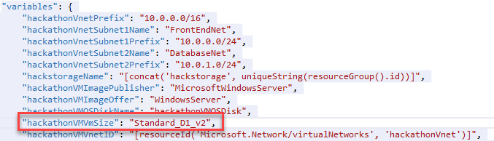

1. Save your changes to the **azuredeploy.json** template file.

### Task 3: Add a Windows virtual machine for the database server

1. Add another virtual machine to the template by clicking **Add Resource** and then selecting **Windows Virtual Machine**.

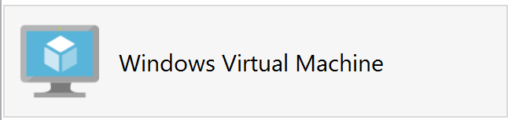

1. Name this virtual machine resource **hackathonSqlVM** and reference the parameters **hackStorage** and **hackathonVnetSubnet2Name** respectively.

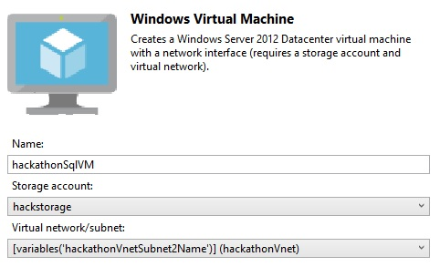

1. Navigate to the **variables** section and find the following variables:

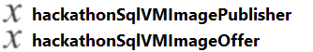

1. Modify the following **hackathonSqlVMImagePublisher** and **hackathonSqlVMImageOffer** variables to the following SQL Server image values:

"hackathonSqlVMImagePublisher": "MicrosoftSQLServer",

"hackathonSqlVMImageOffer": "f",

1. Find the **hackathonSqlVMWindowsOSVersion** parameter.

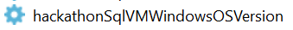

1. Replace the **hackathonSqlVMWindowsOSVersion** parameter with the following:

"hackathonSqlVMSKU": {

"type": "string",

"defaultValue": "Web",

"allowedValues": [

"Web",

"Standard",

"Enterprise"

]

}

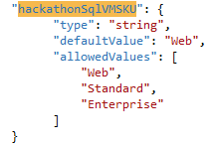

1. Click the **hackathonSqlVM** resource to move to its properties.

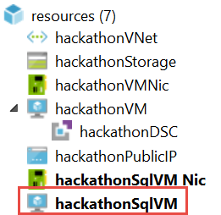

1. Update the **SKU** property to point to the new parameter: **hackathonSqlVMSKU**.

"sku": "[parameters('hackathonSqlVMSKU')]",

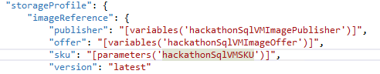

1. Navigate to the **parameters** section of the template and add a new parameter called **vmSizeSQL** to define the size of the virtual machine.

**Tip:** Do not forget the preceding comma.

"vmSizeSql": {

"type": "string",

"defaultValue": "Standard_D1_v2",

"allowedValues": [

"Standard_D1_v2",

"Standard_D2_v2",

"Standard_D3_v2",

"Standard_D4_v2",

"Standard_D5_v2"

]

}

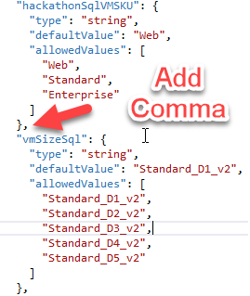

1. Navigate to the **resources** section for the **hackathonSqlVM**. Find the **hardwareProfile** section and replace the **vmSize** property with the following:

"vmSize": "[parameters('vmSizeSql')]"

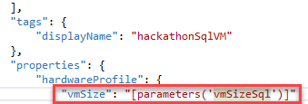

1. Next, add two data disks to the **hackathonSqlVM** by first adding the storage paths as variables in the variables section of the template.

"dataDisk1VhdName": "[concat('http://',variables('hackStorageName'),'.blob.core.windows.net/','vhds','/','dataDisk1.vhd')]",

"dataDisk2VhdName": "[concat('http://',variables('hackStorageName'),'.blob.core.windows.net/','vhds','/','dataDisk2.vhd')]"

Do not forget to add a comma after the last variable first and then hitting enter. This will start a new line where you can paste.

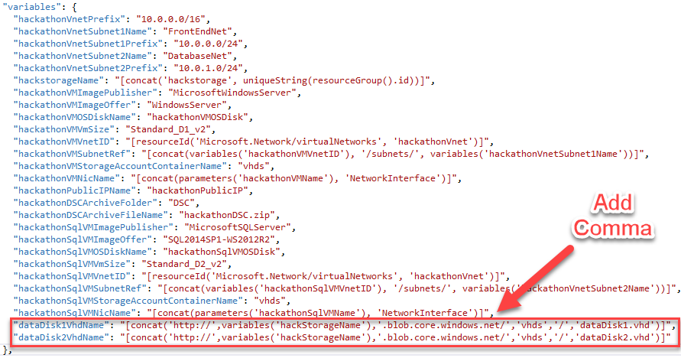

1. In order to deploy two 1 TB disks, add the following section to the properties, storage profile section of the **hackathonSqlVM** (right after osDisk).

Tip: Do not forget to add a comma at the end of the osDisk section.

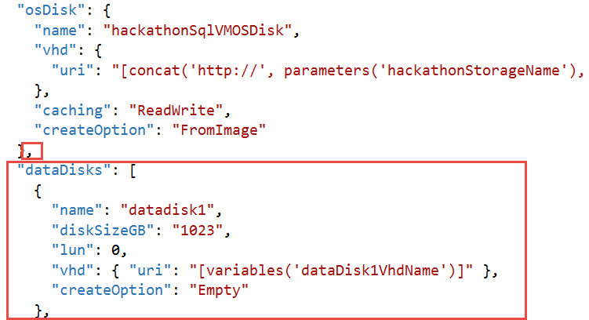

"dataDisks": [

{

"name": "datadisk1",

"diskSizeGB": "1023",

"lun": 0,

"vhd": { "uri": "[variables('dataDisk1VhdName')]" },

"createOption": "Empty"

},

{

"name": "datadisk2",

"diskSizeGB": "1023",

"lun": 1,

"vhd": {"uri": "[variables('dataDisk2VhdName')]"},

"createOption": "Empty"

}]

1. Next you will add the PowerShell DSC Extension to the **azuredeploy.json** file for the SQL VM. This will register the VM with Azure Automation DSC Extension.

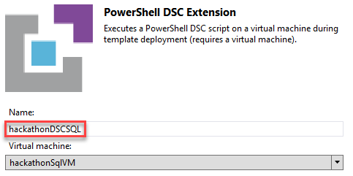

1. We do need to create a new parameter that will be different for the SQL VM. In the parameters section duplicate the **nodeConfigurationName** parameter and change its name to **sqlnodeConfigurationName**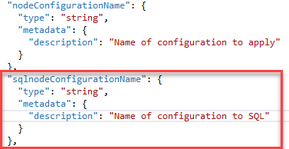
2. Save your changes to the **azuredeploy.json** template file.
3. Change the Type Handler from 2.9 to 2.19 and make sure that autoUpgradeMinorVersion is true.



1. Find the settings code within the PowerShell DSC section you just added and replace it with this code:



"settings": {

"modulesUrl": "https://opsgilityweb.blob.core.windows.net/20160629-arm-hackathon/RegistrationMetaConfigV2.zip",

"configurationFunction": "RegistrationMetaConfigV2.ps1\\RegistrationMetaConfigV2",

"Properties": [

{

"Name": "RegistrationKey",

"Value": {

"UserName": "PLACEHOLDER_DONOTUSE",

"Password": "PrivateSettingsRef:registrationKeyPrivate"

},

"TypeName": "System.Management.Automation.PSCredential"

},

{

"Name": "RegistrationUrl",

"Value": "[parameters('registrationUrl')]",

"TypeName": "System.String"

},

{

"Name": "NodeConfigurationName",

"Value": "[parameters('sqlnodeConfigurationName')]",

"TypeName": "System.String"

},

{

"Name": "ConfigurationMode",

"Value": "[parameters('configurationMode')]",

"TypeName": "System.String"

},

{

"Name": "ConfigurationModeFrequencyMins",

"Value": "[parameters('configurationModeFrequencyMins')]",

"TypeName": "System.Int32"

},

{

"Name": "RefreshFrequencyMins",

"Value": "[parameters('refreshFrequencyMins')]",

"TypeName": "System.Int32"

},

{

"Name": "RebootNodeIfNeeded",

"Value": "[parameters('rebootNodeIfNeeded')]",

"TypeName": "System.Boolean"

},

{

"Name": "ActionAfterReboot",

"Value": "[parameters('actionAfterReboot')]",

"TypeName": "System.String"

},

{

"Name": "AllowModuleOverwrite",

"Value": "[parameters('allowModuleOverwrite')]",

"TypeName": "System.Boolean"

},

{

"Name": "Timestamp",

"Value": "[parameters('timestamp')]",

"TypeName": "System.String"

}

]

},

1. Next in the protectedSettings section delete the “configurationUrlSasToken” line; replacing it with this code.

"Items": {

"registrationKeyPrivate": "[parameters('registrationKey')]"

}



1. Save your changes to the **azuredeploy.json** template file.

### Task 4: Deploy your updated template to Azure

1. Before deploying your updated template, you should make note of your Automation key and registration URL. In the Azure Portal, click **Resource groups > Automation_RG > Automation-Acct**, and then in the Account Settings area click the **Keys** icon.

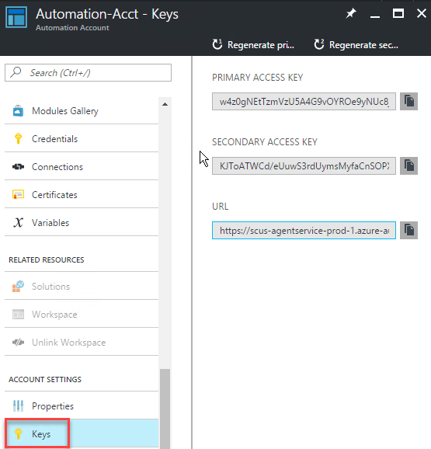

1. The information you will need to deploy your template is on the **Manage Keys** blade to the right. When doing the deployment from within Visual Studio a Key need to be provided. The **Primary Access Key** can be copied to the clipboard by clicking the button next to the Key on this blade.

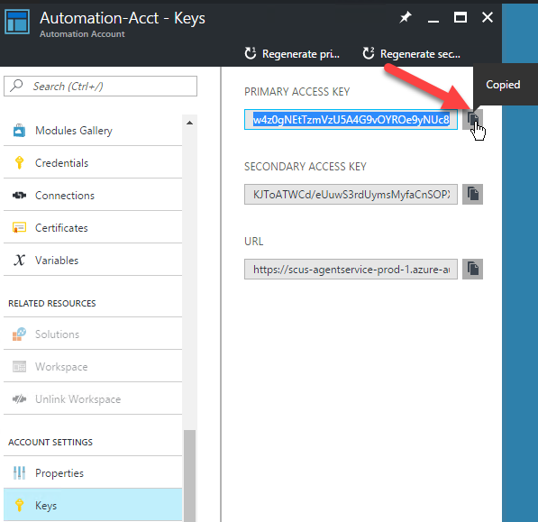

1. Using this same process, the **URL** can also be copied to use with Visual Studio.

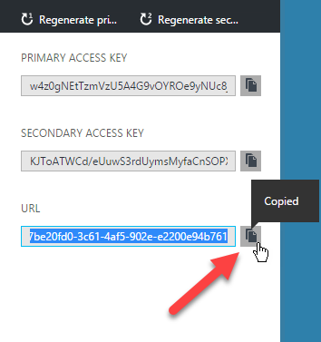

1. You will also need the name of your Node Configurations which you uploaded using the portal during Exercise 1. To find these click the DSC Configuration tile on the Azure Automation Blade. Then click the name of each to find the Node Name.

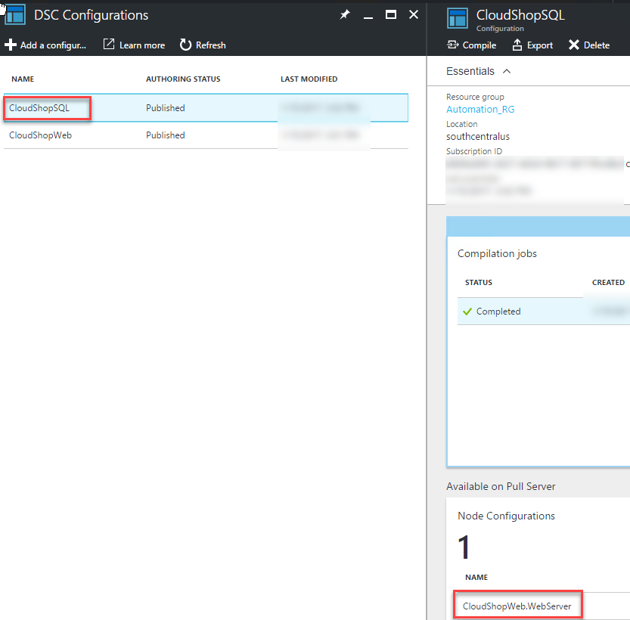

1. From within Visual Studio create a new deployment (*specify the same Resource group as before ARMHackathon)*.   
   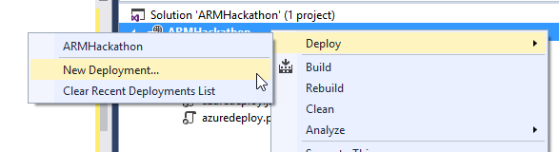
2. On the **Deploy to Resource Group** dialog box, click **Edit Parameters** and populate the empty values.  
     
   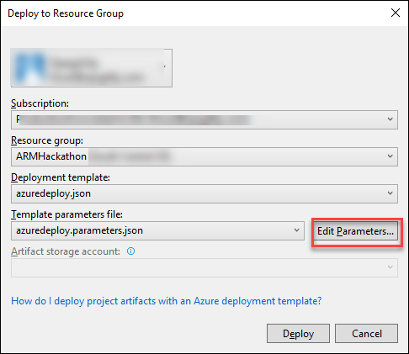

* hackathonVMName: **armweb**
* hackathonVMAdminUserName: **demouser**
* hackathonVMAdminPassword: **demo@pass123**
* hackathonPublicIPDnsName: **Choose a unique looking DNS name (must be lowercase)**
* registrationKey: **Automation account key**
* registrationUrl: **Automation registration URL**
* nodeConfigurationName: **CloudShopWeb.WebServer**
* sqlnodeConfigurationName: **CloudShopSQL.SQLSERVER**
* rebootNodeIfNeeded: **True**
* allowModuleOverwrite: **True**
* configurationModeFrequencyMins: **15**
* refreshFrequencyMins: **30**
* timestamp: **<enter current value in format like screenshot below>**
* hackathonSQLVMName: **armsql**
* hackathonVMSQLAdminUserName: **demouser**
* hackathonVMSQLAdminPassword: **demo@pass123**
* hackathonVMSQLSKU: **Web**
* vmsizeSQL: **Standard_D3_v2**
* **Check: Save passwords as plain text in the parameters file**

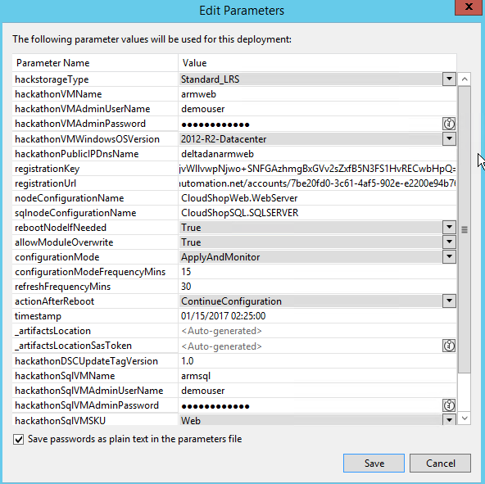

Note: The deployment may take 20 to 30 minutes to complete.

Extension Troubleshooting tip: If you make a mistake with either of the Azure DSC extensions and need to redeploy, open the virtual machine in the portal, under all settings, click extensions and remove the failed extension before deploying and also in your Automation Account under the DSC Nodes Unregister the Node.

1. Launch the **Azure Management Portal** <http://portal.azure.com> and navigate to the resource group you deployed to. Click the **virtual machine** for the web server and then click the **public IP**.

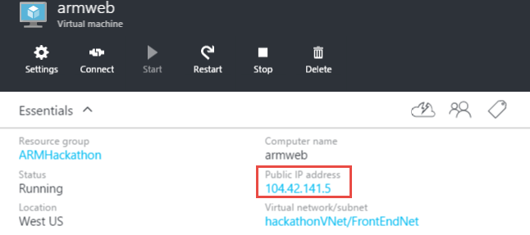

1. Copy the **DNS Name** and navigate to it in the browser.

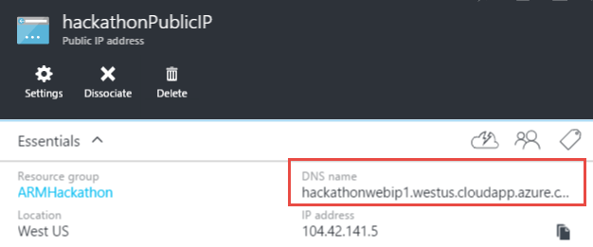

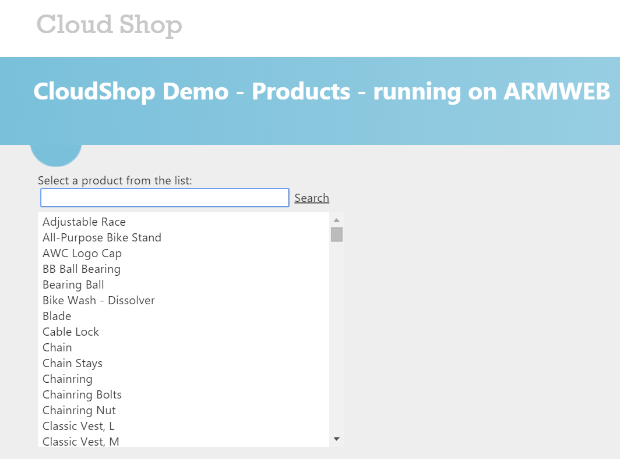

1. You should also verify that your VMs are registered as DSC Nodes in your Automation account. In the Azure Portal, click **Resource groups > Automation_RG > Automation-Acct**, and then click the **DSC Nodes** tile   
   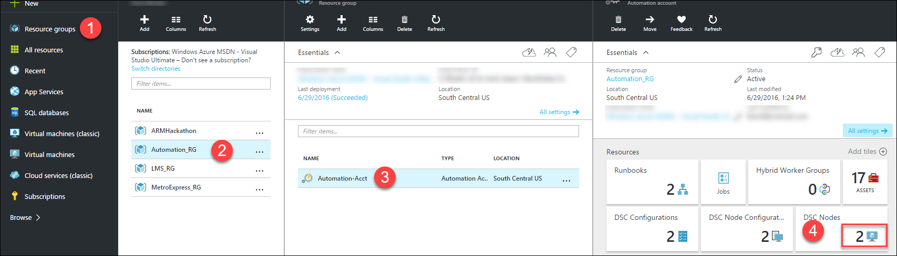  
     
   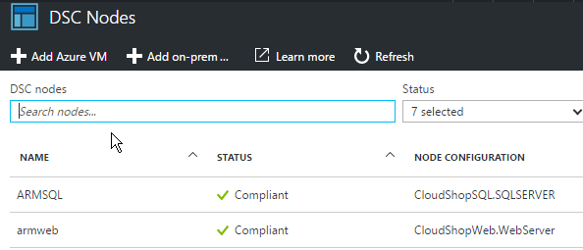

### Summary

In this lab, you provisioned two virtual machines that were customized with the PowerShell DSC extension to automatically deploy a web application and a SQL Server database.

## Exercise 4: Lock down the environment

### Overview

In this portion of the exercise, you will deploy a network security group to restrict the network attack surface for the deployment.

### Task 1: Restrict traffic to the web server

1. Add the following at the beginning of the JSON template as the first item under the **resources** node. This will deploy the network security group resource and add a rule so that the only port open on the public IP is port 80.

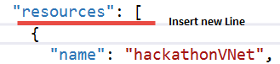

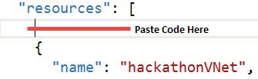

{

"apiVersion": "2016-03-30",

"type": "Microsoft.Network/networkSecurityGroups",

"name": "hackathonNetworkSecurityGroup",

"location": "[resourceGroup().location]",

"properties": {

"securityRules": [

{

"name": "webrule",

"properties": {

"description": "This rule allows traffic in on port 80",

"protocol": "Tcp",

"sourcePortRange": "*",

"destinationPortRange": "80",

"sourceAddressPrefix": "INTERNET",

"destinationAddressPrefix": "10.0.0.0/24",

"access": "Allow",

"priority": 100,

"direction": "Inbound"

}

}

]

}

},

1. Click the **hackathonVNet** resource to go to its configuration.

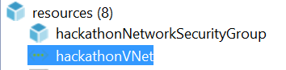

1. Associate the network security group with the **hackathonVnetSubnet1Name** subnet by adding a comma at the end of the **addressPrefix** block, and pasting in the **networkSecurityGroup** reference.

"networkSecurityGroup": {

"id": "[resourceId('Microsoft.Network/networkSecurityGroups', 'hackathonNetworkSecurityGroup')]"

}

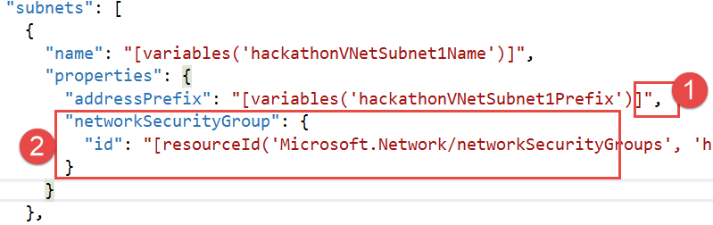

1. Update the virtual network to have a dependency on the network security group.
2. Click the **hackathonVNet** resource to view the configuration.

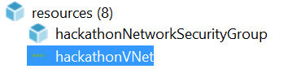

1. Change the **dependsOn** configuration to refer back to the network security group.

"dependsOn": [

"[resourceId('Microsoft.Network/networkSecurityGroups', 'hackathonNetworkSecurityGroup')]"

],

1. Right-click the Visual Studio project and select **Deploy** from the context menu, followed by **New Deployment**. Click **Deploy** to update the existing deployment with the network security group.
2. To validate the network security group is working:
   * Browse to the public IP or DNS name of the web server. The site should load because traffic is allowed on port 80.
   * Connect to the web virtual machine by clicking **Connect** in the preview portal. This should fail because port 3389 is not allowed in.

### Task 2: Update the network security group to allow Windows Remote Desktop

1. Add a new rule to the network security group to allow in traffic on port 3389 Remote Desktop Protocol (RDP) by adding a comma at the end of the web rule and add the following code:

{

"name": "rdprule",

"properties": {

"description": "This rule allows traffic on port 3389 from the web",

"protocol": "Tcp",

"sourcePortRange": "*",

"destinationPortRange": "3389",

"sourceAddressPrefix": "INTERNET",

"destinationAddressPrefix": "10.0.0.0/24",

"access": "Allow",

"priority": 200,

"direction": "Inbound"

}

}

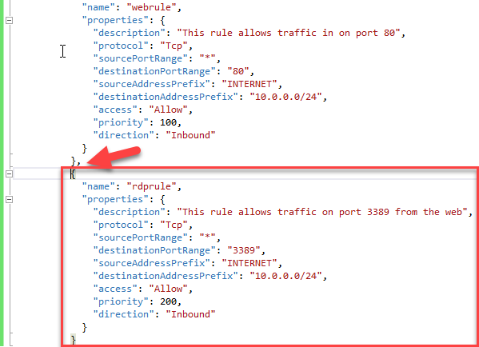

1. Deploy the updated rule and test RDP connectivity again.
2. Open the Azure Preview Portal, and navigate to the resource group containing your deployment.
3. Click the **hackathonNetworkSecurityGroup** in the resources summary.

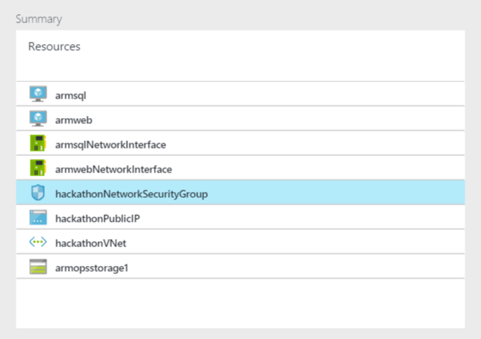

1. Examine the created rule.

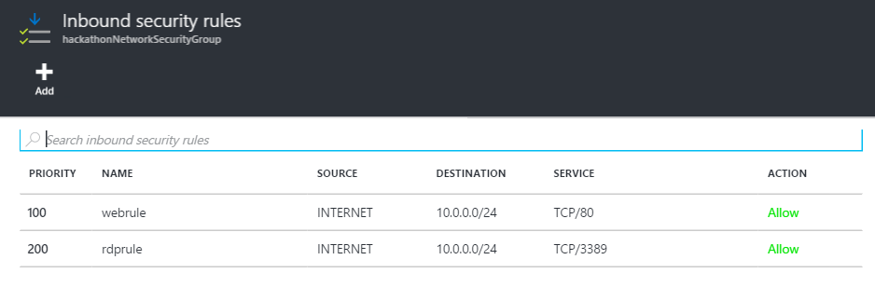

### Summary

In this lab, you created a network security group and applied it to the resource group to further constrain traffic to the network.

## Exercise 5: Scale out the deployment

### Overview

In this exercise, you will configure the template to scale out the web front end using a scalable number of virtual machines and storage accounts. For this, you will use the load balancer and the scale sets feature.

### Task 1: Parameterize and scale out the environment

1. Add the following variables to the end of the **variables** section of the **azuredeploy.json** file:

Tip: Do not forget to put a comma after the previous variables.

"vmSSName": "webset",

"publicIPAddressID": "[resourceId('Microsoft.Network/publicIPAddresses',variables('hackathonPublicIPName'))]",

"lbName": "loadBalancer1",

"lbID": "[resourceId('Microsoft.Network/loadBalancers',variables('lbName'))]",

"lbFEName": "loadBalancerFrontEnd",

"lbWebProbeName": "loadBalancerWebProbe",

"lbBEAddressPool": "loadBalancerBEAddressPool",

"lbFEIPConfigID": "[concat(variables('lbID'),'/frontendIPConfigurations/',variables('lbFEName'))]",

"lbBEAddressPoolID": "[concat(variables('lbID'),'/backendAddressPools/',variables('lbBEAddressPool'))]",

"lbWebProbeID": "[concat(variables('lbID'),'/probes/',variables('lbWebProbeName'))]",

"storageAccountPrefix": [

"a",

"g",

"m",

"s",

"y"

]

1. Add the following parameters to the end of the **parameters** section of the **azuredeploy.json** file (do not forget to add the comma after the last parameter).

"instanceCount": {

"type": "string",

"metadata": {

"description": "Number of VM instances"

}

},

"newStorageAccountSuffix": {

"type": "string",

"metadata": {

"description": "The Prefix for the names of the new storage accounts created"

}

}

1. Add a new storage account resource using the copy function by pasting the following code as the first resource in the list.

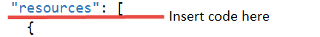

{

"type": "Microsoft.Storage/storageAccounts",

"name": "[concat(variables('StorageAccountPrefix')[copyIndex()],parameters('newStorageAccountSuffix'))]",

"apiVersion": "2015-06-15",

"copy": {

"name": "storageLoop",

"count": 5

},

"location": "[resourceGroup().location]",

"properties": {

"accountType": "[parameters('hackStorageType')]"

}

},

Note: This code will create five storage accounts. The virtual machine scale set will distribute the virtual machine disks across the storage accounts to ensure the VMs do not run out of IO capacity.

1. Add a load balancer resource by pasting the following code as the first resource in the list.



{

"apiVersion": "2016-03-30",

"name": "[variables('lbName')]",

"type": "Microsoft.Network/loadBalancers",

"location": "[resourceGroup().location]",

"dependsOn": [

"[concat('Microsoft.Network/publicIPAddresses/',variables('hackathonPublicIPName'))]"

],

"properties": {

"frontendIPConfigurations": [

{

"name": "[variables('lbFEName')]",

"properties": {

"publicIPAddress": {

"id": "[variables('publicIPAddressID')]"

}

}

}

],

"backendAddressPools": [

{

"name": "[variables('lbBEAddressPool')]"

}

],

"loadBalancingRules": [

{

"name": "weblb",

"properties": {

"frontendIPConfiguration": {

"id": "[variables('lbFEIPConfigID')]"

},

"backendAddressPool": {

"id": "[variables('lbBEAddressPoolID')]"

},

"probe": {

"id": "[variables('lbWebProbeID')]"

},

"protocol": "Tcp",

"frontendPort": 80,

"backendPort": 80,

"enableFloatingIP": false

}

}

],

"probes": [

{

"name": "[variables('lbWebProbeName')]",

"properties": {

"protocol": "Http",

"port": 80,

"intervalInSeconds": 15,

"numberOfProbes": 5,

"requestPath": "/"

}

}

]

}

},

Note: This code creates a load balancer resource that is listening on port 80.

1. Add the virtual machine scale set to the **resources** section using the following configuration:

{

"type": "Microsoft.Compute/virtualMachineScaleSets",

"apiVersion": "2015-06-15",

"name": "[variables('vmSSName')]",

"location": "[resourceGroup().location]",

"tags": {

"vmsstag1": "Myriad"

},

"dependsOn": [

"[concat('Microsoft.Storage/storageAccounts/a',parameters('newStorageAccountSuffix'))]",

"[concat('Microsoft.Storage/storageAccounts/g',parameters('newStorageAccountSuffix'))]",

"[concat('Microsoft.Storage/storageAccounts/m',parameters('newStorageAccountSuffix'))]",

"[concat('Microsoft.Storage/storageAccounts/s',parameters('newStorageAccountSuffix'))]",

"[concat('Microsoft.Storage/storageAccounts/y',parameters('newStorageAccountSuffix'))]",

"[concat('Microsoft.Network/loadBalancers/',variables('lbName'))]",

"[concat('Microsoft.Network/virtualNetworks/','hackathonVnet')]"

],

"sku": {

"name": "Standard_A2",

"tier": "Standard",

"capacity": "[parameters('instanceCount')]"

},

"properties": {

"upgradePolicy": {

"mode": "Manual"

},

"virtualMachineProfile": {

"storageProfile": {

"osDisk": {

"vhdContainers": [

"[concat('https://a',parameters('newStorageAccountSuffix'),'.blob.core.windows.net/vmss')]",

"[concat('https://g',parameters('newStorageAccountSuffix'),'.blob.core.windows.net/vmss')]",

"[concat('https://m',parameters('newStorageAccountSuffix'),'.blob.core.windows.net/vmss')]",

"[concat('https://s',parameters('newStorageAccountSuffix'),'.blob.core.windows.net/vmss')]",

"[concat('https://y',parameters('newStorageAccountSuffix'),'.blob.core.windows.net/vmss')]"

],

"name": "vmssosdisk",

"caching": "ReadOnly",

"createOption": "FromImage"

},

"imageReference": {

"publisher": "[variables('hackathonVMImagePublisher')]",

"offer": "[variables('hackathonVMImageOffer')]",

"sku": "[parameters('hackathonVMWindowsOSVersion')]",

"version": "latest"

}

},

"osProfile": {

"computerNamePrefix": "[variables('vmSSName')]",

"adminUsername": "[parameters('hackathonVMAdminUserName')]",

"adminPassword": "[parameters('hackathonVMAdminPassword')]"

},

"networkProfile": {

"networkInterfaceConfigurations": [

{

"name": "nic1",

"properties": {

"primary": true,

"ipConfigurations": [

{

"name": "ip1",

"properties": {

"subnet": {

"id": "[variables('hackathonVMSubnetRef')]"

},

"loadBalancerBackendAddressPools": [

{ "id": "[variables('lbBEAddressPoolID')]" }

]

}

}

]

}

}

]

},

"extensionProfile": {

"extensions": [

{

"name": "hackathonDSC",

"properties": {

"publisher": "Microsoft.Powershell",

"type": "DSC",

"typeHandlerVersion": "2.19",

"autoUpgradeMinorVersion": true,

"protectedSettings": {

"Items": {

"registrationKeyPrivate": "[parameters('registrationKey')]"

}

},

"settings": {

"modulesUrl": "https://opsgilityweb.blob.core.windows.net/20160629-arm-hackathon/RegistrationMetaConfigV2.zip",

"configurationFunction": "RegistrationMetaConfigV2.ps1\\RegistrationMetaConfigV2",

"Properties": [

{

"Name": "RegistrationKey",

"Value": {

"UserName": "PLACEHOLDER_DONOTUSE",

"Password": "PrivateSettingsRef:registrationKeyPrivate"

},

"TypeName": "System.Management.Automation.PSCredential"

},

{

"Name": "RegistrationUrl",

"Value": "[parameters('registrationUrl')]",

"TypeName": "System.String"

},

{

"Name": "NodeConfigurationName",

"Value": "CloudShopWeb.WebServer",

"TypeName": "System.String"

},

{

"Name": "ConfigurationMode",

"Value": "[parameters('configurationMode')]",

"TypeName": "System.String"

},

{

"Name": "ConfigurationModeFrequencyMins",

"Value": "[parameters('configurationModeFrequencyMins')]",

"TypeName": "System.Int32"

},

{

"Name": "RefreshFrequencyMins",

"Value": "[parameters('refreshFrequencyMins')]",

"TypeName": "System.Int32"

},

{

"Name": "RebootNodeIfNeeded",

"Value": "[parameters('rebootNodeIfNeeded')]",

"TypeName": "System.Boolean"

},

{

"Name": "ActionAfterReboot",

"Value": "[parameters('actionAfterReboot')]",

"TypeName": "System.String"

},

{

"Name": "AllowModuleOverwrite",

"Value": "[parameters('allowModuleOverwrite')]",

"TypeName": "System.Boolean"

},

{

"Name": "Timestamp",

"Value": "[parameters('timestamp')]",

"TypeName": "System.String"

}

]

}

}

}

]

}

}

}

},

This code creates a virtual machine scale sets resource that will create as many instances of the virtual machine as specified in the instanceCount parameter. The DSC extension will execute on each VM when it is created to configure the cloud shop web application. The scale set will distribute the VM disks across the previously created storage accounts.

1. Delete the existing **hackathonVM** and the **hackathonVMNic** resources by right-clicking each resource and clicking **Delete**.

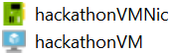

This VM and NIC will be replaced by the VMs in the scale set.

1. Delete the existing deployment (to save on core quota) by opening the Azure portal (portal.azure.com) in your browser.
2. Click **Resource groups**.

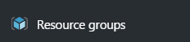

1. Click the **ARMHackathon** resource group (or whatever you named your deployment).

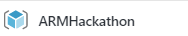

1. Click **Delete**, and then confirm by typing in the name of the resource group.

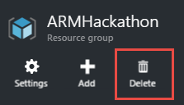

1. Create a **new deployment** and choose a new **resource group**. Name the new resource group **ARMHackathonScaleSet**.



1. Choose any of the template parameters files, and click **Edit Parameters**.



1. Provide a unique value for the **hackathonPublicIPDnsName** and **newStorageAccountSuffix** parameters. Enter a value of 2 for the **instanceCount**. Click **Save** and then **Deploy**.

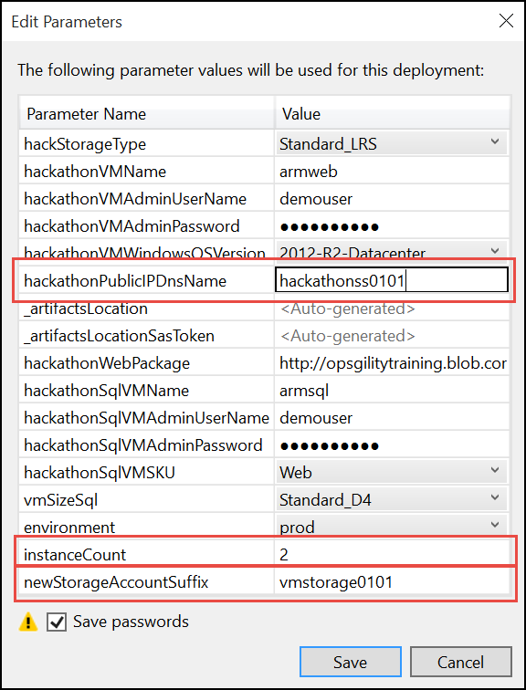

Note: The deployment may take 20 to 30 minutes to complete. If Visual Studio fails monitoring the solution with an error about the SAS Token expiring you can open the resource group in the Portal and you can monitor the deployment by clicking the link under the Last Deployment lab on the essentials pane.

1. Within the **Azure Management Portal**, open the **resource group** and click the **hackathonPublicIP** resource.

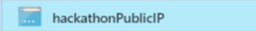

1. Copy the **DNS name** and navigate to it in a browser to validate that the load balancer and the scale set are working. Click **Refresh** several times and the page should flip from WEBSET-0 to WEBSET-1.

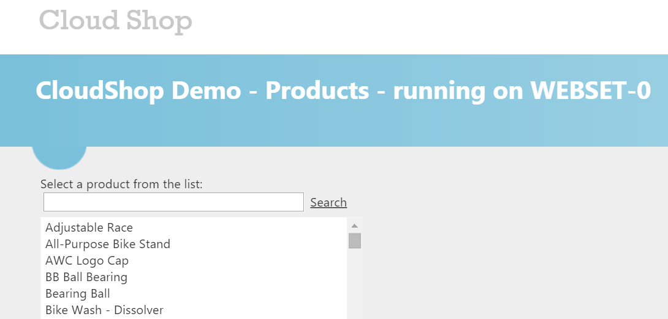

# Internet of Things (IoT) hackathon

## Overview

Fabrikam provides services and smart meters for enterprise energy (electrical power) management. There *You-Left-The-Light-On* service enables the enterprise to understand their energy consumption.

In this Hackathon, you will construct an end-to-end solution for an IoT scenario that includes device management; telemetry ingest; hot and cold path processing; and reporting.

## Requirements

* Microsoft Azure subscription must be pay-as-you-go or MSDN.
  + Trial subscriptions will *not* work.
* Local machine or a virtual machine configured with:
  + Visual Studio 2015 Community Edition or later
  + Azure SDK 2.8.2 for Visual Studio
  + Azure PowerShell 1.0.0 or later
* A running HD Insight Spark cluster (see Exercise 0).

## Exercise 0: Before the Hackathon

Duration: 60 minutes

Synopsis: You should follow all of the steps provided in Exercise 0 of the Proctor Guide (included in this document) *before* attending the Hackathon.

### Task 1: Provision Power BI

1. If you do not already have a Power BI account, go to <https://www.powerbi.com>.
2. On the page, enter your work email address (which should be the same account as the one you use for your Azure subscription) and click **Use it free**.

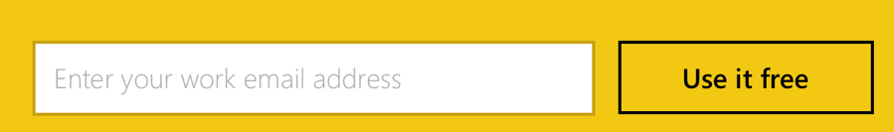

1. Follow the on-screen prompts and your Power BI environment should be ready within minutes. You can always return to it via <https://app.powerbi.com>.

### Task 2: Provision an HDInsight with Spark Cluster

Using the Azure Portal, provision a new HDInsight cluster.

1. Select **+New**, select **Intelligence + Analytics**, **HDInsight**

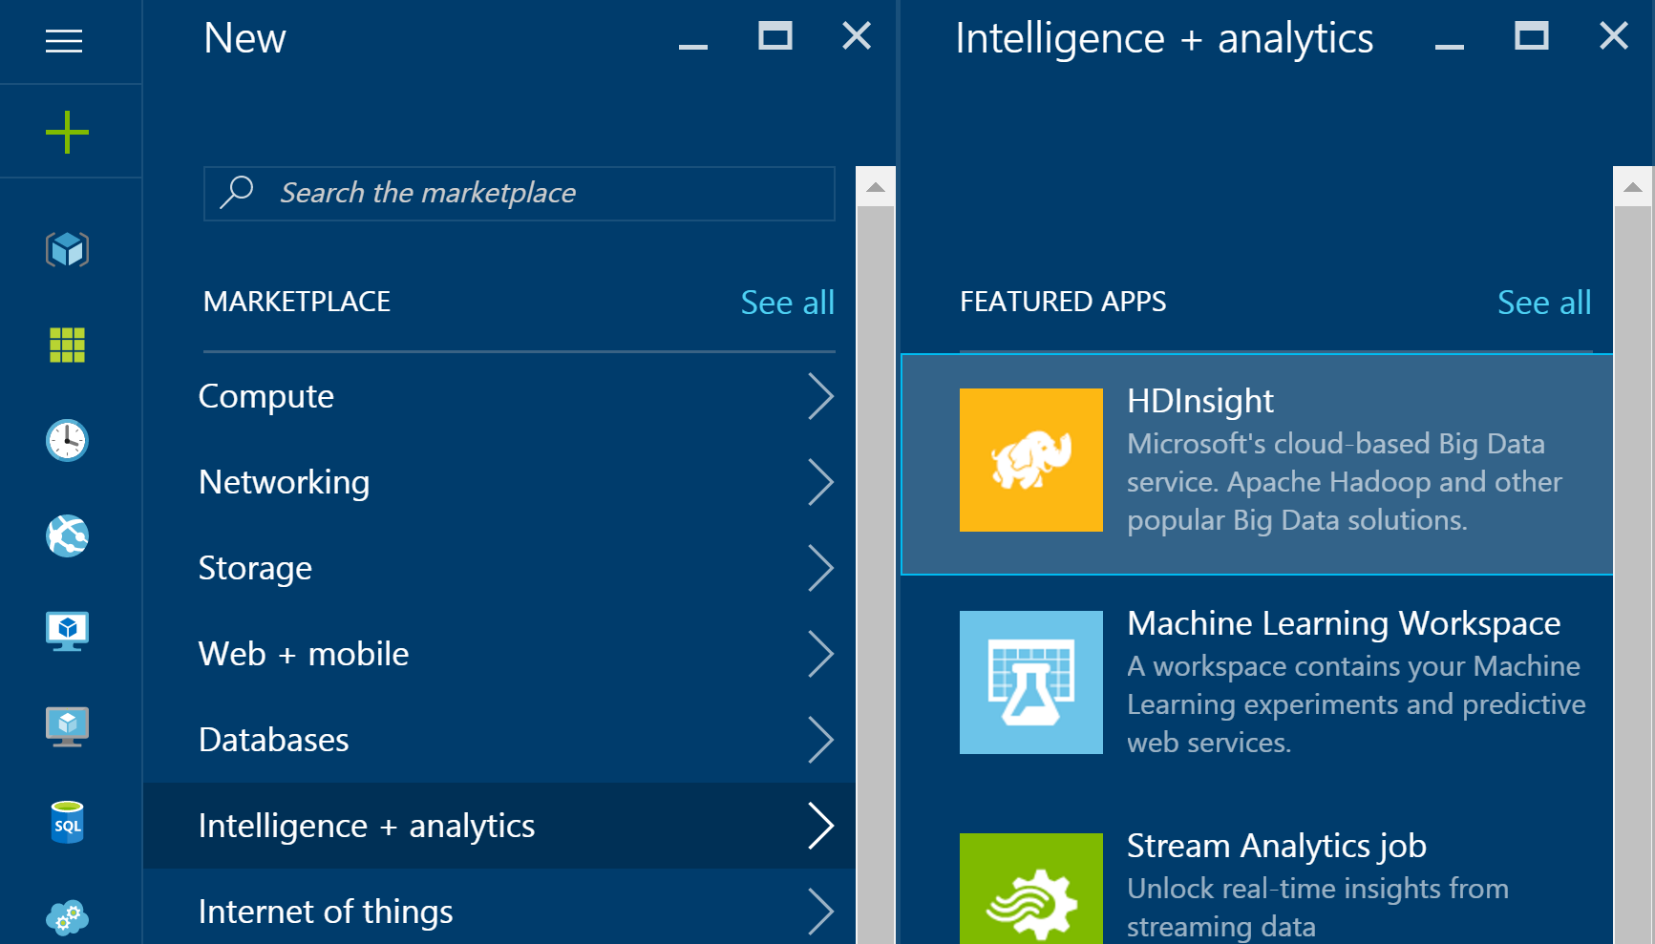

1. Provide a unique Cluster Name.
2. Select **Subscription**.
3. Choose the Azure Subscription into which you want to deploy the cluster.
4. Select **Cluster Type**.
5. Set the **Cluster Type** to **Spark** and the **Version** to **1.6.2** (or later). Note that the Operating System option for the Spark cluster is fixed to Linux.
6. Select the **Standard** tier.  
   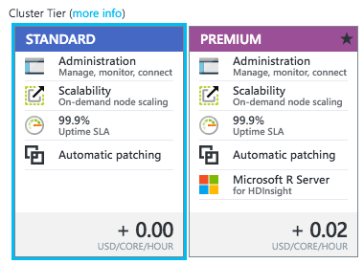
7. Click **Select**.
8. Click **Credentials**.
9. Leave Cluster Login Username as admin, set a Cluster Login Password and Confirmation. Also set an SSH username and password. Leave SSH Authentication Type set to Password.

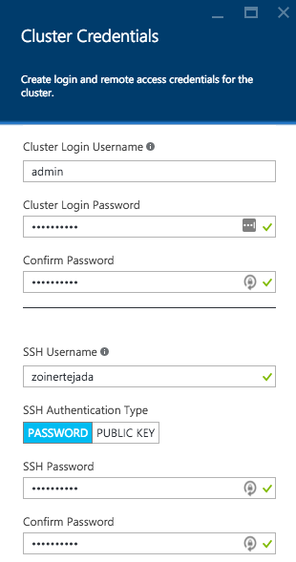

1. Click **Select**.
2. Click **Data Source**.
3. Leave Selection Method at From all subscriptions, then choose or create a new storage account.

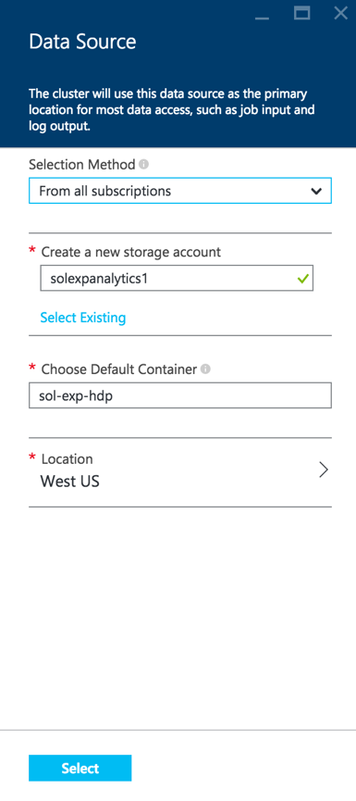

1. Set the Choose Default Container to the name of your cluster.

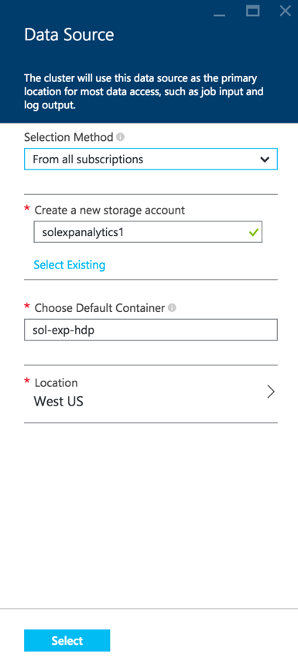

1. Ensure that the location is set to the same as other demo resources.

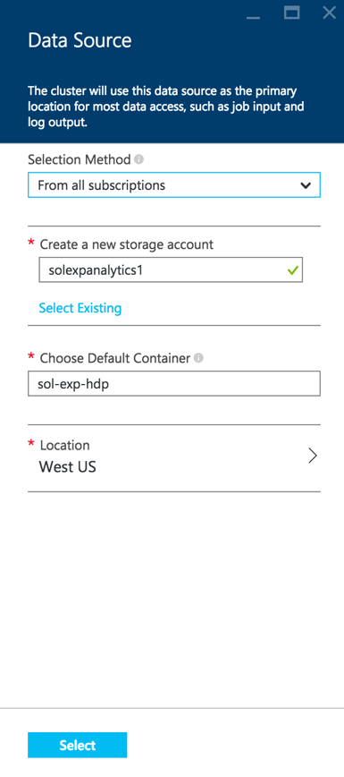

1. Click **Select**.
2. Click **Pricing**.

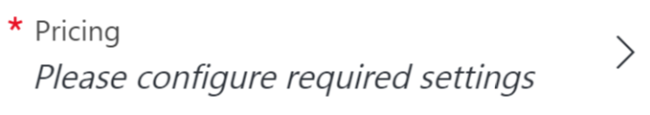

1. Leave the number of Worker Nodes at **4.**
2. Select **Worker node size**, click **D12 v2** and click **Select**.
3. Select **Head node size**, click **D12 v2** and click **Select**.

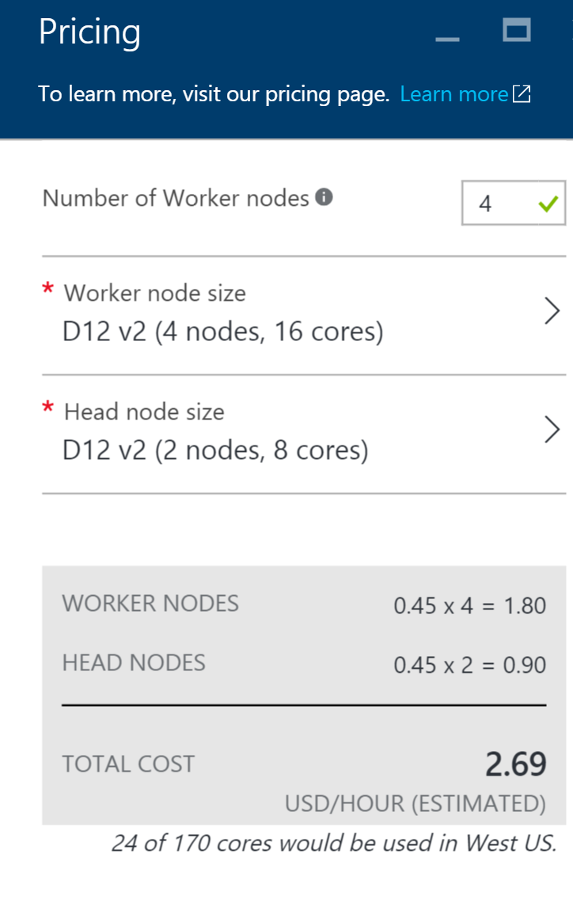

1. Select **Resource Group** and create a new Resource Group called **Hackathon**.  
   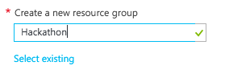
2. On the New HDInsight Cluster blade, click **Create**. Your cluster should be ready within 30 minutes.

## Exercise 1: Environment setup

Duration: 10 minutes

Fabrikam has provided a Smart Meter Simulator that they use to simulate device registration as well as the generation and transmission of telemetry data. They have asked you to use this as the starting point for integrating their smart meters with Azure.

### Task 1: Download and open the Smart Meter Simulator

1. Download the Smart Meter Simulator starter project from the following URL:  
   <http://bit.ly/1KR8TPY>. (Note: the URL is case-sensitive)
2. Unzip the contents.
3. Open SmartMeterSimulator.sln with Visual Studio.

**Note:** If you attempt to build the solution at this point, you will see many build errors. This is intentional. You will correct these in the exercises that follow.

## Exercise 2: IoT Hub provisioning

Duration: 20 minutes

In your architecture design session with Fabrikam, it was agreed that you would use an Azure IoT Hub to manage both the device registration and telemetry ingest from the Smart Meter Simulator. Your team also identified the Microsoft provided Device Explorer project that Fabrikam can use to view the list and status of devices in the IoT Hub registry.

### Task 1: Provision an IoT Hub

### Tasks to complete

* Provision an IoT Hub.
* Determine and take note of the connection strings required for 1) full control and 2) read/write access to the device registry.

### Exit criteria

* You have an IoT Hub provisioned in your Azure subscription.
* You have properly selected the connection strings having appropriate permissions.

### Task 2: Configure the Smart Meter Simulator

### Tasks to complete

* Edit the Fabrikam Smart Meter Simulator so that the IoT connection string text box has a value of your connection string to the IoT Hub having full permissions.

### Exit criteria

* Your connection string should now be present every time you run the Smart Meter Simulator (in subsequent steps).

### Task 3: Download and configure the Device Explorer

### Tasks to complete

* Download the Azure IoT SDK from: <https://github.com/Azure/azure-iot-sdks>.
* Within the download, locate the DeviceExplorer.sln solution and open it within Visual Studio.
* Build and run the DeviceExplorer project.
* Provide your IoT connection string to DeviceExplorer.

### Exit criteria

* Verify that on the **Management** tab you can list the currently registered devices. You should have 0 devices at this point.

## Exercise 3: Completing the Smart Meter Simulator

Duration: 90 minutes

Fabrikam has left you a partially completed sample in the form of the Smart Meter Simulator solution. You will need to complete the missing lines of code that deal with device registration management and device telemetry transmission that communicate with your IoT Hub.

### Task 1: Implement device management with the IoT Hub

### Tasks to complete

* In the solution, open **DeviceManager.cs** and complete the lines of code below each of the TODO comments.

### Exit criteria

* There are 16 TODOs in this file and you should have completed all of them. You can use the Task List to see all of the tasks at a glance. From the **View** menu, click **Task List**. There you will see a list of TODO tasks, where each task represents one line of code that needs to be completed.

### Task 2: Implement the communication of telemetry with the IoT Hub

### Tasks to complete

* In the solution, open **Sensor.cs** and complete the lines of code below each of the TODO comments.

### Exit criteria

* There are four TODOs in this file and you should have completed all of them. You can use the Task List to see all of the tasks at a glance. From the **View** menu, click **Task List**. There you will see a list of TODO tasks, where each task represents one line of code that needs to be completed.

### Task 3: Verify Device Registration and Telemetry

### Tasks to complete

* Build and run the Smart Meter Simulator.
* Register all devices.
* By clicking on 1–10 of the windows within the building in the app, select the devices to install (they should turn yellow) and then activate them (after which they turn green).
* Use Device Explorer to view the list of registered devices. How many of them have been activated in the list? How can you tell?
* Connect the activated devices and observe that they are sending telemetry.

### Exit criteria

* You should have the Smart Meter Simulator running and actively transmitting telemetry.

## Exercise 4: Hot path data processing with Stream Analytics

Duration: 45 minutes

Fabrikam would like to visualize the “hot” data showing the average temperature reported by each device over a 5-minute window in Power BI.

### Task 1: Create a Stream Analytics job for hot path processing to Power BI

### Tasks to complete

* Create an Azure Stream Analytics job that reads the JSON/UTF8 serialized telemetry from your IoT Hub and writes to Power BI.
* Query the input data over a 5-minute tumbling window.

### Exit criteria

* Verify that your Stream Analytics job is receiving and processing telemetry from your Smart Meter Simulator instance.

### Task 2: Visualize hot data with Power BI

### Tasks to complete

* Using Power BI, create a report that contains a Column Chart visualization that on the x-axis has the device IDs and on the y-axis has the maximum value of the average temperature reported.
* Add another Column Chart visualization that plots the minimum value of the average temperature by device.
* Add a Table visualization that lists a table with a device ID and an average of the temperature columns.

### Exit criteria

* You can view the report in Reading View and click one device’s data point to highlight it across all three of the visualizations.

## Exercise 5: Cold path data processing with HDInsight Spark

Duration: 60 minutes

Fabrikam would like to be able to capture all of the “cold” data into scalable storage so that they can summarize it periodically using a Spark SQL query.

### Task 1: Create the Stream Analytics job for cold path processing

### Tasks to complete

* Create an Azure Stream Analytics job that reads from your IoT Hub the JSON/UTF8 serialized telemetry and writes to Azure Storage blobs as CSV files.
* Query the input data so that all data points are written raw to storage without any filtering or summarization.

### Exit criteria

* Verify that your Stream Analytics job is receiving and processing telemetry from your Smart Meter Simulator instance.

### Task 2: Verify CSV files in Blob storage

### Tasks to complete

* Locate the CSV file created in Blob storage.

### Exit criteria

* You have taken note of the container relative path to the CSV file as it appears in Blob storage.

### Task 3: Process with Spark SQL

### Tasks to complete

* Process the data by using a Jupyter notebook on HDInsight Spark to summarize the data by device ID, count of events per device, and the average temperature per device.

### Exit criteria

* You can visualize the results of the query in the Jupyter notebook using a column chart that displays the ID as the x-axis and the average of the averageTemp as the y-axis.

## Exercise 6: Reporting device outages with IoT Hub Operations Monitoring

Duration: 20 minutes

Synopsis: Fabrikam would like to be alerted when devices disconnect, but fail to reconnect after a period. Since they are already using Power BI to visualize hot data, they would like to see a list of any of these devices in a report.

### Task 1: Enable verbose connection monitoring on the IoT Hub

### Tasks to complete

* Enable verbose connection monitoring.

### Exit criteria

* You have enabled connection monitoring via IoT Hub Operations Monitoring, collecting all device connect and disconnect events.

### Task 2: Collect device connection telemetry with the hot path Stream Analytics job

### Tasks to complete

* Update your hot path Stream Analytics job (the first one you created) with a new input that ingests device telemetry from Operations Monitoring.
* Create a query that joins all connected and disconnected events with a DATEDIFF function that only returns devices with a disconnect event, but no reconnect event within 120 seconds.
* Output the events to Power BI.

### Exit criteria

* Verify that your Stream Analytics job is still receiving and processing telemetry from your Smart Meter Simulator instance, and that new events are being captured after the devices have been disconnected for at least 2 minutes.

### Task 3: Test the device outage notifications

### Tasks to complete

* Register and activate a few devices on the Smart Meter Simulator, then connect them.
* Deactivate the devices without reconnecting in order for them to show up in the device outage report we will create in the next task.

### Task 4: Visualize disconnected devices with Power BI

### Tasks to complete

* Create a Table visualization in Power BI, referencing the new device outage dataset created by the Stream Analytics output that was configured in Task 2.

### Exit criteria

* Devices that connected then were disconnected for longer than 120 seconds via the Smart Meter Simulator should be listed in the Table visualization in Power BI. Use the column headings to sort the devices by Device Id or Timestamp.

## Exercise 7: Cleanup

### Tasks to complete

* Delete your HDInsight cluster.
* Delete (or at least stop) both Stream Analytics jobs.
* Delete the IoT Hub.

### Exit criteria

* You have deleted or stopped the major, cost incurring services used in the Hackathon. You may optionally choose to delete the associated storage account, but the costs for this are minimal (and by keeping the storage account, you can re-create your clusters in the future to read from the data sets you have created).

# Internet of Things hackathon answers

## Overview

In this Hackathon, attendees will construct an end-to-end solution for an IoT scenario that includes device management; telemetry ingest; hot and cold path processing; and reporting.

## Requirements

* Microsoft Azure subscription must be pay-as-you-go or MSDN.
  + Trial subscriptions will *not* work.
* Local machine or a virtual machine configured with:
  + Visual Studio 2015 Community Edition or later
  + Azure SDK 2.8.2 for Visual Studio
  + Azure PowerShell 1.0.0 or later
* A running HD Insight Spark cluster (see Exercise 0).

## Exercise 0: Before the Hackathon

Duration: 60 minutes

Synopsis: You should follow all of the steps provided in Exercise 0 of the Proctor Guide (included in this document) *before* attending the Hackathon.

### Task 1: Provision Power BI

1. If you do not already have a Power BI account, go to <https://www.powerbi.com>.
2. On the page, enter your work email address (which should be the same account as the one you use for your Azure subscription) and click **Use it free**.



1. Follow the on-screen prompts and your Power BI environment should be ready within minutes. You can always return to it via <https://app.powerbi.com>.

### Task 2: Provision an HDInsight with Spark Cluster

Using the Azure Portal, provision a new HDInsight cluster.

1. Select **+New**, select **Intelligence + analytics**, **HDInsight**



1. Provide a unique Cluster Name.
2. Select **Subscription**.
3. Choose the Azure Subscription into which you want to deploy the cluster.
4. Select **Cluster Type**.
5. Set the **Cluster Type** to **Spark** and the **Version** to **1.6.2** (or later). Note that the Operating System option for the Spark cluster is fixed to Linux.
6. Select the **Standard** tier.  
   
7. Click **Select**.
8. Click **Credentials**.
9. Leave Cluster Login Username as admin, set a Cluster Login Password and Confirmation. Also, set an SSH username and password. Leave SSH Authentication Type set to Password.



1. Click **Select**.
2. Click **Data Source**.
3. Leave Selection Method at From all subscriptions, then choose or create a new storage account.



1. Set the Choose Default Container to the name of your cluster.



1. Ensure that the location is set to the same as other demo resources.



1. Click **Select**.
2. Click **Pricing**.



1. Leave the number of Worker Nodes at **4.**
2. Select **Worker node size**, click **D12 v2** and click **Select**.
3. Select **Head node size**, click **D12 v2** and click **Select**.



1. Select **Resource Group** and create a new Resource Group called **Hackathon**.  
   
2. On the New HDInsight Cluster blade, click **Create**. Your cluster should be ready within 30 minutes.

## Exercise 1: Environment setup

Duration: 10 minutes

Synopsis: Fabrikam has provided a Smart Meter Simulator that they use to simulate device registration as well as the generation and transmission of telemetry data. They have asked you to use this as the starting point for integrating their smart meters with Azure.

### Task 1: Download and open the Smart Meter Simulator project

1. Download the Smart Meter Simulator starter project from the following URL:  
   <http://bit.ly/1KR8TPY>. (Note: the URL is case-sensitive)
2. Unzip the contents.
3. Open SmartMeterSimulator.sln with Visual Studio.

**Note:** If you attempt to build the solution at this point, you will see many build errors. This is intentional. You will correct these in the exercises that follow.

## Exercise 2: IoT Hub provisioning

Duration: 20 minutes

Synopsis: In your architecture design session with Fabrikam, it was agreed that you would use an Azure IoT Hub to manage both the device registration and telemetry ingest from the Smart Meter Simulator. Your team also identified the Microsoft provided Device Explorer project that Fabrikam can use to view the list and status of devices in the IoT Hub registry.

### Task 1: Provision an IoT Hub

1. In your browser, navigate to the **Azure Portal** (<https://portal.azure.com)>.
2. Click **+New** in the navigation bar at the left.

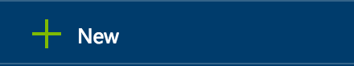

1. Within the **New** blade, click **Internet of Things**.

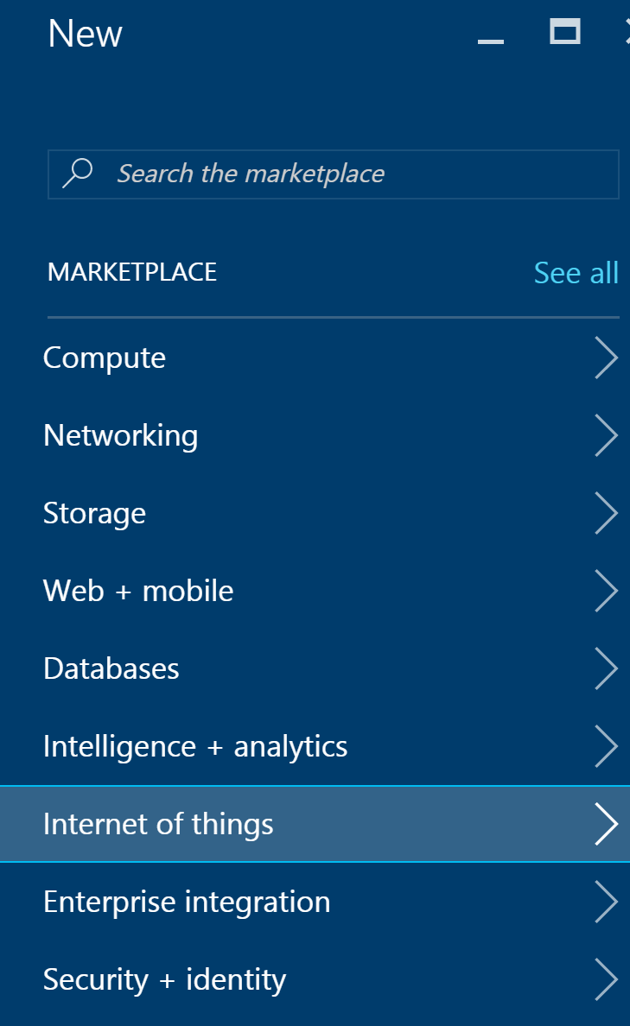

1. On the **Internet of Things** blade, click **IoT Hub**.

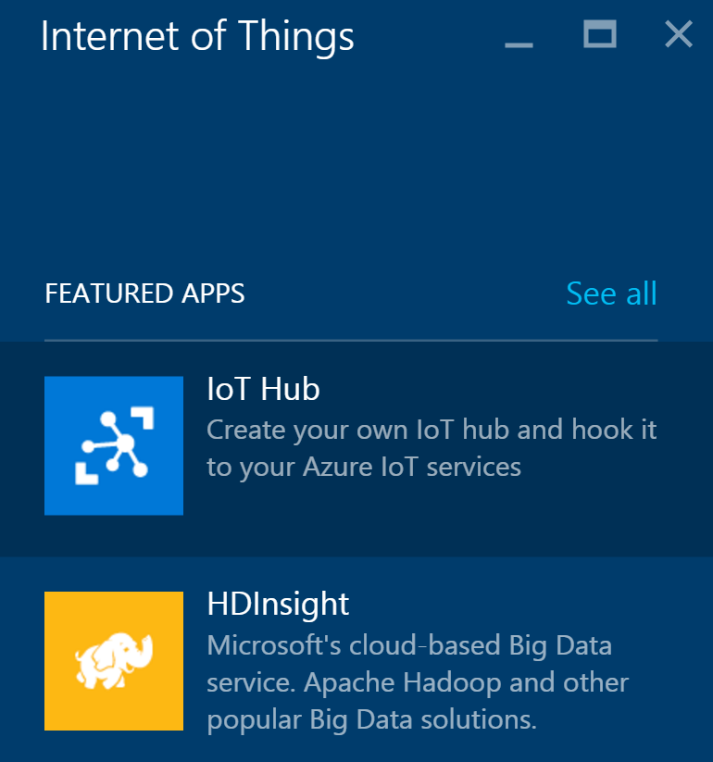

1. In the **IoT Hub** blade, provide a name for your new IoT Hub, choose a **Pricing and scale tier** (**S1** or **Free** is appropriate), set the **IoT Hub units** to **1**, choose the **Resource group** you created earlier, and choose the **Location**.

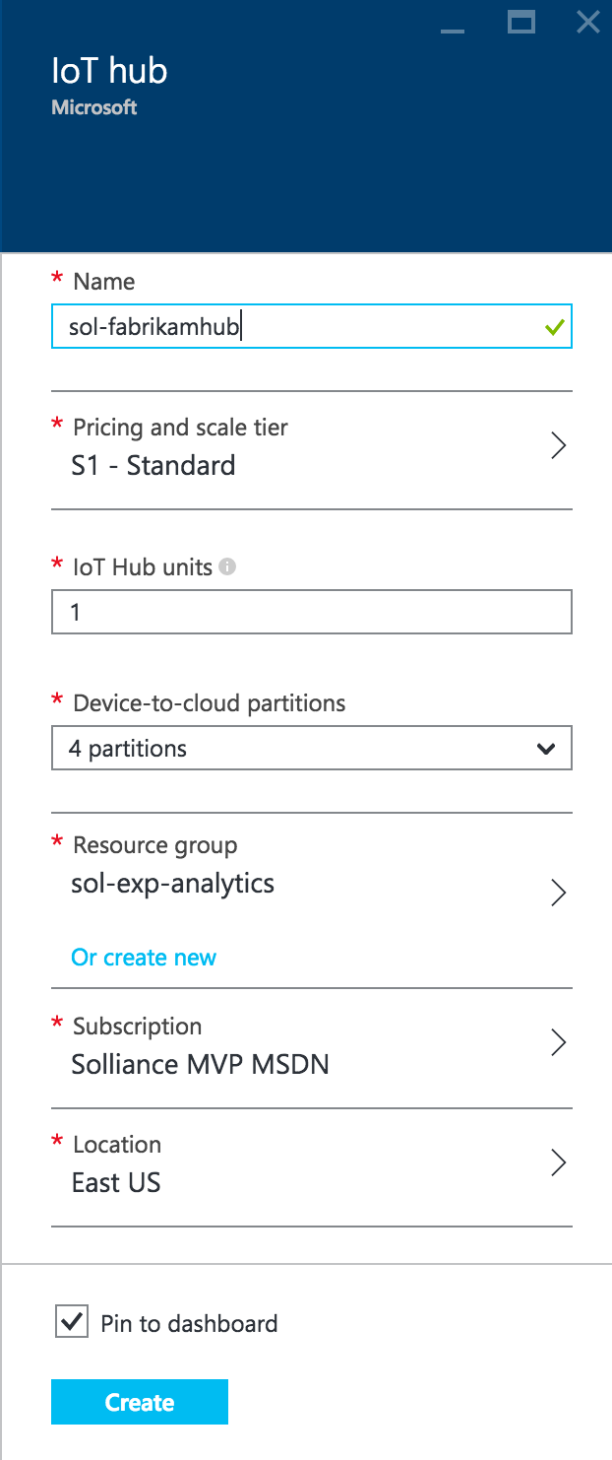

1. Click **Create**.
2. In the **Settings** blade that appears for your new IoT Hub, click **Shared access policies**.

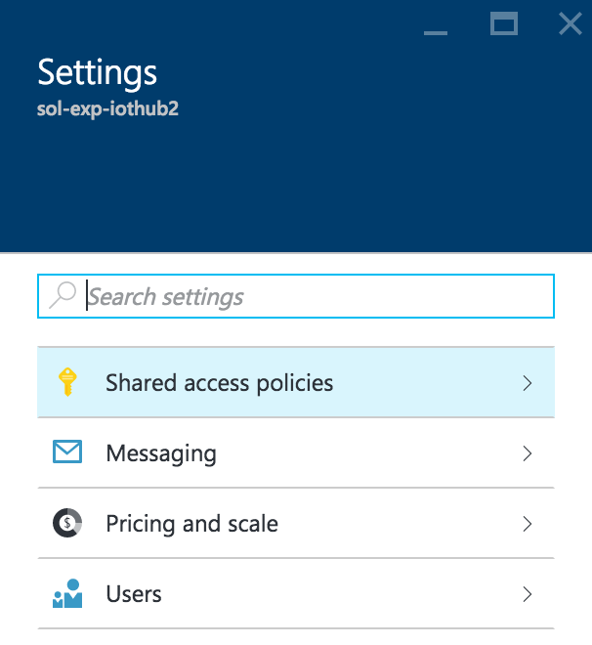

1. Click **iothubowner** policy.

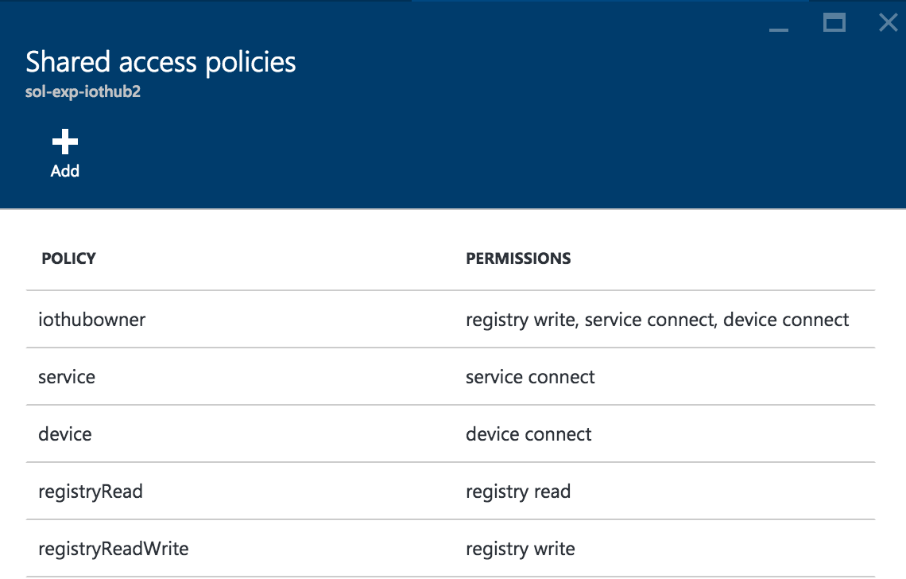

1. In the blade that appears, click the **Copy** button to the right of the Connection string—primary key located under the **Shared access keys** section.

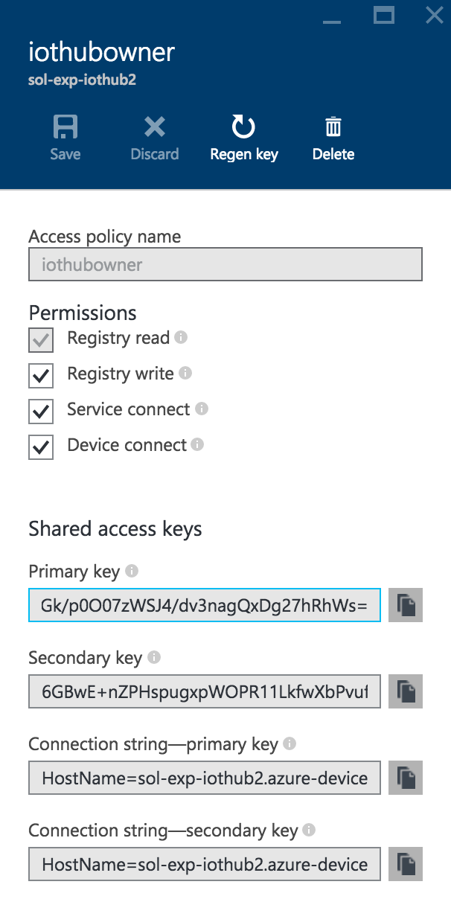

### Task 2: Configure the Smart Meter Simulator

If you want to save this connection string with your project (in case you stop debugging or otherwise close the simulator), you can set this as the default text for the text box. Follow these steps to configure the connection string:

1. Open the Smart Meter Simulator project in Visual Studio.
2. In **Solution Explorer**, double-click **MainForm.cs**.
3. In the **Windows Forms** designer surface, click the **text box** to select it.

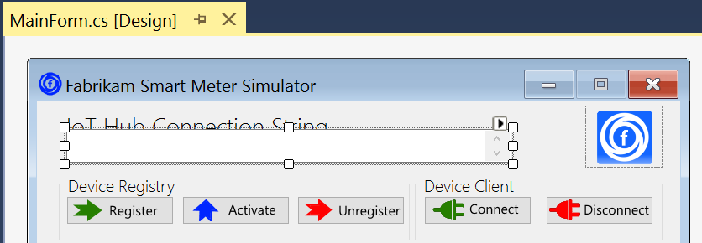

1. In the **Properties** panel, scroll until you are viewing the **Appearance** group and see the **Text** property. For the value of the **Text** property, paste your **IoT Hub connection string**.

Your connection string should now be present every time you run the Smart Meter Simulator.

### Task 3: Download and configure the Device Explorer

The Device Explorer is a sample project provided by Microsoft that enables you to see the list of devices provisioned within the IoT Hub registry.

1. Open your browser and navigate to:  
   <https://github.com/Azure/azure-iot-sdks>.
2. On the far right, click **Clone or download** and then **Download Zip**.

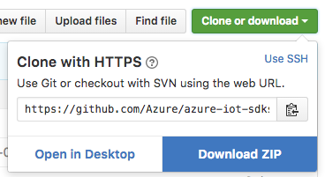

1. Extract the zip file, navigate to Tools\DeviceExplorer, and open **DeviceExplorer.sln**.
2. Build the **Solution**.
3. Press **Ctrl+F5** to run the solution without debugging (or click on Start Without Debugging from the Debug menu).
4. Device Explorer will appear as follows:

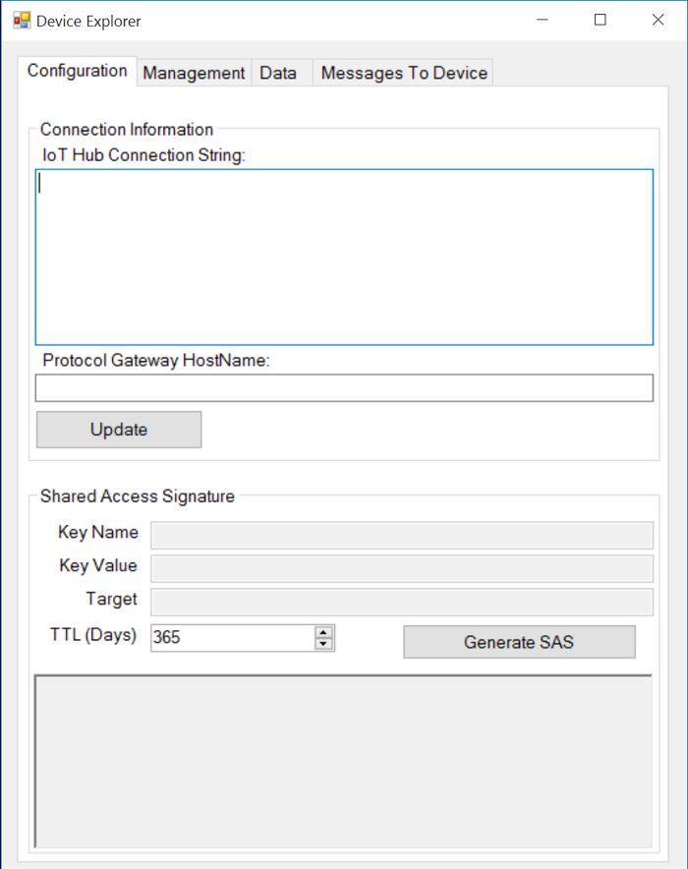

1. To get to the IoT Hub connection string to use, you could reuse the same connection string for the iothubowner policy you used for the Smart Meter Simulator; however, since we are only interested in querying the device registry, we can use the more specific registryRead.
2. From your **IoT Hub’s** blade, click **Settings**. In the **Settings** blade that appears, click **Shared access policies**.



1. Click the **registryRead** policy.



1. In the blade that appears, click the **Copy** button to the right of the Connection string—primary key located under the **Shared access keys** section.

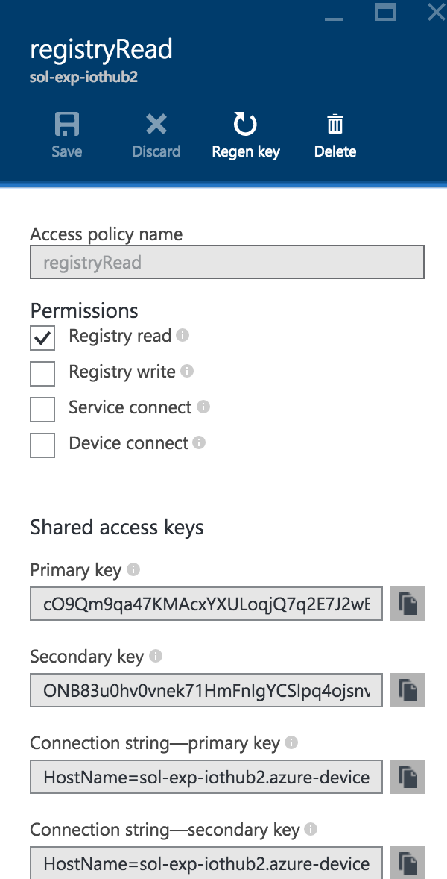

1. Return to **Device Explorer** and paste this value into the **IoT Hub Connection String**.
2. Click **Update**.

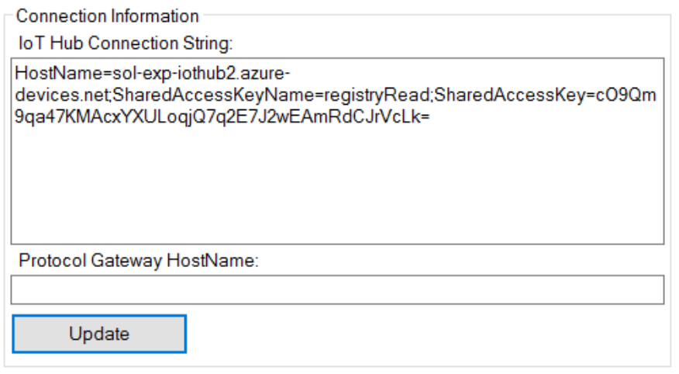

1. Click **OK** on the confirmation prompt.

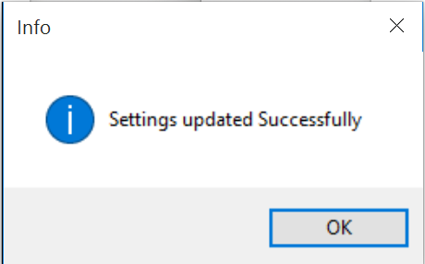

1. To confirm that you can query the registry, click the **Management** tab and then click **List**.

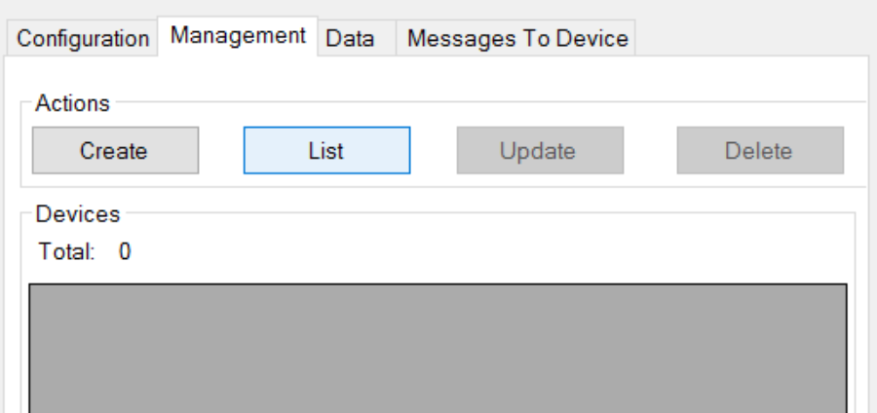

1. The grid under **Devices** should change to have headers as follows, and list any devices (which at this point should be 0).

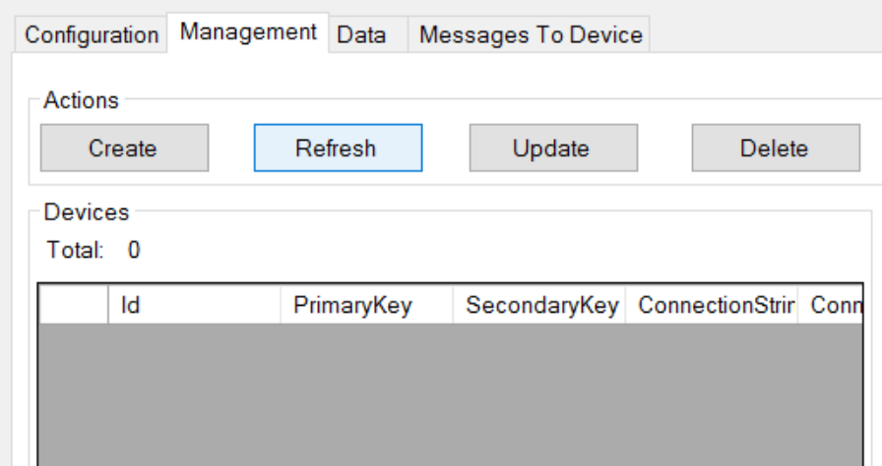

## Exercise 3: Completing the Smart Meter Simulator

Duration: 90 minutes

Synopsis: Fabrikam has left you a partially completed sample in the form of the Smart Meter Simulator solution. You will need to complete the missing lines of code that deal with device registration management and device telemetry transmission that communicate with your IoT Hub.

### Task 1: Implement device management with the IoT Hub

1. With the Smart Meter Simulator solution open in Visual Studio, use Solution Explorer to open the file **DeviceManager.cs**.
2. From the **View** menu, click **Task List**. There you will see a list of TODO tasks, where each task represents one line of code that needs to be completed. Copy the code in bold below the corresponding TODO item in the completed code that follows.
3. The following code represents the completed tasks in DeviceManager.cs:

class DeviceManager

{

static string connectionString;

static RegistryManager registryManager;

public static string HostName { get; set; }

public static void IotHubConnect(string cnString)

{

connectionString = cnString;

**//TODO: 1.Create an instance of RegistryManager from connectionString**

**registryManager = RegistryManager.CreateFromConnectionString(connectionString);**

var builder = IotHubConnectionStringBuilder.Create(cnString);

HostName = builder.HostName;

}

/// <summary>

/// Register a single device with the IoT hub. The device is initially registered in a

/// disabled state.

/// </summary>

/// <param name="connectionString"></param>

/// <param name="deviceId"></param>

/// <returns></returns>

public async static Task<string> RegisterDevicesAsync(string connectionString, string deviceId)

{

//Make sure we're connected

if (registryManager == null)

IotHubConnect(connectionString);

**//TODO: 2.Create new device**

**Device device = new Device(deviceId);**

**//TODO: 3.Initialize device with a status of Disabled**

**//Enabled in a subsequent step**

**device.Status = DeviceStatus.Disabled;**

try

{

**//TODO: 4.Register the new device**

**device = await registryManager.AddDeviceAsync(device);**

}

catch (Exception ex)

{

if (ex is DeviceAlreadyExistsException ||

ex.Message.Contains("DeviceAlreadyExists"))

{

**//TODO: 5.Device already exists, get the registered device**

**device = await registryManager.GetDeviceAsync(deviceId);**

**//TODO: 6.Ensure the device is disabled until Activated later**

**device.Status = DeviceStatus.Disabled;**

**//TODO: 7.Update IoT Hubs with the device status change**

**await registryManager.UpdateDeviceAsync(device);**

}

else

{

MessageBox.Show($"An error occurred while registering one or more devices:\r\n{ex.Message}");

}

}

//return the device key

return device.Authentication.SymmetricKey.PrimaryKey;

}

/// <summary>

/// Activate an already registered device by changing its status to Enabled.

/// </summary>

/// <param name="connectionString"></param>

/// <param name="deviceId"></param>

/// <param name="deviceKey"></param>

/// <returns></returns>

public async static Task<bool> ActivateDeviceAsync(string connectionString, string deviceId, string deviceKey)

{

//Server-side management function to enable the provisioned device

//to connect to IoT Hub after it has been installed locally.

//If device id device key are valid, Activate (enable) the device.

//Make sure we're connected

if (registryManager == null)

IotHubConnect(connectionString);

bool success = false;

Device device;

try

{

**//TODO: 8.Fetch the device**

**device = await registryManager.GetDeviceAsync(deviceId);**

**//TODO: 9.Verify the device keys match**

**if (deviceKey ==** **device.Authentication.SymmetricKey.PrimaryKey)**

{

**//TODO: 10.Enable the device**

**device.Status = DeviceStatus.Enabled;**

**//TODO: 11.Update IoT Hubs**

**await registryManager.UpdateDeviceAsync(device);**

success = true;

}

}

catch(Exception)

{

success = false;

}

return success;

}

/// <summary>

/// Deactivate a single device in the IoT Hub registry.

/// </summary>

/// <param name="connectionString"></param>

/// <param name="deviceId"></param>

/// <returns></returns>

public async static Task<bool> DeactivateDeviceAsync(string connectionString, string deviceId)

{

//Make sure we're connected

if (registryManager == null)

IotHubConnect(connectionString);

bool success = false;

Device device;

try

{

**//TODO: 12.Lookup the device from the registry by deviceId**

**device = await registryManager.GetDeviceAsync(deviceId);**

**//TODO: 13.Disable the device**

**device.Status = DeviceStatus.Disabled;**

**//TODO: 14.Update the registry**

**await registryManager.UpdateDeviceAsync(device);**

success = true;

}

catch (Exception)

{

success = false;

}

return success;

}

/// <summary>

/// Unregister a single device from the IoT Hub Registry

/// </summary>

/// <param name="connectionString"></param>

/// <param name="deviceId"></param>

/// <returns></returns>

public async static Task UnregisterDevicesAsync(string connectionString, string deviceId)

{

//Make sure we're connected

if (registryManager == null)

IotHubConnect(connectionString);

**//TODO: 15.Remove the device from the Registry**

**await registryManager.RemoveDeviceAsync(deviceId);**

}

/// <summary>

/// Unregister all the devices managed by the Smart Meter Simulator

/// </summary>

/// <param name="connectionString"></param>

/// <returns></returns>

public async static Task UnregisterAllDevicesAsync(string connectionString)

{

//Make sure we're connected

if (registryManager == null)

IotHubConnect(connectionString);

for(int i = 0; i <= 9; i++)

{

string deviceId = "Device" + i.ToString();

**//TODO: 16.Remove the device from the Registry**

**await registryManager.RemoveDeviceAsync(deviceId);**

}

}

}

### Task 2: Implement the communication of telemetry with the IoT Hub

1. Open **Sensor.cs** and complete the TODO items indicated within the code that are responsible for transmitting telemetry data to the IoT Hub.
2. The following code shows the completed result:

class Sensor

{

private DeviceClient _DeviceClient;

private string _IotHubUri { get; set; }

public string DeviceId { get; set; }

public string DeviceKey { get; set; }

public DeviceState State { get; set; }

public string StatusWindow { get; set; }

public double CurrentTemperature

{

get

{

double avgTemperature = 70;

Random rand = new Random();

double currentTemperature = avgTemperature + rand.Next(-6, 6);

if(currentTemperature <= 68)

TemperatureIndicator = SensorState.Cold;

else if(currentTemperature > 68 && currentTemperature < 72)

TemperatureIndicator = SensorState.Normal;

else if(currentTemperature >= 72)

TemperatureIndicator = SensorState.Hot;

return currentTemperature;

}

}

public SensorState TemperatureIndicator { get; set; }

public Sensor(string iotHubUri, string deviceId, string deviceKey)

{

_IotHubUri = iotHubUri;

DeviceId = deviceId;

DeviceKey = deviceKey;

State = DeviceState.Registered;

}

public void InstallDevice(string statusWindow)

{

StatusWindow = statusWindow;

State = DeviceState.Installed;

}

/// <summary>

/// Connect a device to the IoT Hub by instantiating a DeviceClient for that Device by Id and Key.

/// </summary>

public void ConnectDevice()

{

**//TODO: 17. Connect the Device to Iot Hub by creating an instance of DeviceClient**

**_DeviceClient = DeviceClient.Create(_IotHubUri, new DeviceAuthenticationWithRegistrySymmetricKey(DeviceId, DeviceKey));**

//Set the Device State to Ready

State = DeviceState.Ready;

}

public void DisconnectDevice()

{

//Delete the local device client

_DeviceClient = null;

//Set the Device State to Activate

State = DeviceState.Activated;

}

/// <summary>

/// Send a message to the IoT Hub from the Smart Meter device

/// </summary>

public async void SendMessageAsync()

{

var telemetryDataPoint = new

{

id = DeviceId,

time = DateTime.UtcNow.ToString("o"),

temp = CurrentTemperature

};

**//TODO: 18.Serialize the telemetryDataPoint to JSON**

**var messageString = JsonConvert.SerializeObject(telemetryDataPoint);**

**//TODO: 19.Encode the JSON string to ASCII as bytes and create new Message with the bytes**

**var message = new Message(Encoding.ASCII.GetBytes(messageString));**

**//TODO: 20.Send the message to the IoT Hub**

**var sendEventAsync = _DeviceClient?.SendEventAsync(message);**

**if (sendEventAsync != null) await sendEventAsync;**

}

}

### Task 3: Verify device registration and telemetry

1. Return to your running instance of **Device Explorer**, click the **Management** tab, and then click **Refresh**. Confirm that you have 0 devices listed.



1. Next, run the **Smart Meter Simulator**.

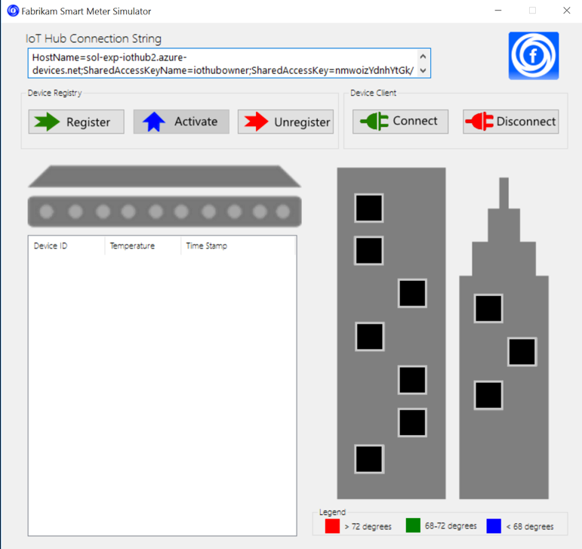

1. Click **Register**. The windows within the building should turn from black to gray.

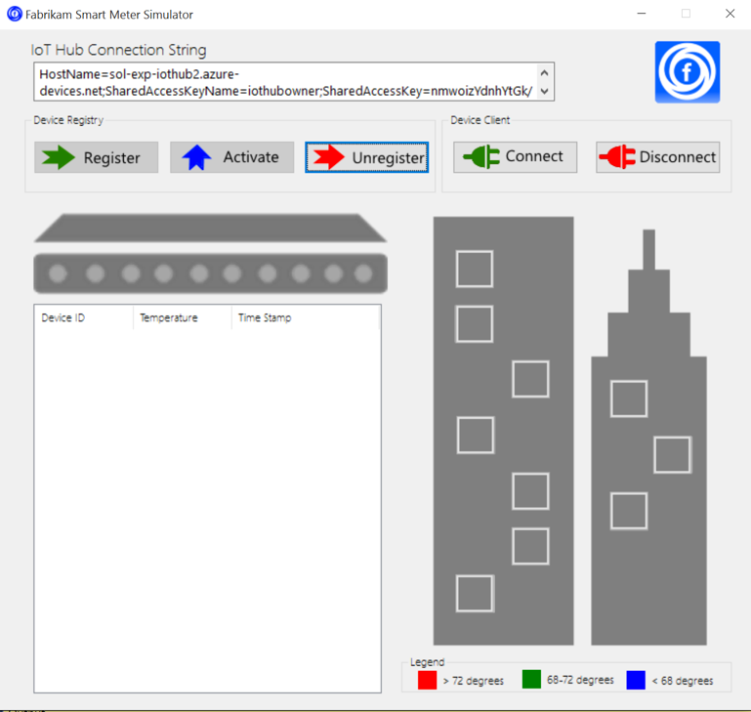

1. Click the windows. Each represents a device for which you want to simulate device installation. The selected windows should turn yellow.

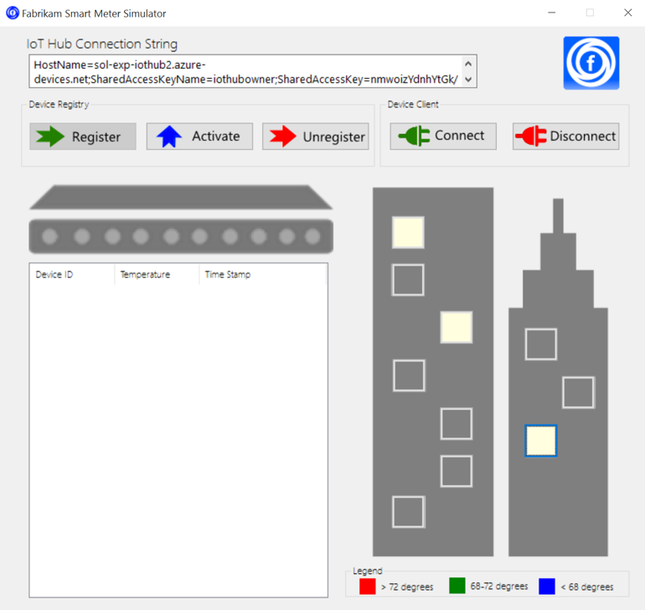

1. Click **Activate** to simulate changing the device status from disabled to enabled in the Iot Hub Registry. The selected windows should turn green.

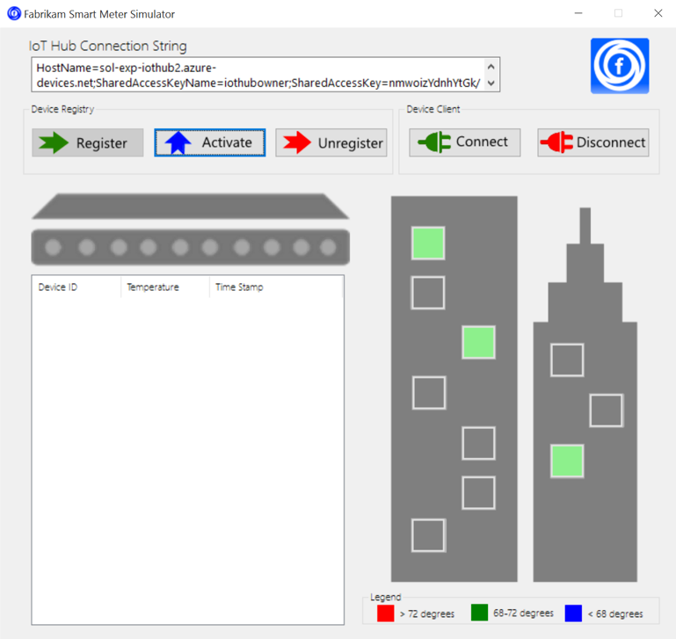

1. At this point, you have registered 10 devices (the gray windows) but activated only the ones you selected (in green). To view this list of devices, switch over to **Device Explorer**.
2. On the **Management** tab, click **Refresh**.
3. This time you should see all 10 devices listed.

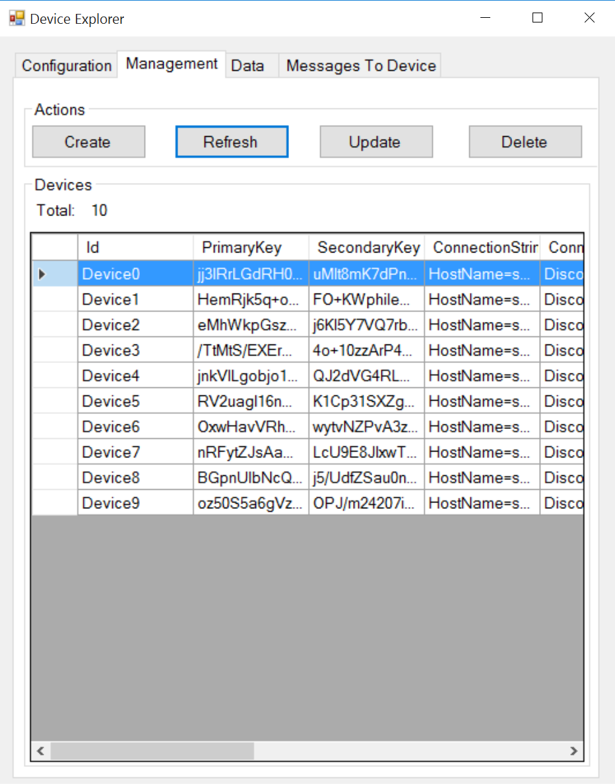

1. If you scroll the **Devices grid** to the right, you should see a **State** column. The devices that you activated will have a **State** value of **Enabled**. Those that you did not, will have a **State** value of **Disabled**.

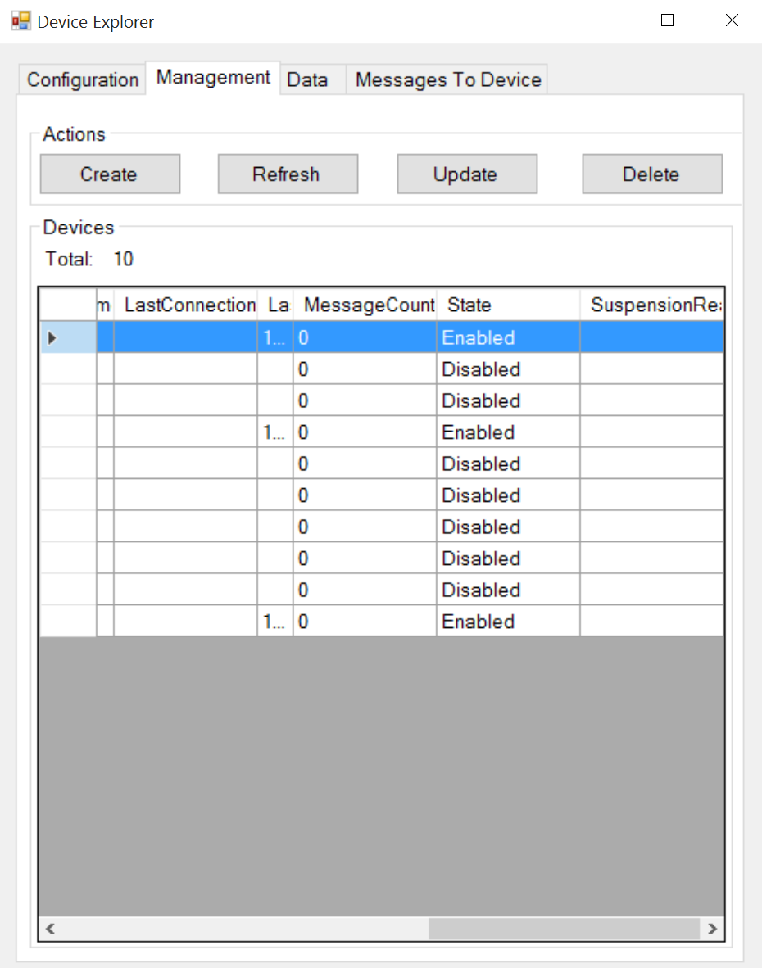

1. Return to the **Smart Meter Simulator**.
2. Click **Connect**. Within a few moments, you should begin to see activity as the windows change color indicating the smart meters are transmitting telemetry. The grid on the left will list each telemetry message transmitted and the simulated temperature value.

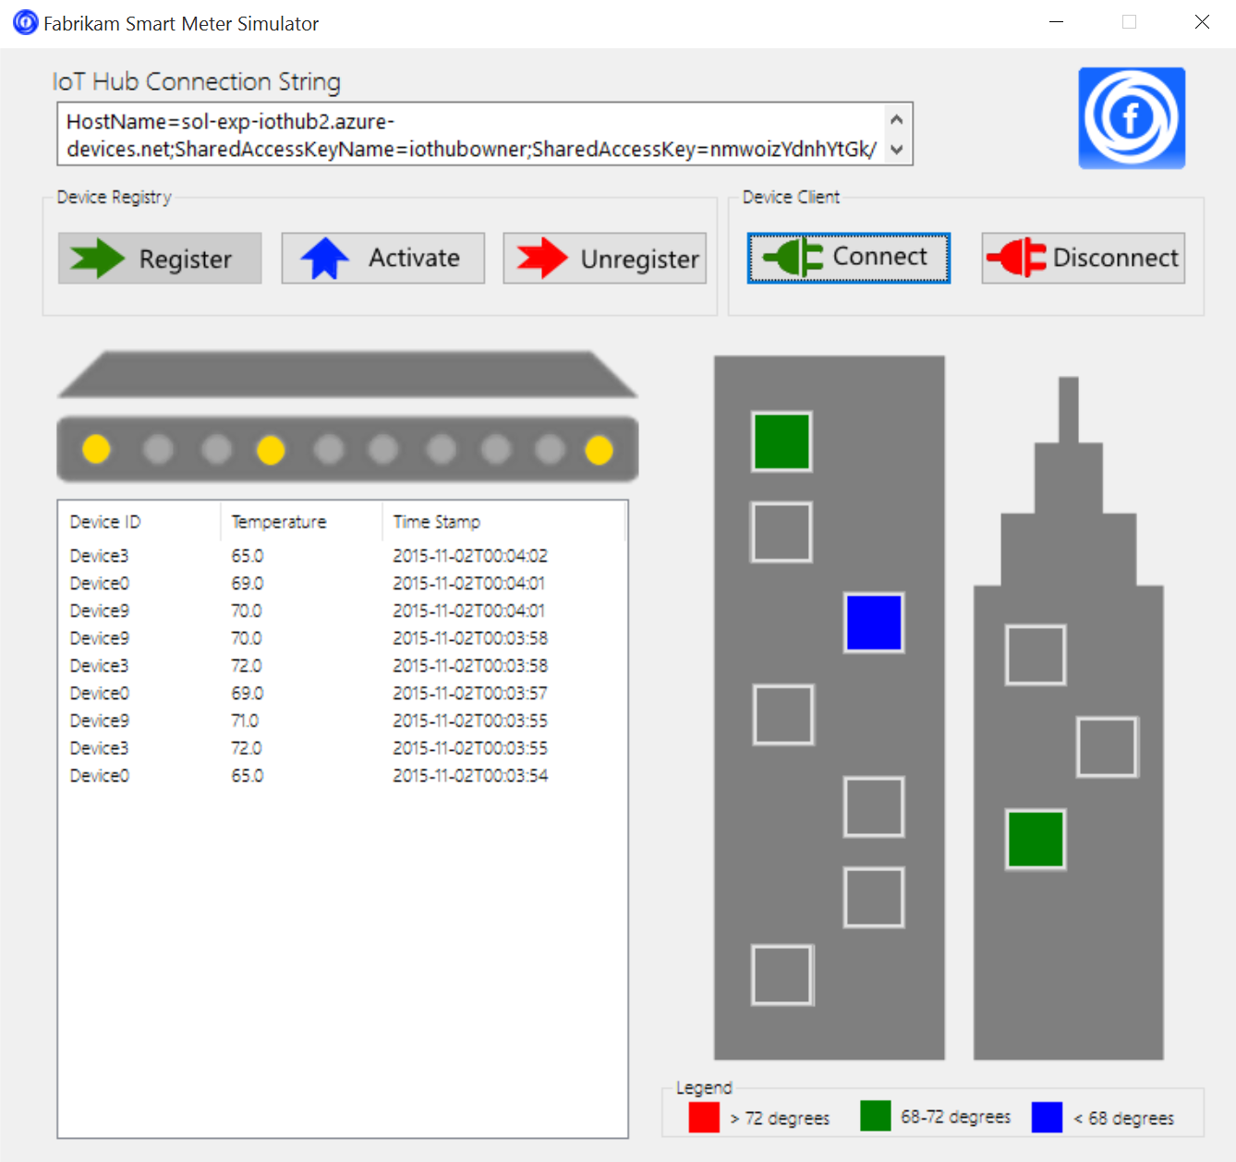

1. Allow the smart meter to continue to run. (Whenever you want to stop the transmission of telemetry, click the **Disconnect** button.)

## Exercise 4: Hot path data processing with Stream Analytics

Duration: 45 minutes

Synopsis: Fabrikam would like to visualize the “hot” data showing the average temperature reported by each device over a 5-minute window in Power BI.

### Task 1: Create a Stream Analytics job for hot path processing to Power BI

1. In your browser, navigate to the **Azure Portal** (<https://portal.azure.com>).
2. Click **+New** in the navigation bar at the left.  
   
3. Click **Internet of things**, then **Stream Analytics job**.  
   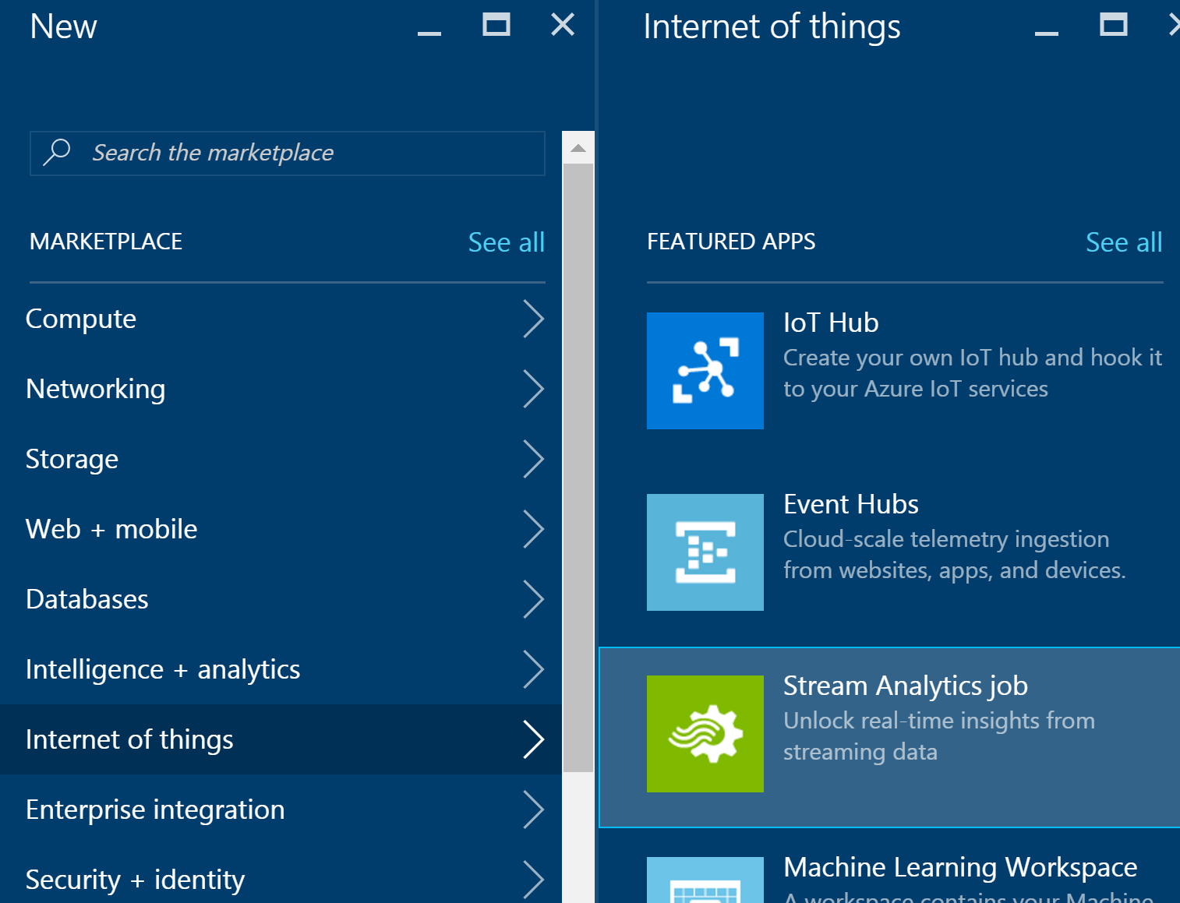
4. Provide the following:
   1. Job Name: <name>
   2. Subscription: <your subscription>
   3. Resource Group: <same group as other resources>
   4. Location: <same region as other resources>

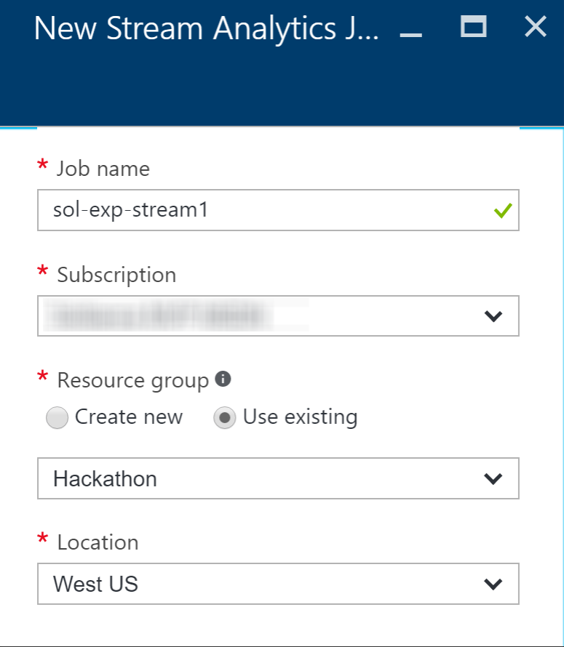

1. Click **Create**.

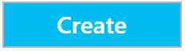

1. Once provisioned, go to **Inputs** for your Stream Analytics job and add an input connected to your IoT Hub.
   1. Click on **Inputs** under JOB TOPOLOGY, or click the Inputs box on the Overview blade.  
      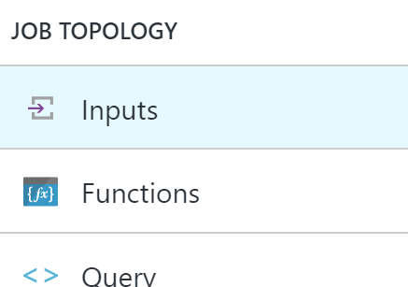
   2. On the **Inputs** blade, click **Add** in the **command bar** at the top.



* 1. Configure the **IoT Hub settings** as follows:
     1. Input Alias: temps.
     2. Source Type: Data stream
     3. Subscription: Use IoT hub from current subscription
     4. IoT Hub: Select your existing IoT Hub
     5. Endpoint: Messaging
     6. Shared Access Policy Name: Set to Service
     7. Consumer Group: Leave as $Default
     8. Event serialization format: JSON
     9. Encoding: UTF-8  
        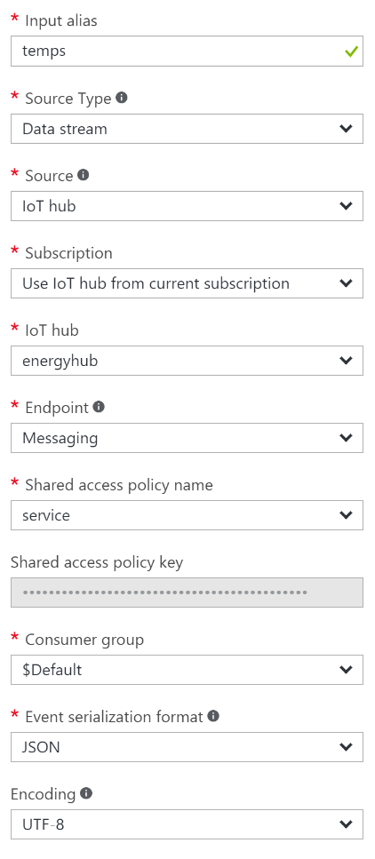
  2. Click **create**.

1. Go to the **Outputs** blade and add the output destination for the query.
   1. Click on **Outputs** under JOB TOPOLOGY.  
      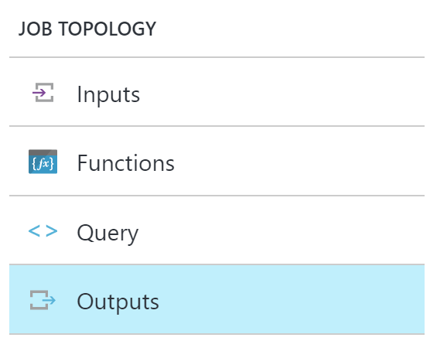
   2. On the **Outputs** blade, click **Add** in the **command bar** at the top.



* 1. Set the **Output alias** to **powerbi**.
  2. Select **Power BI** under **Sink**.
  3. Click on **Authorize** underneath Authorize Connection.

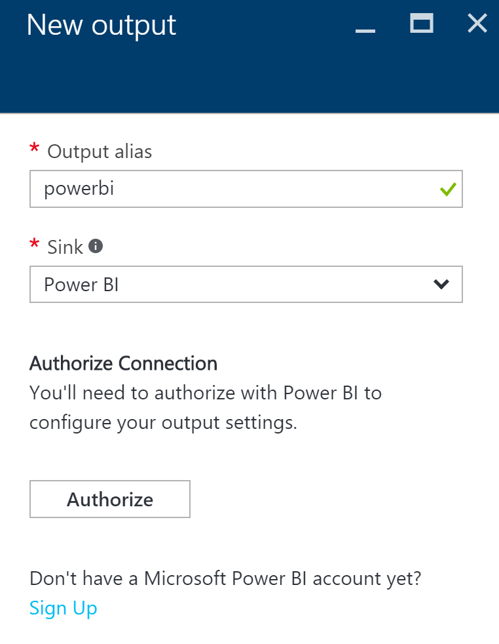

* 1. Follow the on screen prompts to log on to your Power BI account. Make sure you select **Work or school account**, since Power BI only supports organizational accounts at this time.

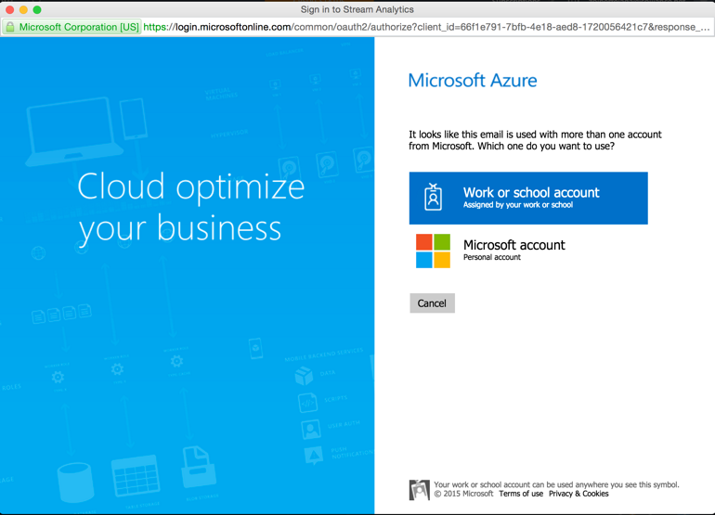

* 1. After authenticating, you will be taken back to the **New output** form, which will display Group Workspace: leave at My Workspace three new fields to fill out:
     1. Dataset Name: avgtemps
     2. Table Name: avgtemps
     3. Click on **Create**.  
        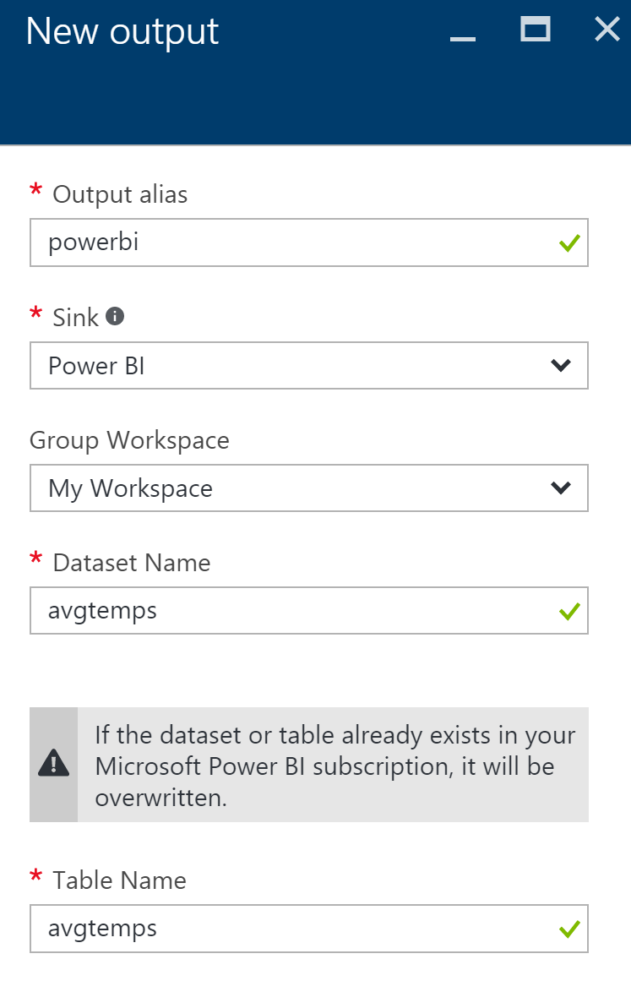

1. Go to the **Query** blade by clicking on Query under JOB TOPOLOGY.  
   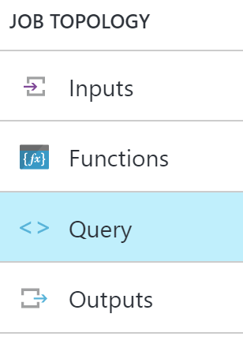
2. Paste the following query, and click **Save** in the **command bar** at the top. (Be sure to substitute in your output alias and input alias):

SELECT AVG(temp) AS Average, id

INTO powerbi

FROM temps

GROUP BY TumblingWindow(minute, 5), id

1. Go to the **Overview** blade on your **Stream Analytics job**, click **Start** in the **command bar** to begin the job.
   1. Leave the **Job output start time** setting at **Now** and click **Start**.

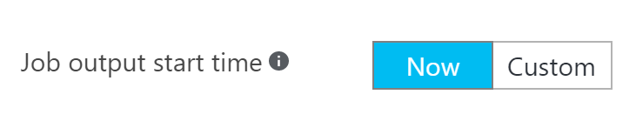

1. Verify that you are showing a non-zero amount of **Input Events** on the **Monitoring** chart on the overview page. You may need to reconnect your devices on the Smart Meter Simulator and let it run for a while to see the events.

### Task 2: Visualize hot data with Power BI

1. Log on to **Power BI** to see if data is being collected.
2. A new dataset should appear. (It is starred to indicate it is new)

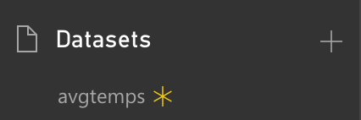

1. Click the new dataset to go the **report designer**.
2. Add a **Column Chart visualization**.

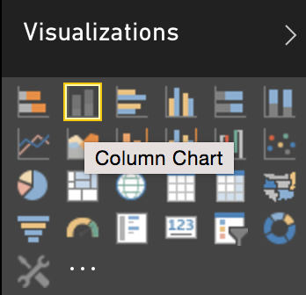

1. Set the **axis** to **id** and the value to Max of average. To do this, drag the **id** field to Axis, then the **average** field to Value. Click the down arrow next to **average**, and select **Maximum**.

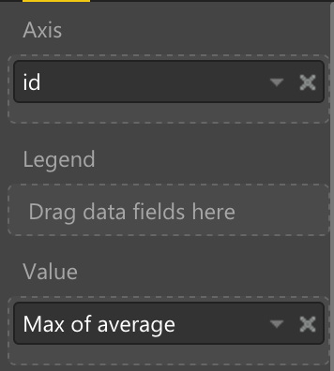

1. Repeat steps 4 and 5, this time adding a **Column Chart** for **Min of average**.

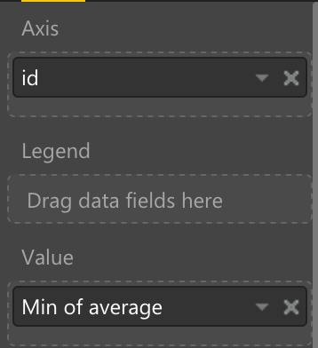

1. Add a **table visualization**.

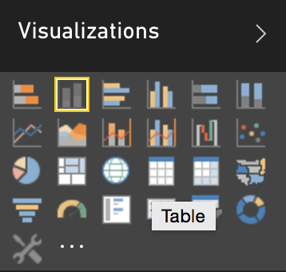

1. Set the values to **id** and **Average of average**.

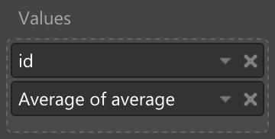

1. Save the report.

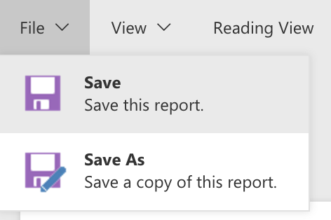

1. Switch to **Reading View**.

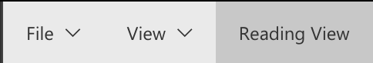

1. Within the report, click one of the columns to see the data for just that device.

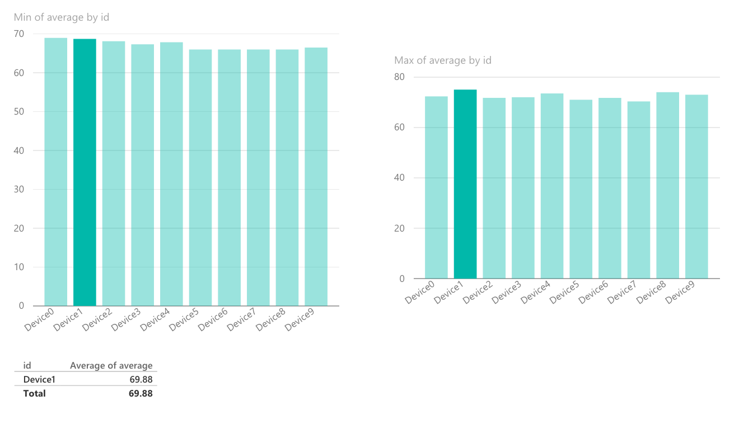

## Exercise 5: Cold path data processing with HDInsight Spark

Duration: 60 minutes

Synopsis: Fabrikam would like to be able to capture all of the “cold” data into scalable storage so that they can summarize it periodically using a Spark SQL query.

### Task 1: Create the Stream Analytics job for cold path processing

In order to capture all metrics for the cold path, set up another Stream Analytics job that will write all events to Blob storage for analyses by Spark running on HDInsight.

1. In your browser, navigate to the **Azure Portal** (<https://portal.azure.com>).
2. Click **+New** in the navigation bar at the left.  
   
3. Click **Internet of things**, then **Stream Analytics job**.  
   
4. Provide the following:
   1. Job Name: <name>
   2. Subscription: <your subscription>
   3. Resource Group: <same group as other resources>
   4. Location: <same region as other resources>

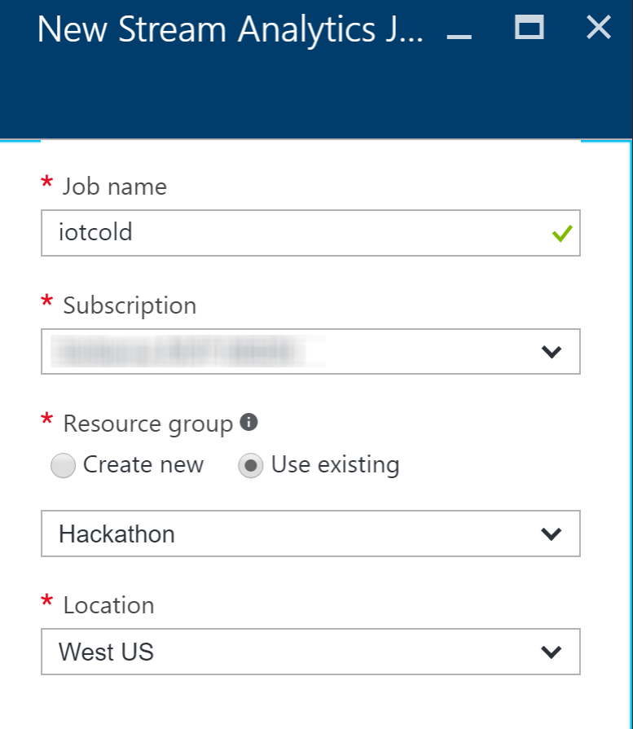

1. Click **Create**.



1. Once provisioned, go to **Inputs** for your Stream Analytics job and add an input connected to your IoT Hub.
   1. Click on **Inputs** under JOB TOPOLOGY, or click the Inputs box on the Overview blade.  
      
   2. On the **Inputs** blade, click **Add** in the **command bar** at the top.



* 1. Configure the **IoT Hub settings** as follows:
     1. Input Alias: iothub
     2. Source Type: Data stream
     3. Subscription: Use IoT hub from current subscription
     4. IoT Hub: Select your existing IoT Hub
     5. Endpoint: Messaging
     6. Shared Access Policy Name: Set to Service
     7. Consumer Group: Leave as $Default
     8. Event serialization format: JSON
     9. Encoding: UTF-8  
        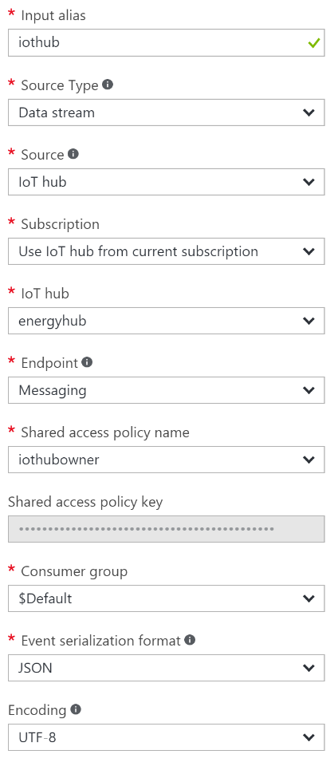
  2. Click **create**.

1. Go to the **Outputs** blade and add the output destination for the query.
   1. Click on **Outputs** under JOB TOPOLOGY.  
      
   2. On the **Outputs** blade, click **Add** in the **command bar** at the top.



* 1. On the **New output** blade, provide the following:
     1. Output Alias: blobs
     2. Sink: Blob storage
     3. Subscription: <choose Use Storage Account from Current Subscription>
     4. Storage Account: <enter the storage account name you used for HDInsight>
     5. Container: <select the existing container, which should be the same one as used for your HDInsight cluster>
     6. Path Prefix Pattern: smartmeters/{date}/{time}
     7. Date Format: YYYY/MM/DD
     8. Time Format: HH
     9. Event Serialization Format: <select CSV>
     10. Delimiter: <select comma (,)>
     11. Encoding: <select UTF-8>
  2. Click **Create**.

1. Go to the **Query** blade by clicking on Query under JOB TOPOLOGY.  
   
2. Paste the following query, and click **Save** in the **command bar** at the top. (Be sure to substitute in your output alias and input alias):  
     
   SELECT

*

INTO

blobs

FROM  
 iothub

1. Go to the **Overview** blade on your **Stream Analytics job**, click **Start** in the **command bar** to begin the job.
   1. Leave the **Job output start time** setting at **Now** and click **Start**.



1. Verify that you are showing a non-zero amount of **Input Events** on the **Monitoring** chart on the overview page.

### Task 2: Verify CSV files in Blob storage

1. Open **Visual Studio**. From the **View** menu, select **Server Explorer**.

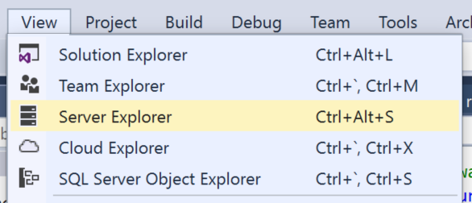

1. In **Server Explorer**, click **Connect to Microsoft Azure Subscription**.

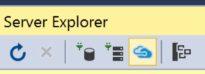

1. When prompted to sign in to Visual Studio, enter your **login** and click **Continue**.

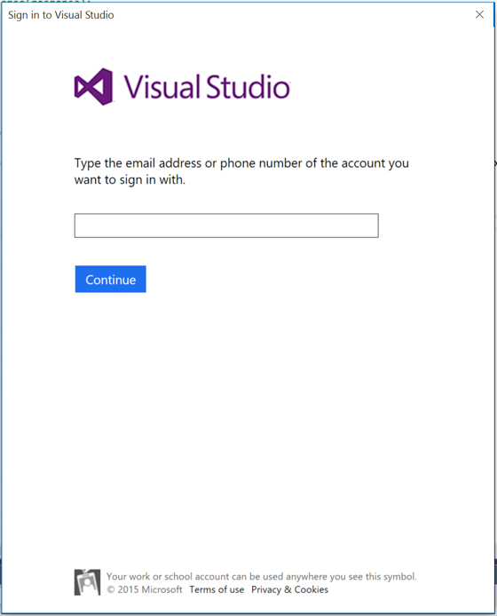

1. Choose the appropriate option for your work or school account or Microsoft account.

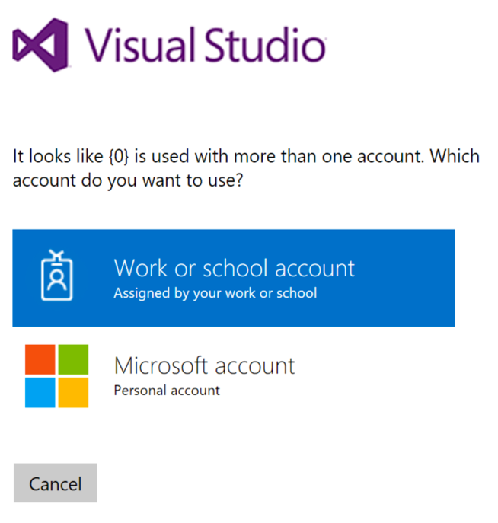

1. Complete your sign in by entering your **password** and clicking **Sign in**.

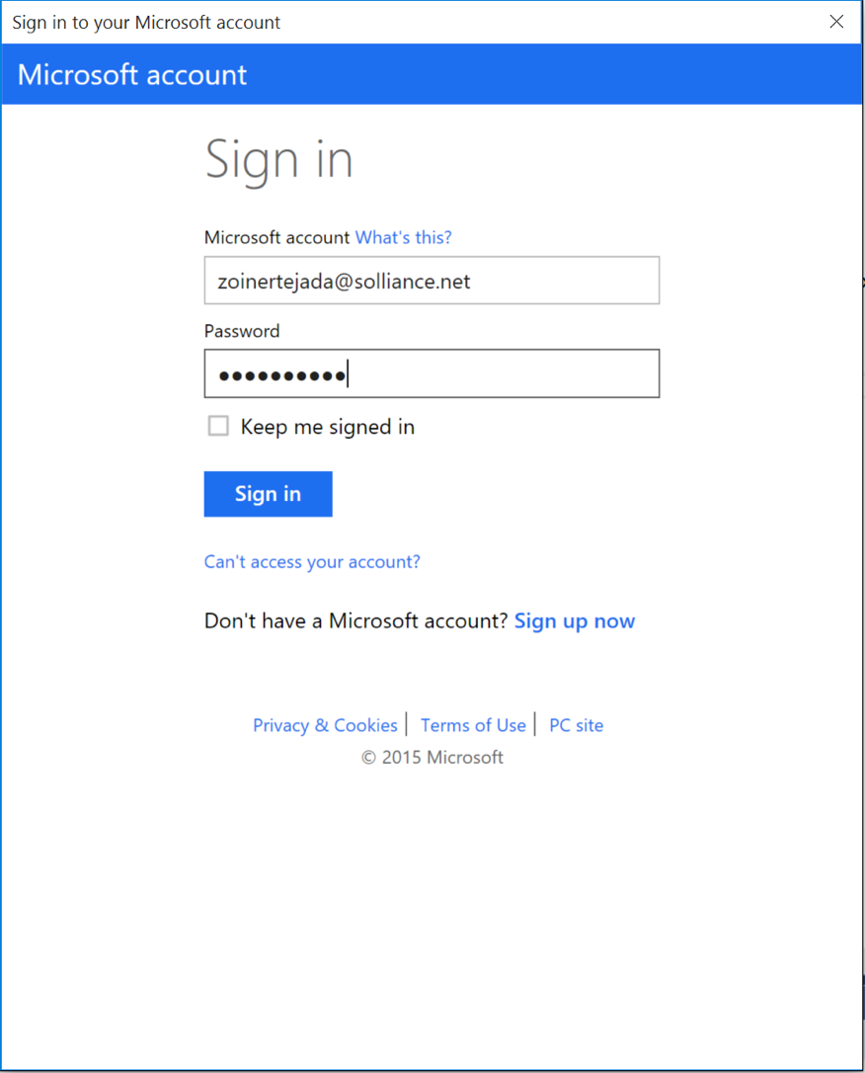

1. Allow Server Explorer about 30 seconds to load your subscription resources.
2. Expand **Azure** and then expand **HDInsight**. It may take a few moments to load your storage accounts.

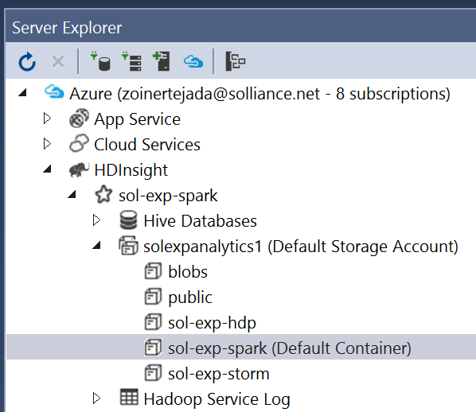

1. Expand the **Default Storage Account** used for your HDInsight cluster, and right-click the container named after your HDInsight cluster. Select **View Container**.

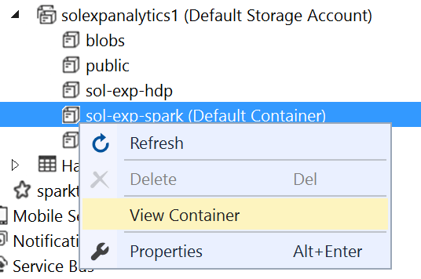

1. Verify files are being written to Blob storage and take note of the path to one of the files (the files should be located underneath the smartmeters folder).

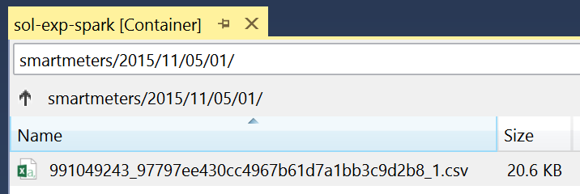

### Task 3: Process with Spark SQL

1. Navigate to the blade for your Spark Cluster in the Portal.
2. Under Quick Links, click **Cluster Dashboards**.

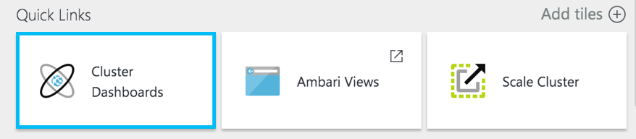

1. On the Cluster Dashboards blade, select **Jupyter Notebook**. If prompted, login with admin credentials your provided.  
   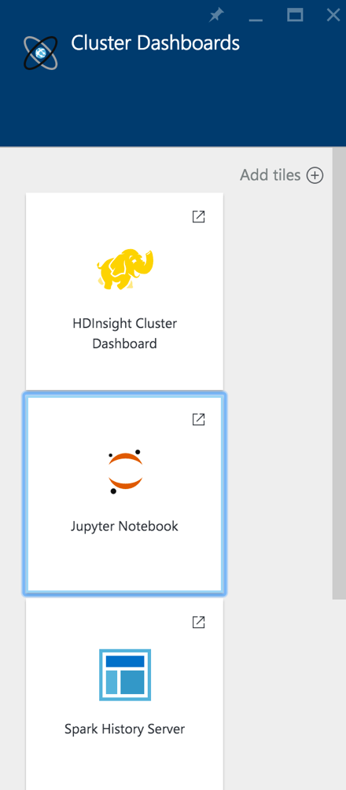
2. From the navigation bar in the Jupyter site, select **New** and then **Spark.**   
   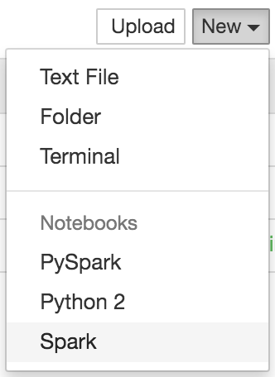
3. In the first text area (referred to as a paragraph in notebook jargon), enter the following **Scala code** that will load, parse, and save your batch scored flight data as a table that you can later query using Spark SQL. Modify the second line with the corrected path to your telemetry file.

var hiveContext = sqlContext

val rawText = hiveContext.read.text("wasb:///smartmeters/**2015/10/23/01/991049243_a399a1767ced448c9f6482285f35ab1b_1.csv**")

case class SmartMeterMetrics(id:String,time:String,temp:Integer)

val telemetryRDD = rawText.map(row => row.getString(0).split(",")).filter(s=>s(0) != "id").map(

s => SmartMeterMetrics(s(0), s(1), s(2).toInt)

)

val telemetryDF = hiveContext.createDataFrame(telemetryRDD)

telemetryDF.write.saveAsTable("SmartMeters")

1. Next, click the **Run** icon in the toolbar to execute this code and create the **SmartMeters** table.   
   
2. The block is finished running when the In[*] changes to In[1]  
   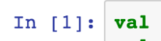
3. In the second cell, enter the following SQL query and run it.

%%sql

select id, count(*) as count, avg(temp) averageTemp from SmartMeters group by id order by id

1. Next, create a table that will summarize the telemetry collected using the previous query. In a new paragraph, try running the following query:

//query the table to create a summary result set

val summary = hiveContext.sql("select id, count(*) as count, avg(temp) averageTemp from SmartMeters group by id order by id")

//save the new pre-computed view

summary.write.saveAsTable("DeviceSummary")

1. Next, query from this summary table by executing the following query.

%%sql

select * from DeviceSummary

1. In the results, click the **Bar** button.
2. In the X dropdown, select id.
3. In the Y dropdown, select averageTemp.
4. In the Func dropdown, select Avg.
5. Check the box for Log scale Y.
6. Observe the results graphed as a column chart, where each column represents a device’s average temperature.

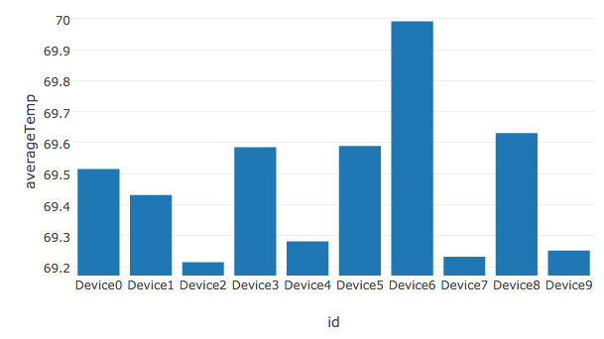

## Exercise 6: Reporting device outages with IoT Hub Operations Monitoring

Duration: 20 minutes

Synopsis: Fabrikam would like to be alerted when devices disconnect, but fail to reconnect after a period. Since they are already using PowerBI to visualize hot data, they would like to see a list of any of these devices in a report.

### Task 1: Enable verbose connection monitoring on the IoT Hub

To keep track of device connects and disconnects, we first need to enable verbose connection monitoring.

1. In your browser, navigate to the **Azure Portal** (<https://portal.azure.com)>.
2. Open the IoT Hub you provisioned earlier.
3. Under GENERAL in the left-hand menu, click on **Operations monitoring**.  
   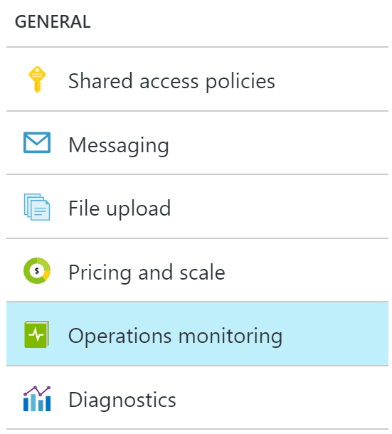
4. Click on **Verbose** under **Connections**.  
   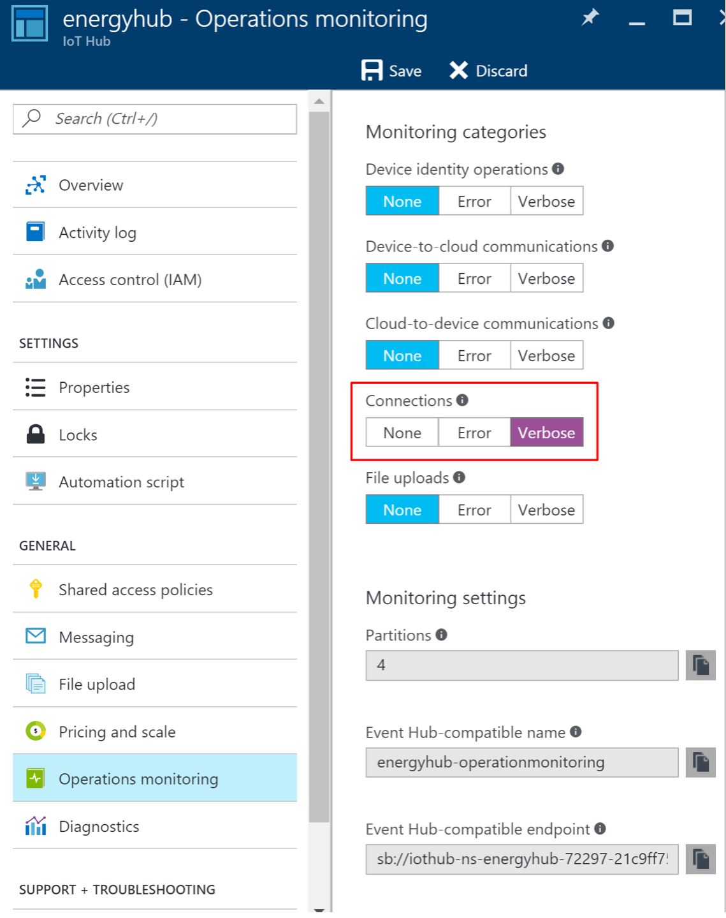
5. Click **Save**.

### Task 2: Collect device connection telemetry with the hot path Stream Analytics job

Now that the device connections are being logged, update your hot path Stream Analytics job (the first one you created) with a new input that ingests device telemetry from Operations Monitoring. Next, create a query that joins all connected and disconnected events with a DATEDIFF function that only returns devices with a disconnect event, but no reconnect event within 120 seconds. Output the events to Power BI.

1. In your browser, navigate to the **Azure Portal** (<https://portal.azure.com)>.
2. Open the hot path Stream Analytics job (the first one you created).
3. Stop the job if it is currently running, from the Overview blade.
4. Go to **Inputs** for your Stream Analytics job and add an input connected to your IoT Hub.
   1. Click on **Inputs** under JOB TOPOLOGY, or click the Inputs box on the Overview blade.  
      
   2. On the **Inputs** blade, click **Add** in the **command bar** at the top.



* 1. Configure the **Input settings** as follows:
     1. Input Alias: connections
     2. Source Type: Data stream
     3. Source: **IoT hub**
     4. Subscription: Use IoT hub from current subscription
     5. IoT Hub: Select your existing IoT Hub
     6. Endpoint: **Operations monitoring**
     7. Shared Access Policy Name: Set to Service
     8. Consumer Group: Leave as $Default
     9. Event serialization format: JSON  
        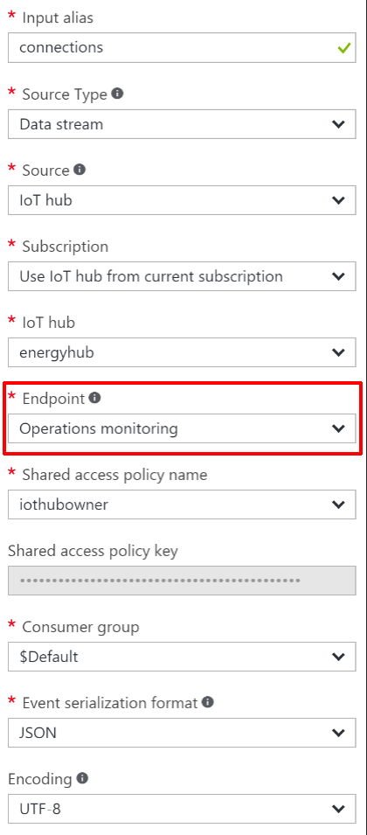
  2. Click **Create**.

1. Go to the **Outputs** blade and add the output destination for the query.
   1. Click on **Outputs** under JOB TOPOLOGY.  
      
   2. On the **Outputs** blade, click **Add** in the **command bar** at the top.



* 1. Set the **Output alias** to **powerbi-outage**.
  2. Select **Power BI** under **Sink**.
  3. Click on **Authorize** underneath Authorize Connection.

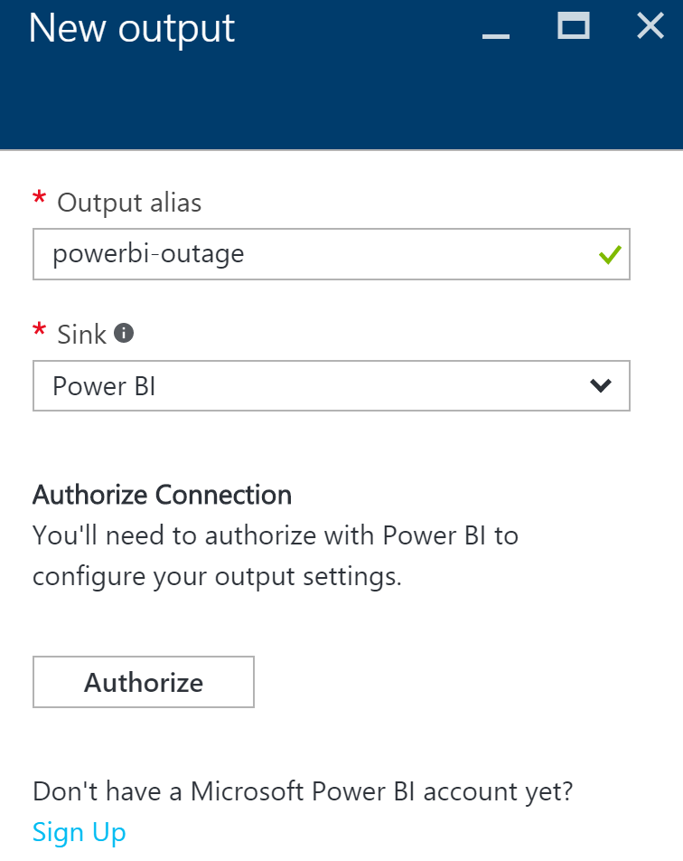

* 1. Follow the on screen prompts to log on to your Power BI account. Make sure you select **Work or school account**, since Power BI only supports organizational accounts at this time.



* 1. After authenticating, you will be taken back to the **New output** form, which will display Group Workspace: leave at My Workspace three new fields to fill out:
     1. Dataset Name: deviceoutage
     2. Table Name: deviceoutage
     3. Click on **Create**.  
        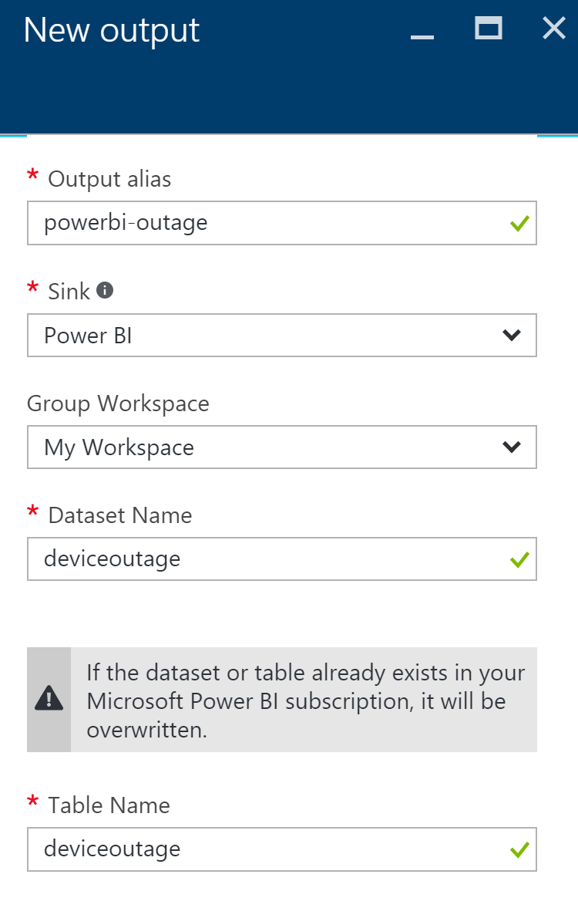

1. Go to the **Query** blade by clicking on Query under JOB TOPOLOGY.  
   
2. We will replace the hot path query, which selects the averages of the temperatures into the PowerBI output, with queries that perform the following:
   1. Select device disconnection events.
   2. Select device connection events.
   3. Join these two streams together using the Stream Analytics DATEDIFF operation on the LEFT JOIN, and then filter out any records where there was a match. This gives us devices that had a disconnect event, but no corresponding connect event within 120 seconds. Output to the Service Bus.
   4. Execute the original hot path query.
3. Replace the existing query with the following, and click **Save** in the **command bar** at the top. (Be sure to substitute in your output aliases and input aliases):

WITH

Disconnected AS (

SELECT *

FROM connections TIMESTAMP BY [Time]

WHERE OperationName = 'deviceDisconnect'

AND Category = 'Connections'

),

Connected AS (

SELECT *

FROM connections TIMESTAMP BY [Time]

WHERE OperationName = 'deviceConnect'

AND Category = 'Connections'

)

SELECT Disconnected.DeviceId, Disconnected.Time

INTO [powerbi-outage]

FROM Disconnected

LEFT JOIN Connected

ON DATEDIFF(second, Disconnected, Connected) BETWEEN 0 AND 120

AND Connected.deviceId = Disconnected.deviceId

WHERE Connected.DeviceId IS NULL;

SELECT AVG(temp) AS Average, id

INTO powerbi

FROM temps

GROUP BY TumblingWindow(minute, 5), id;

1. Go to the **Overview** blade on your **Stream Analytics job**, click **Start** in the **command bar** to begin the job.
   1. Leave the **Job output start time** setting at **Now** and click **Start**.



### Task 3: Test the device outage notifications

Register and activate a few devices on the Smart Meter Simulator, then connect them. Deactivate them without reconnecting in order for them to show up in the device outage report we will create in the next task.

1. Run the Smart Meter Simulator from Visual Studio.
2. Click the **Register** button.  
   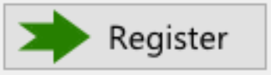
3. Click on 3 of the windows to highlight them.  
   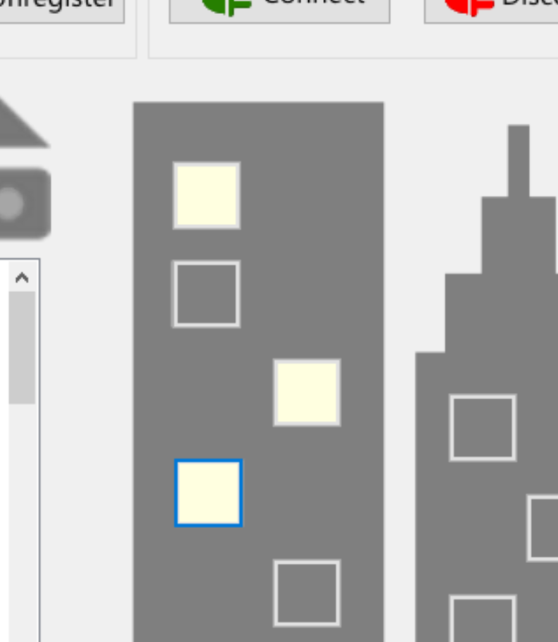
4. Click the **Activate** button.  
   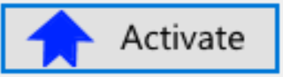
5. Click the **Connect** button.  
   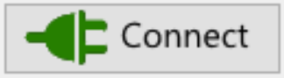
6. After a few seconds, click **Disconnect**.  
   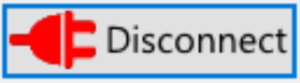
7. Click **Unregister**.  
   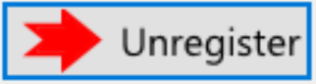
8. It may take up to 10 minutes, but you should receive 3 emails that contain the corresponding Device Id and date/time stamps of when the device was disconnected, one for each device.

### Task 4: Visualize disconnected devices with Power BI

1. Log on to **Power BI** to see if data is being collected.
2. A new dataset should appear, named **deviceoutage**. (It is starred to indicate it is new) If you do not see the dataset, you may need to connect your devices on the Smart Meter Simulator, then disconnect and unregister them and wait up to 5 minutes.

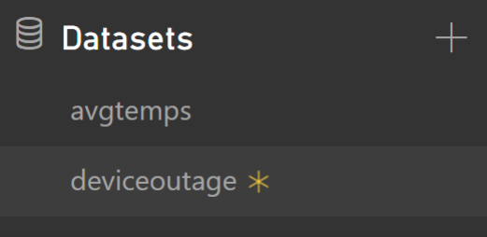

1. Click the new dataset to go the **report designer**.
2. Add a **Table visualization**.

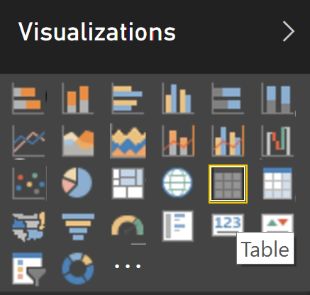

1. Select the **deviceid** and **time** fields, which will automatically be added to the table. You should see the Device Id of each of the devices you connected, and then disconnected for more than 2 minutes.  
   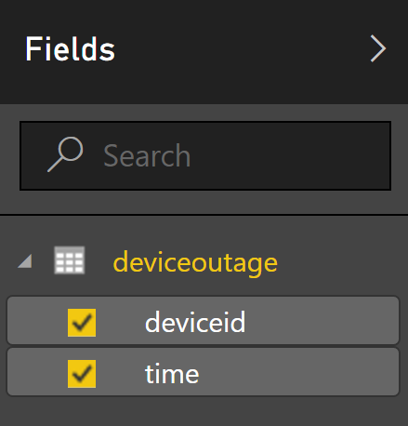  
     
   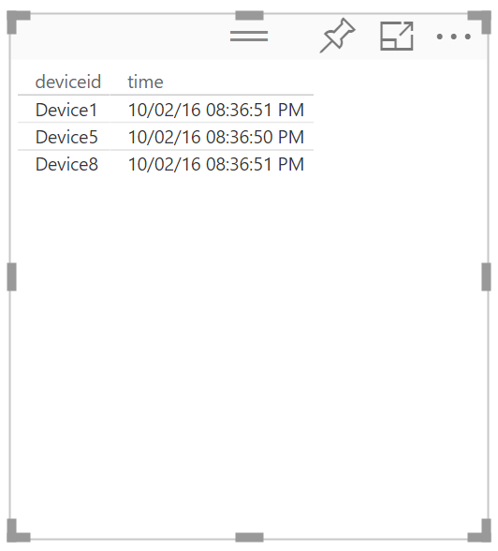
2. Save the report.



1. Switch to **Reading View**.



1. Within the report, click the column headers to sort by device or date. You may run a few more tests with the Smart Meter Simulator and periodically refresh the report to see new devices.

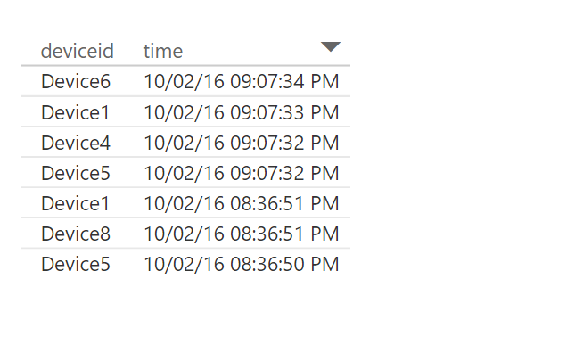

## Exercise 7: Cleanup

Duration: 10 minutes

Synopsis: In this exercise, attendees will de-provision any Azure resources that were created in support of the lab.

1. Delete the HDInsight cluster.
   1. From the Portal, navigate to the blade of your HDInsight cluster and click **Delete** in the **command bar** at the top.

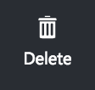

* 1. When prompted to confirm the deletion, click **Yes**.

1. Delete the *two* Stream Analytics jobs.
   1. From the **Existing** **Portal**, navigate to the **Stream Analytics** tab.
   2. In the list, select the **Stream Analytics job** and click **Delete**.
   3. Confirm the prompt by clicking **Yes**.
2. Delete the IoT Hub.
   1. From the **Portal**, navigate to the blade of your IoT Hub.
   2. Click the **Delete** button in the **command** **bar**.
   3. Confirm the prompt by clicking **Yes**.

# Big data and visualization hackathon

## Overview

AdventureWorks Travel (AWT) provides concierge services for business travelers. In an increasingly crowded market, they are always looking for ways to differentiate themselves and provide benefit to their corporate customers.

They are looking to pilot a web-app that their internal customer service agents can use to provide additional information useful to the traveler during the flight booking process. They want to enable their agents to enter in the flight information and produce a prediction as to if the departing flight will encounter a 15-minute or longer delay, taking into account the weather forecasted for the departure hour.

In this hackathon, attendees will build an end-to-end solution to predict flight delays taking into account the weather forecast.

## Requirements

* A corporate e-mail address (e.g., your @microsoft.com email)
* Microsoft Azure Subscription must be pay-as-you-go or MSDN
  + Trial subscriptions will *not* work
* Local machine or a virtual machine configured with:
  + Visual Studio 2015 Community Edition or later
  + Azure SDK 2.8.2 for Visual Studio
  + Azure PowerShell 1.0.0 or later

## Exercise 0: Before the hackathon

Duration: 60 mins

Synopsis: Before attending the hackathon, you should follow these steps to prepare your environment for an efficient day.

### Task 1: Provision Power BI

1. If you do not already have a Power BI account, go to <https://www.powerbi.com>.
2. On the page, enter your work email address (it should be the same account as the one you use for your Azure subscription) and click **Use it free**.



1. Follow the on-screen prompts and your Power BI environment should be ready within minutes. You can always return to it via <https://app.powerbi.com>

### Task 2: Provision Azure SQL Data Warehouse

Using the Azure Portal, provision a new instance of SQL Data Warehouse.

1. For convenience, and to help simplify cleanup of resources at the end of the hackathon, we recommend creating a new Resource Group and assign all new resources to that group (optional)
   1. Click **Resource groups**, **+Add**  
      
   2. Enter the **resource group name**, select your subscription, and select a resource group location that you will also use for your assigned resources  
      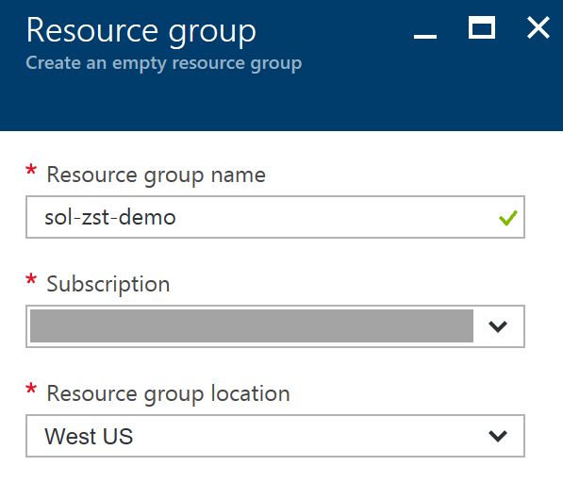
   3. Click **Create**

Placeholder for Resource Group Name

1. Click **+New**, select **Databases**, **SQL Data Warehouse**.

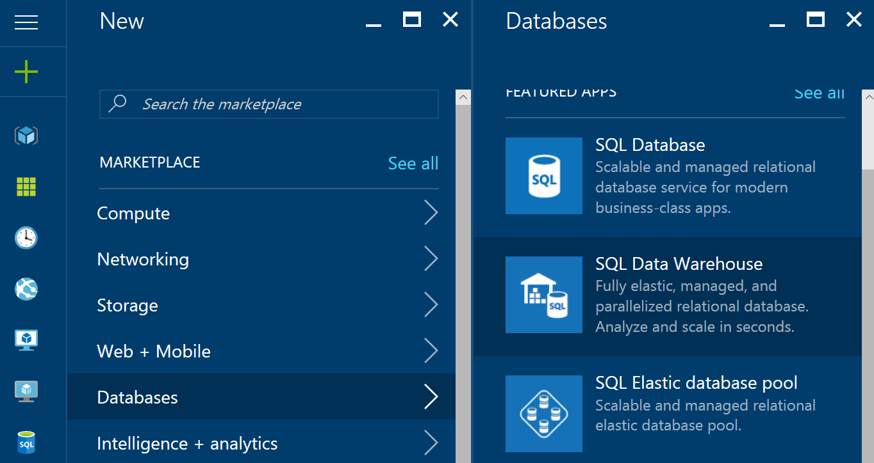

1. Provide a Name for the SQL Data Warehouse.  
   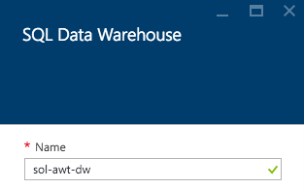

Placeholder for SQL Data Warehouse Name

1. Select Server.  
   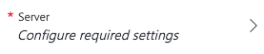
2. Create a new server or use an existing server as desired.

Placeholder for SQL Server Name

1. Set the **Performance** to **100 DWU**. (You will not need any more for this hackathon.)  
     
   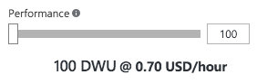
2. Select **Create**.  
   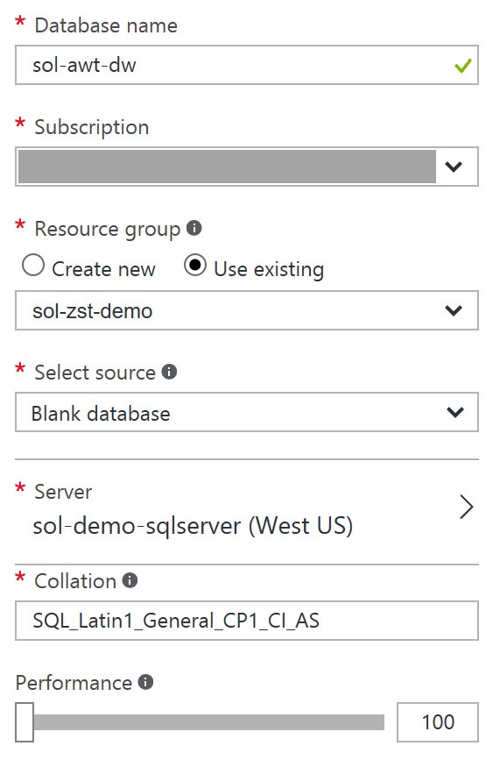  
     
   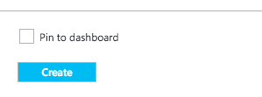

### Task 3: Provision a Storage Account

Using the Azure Portal, provision a new Azure Storage Account to use for this Hackathon.

1. Click **+New**, select **Storage**, **Storage Account**.   
   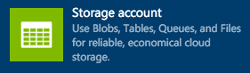
2. Provide a Name for the storage account.
3. For the resource group, add it to the Resource Group you are using for this Hackathon.
4. For the location, choose the same Location as your SQL Data Warehouse.   
   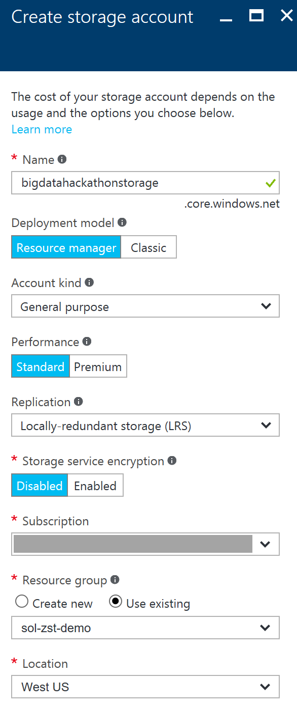
5. Select **Create**.

Placeholder for Storage Name

## Exercise 1: Environment setup

Duration: 20 minutes

AdventureWorks Travel has provided a sample solution you can use as a starting point for integrating the features they have requested.

### Task 1: Download and unzip the sample

### Tasks to Complete

* Download the sample project from the following link: <http://bit.ly/2kv0KMm>
* Open the solution in Visual Studio
* Publish the web project to a new Azure Web App

### Exit criteria

* You can browse to the deployed sample (https://<yourappname>.azurewebsites.net/Main) and view the starting point of the prediction page.

### Task 2: Register Web App with Azure Active Directory

### Tasks to Complete

* Login to the Manage Portal, and within your default Azure Active Directory add an application that represents your web app (whose sign-in URL and APP ID URL are both the deployment address of your web app).
* Configure the app to have a key and copy this key value.
* Paste the key value into the ClientSecret setting present in the Visual Studio Project properties, settings.
* From the app in Azure Active Directory, also copy the ClientID and paste this key value into the ClientID setting in the Project properties, settings.
* In addition, within the settings pane, set the RedirectURL property to be the URL of your newly deployed Web App, with /Redirect appended to the end (e.g., <http://yourapp.azurewebsites.net/Redirect)>.
* Save the project.

### Exit criteria

* You have set the values for the ClientID, ClientSecret and RedirectURL settings.

### Task 3: Update sample app with Storage Account credentials

### Tasks to Complete

* From the Portal, copy the Connecting String to your Storage Account
* Paste the Connection String value into the project properties, settings for the setting named “ML_StorageAccount”
* Save the project.

### Exit criteria

* You have set the value for the ML_StorageAccount setting.

## Exercise 2: Check the weather

Duration: 20 minutes

AdventureWorks has researched providers of Weather Forecasts and determined that they prefer the data from WeatherUnderground, which they would like to see the 10-day weather forecast integrated into starter web app provided.

### Task 1: Register for trial account in WeatherUnderground.com

### Tasks to Complete

* Register for a developer trial account for WeatherUnderground, from <http://www.wunderground.com/weather/api/>
* Confirm your email address
* Login to the site with your wunderground.com account and get your API Key for the Anvil Plan at the Developer level

### Exit criteria

* You are able to copy your API Key (e.g., the “Key ID”)
* You can navigate to [http://api.wunderground.com/api/<YOURAPIKEY>/forecast10day/q/CA/SEA.json](http://api.wunderground.com/api/%3CYOURAPIKEY%3E/forecast10day/q/CA/SEA.json) in the browser after substituting in your API Key and see the 10-day hourly weather forecast for the Seattle-Tacoma International Airport

### Task 2: Update sample Web App with API Key

### Tasks to Complete

* In Visual Studio, navigate to the project properties, settings and set the Weather_APIKey to have the value of the API Key you were provided.
* Deploy the updated web app.

### Exit criteria

* With the deployed web app running in your browser, click Predict. You should be able to see a prediction for just the weather, similar to the following:

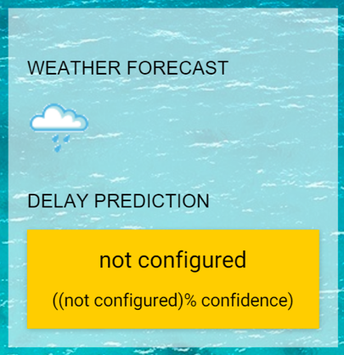

## Exercise 3: Building a ML Model

Duration: 90 minutes

AdventureWorks Travel is interested in building a Machine Learning solution to power their delay predictions. They have heard of the capabilities to build and operationalize Machine Learning using Azure Machine Learning, but are relying on you to implement it for them.

### Task 1: Create ML Workspace

### Tasks to Complete

* Create the Machine Learning Workspace and open it within ML Studio. You should follow the detailed step by step for this Task available in the Proctor Guide.

### Exit criteria

* You can open your Workspace in ML Studio.

### Task 2: Upload the Sample Datasets

### Tasks to Complete

* Download the three CSV sample datasets from here: <http://bit.ly/1Hrm5es>
* Extract the ZIP and verify you have the following files:
  + FlightDelaysWithAirportCode.csv
  + FlightWeatherWithAirportCodes.csv
  + AirportCodeLocationClean.csv
* Upload them as new Datasets available in ML Studio

### Exit criteria

* You should be able to navigate to the Datasets page in ML Studio and see your three CSV datasets:

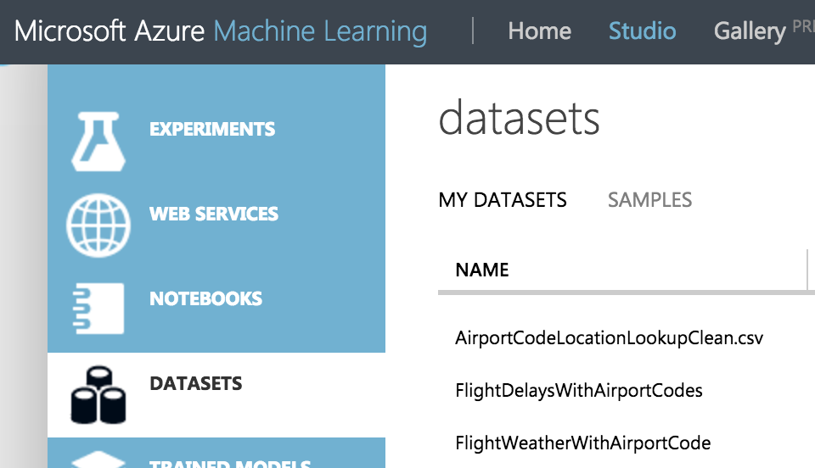

### Task 3: Start a New Experiment

### Tasks to Complete

* Create the Machine Learning Experiment within ML Studio. You should follow the detailed step by step for this Task available in the Proctor Guide.

### Exit criteria

* You can have an Experiment that prepares the data from the FlightDelaysWithAirportCodes dataset.

### Task 4: Prepare the Weather Data

### Tasks to Complete

* Update Machine Learning Experiment within ML Studio to prepare the FlightWeatherWithAirportCode. You should follow the detailed step by step for this Task available in the Proctor Guide.

### Exit criteria

* You can have an Experiment that prepares the data from the FlightWeatherWithAirportCode dataset.

### Task 5: Join the Flight and Weather datasets

### Tasks to Complete

* Join the two datasets- the data prepared from FlightDelaysWithAirportCodes and the data prepared from FlightWeatherWithAirportCode. You should follow the detailed step by step for this Task available in the Proctor Guide.

### Exit criteria

* You can have an Experiment that has a single dataset that provides information about flights and the weather at the time of departure.

### Task 6: Train the model

### Tasks to Complete

* Complete the Experiment by training a model using a Two-Class Logistic Regression. You should follow the detailed step by step for this Task available in the Proctor Guide.

### Exit criteria

* You should be able to Evaluate your model’s performance and verify that its predictions are performing better than random.

### Task 7: Operationalize the experiment

### Tasks to Complete

* Operationalize the model by packaging it up as a Predictive Web Service. You should follow the detailed step by step for this Task available in the Proctor Guide.

### Exit criteria

* You should be able to view the Web Service dashboard for your deployed Predictive Web Service, similar to the following:

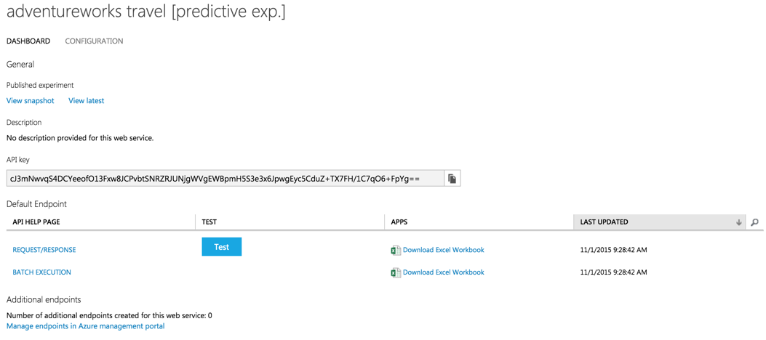

### Task 8: Integrate the Web Service with the Sample Web App

### Tasks to Complete

* Copy the value of the API Key from the Web Service Dashboard.
* Paste this value for the setting named ML_APIKey.in the sample web app project.
* Retrieve your Workspace ID and Service ID and paste these values into the settings named ML_RegionPrefix, ML_WorkspaceID, and ML_ServiceID, respectively.
* Publish the solution and navigate to the home page.

### Exit criteria

* You should be able to fill out the flight criteria, and click Predict Delays (remember to update the departure date so it is within 10 days of today). In addition to the Weather Forecast, you should see the delay prediction and confidence, similar to the following:

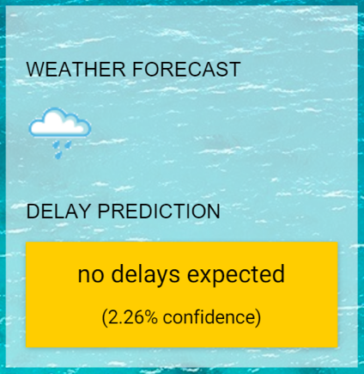

## Exercise 4: Batch score data with Azure ML and summarize with SQL Data Warehouse

Duration: 60 minutes

Besides being able to predict delays for an individual flight from the web app, AdventureWorks Travel would like to be able to display a map that shows the number of predicted flight delays by airport for a given period. Each airport would have a circle above it whose diameter increases as the number of predicted delays increases. Fabrikam would like to use the Batch Scoring capabilities of Azure ML to score all departing flights for a particular period, and then summarize these results by Airport using SQL Data Warehouse.

### Task 1: Batch score flight data

### Tasks to Complete

* Download the sample file AdventureWorks Travel has provided for batch scoring: <http://bit.ly/1XGg6M5>
* Using Visual Studio or your favorite Azure Storage explorer, upload this file to the container you created in your Storage Account. You should place it under the folder “flights”.
* Within Visual Studio, in the project properties, settings set the value of the ML_StorageAccount to be the connection string to the Storage Account.
* Publish the web app and navigate to /BatchScore
* Within the BatchScore web page, modify the values of relatives paths for the location of the file to score and the location of scored output to that it is correct for your environment
* Submit, Start, and Check the Job Status until the Job Status reads, “Job is finished.”

### Exit criteria

* The scoring job should have completed successfully.
* If desired, using the Azure Storage explorer of your choice, verify that you can see the scored CSV file in the location you configured.

### Task 2: Summarize delays by airport

### Tasks to Complete

* Using Visual Studio or SQL Server Management Studio, connect to your SQL Data Warehouse.
* Create a table called FlightDelays to represent the scored CSV file you uploaded. It should have the columns and types (in parenthesis): OriginAirportCode (String), OriginLatLong (String), Month (Int), Day (Int), Hour (Int), Carrier, DelayPredicted (Int) and DelayProbability (Double). The OriginLatLong field should have values that are of the form “OriginLatitude,OriginLongitude”, such as 29.9832,-95341.
* Create another table called FlightDelaysSummary that summarizes the former and has the following columns: OriginAirportCode, OriginLatLong, Month, Day, Hour, NumDelays and AvgDelayProbability. NumDelays is computed by summing the values for DelayPredicted when the dataset is filtered to Month = 4 and the rows are grouped by OriginAirportCode, OriginLatLong, Month, Day, and Hour. AvgDelayProbability is similarly computed, as the average of the DelayProbability column.

### Exit criteria

* You should be able to query the FlightDelaysSummary table and see results similar to the following:

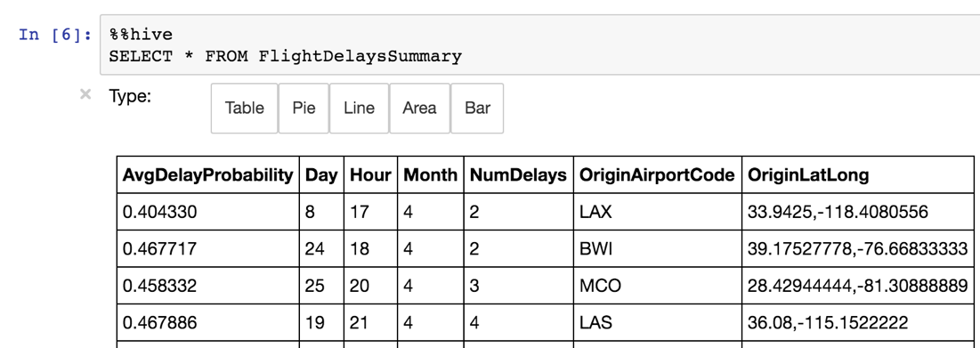

## Exercise 5: Visualizing in Power BI

Duration: 20 minutes

AdventureWorks Travel would like to visualize the summarized predicted flight delays in a map visualization, using an embedded Power BI tile.

### Task 1: Connect Power BI to SQL Data Warehouse

### Tasks to Complete

* From Power BI, connect to your SQL Data Warehouse.
* View the dataset that represents your data.
* Add a Map visualization. It should use the OriginLatLong for the location and the NumDelays field for the Values.

### Exit criteria

* Your map visualization should display as follows:

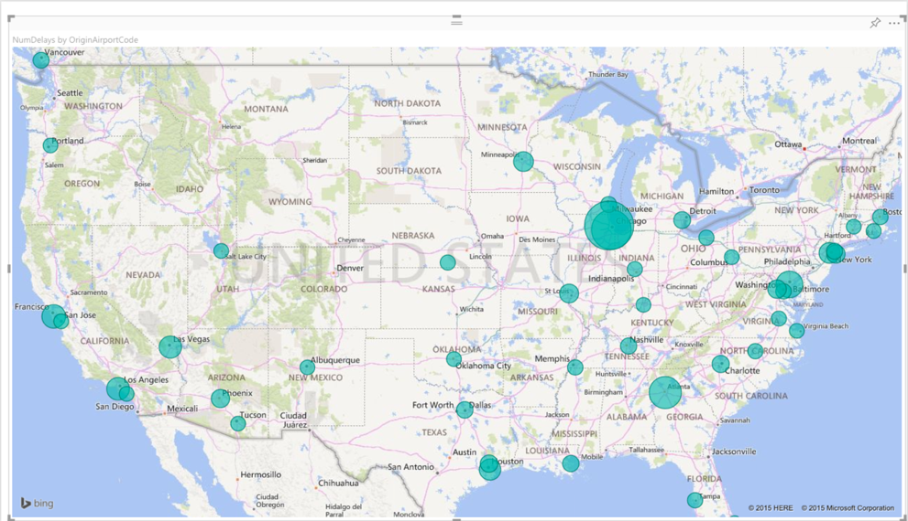

### Task 2: Create a Dashboard

### Tasks to Complete

* Save the report you created in the previous task with the name FlightDelays.
* Pin this report to a new Dashboard that is named AdventureWorks.

### Exit criteria

* You should be able to see your map on the AdventureWorks dashboard.

### Task 3: Observe the batch score results

### Tasks to Complete

* Open your deployed sample app in the browser, and navigate to /Main.
* Click the button labeled Sign In to Power BI and sign in with your Power BI credentials.

### Exit criteria

* Your browser should display the sample web app with the Power BI tile showing the FlightDelays map visualization:

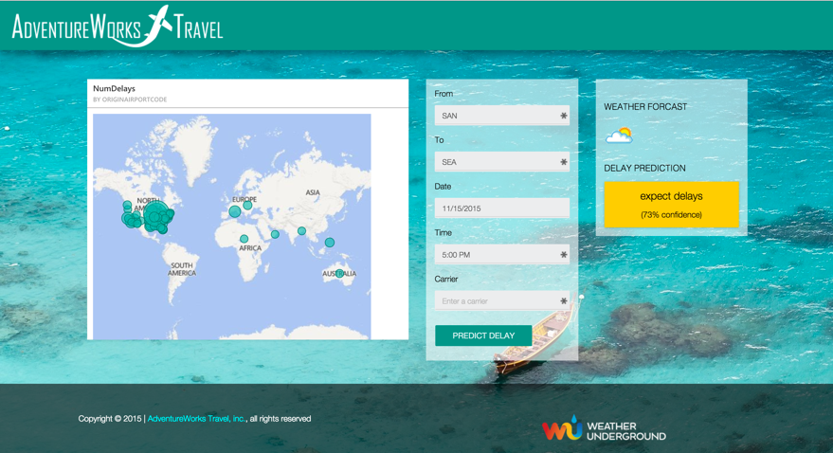

## Exercise 6: Cleanup

### Tasks to Complete

* Delete your SQL Data Warehouse.
* Delete the Web App and the App Service Plan that hosts it.

### Exit criteria

* You have deleted or stopped the major, cost incurring services used in the hackathon. You may optionally choose to delete the associated Storage account, but the costs for this are minimal (and by keeping the Storage account, you can re-create your clusters in the future to read from the data sets you have created).

# Big data and visualization hackathon answers

## Overview

AdventureWorks Travel (AWT) provides concierge services for business travelers. In an increasingly crowded market, they are always looking for ways to differentiate themselves and provide benefit to their corporate customers.

They are looking to pilot a web app that their internal customer service agents can use to provide additional information useful to the traveler during the flight booking process. They want to enable their agents to enter in the flight information and produce a prediction as to whether the departing flight will encounter a 15-minute or longer delay, taking into account the weather forecasted for the departure hour.

In this hackathon, attendees will build an end-to-end solution to predict flight delays taking into account the weather forecast.

## Requirements

* A corporate email address (e.g., your @microsoft.com email)
* Microsoft Azure Subscription must be pay-as-you-go or MSDN
  + Trial subscriptions will *not* work
* Local machine or a virtual machine configured with:
  + Visual Studio 2015 Community Edition or later
  + Azure SDK 2.8.2 for Visual Studio
  + Azure PowerShell 1.0.0 or later

## Exercise 0: Before the hackathon

Duration: 60 mins

Synopsis: Before attending the hackathon, you should follow these steps to prepare your environment for an efficient day.

### Task 1: Provision Power BI

1. If you do not already have a Power BI account, go to <https://www.powerbi.com>.
2. On the page, enter your work email address (it should be the same account as the one you use for your Azure subscription) and select **Use it free**.



Follow the on-screen prompts and your Power BI environment should be ready within minutes. You can always return to it via <https://app.powerbi.com>.

### Task 2: Provision Azure SQL Data Warehouse

Using the Azure Portal, provision a new instance of SQL Data Warehouse.

1. For convenience, and to help simplify cleanup of resources at the end of the hackathon, we recommend creating a new Resource Group and assign all new resources to that group (optional)
   1. Click **Resource groups**, **+Add**  
      
   2. Enter the **resource group name**, select your subscription, and select a resource group location that you will also use for your assigned resources  
      
   3. Click **Create**

Placeholder for Resource Group Name

1. Click **+New**, select **Databases**, **SQL Data Warehouse**.



1. Provide a Name for the SQL Data Warehouse.  
   

Placeholder for SQL Data Warehouse Name

1. Select Server.  
   
2. Create a new server or use an existing server as desired.

Placeholder for SQL Server Name

1. Set the **Performance** to **100 DWU**. (You will not need any more for this hackathon.)  
     
   
2. Select **Create**.  
     
   

### Task 3: Provision a Storage Account

Using the Azure Portal, provision a new Azure Storage Account to use for this Hackathon.

1. Click **+New**, select **Storage**, **Storage Account**.   
   
2. Provide a Name for the storage account.
3. For the resource group, add it to the Resource Group you are using for this Hackathon.
4. For the location, choose the same Location as your SQL Data Warehouse.   
   
5. Select **Create**.

Placeholder for Storage Name

## Exercise 1: Environment setup

Duration: 20 minutes

Synopsis: In this exercise, attendees will download the start project files and take a tour of the provided solution.

### Task 1: Download and unzip the sample

1. Download the sample project from the following link: <http://bit.ly/2kv0KMm>
2. Extract the ZIP file.
3. Open the solution AdventureWorksTravel.sln using Visual Studio.
4. Build the solution, making sure the build succeeded.
5. In Solution Explorer, right-click the Project and select **Publish**.
6. In the first dialog box, under Select a Publish Target, click **Microsoft Azure App Service**.
7. Sign in to your account when prompted.
8. Click **New**.

Placeholder for Web App Name

1. In the Create App Service dialog box, provide a name for the web app. Choose your subscription and choose to use an existing App Service Plan (if you already have one) or create a new one. If you choose to create a new App Service plan, provide a name for that new App Service plan. Similarly, if creating a new App Service plan, choose an existing Resource Group or create a new one and provide a name for the new resource group (e.g., hackathon).

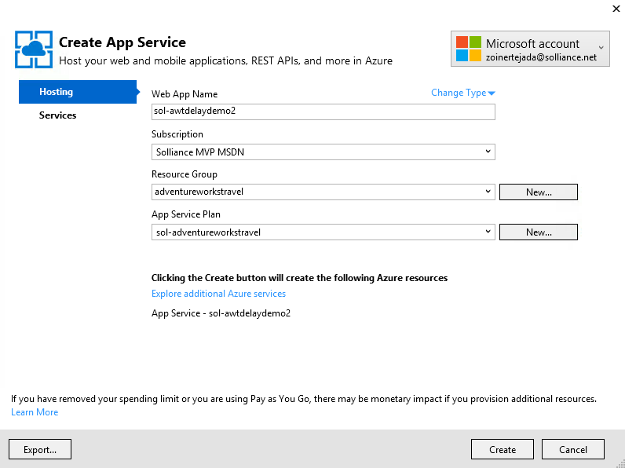

1. Click **Create**.
2. Click **Publish**. After a few moments, the initial version of the web app should appear in the browser.

### Task 2: Register Web App with Azure Active Directory

1. Login in to the existing portal (<https://manage.windowsazure.com/>) using the same credentials you used for Power BI.
2. Click the **active directory** tab.

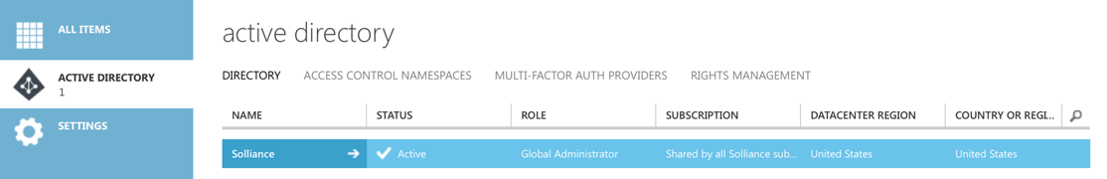

1. Click the name of your default directory in the grid (ensure this is **not** the Microsoft directory).
2. Click the **Applications** tab.

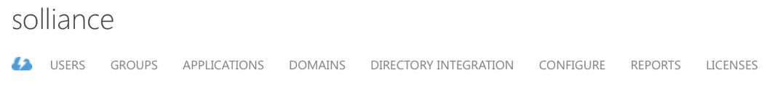

1. In the command bar at the bottom, click **Add**.

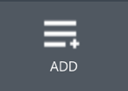

1. In the dialog box, click **Add an application my organization is developing**.

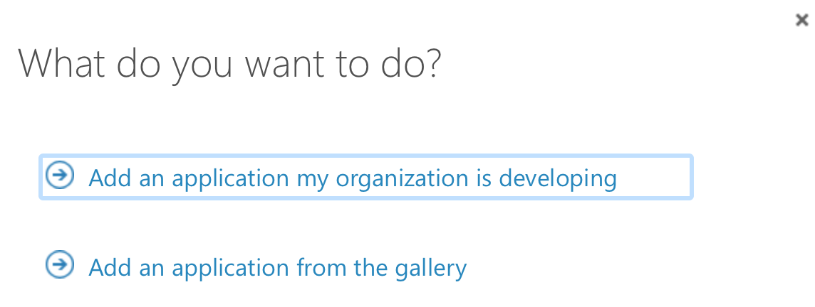

1. In the next dialog box, enter a unique name for your application (e.g., “AdventureWorksTravelYourMSAlias”) and leave the Web Application radio button selected.

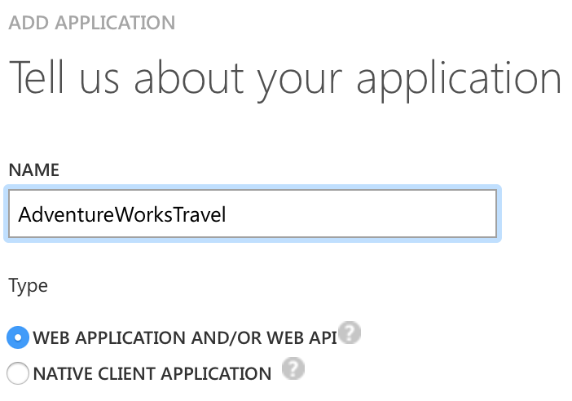

1. Click the right arrow button to move to the next screen.
2. For both fields, provide the URL to your newly deployed web app (make sure the URLs start with https).

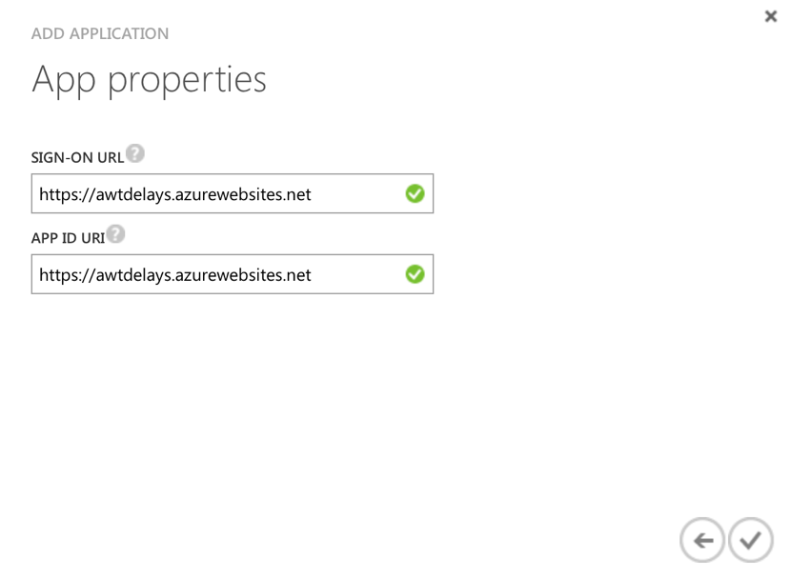

1. Click the checkmark button.
2. On the dashboard for your application, click the **Configure** tab.

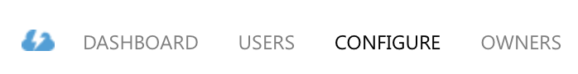

1. Scroll down to the permissions to other applications section and click **Add** **application**

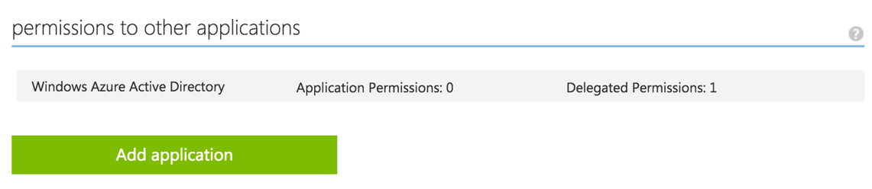

Placeholder for Application Name

1. In the dialog click on Power BI Service so that it appears in the list on the right and then click the checkmark.

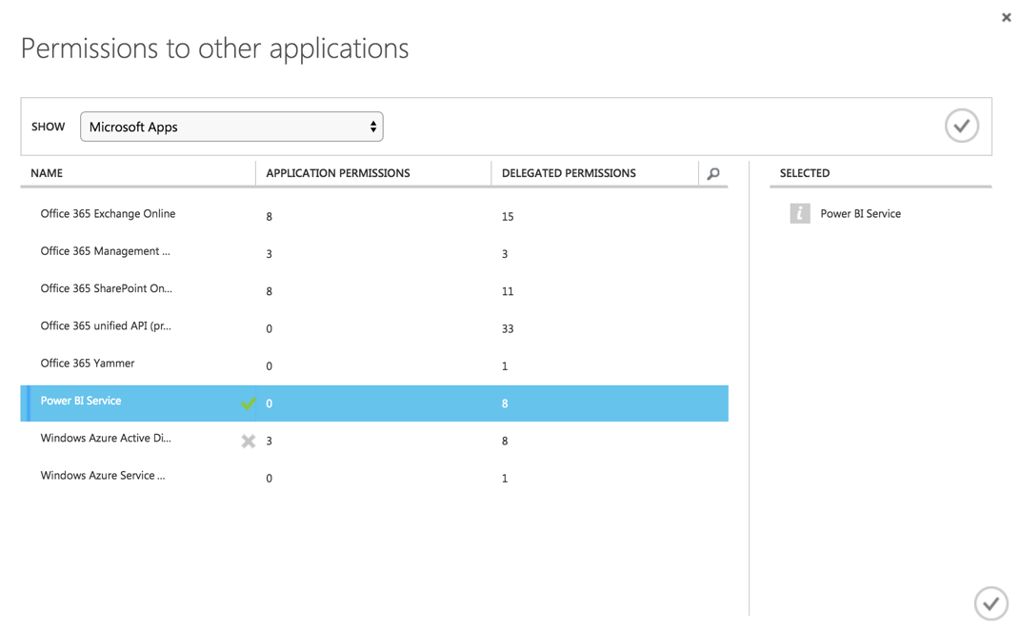  
* If Power BI Service does not show up on the list of applications, visit <https://powerbi.microsoft.com/en-us/documentation/powerbi-admin-free-with-custom-azure-directory/> to learn how to correct this. You will need to log in to Power BI as an organizational user within your directory before the service shows up in AAD.

1. In the Power BI Service row that appears, click on **Delegated permissions** and check **View all Dashboards**.

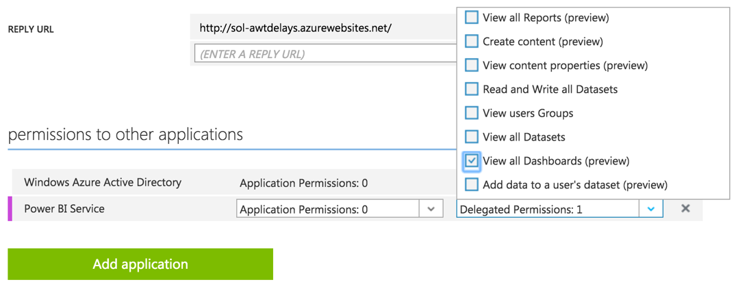

1. Scroll up to the Keys section.
2. Click the **Select duration** drop-down and select **1 year**.

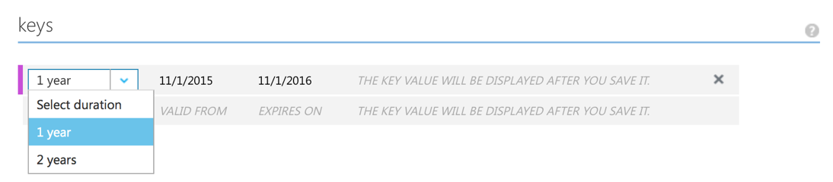

1. Click **Save** in the command bar at the bottom.
2. Copy the key value that appears after the save completes.

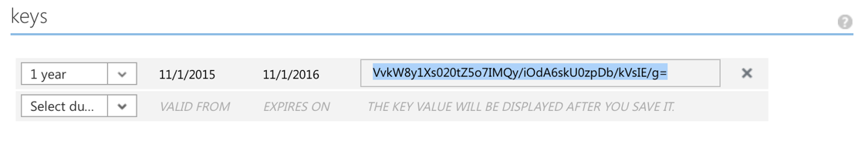

Placeholder for Application Keys

1. Return to the sample app in Visual Studio, right-click the project in Solution Explorer and select **Properties**.
2. Click the **Settings** tab. For the value of the ClientSecret setting, paste the key you just copied.



1. Return to the Configure page and copy the Client ID value.



1. In the sample Settings, paste the value of the ClientID in the ClientID setting.



1. Set the value of the RedirectURL to the URL of your newly deployed web app (including HTTPS), and append /Redirect to the end.



1. Save the project.

### Task 3: Update sample app with Storage Account credentials

1. Using the New Portal, navigate to the blade for your Storage Account.
2. Click **Access Keys**.

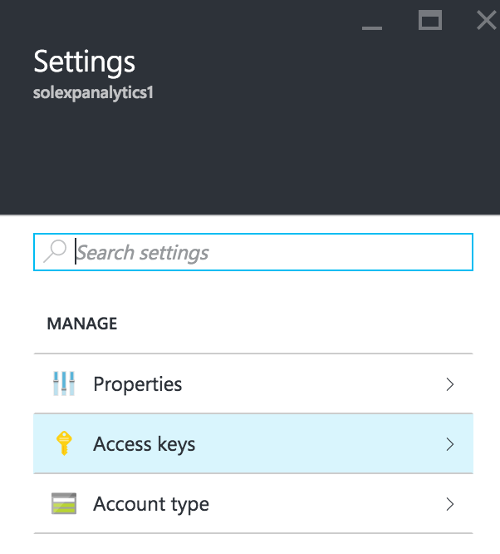

Placeholder for Storage Info

1. To the right of key1 in the table, click the ellipses (…) and select View connection string.  
   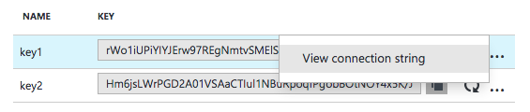
2. Copy the displayed **Connection String**. Be sure to copy the entire Connection String, not the Access key only.

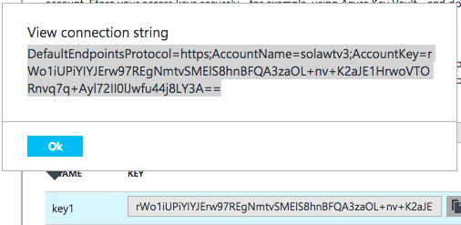

1. Return to the settings pane of the sample web app, and paste this connection string into the value field of the ML_StorageAccount setting.



1. Save the project.

## Exercise 2: Check the weather

Duration: 20 mins

Synopsis: In this exercise, attendees will integrate the 10-day weather forecast into the sample solution.

### Task 1: Register for trial account in WeatherUnderground.com

1. To retrieve the 10-day hourly weather forecast, you will use an API from WeatherUnderground.com. There is a free developer version that provides you access to the API you need for this hackathon.
2. Navigate to <http://www.wunderground.com/weather/api/> .
3. Click **Explore My Options**.

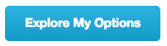

1. On the Get Your API Key page, select **Anvil Plan**.



1. Scroll down until you see the area titled How much would you use our service? Ensure Developer is selected.

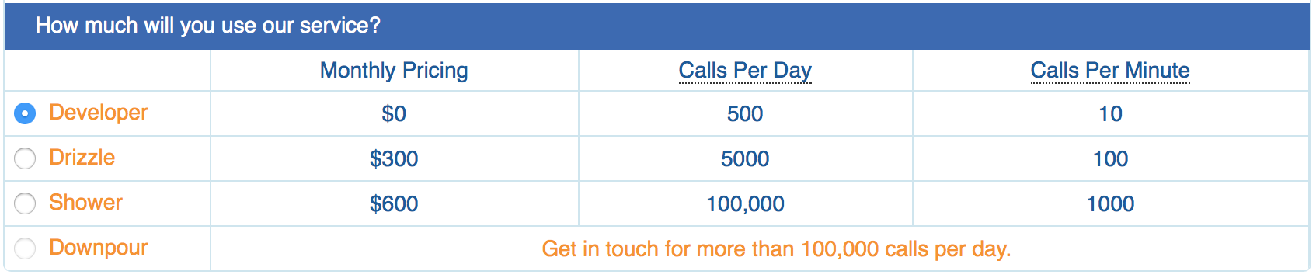

1. Click **Purchase Key**.

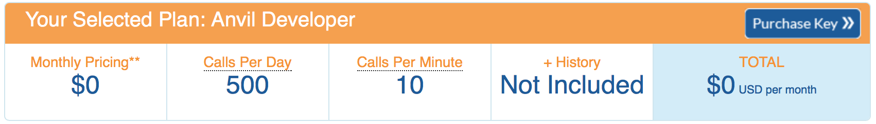

1. Complete the Create an Account form by providing your email, username and a password and agreeing to the terms. Click Basic – Free.

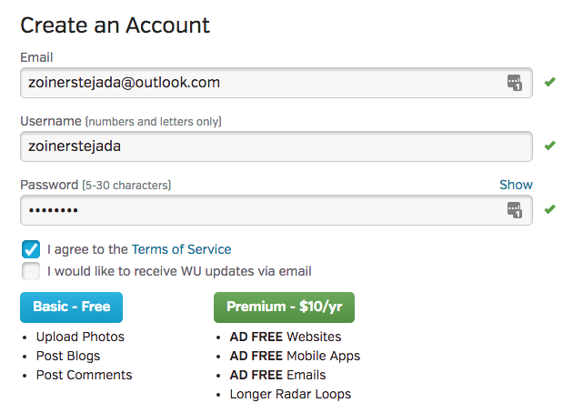

1. Back on the Get Your API Key page, re-select Anvil, and click Purchase Key.
2. In a few moments, you should receive a confirmation email at the email address you provided. Click the link found within the email.

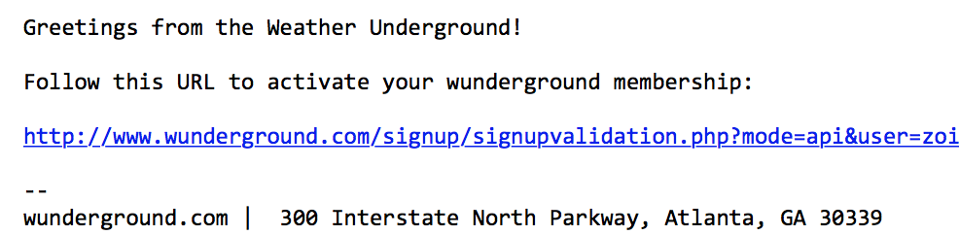

1. On the page that loads, you will see a message like the following:



1. Complete the brief contact form. When answering where will the API be used, select **Website**. For Will the API be used for commercial use, select **No**. Click **Purchase Key**.

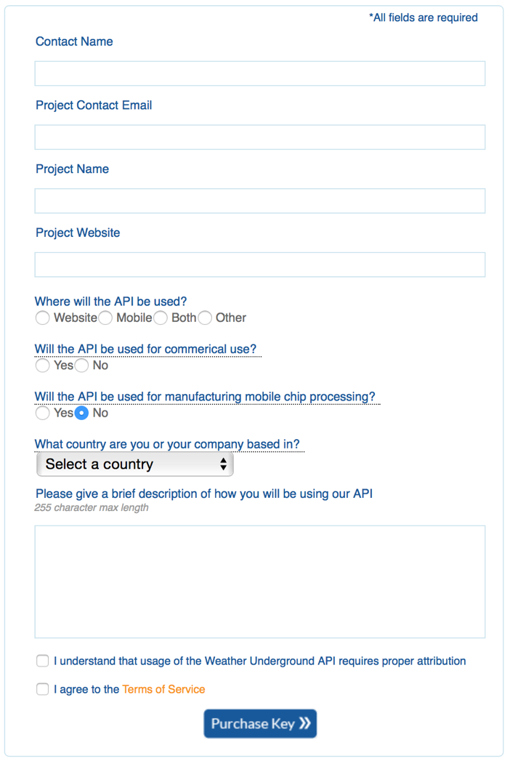

1. You should be taken to a page that displays your key, similar to the following:

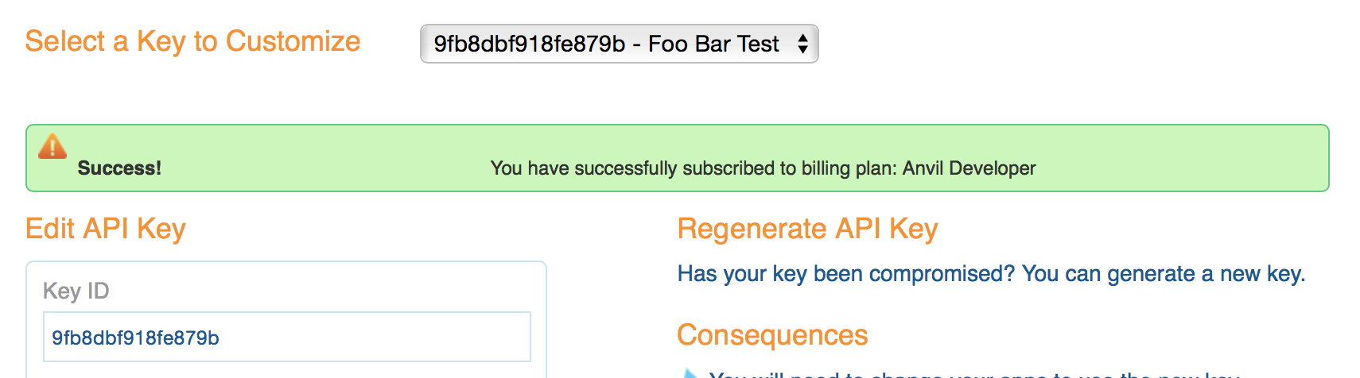

1. Take note of your API Key. It is available from the text box labeled **Key ID**.
2. To verify that your API Key is working, modify the following URL to include your API Key: [http://api.wunderground.com/api/<YOURAPIKEY>/hourly10day/q/CA/SEATAC.json](http://api.wunderground.com/api/%3cYOURAPIKEY%3e/hourly10day/q/CA/SEATAC.json).

Placeholder for Weather API Key

1. Open your modified link in a browser, you should get a JSON result showing the 10-day, hourly weather forecast for the Seattle-Tacoma International Airport.

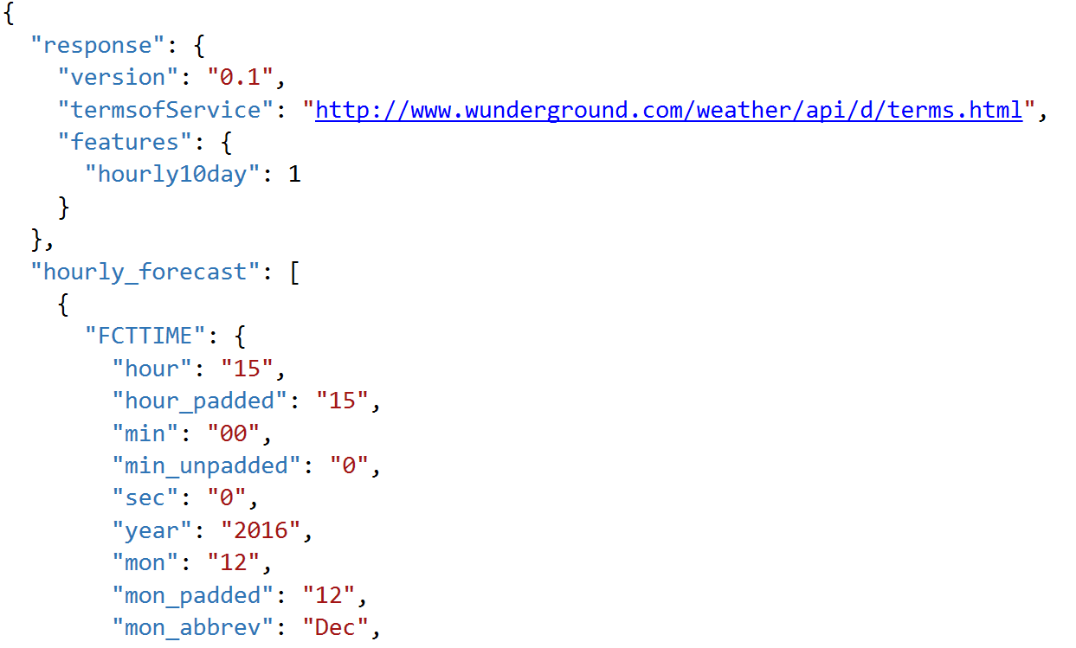

### Task 2: Update sample Web App with API Key

1. Next, you will update the sample app with your Weather Underground API Key.
2. With the sample app open in Visual Studio, in Solution Explorer, right-click the project and select **Properties**.
3. Click the **Settings** tab.

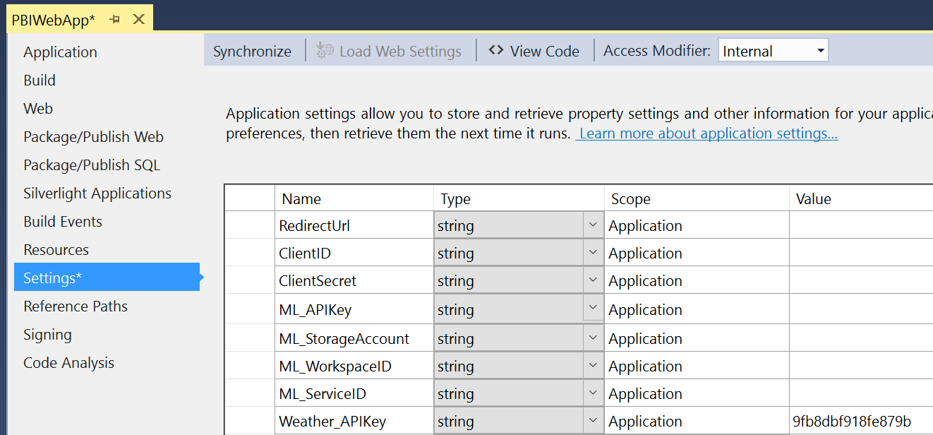

1. Edit the value for the Weather_APIKey and click **Save**.
2. In the dialog box that appears, right-click your project, select **Publish**, and then click **Publish**.
3. On your deployed web app, change the date of the flight to tomorrow's date (or another future date no further than 10 days away).
4. Click **Predict Delay**. You should see the weather icon display. If you hover over the icon, you will get the description of the weather conditions forecasted. At this point, Delay Prediction should display not configured. You will set Delay Prediction up shortly.

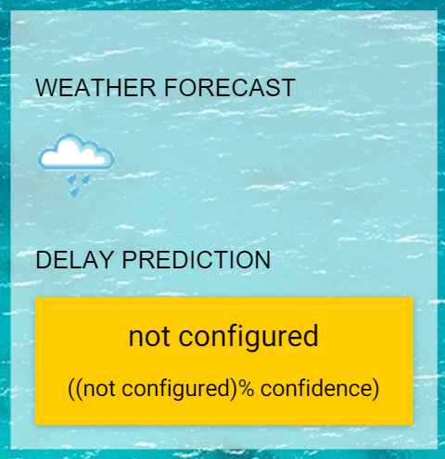

## Exercise 3: Building a ML Model

Duration: 90 mins

Synopsis: In this exercise, attendees will implement a classification experiment. They will load the training data from their local machine into a dataset. Then they will explore the data to identify the primary components they should use for prediction, and use two different algorithms for predicting the classification. They will evaluate the performance of both and algorithms choose the algorithm that performs best. The model selected will be exposed as a web service that is integrated with the sample web app.

### Task 1: Create ML Workspace

1. Login to the existing Azure portal (<https://manage.windowsazure.com)>.
2. Click **+ New**, point to **Data Services**, and then select **Machine Learning**.

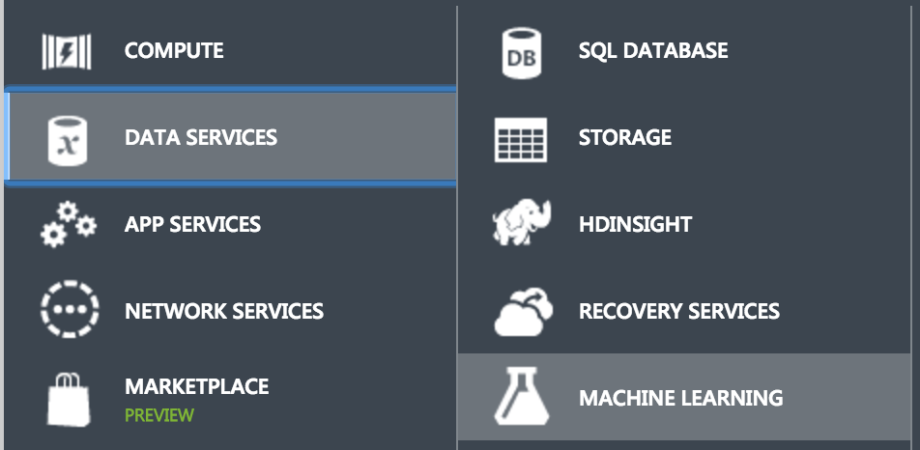

1. Click **Quick Create**.

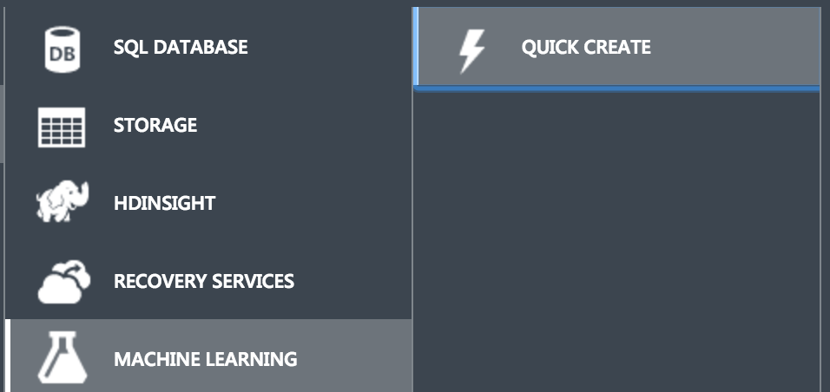

1. In the Quick Create panel, enter a workspace name, select the location nearest you, and use an existing storage account or create a new one as desired.
2. Click **Create an ML Workspace**.

Placeholder for ML Info

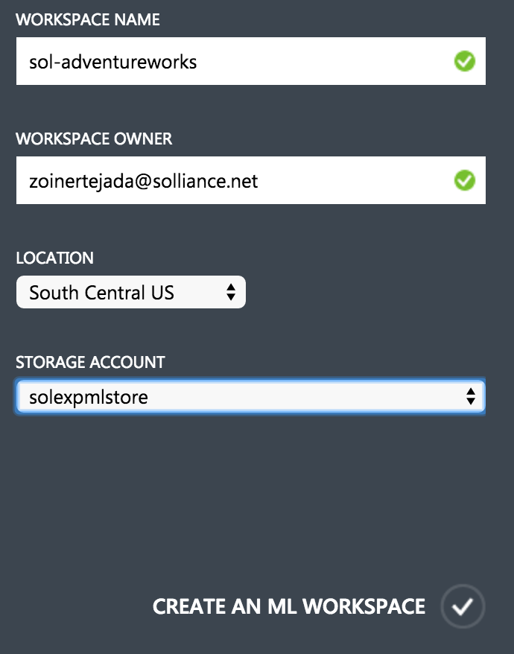

1. Navigate to your ML workspace by clicking **Machine Learning** in the navigation bar.

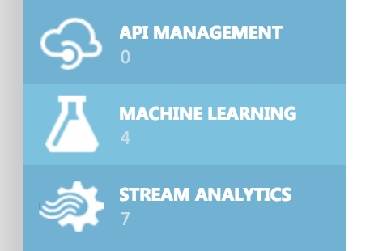

1. In the list of machine learning workspace, click the name of the workspace you just created.

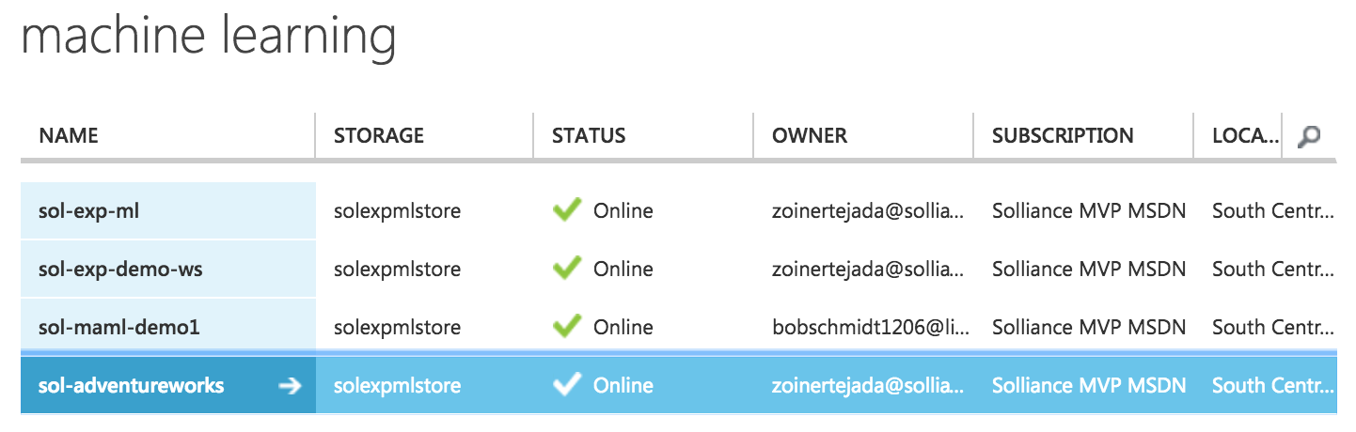

1. In the command bar at the bottom, click **Open in Studio** to open your workspace using the development environment ML Studio.

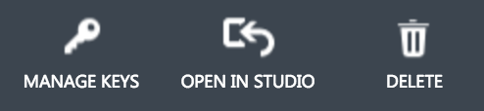

### Task 2: Upload the Sample Datasets

1. Before you begin creating a machine learning experiment, there are three datasets you need to load.
2. Download the three CSV sample datasets from here: <http://bit.ly/1Hrm5es>
3. Extract the ZIP and verify you have the following files:

* FlightDelaysWithAirportCodes.csv
* FlightWeatherWithAirportCodes.csv
* AirportCodeLocationLookupClean.csv

1. Within Machine Learning Studio, click **+ NEW** at the bottom, point to **Dataset**, and select **From Local File**.

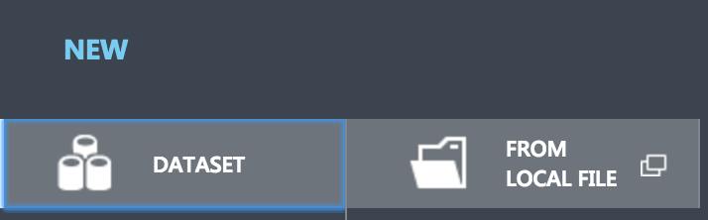

1. In the dialog that appears, click **Choose File** and browse to the FlightDelaysWithAirportCodes file and click **Open**.
2. Change the name of the dataset to “FlightDelaysWithAirportCodes” and click the checkmark to upload the data into a new dataset.

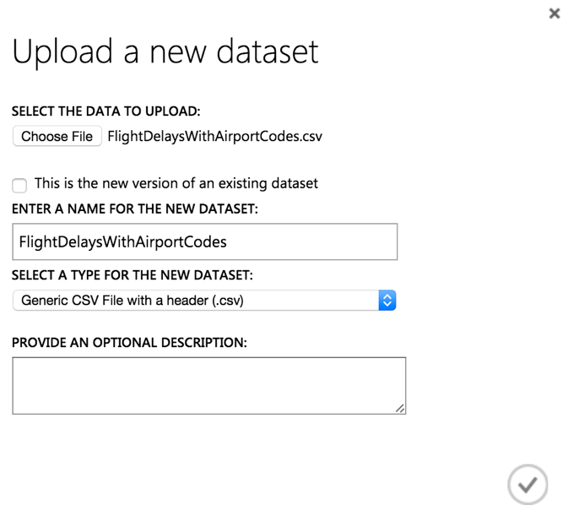

1. Repeat the previous step for the FlightWeatherWithAirportCodes and AirportCodeLocationsClean, setting the name for the dataset in a similar fashion. (Please note that this might take more than 15 minutes to complete)

### Task 3: Start a new experiment

1. Click **+ NEW** in the command bar.
2. In the options that appear, click **Blank Experiment**.

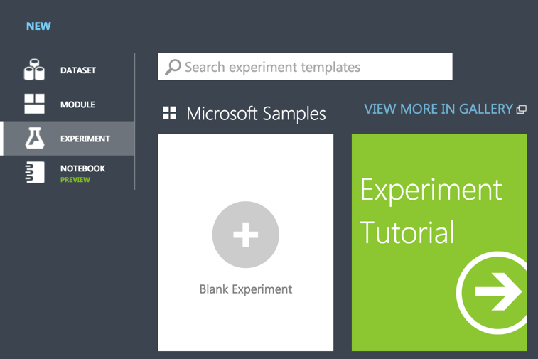

1. Give your new experiment a name, such as AdventureWorks Travel by editing the label near the top of the design surface.

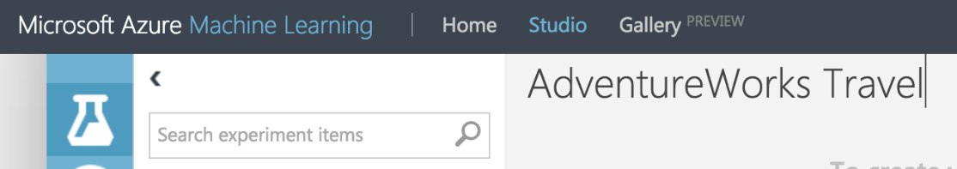

1. In the toolbar on the left, in the Search experiment items box, type the name of the dataset you created with flight delay data (FlightDelaysWithAirportCodes). You should see a component for it listed under Saved Datasets, My Datasets.

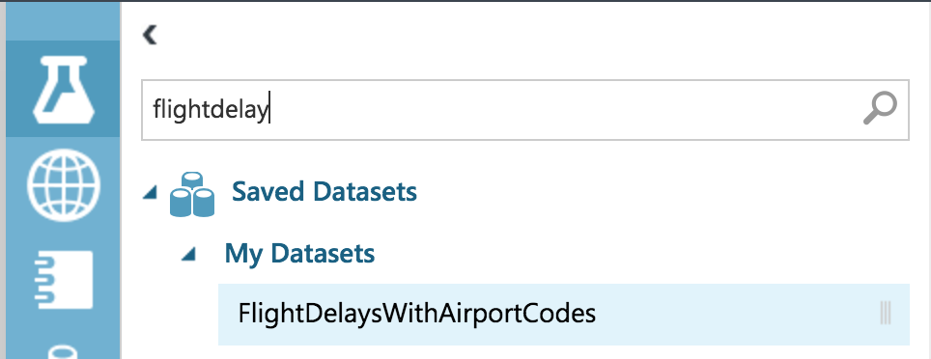

1. Click and drag on the FlightDelaysWithAirportCodes to add it to the design surface.

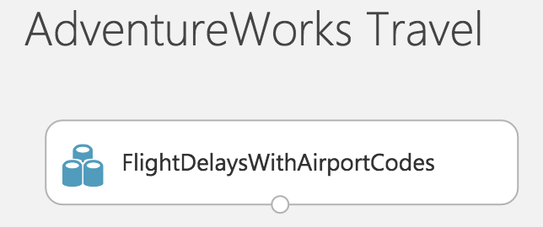

1. Next, you will explore each of the datasets to understand what kind of cleanup (aka data munging) will be necessary.
2. Hover over the output port of the FlightDelaysWithAirportCodes dataset.

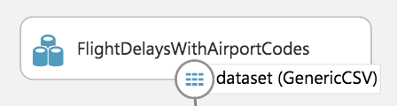

1. Right-click on the port and select **Visualize**.

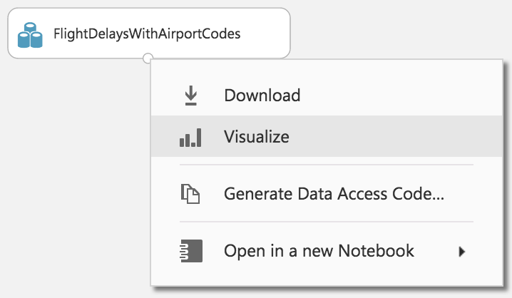

1. A new dialog will appear showing a maximum of 100 rows by 100 columns sample of the dataset. You can see at the top that the dataset has a total of 2,719,418 rows (also referred to as examples in Machine Learning literature) and has 20 columns (also referred to as features).

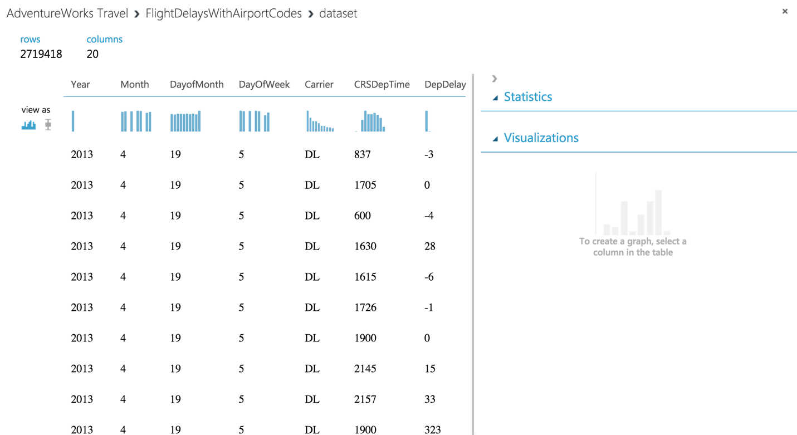

1. Because all 20 columns are displayed, you can scroll the grid horizontally. Scroll until you see the DepDel15 column and click it to view statistics about the column. The DepDel15 column displays a 1 when the flight was delayed at least 15 minutes and 0 if there was no such delay. In the model you will construct, you will try to predict the value of this column for future data.

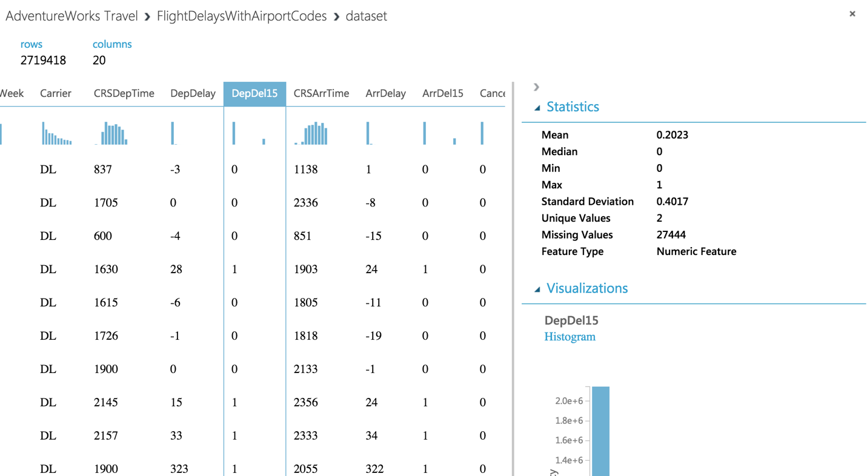

1. Notice in the Statistics panel that a value of 27444 appears for Missing Values. This means that 27,444 rows do not have a value in this column. Since this value is very important to our model, we will eliminate any rows that do not have a value for this column.
2. To eliminate these problem rows, close the dialog and go back to the design surface. From the toolbar, search for **Clean Missing Data**.

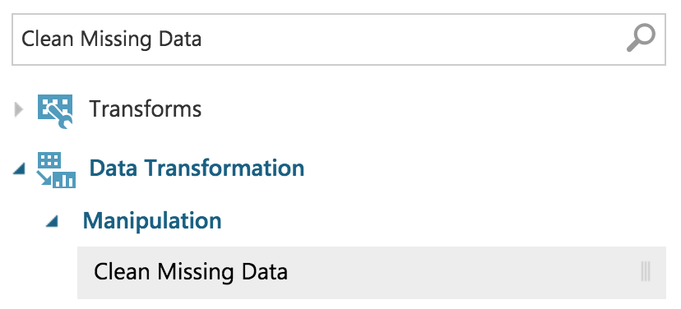

1. Drag this module on to the design surface beneath your FlightDelaysWithAirportCodes dataset. Click the small circle at the bottom of the FlightDelaysWithAirportCodes dataset, drag and release when your mouse is over the circle found in the top center of the Clean Missing Data module. These circles are referred to as ports, and by taking this action you have connected the output port of the dataset with the input port of the Clean Missing Data module, which means the data from the dataset will flow along this path.

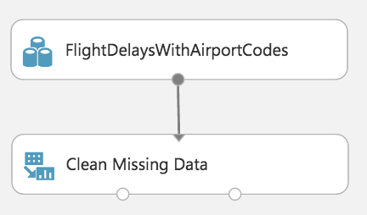

1. Click **Save** on the command bar at the bottom to save your in-progress experiment.

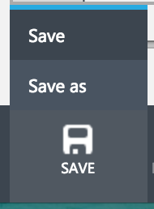

1. Click **Run** in the command bar at the bottom to run the experiment.



1. When the experiment is finished running, you will see a finished message in the top right corner of the design surface, and green check marks over all modules that ran.

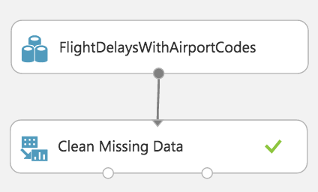

1. You should run your experiment whenever you need to update the metadata describing what data is flowing through the modules, so that newly added modules can be aware of the shape of your data (most modules have dialogs that can suggest columns, but before they can make suggestions you need to have run your experiment).
2. Click the **Clean Missing Data** module to select it. The property panel on the right will display the settings appropriate to the selected module.
3. In this case, we want to remove rows that have no value for the DepDel15 column. Begin by clicking **Launch Column Selector**.

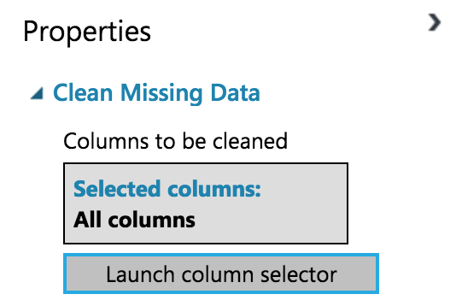

1. For the **Begin With** drop down, select **No Columns**. In the row of controls that appears, change the second drop down to **Include** and then **Column Names**. Then in the text box that appears begin to type DepDel15 and select that item from type-ahead list.

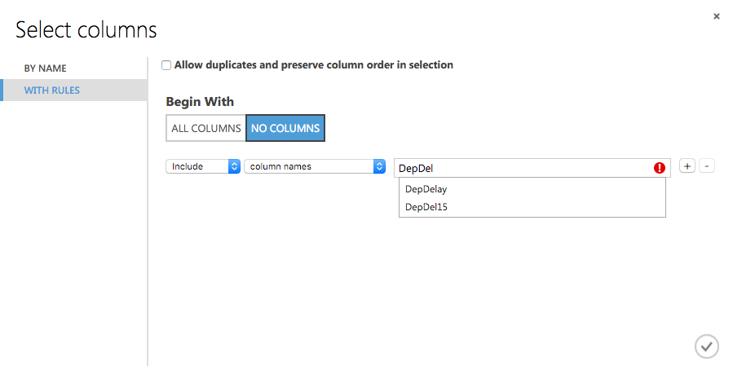

1. Click the checkmark to apply the settings. You have now indicated to the Clean Missing Data module that the DepDel15 is the only column it should act on.

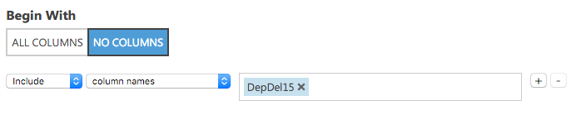

1. In the **Properties** panel for **Clean Missing Data**, click the **Cleaning mode** drop-down and select **Remove entire row**. Now your Clean Missing Data module is fully configured to remove any rows that are missing values for DepDel15.

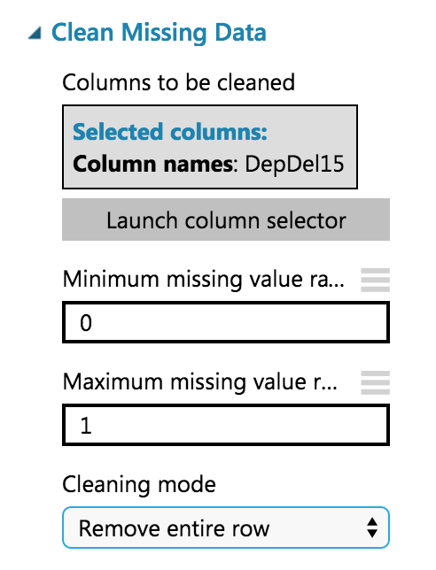

1. To verify the result, run your experiment again. After it is finished, click the left output port (Cleaned dataset) of the Clean Missing Data module and select **Visualize**.
2. In the dialog that appears, scroll over to DepDel15 and click the column. In the statistics, you should see that Missing Values reads 0.

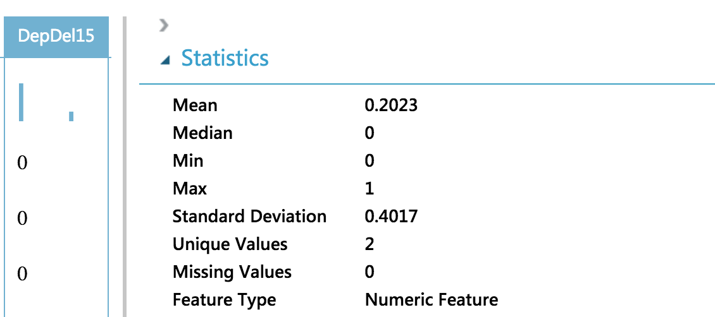

1. Our model will approximate departure times to the nearest hour, but departure time is captured as an integer. For example, 8:37 am is captured as 837. Therefore, we will need to process the CRSDepTime column and round it down to the nearest hour. To perform this rounding will require two steps, first you will need to divide the value by 100 (so that 837 becomes 8.37). Second, you will round this value down to the nearest hour (so that 8.37 becomes 8).
2. Begin by adding an Apply Math Operation module beneath the Clean Missing Data module and connect the output port (1) of the Clean Missing Data module to the input port of the Apply Math Operation.

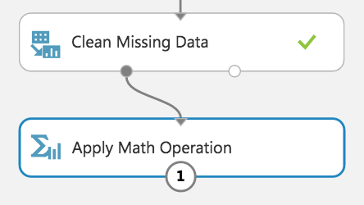

1. In the properties of the Apply Math Operation, set the Category to **Operations**, Basic operation to **Divide**, Operation argument type to **Constant**, Constant operation argument to **100**, Selected columns to **CRSDepTime**, and Output mode to **Append**.

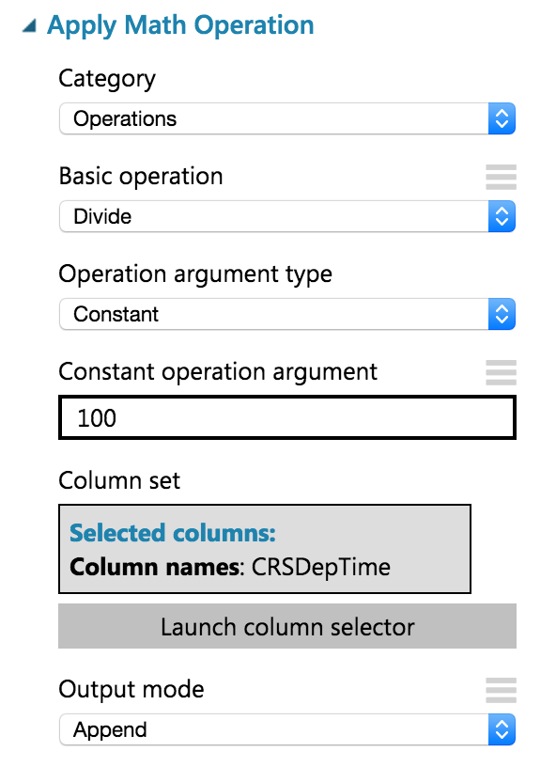

1. Run the experiment to update the metadata.
2. This module will add a new column to the dataset called Divide(CRSDeptTime_$100), but we want to rename it to CRSDepHour. To do so, add an **Edit Metadata** module and connect its input port to the output port of Apply Math Operation.

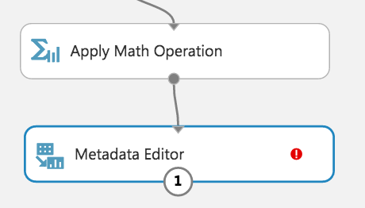

1. For the properties of the Metadata Editor, set the Selected Columns to **Divide(CRSDeptTime_$100)**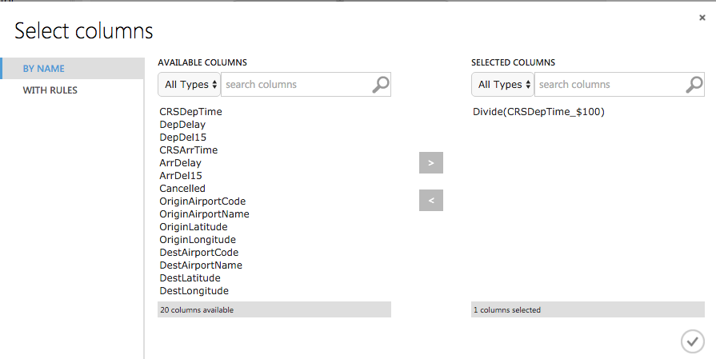
2. Back on the Properties for the Metadata Editor, set New column names to **CRSDepHour**.

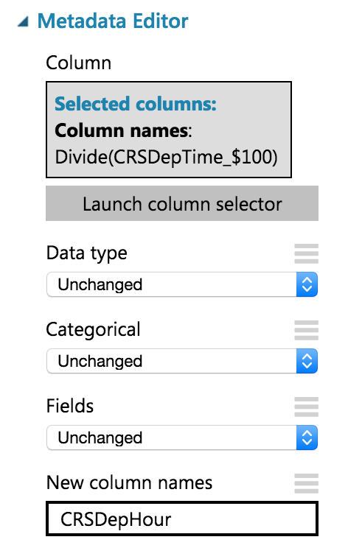

1. Run the experiment to update the metadata.
2. Add another **Apply Math Operation** module to round the time down to the nearest hour. Set the Category to **Rounding**, Selected columns to **CRSDepHour**, and Output mode to **Inplace**.

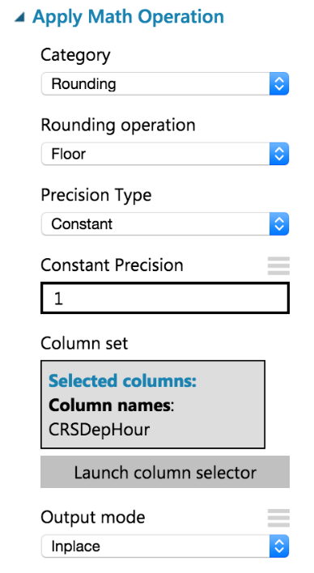

1. Run the experiment to update the metadata.
2. We do not need all of the columns present in the FlightDelaysWithAirportCodes dataset. To pare down the columns we can use multiple options, but in this case, we chose to use an R Script module that selects out only the columns of interest using R code.
3. Add an **Execute R Script** module beneath the last Apply Math Operation, and connect the output of the Apply Math Operation to the first input port (leftmost) of the Execute R Script.

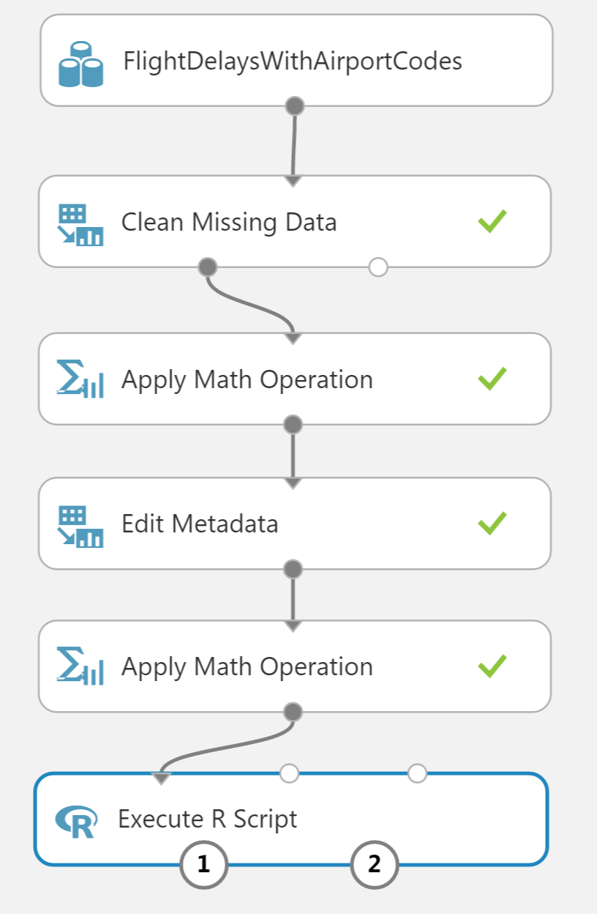

1. In the **Properties** panel for Execute R Script, click the **Double Windows** icon to maximize the script editor.



1. Replace the script with the following and click the check mark to save it. (Press CTRL+A to select all then CTRL+V to paste and then immediately click the check mark—do not worry if the formatting is off before hitting the check mark.)

ds.flights <- maml.mapInputPort(1)

# Trim the columns to only those we will use for the predictive model

ds.flights = ds.flights[, c("OriginAirportCode","OriginLatitude", "OriginLongitude", "Month", "DayofMonth", "CRSDepHour", "DayOfWeek", "Carrier", "DestAirportCode", "DestLatitude", "DestLongitude", "DepDel15")]

maml.mapOutputPort("ds.flights");

1. Run the experiment to update the metadata.
2. Right-click on the first output port of your Execute R Script module and select **Visualize**.
3. Verify that the dataset only contains the 12 columns referenced in the R script.

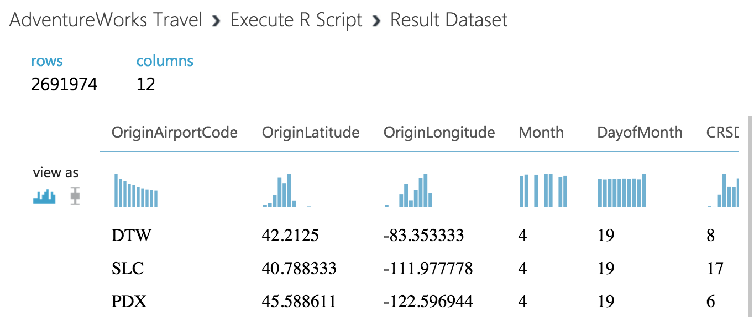

1. At this point, the Flight Delay Data is prepared, and we turn to preparing the historical weather data.

### Task 4: Prepare the weather data

1. To the right of the FlightDelaysWithAirportCodes dataset, add the **FlightWeatherWithAirportCodes** dataset.

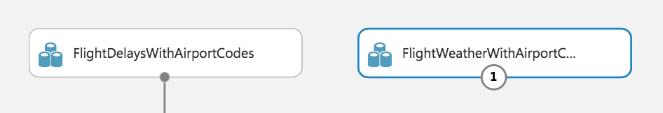

1. Right-click the output port of the FlightWeatherWithAirportCodes dataset and select **Visualize**.

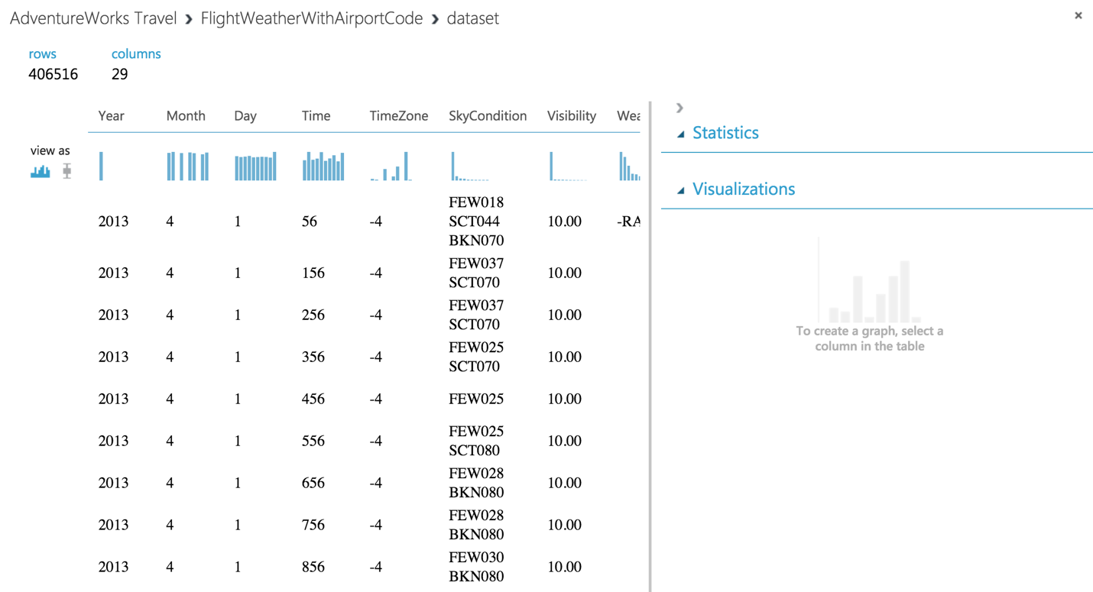

1. Observe that this data set has 406,516 rows and 29 columns. For this model, we are going to focus on predicting delays using WindSpeed (in MPH), SeaLevelPressure (in inches of Hg), and HourlyPrecip (in inches). We will focus on preparing the data for those features.
2. In the dialog, click the **WindSpeed** column and review the statistics. Observe that the Feature Type was inferred as String and that there are 32 Missing Values. Below that, examine the histogram to see that, even though the type was inferred as string, the values are all actually numbers (e.g. the x-axis values are 0, 6, 5, 7, 3, 8, 9, 10, 11, and 13). We will need to ensure that we remove any missing values and convert WindSpeed to its proper type as a numeric feature.

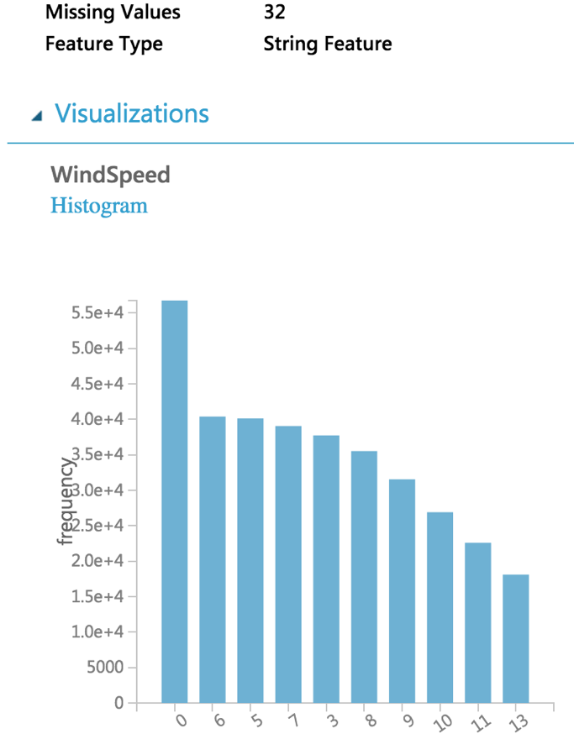

1. Next, click the **SeaLevelPressure** column. Observe that the Feature Type was inferred as String and there are 0 Missing Values. Scroll down to the histogram, and observe that many of the features are of a numeric value (e.g., 29.96, 30.01, etc.), but there are many features with the string value of M for Missing. We will need to replace this value of “M” with a suitable numeric value so that we can convert this feature to be a numeric feature.

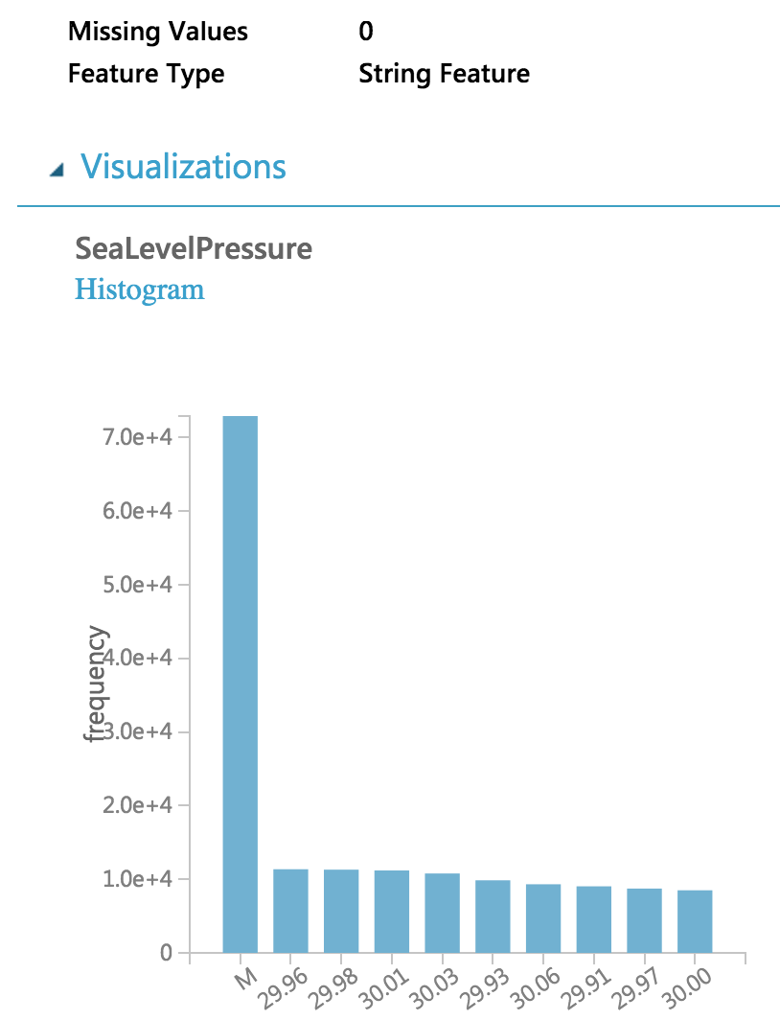

1. Finally, examine the HourlyPrecip feature. Observe that it too was inferred to have a Feature Type of String and is missing values for 374,503 rows. Looking at the histogram, observe that besides the numeric values, there is a value T for Trace amount of rain). We will need to replace the T with a suitable numeric value and covert this feature to a numeric feature.

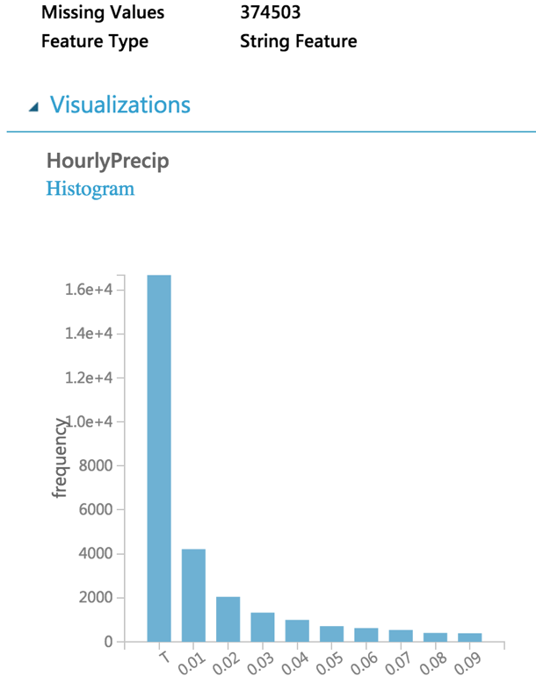

1. Let us begin by cleaning up the missing values for both WindSpeed and HourlyPrecip.
2. Below the FlightWeatherWithAirportCode dataset, drop a Clean Missing Data module and connect the output of the dataset to the input of module.

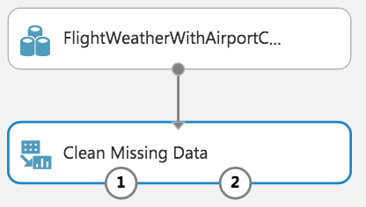

1. Run the experiment to update the metadata available to the Clean Missing Data module.
2. In the **Properties** panel for Clean Missing Data, set the Selected columns to **HourlyPrecip** and **WindSpeed**, set the Cleaning mode to **Custom substitution value,** and set the Replacement value to **0.0**.

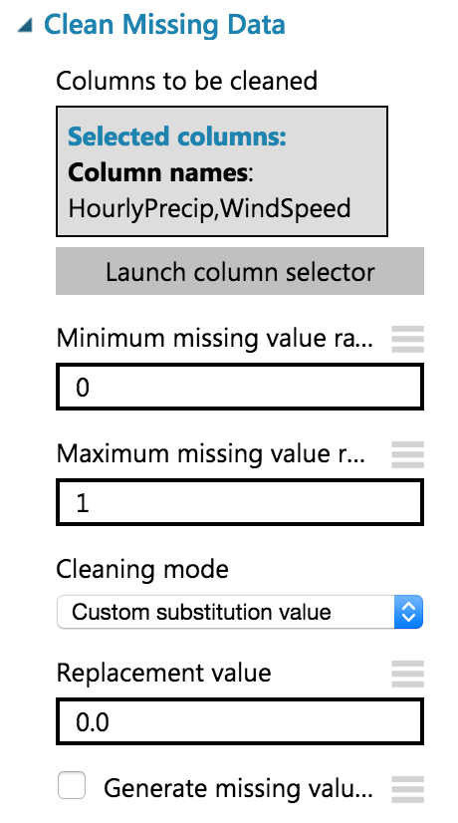

1. Next, add an Execute R Script module below the Clean Missing Data module and connect the first output port of the former to the first input port of the latter.

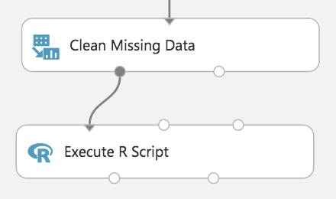

1. In the **Properties** panel for the Execute R Script, click the **Double Windows** icon to open the script editor.
2. Paste in the following script and click the checkmark (press CTRL+A to select all then CTRL+V to paste and then immediately click the checkmark-- don’t worry if the formatting is off before hitting the checkmark). This script replaces the HourlyPrecip values having T with 0.005, WindSpeed values of M with 0.005, and the SeaLevelPressure values of M with the global average pressure of 29.92. It also narrows the dataset to just the few feature columns we want to use with our model.

ds.weather <- maml.mapInputPort(1)

# Round weather time up to the next hour since

# that's the hour for which we want to use flight data

ds.weather$Hour = ceiling(ds.weather$Time / 100)

# Replace any WindSpeed values of "M" with 0.005 and make the feature numeric

speed.num = ds.weather$WindSpeed

speed.num[speed.num == "M"] = 0.005

speed.num = as.numeric(speed.num)

ds.weather$WindSpeed = speed.num

# Replace any SeaLevelPressure values of "M" with 29.92 (the average pressure) and make the feature numeric

pressure.num = ds.weather$SeaLevelPressure

pressure.num[pressure.num == "M"] = 29.92

pressure.num = as.numeric(pressure.num)

ds.weather$SeaLevelPressure = pressure.num

# Adjust the HourlyPrecip variable (convert "T" (trace) to 0.005)

rain = ds.weather$HourlyPrecip

rain[rain %in% c("T")] = "0.005"

ds.weather$HourlyPrecip = as.numeric(rain)

# Pare down the variables in the Weather dataset

ds.weather = ds.weather[, c("AirportCode", "Month", "Day", "Hour", "WindSpeed", "SeaLevelPressure", "HourlyPrecip")]

maml.mapOutputPort("ds.weather");

1. Run the experiment. Currently it should appear as follows:  
    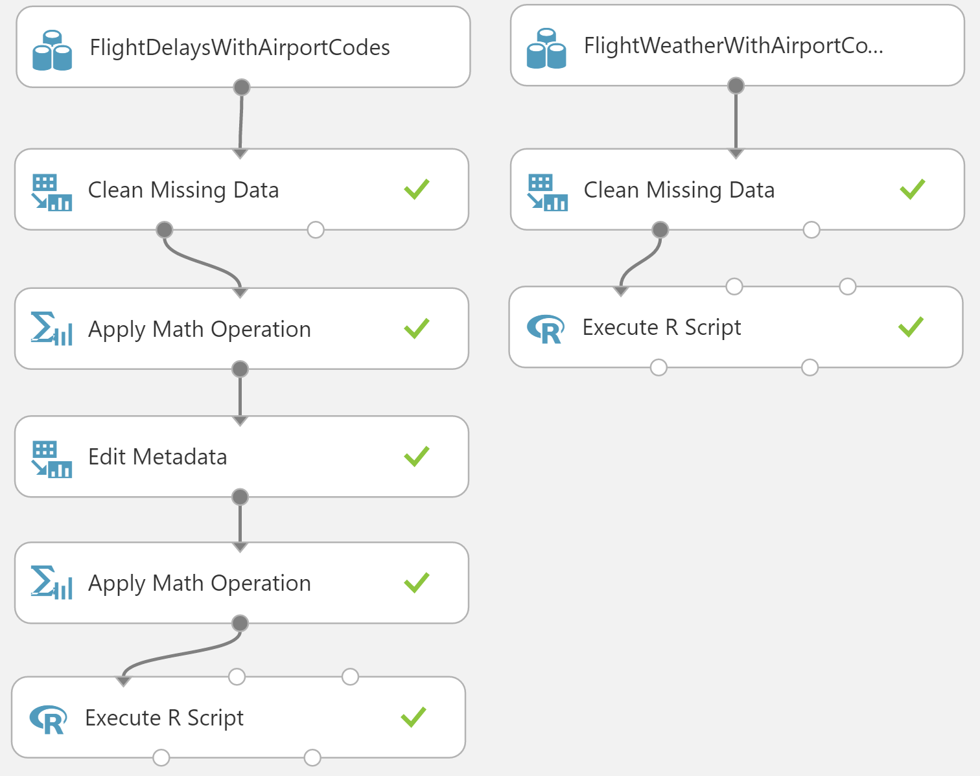
2. Click the first output port of the Execute R Script module.
3. In the statistics, verify that WindSpeed, SeaLevelPressure, and HourlyPrecip are now all Numeric Feature types and that they have no missing values.

### Task 5: Join the Flight and Weather datasets

1. With both datasets ready, we want to join them together so that we can associate historical flight delay with the weather data at departure time.
2. Drag the Join Data module on to the design surface, beneath and centered between both Execute R Script modules. Connect the output port (1) of the left Execute R module to input port (1) of the Join Data module, and the output port (1) of the right Execute R module to the input port (2) of the Join Data module.

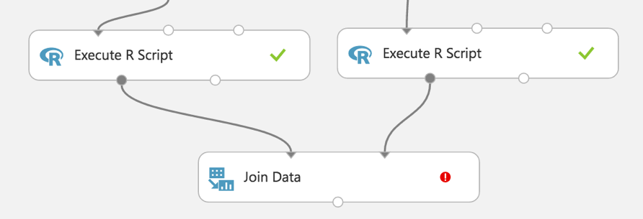

1. In the **Properties** panel, relate the rows of data between the two sets L (the flight delays) and R (the weather). Set the Join key columns for L to include OriginAirportCode, Month, DayofMonth, and CRSDepHour.
2. Set the join key columns for R to include AirportCode, Month, Day, and Hour.
3. Leave the Join Type at inner join and uncheck **Keep right key columns in joined table** (so that we do not include the redundant values of AirportCode, Month, Day, and Hour).

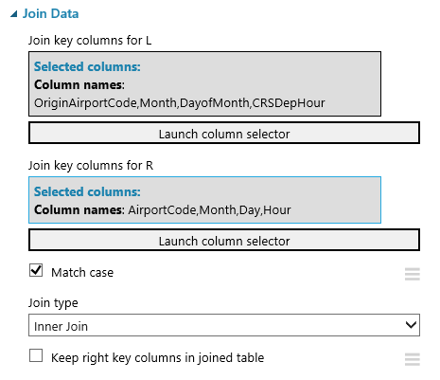

1. Next, add an **Edit Metadata** module and connect its input port to the output port of the Join Data module. We will use this module to convert the fields that were unbounded String feature types, to the enumeration like Categorical feature. On the **Properties** panel, set the Selected columns to DayOfWeek, Carrier, DestAirportCode, and OriginAirportCode. Set the Categorical drop down to **Make categorical**.

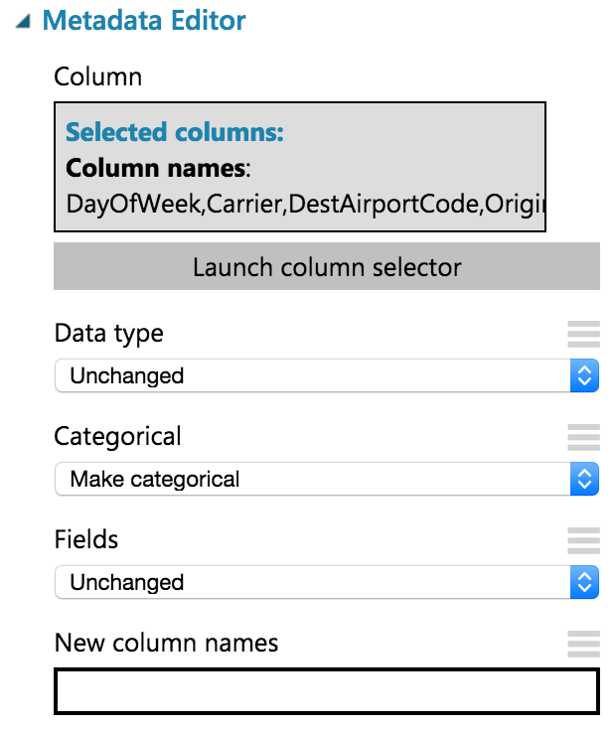

1. Add a **Select Columns in Dataset** module. Choose **Begin With All Columns,** choose **Exclude,** and set the selected columns to exclude: **OriginLatitude, OriginLongitude, DestLatitude**, and **DestLongitude**.

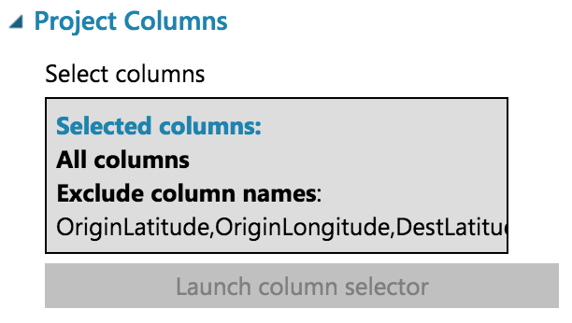

1. Connect the output of the Metadata Editor to the input of the Select Columns in Dataset module.
2. Save your experiment.

### Task 6: Train the model

AdventureWorks Travel wants to build a model to predict if a departing flight will have a 15-minute or greater delay. In the historical data they have provided, the indicator for such a delay is found within the DepDel15 (where a value of 1 means delay, 0 means no delay). To create a model that predicts such a binary outcome, we can choose from the various Two-Class modules that Azure ML offers. For our purposes, we begin with a Two-Class Logistic Regression. This type of classification module needs to be first trained on sample data that includes the features important to making a prediction and must include the actual historical outcome for those features.

The typical pattern is split the historical data so a portion is shown to the model for training purposes, and another portion is reserved to test just how well the trained model performs against examples it has not seen before.

1. Drag a Split module beneath Select Columns in Dataset and connect them.

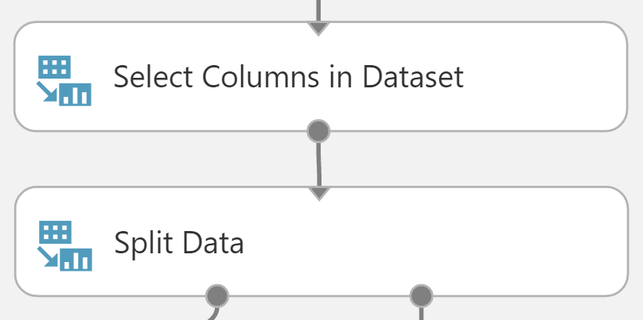

1. On the **Properties** panel for the Split Data module, set the Fraction of rows in the first output dataset to **0.7** (so 70% of the historical data will flow to output port 1). Set the Random seed to **7634**.

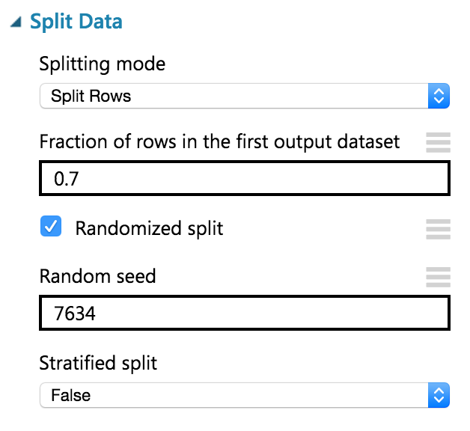

1. Next, add a Train Model module and connect it to output 1 of the Split Data module.

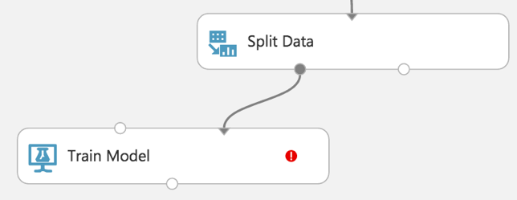

1. On the **Properties** panel for the Train Model module, set the Selected columns to **DepDel15**.

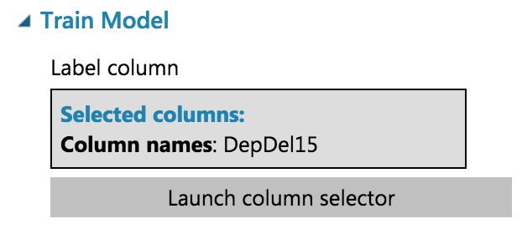

1. Drag a Two-Class Logistic Regression module above and to the left of the Train Model module and connect the output to the leftmost input of the Train Model module

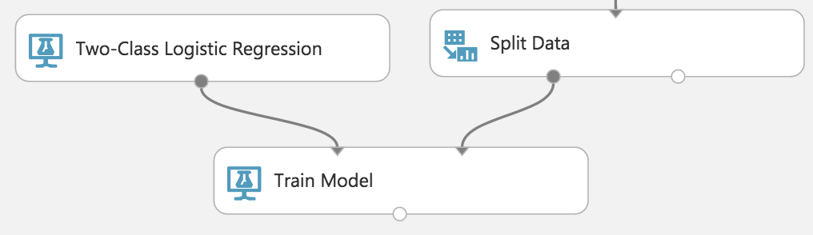

1. Below the Train Model, drop a Score Model module. Connect the output of the Train Model module to the leftmost input port of the Score Model and connect the rightmost output of the Split Data module to the rightmost input of the Score Model.

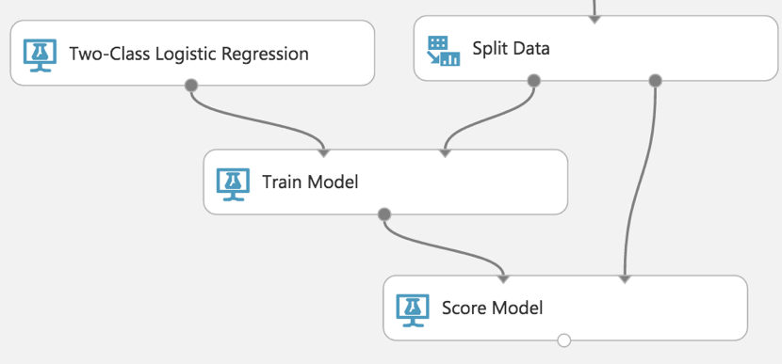

1. Run the experiment.
2. When the experiment is finished running (which takes a few minutes), right-click on the output port of the Score Model module and select **Visualize** to see the results of its predictions. **You should have a total of 13 columns**.

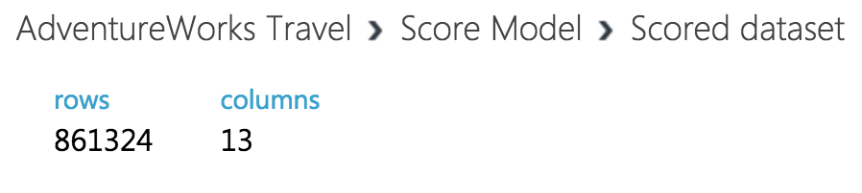

1. If you scroll to the right so that you can see the last two columns, observe there is a Scored Labels column and a Scored Probabilities column. The former is the prediction (1 for predicting delay, 0 for predicting no delay) and the latter is the probability of the prediction. In the following screenshot, for example, the last row shows a delay predication with a 53.1% probability.

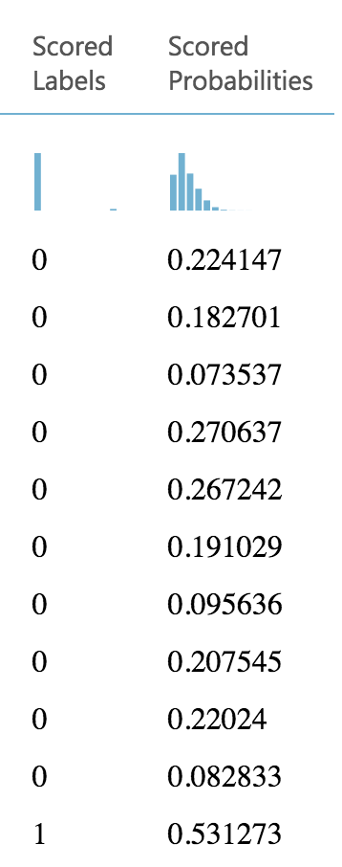

1. While this view enables you to see the prediction results for the first 100 rows, if you want to get more detailed statistics across the prediction results to evaluate your model’s performance, you can use the Evaluate Model module.
2. Drag an Evaluate Model module on to the design surface beneath the Score Model module. Connect the output of the Score Model module to the leftmost input of the Evaluate Model module.

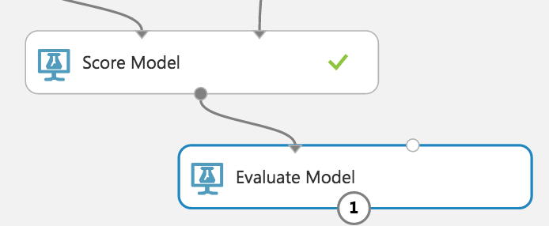

1. Run the experiment.
2. When the experiment is finished running, right-click the output of the Evaluate Model module and select **Visualize**. In this dialog box, you are presented with various ways to understand how your model is performing in the aggregate. While we will not cover how to interpret these results in detail, we can examine the ROC chart that tells us that at least our model (the blue curve) is performing better than random (the light gray straight line going from 0,0 to 1,1)—which is a good start for our first model!

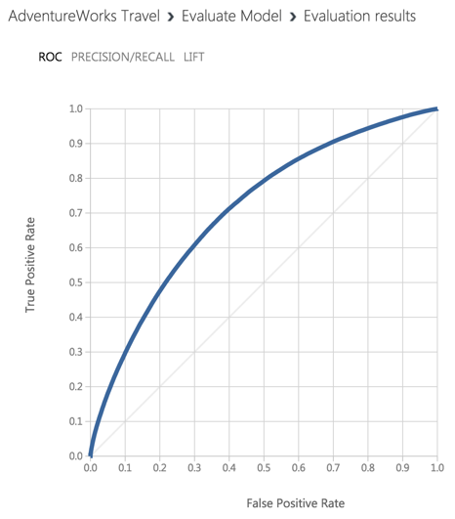

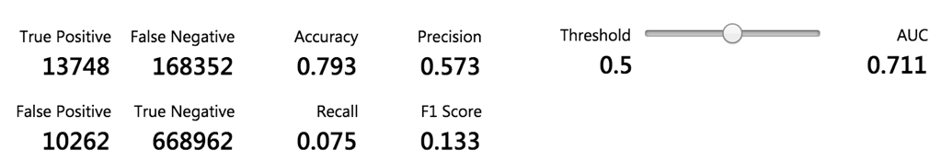

### Task 7: Operationalize the experiment

1. Now that we have a functioning model, let us package it up into a predictive experiment that can be called as a web service.
2. In the command bar at the bottom, click **Set Up Web Service** and then select **Predictive Web Service [Recommended]**. (If Predictive Web Service is grayed out, run the experiment again)

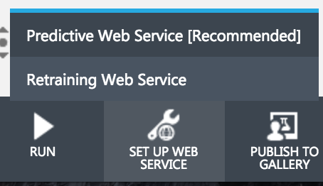

1. A copy of your training experiment is created that contains the trained model wrapped between web service input (e.g. the web service action you invoke with parameters) and web service output modules (e.g., how the result of scoring the parameters are returned).
2. We will adjust the web service input and output modules to control the parameters we require and the results we return.
3. When packaging the Predictive Web Service, Azure ML added two Apply Transformation modules that are not needed. **Delete both of the Apply Transformation Modules**.  
   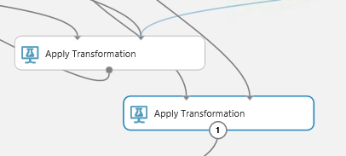
4. The Apply Transformation Modules were added to support the Clean Missing Data modules. We will not be using these steps in our flow, so **delete both Clean Missing Data Modules**.  
   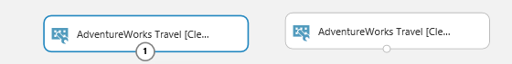
5. Reconnect the FlightDelaysWithAirportCodes to the input to Apply Math Operation module that is directly beneath it.  
   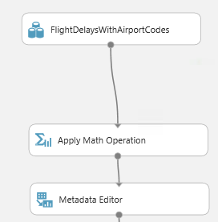
6. Reconnect the FlightWeatherWithAirportCodes module to the leftmost input port of the Execute R Script module beneath it.  
   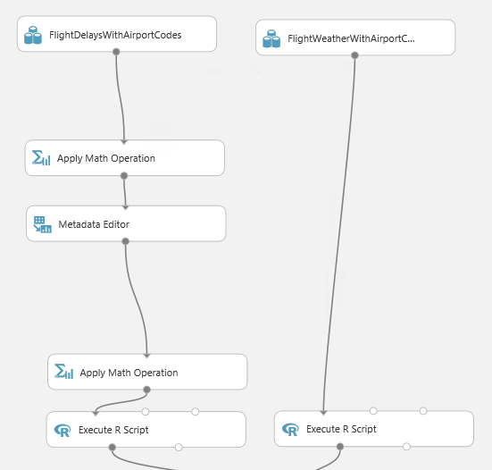
7. Now move the web service input down so it is to the right of the Join Data module. Connect the output of the Web service input to input of the Metadata Editor.

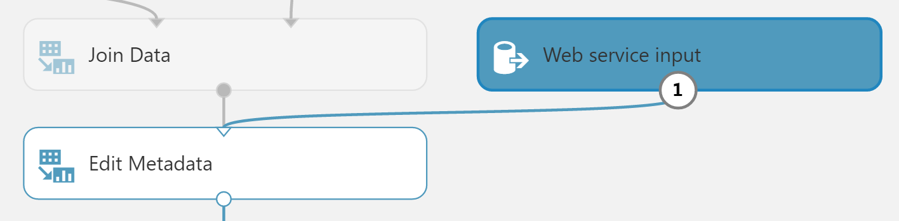

1. Right-click the line connecting the Join Data module and the Edit Metadata and select **Delete**.

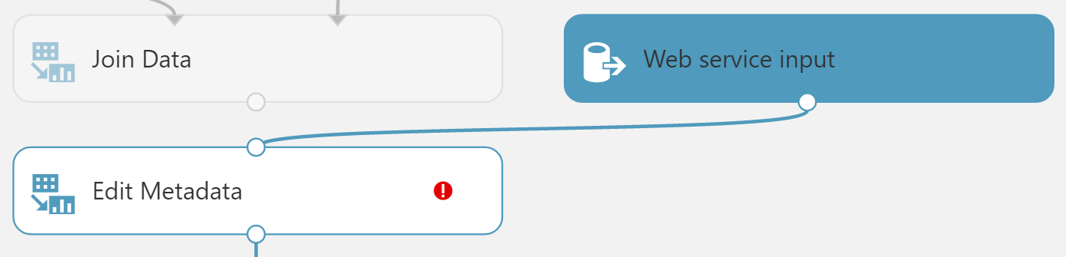

1. In between the Join Data and the Metadata Editor modules, drop a Select Columns in Dataset module. In the **Properties** panel for the Select Columns in Dataset module, set the Select columns to **all columns**, **exclude** **columns DepDel15, OriginLatitude, OriginLongitude, DestLatitude,** and **DestLongitude**. This configuration will update the web service metadata so that these columns do not appear as required input parameters for the web service.

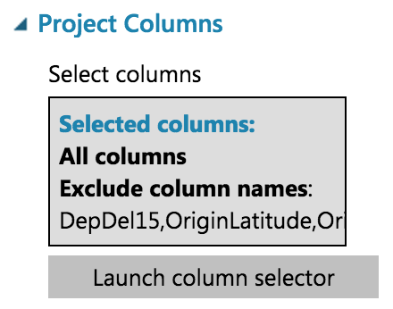

1. Connect the Select Columns in Dataset input to Join Data and its output to Metadata Editor.

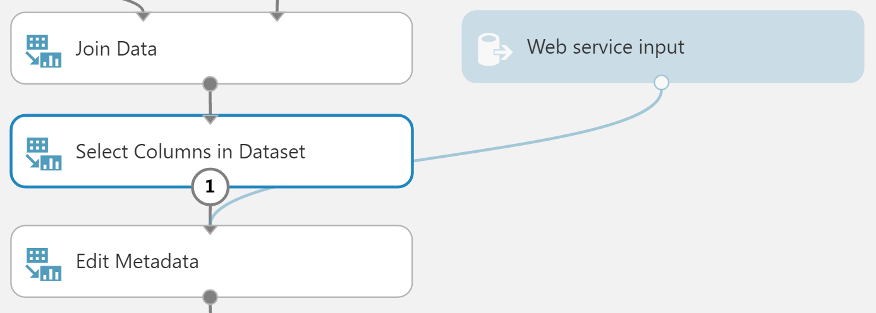

1. Select the Select Columns in Dataset module that comes after the Metadata Editor and delete it.
2. Connect the output of the Edit Metadata directly to the right input of the Score Model module.

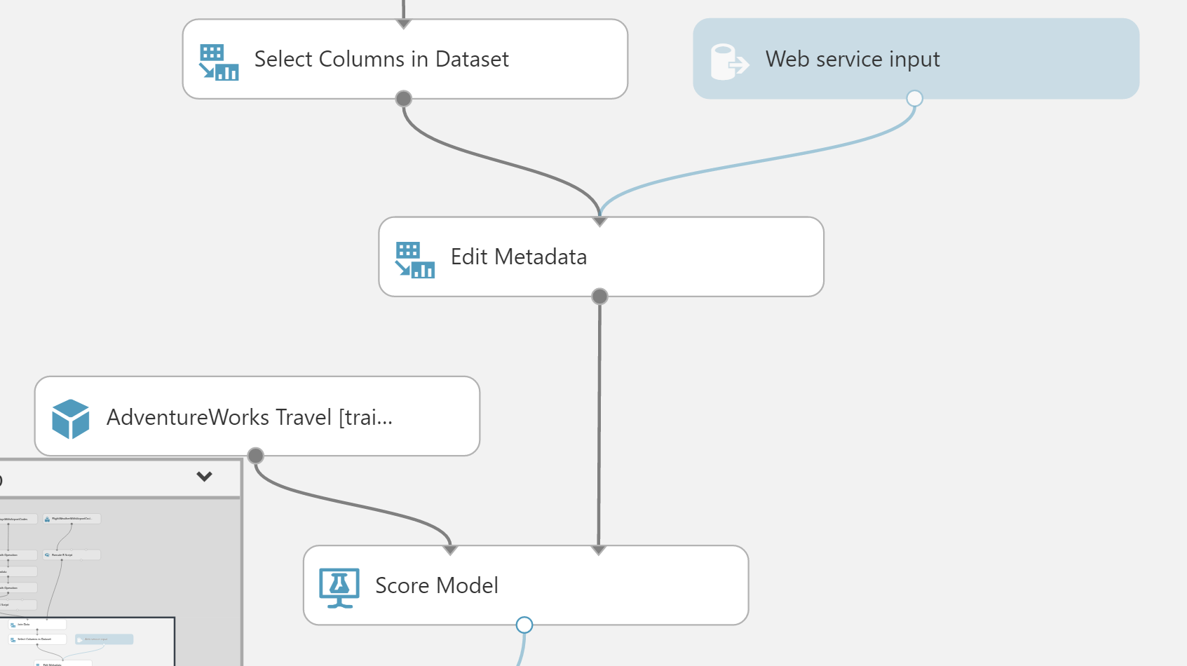

1. As we removed the latitude and longitude columns from the dataset to remove them as input to the web service, we have to add them back in before we return the result so that the results can be easily visualized on a map.
2. To add these fields back, begin by deleting the line between the Score Model and Web service output.
3. Drag the AirportCodeLocationLookupClean dataset on to the design surface, positioning it below the Score Model module.

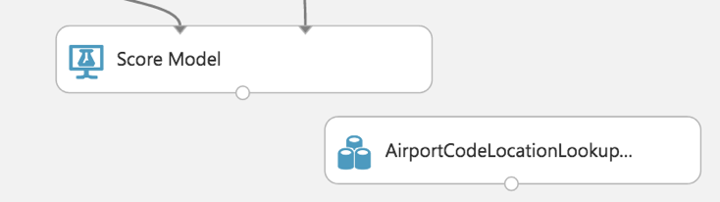

1. Add a Join Data module. In the **Properties** panel for the Join Data module, for the Join key columns for L set the selected columns to **OriginAirportCode**. For the Join key columns for R, set the Selected columns to **AIRPORT**. Uncheck Keep right key columns in joined table.

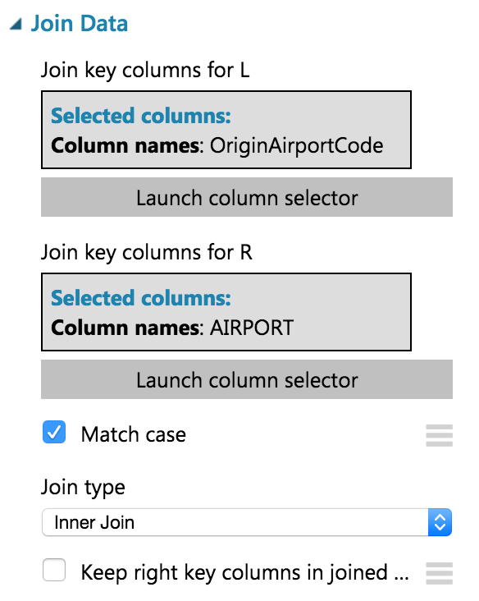

1. Connect the output of the Score Model module to the leftmost input of the Join Data module and the output of the dataset to the rightmost input of the Join Data module.

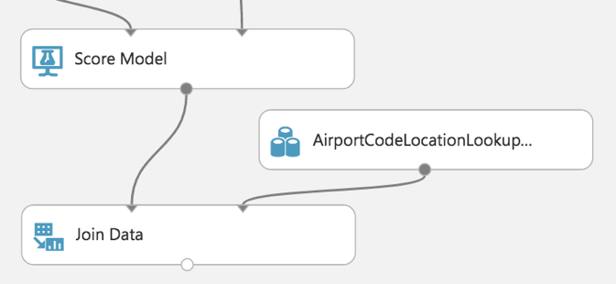

1. Add a Select Columns in Dataset module beneath the Join Data module. In the **Property** panel, begin with **All Columns**, and set the Selected columns to **exclude** the columns: **AIRPORT_ID** and **DISPLAY_AIRPORT_NAME**.

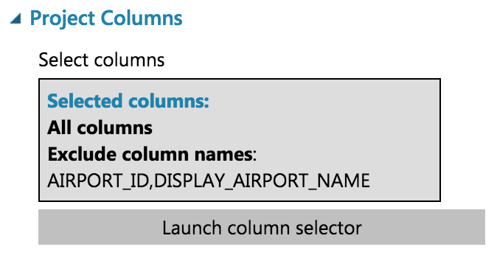

1. Connect the Join Data output to the input of the Select Columns in Dataset module.

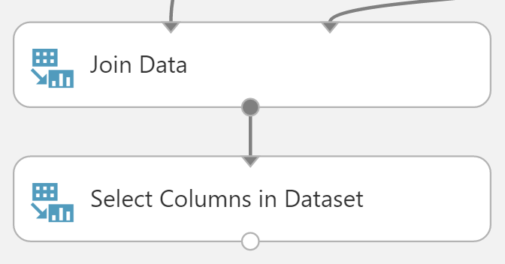

1. Add an Edit Metadata module. In the **Properties** panel for the Metadata Editor, set the Selected columns to LATITUDE and LONGITUDE. In the New column names enter: **OriginLatitude**, **OriginLongitude**.

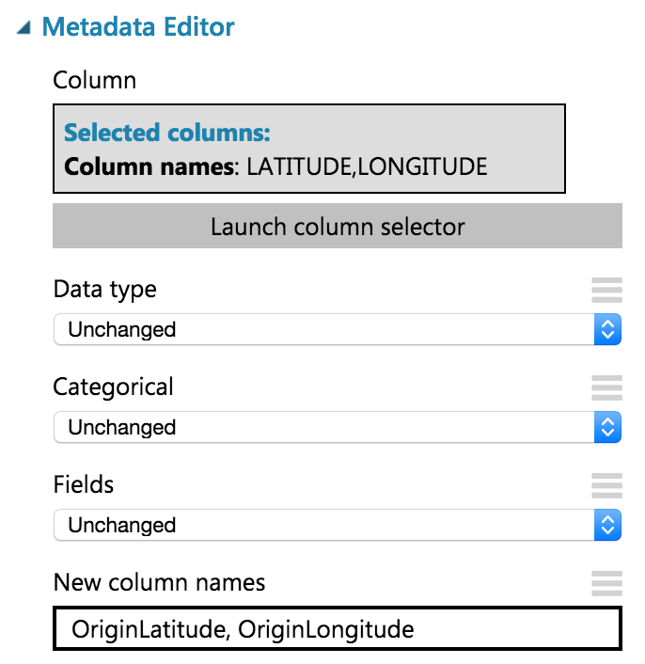

1. Connect the output of the Select Columns in Dataset module to the input of the Edit Metadata module.

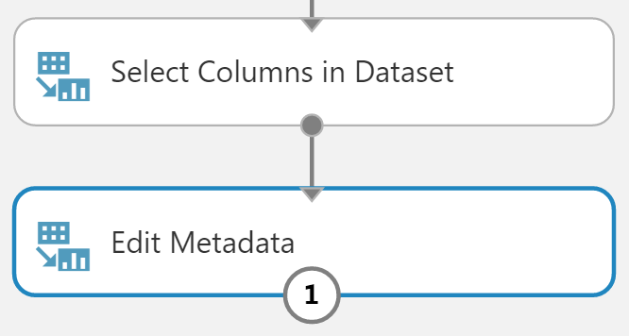

1. Connect the output of the Edit Metadata to the input of the web service output module.

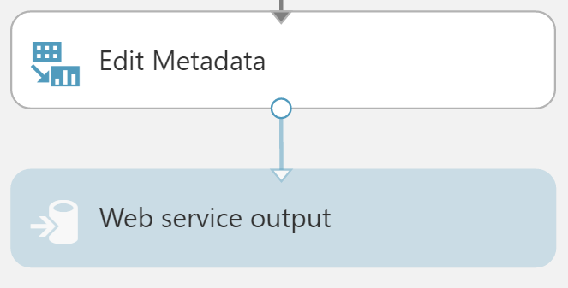

1. Run the experiment.
2. When the experiment is finished running, click **Deploy Web Service**, **Deploy Web Service [NEW]**.  
   (Please be sure to disable any popup blockers, or allow the new popup window)  
   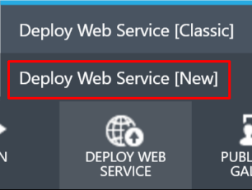
3. Enter a Web Service Name, and then select the **Standard DevTest** (FREE) Monthly Plan Option.  
   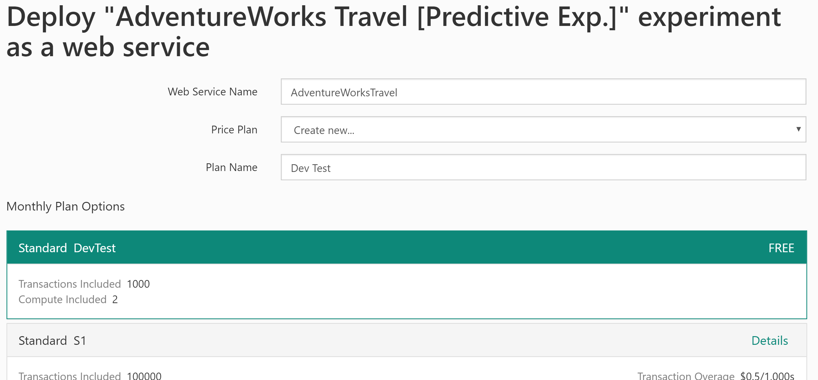
4. Enter a Plan Name, and then click **Deploy**.
5. When the deployment is complete, you will be taken to the Web Service Quickstart page. Click on the **Consume** tab.

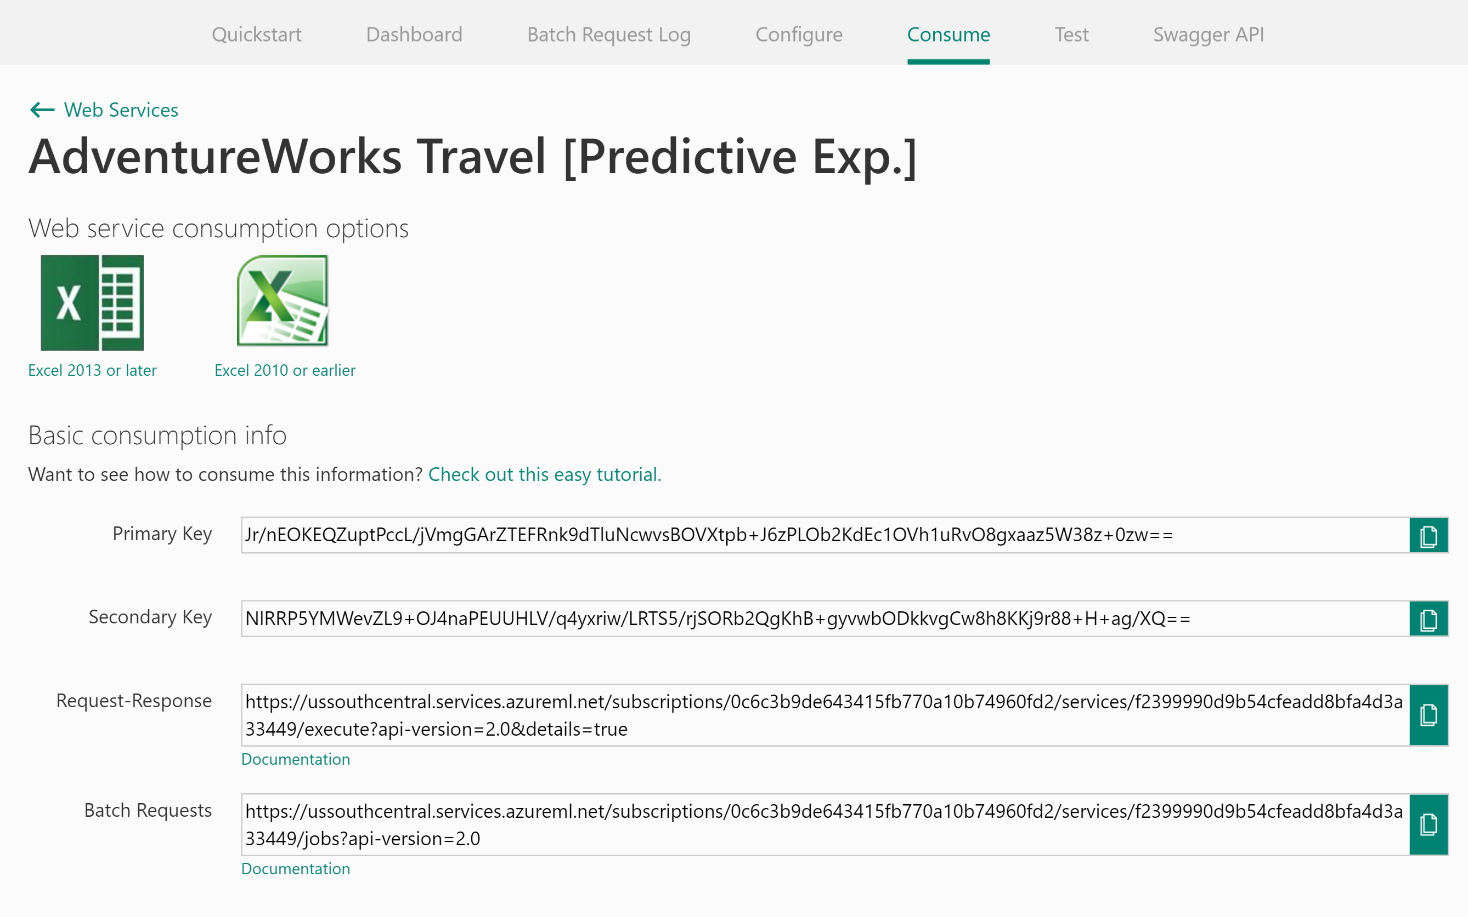

Leave this page open for the next task.

Placeholder for ML Service Information

### Task 8: Integrate the web service with the sample web app

1. From the Web Service consume page, copy the API’s Primary Key.
2. With the sample web app open in Visual Studio, right-click the project properties, click Properties, and then navigate to the **Settings** tab.
3. Paste the API KEY into the value column for the setting titled ML_APIKEY.



1. Scroll down until you see the **Request-Response** URL. From this URL, you can get the Workspace ID and the Service ID.

https://**ussouthcentral**.services.azureml.net/subscriptions/**f8a24adcde7c45e1bb1c9ef85fe36f62**/services/**656c53c99cc848e1a476f5068ba39fb6**/execute?api-version=2.0&details=true

1. The first term (e.g., ussouthcentral) is the region prefix for your ML workspace. The first GUID after workspaces is your Workspace ID. The second GUID after services is your Service ID.
2. Copy each of these values into the settings ML_RegionPrefix, ML_WorkspaceID and ML_ServiceID respectively in the Settings area of the sample web app in Visual Studio.

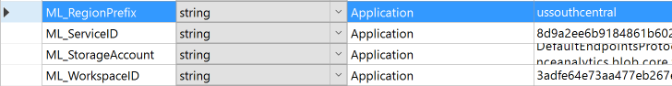

1. Save the solution.
2. Publish the sample.
3. View the sample home page.
4. Fill out the flight criteria and click **Predict Delays** (remember to update the departure date so it is within 10 days of today). In addition to the weather forecast, you should see the delay prediction and confidence.



## Exercise 4: Batch score data with Azure ML and summarize with SQL Data Warehouse

Duration: 60 mins

Synopsis: In this exercise, attendees will batch score and prepare a summary of flight delay data in SQL Data Warehouse.

### Task 1: Batch score flight data

1. AdventureWorks has provided a sample CSV file to batch score using your Azure ML model. You can download it from <http://bit.ly/1XGg6M5>.
2. Open Visual Studio.
3. From the **View** menu, select **Cloud Explorer**.

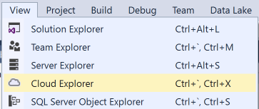

1. If prompted, sign in to Visual Studio. Enter your login and click **Continue**.



1. Select the appropriate option for work or school account or Microsoft account.



1. Enter your password and click **Sign In**.



1. Allow Cloud Explorer about 30 seconds to load your subscription resources.
2. Expand **Storage Accounts**. It may take a few moments to load.

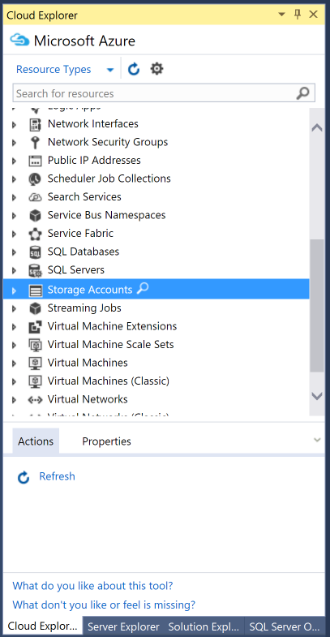

1. Expand the Storage Account you created for this Hackathon, then right-click **Containers** and select **Create Blob Container**.  
    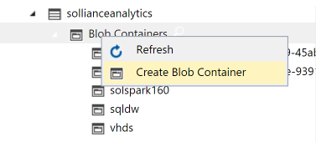
2. Provide a name for the container.

Placeholder for Storage Container Name

1. Right-click the new container, and select **Open Blob Container Editor**.

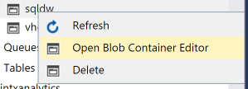

1. In the document that appears, click **Upload Blob**.

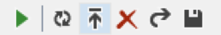

1. In the Upload New File dialog box, browse to the FlightsAndWeather.csv file you downloaded and select it. Enter flights in the Folder field, and click **OK**.

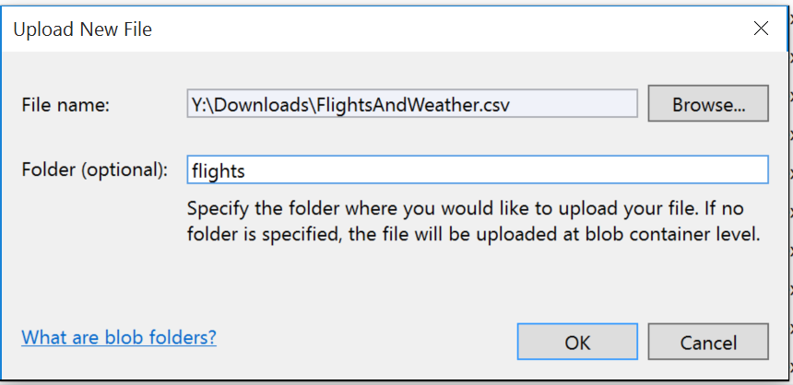

1. Wait for the upload to complete.

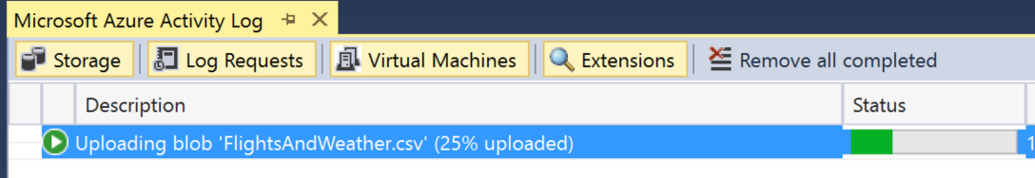

1. Open a browser and navigate to Azure Machine Learning Web Services and click **Web Services**. You can always get there by going to <https://services.azureml.net/>.
2. Click on your web service.
3. Click on the **Consume** tab.
4. On this page, take note of the PRIMARY KEY below the Basic Consumption Info section. You will need this value in a subsequent step.
5. Also within this section, observe the BATCH REQUESTS URL.

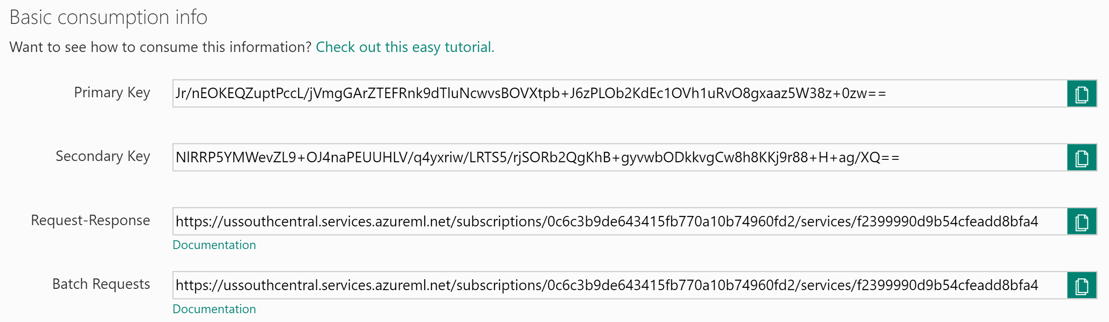

1. The sequence of letters and numbers following subscriptions/ is your workspace ID. Take note of this ID. The sequence of letters and numbers following services/ is your service ID, take note of this ID as well.



1. With the sample app open in Visual Studio. In Solution Explorer, right-click the project, select **Properties**, and then click the **Settings** tab.
2. Verify the values for the following settings from your published Machine Learning service (they should be exactly the same as what you used for the request/response task earlier):

ML_APIKey: PRIMARY KEY for your Machine Learning web service

ML_StorageAccount: The connection string to the Storage Account where you uploaded the flights CSV.

ML_WorkspaceID: The ID of the Machine Learning Workspace.

ML_ServiceID: The ID of your Machine Learning web service.

ML_RegionPrefix: The name of the region in which your ML service is deployed.

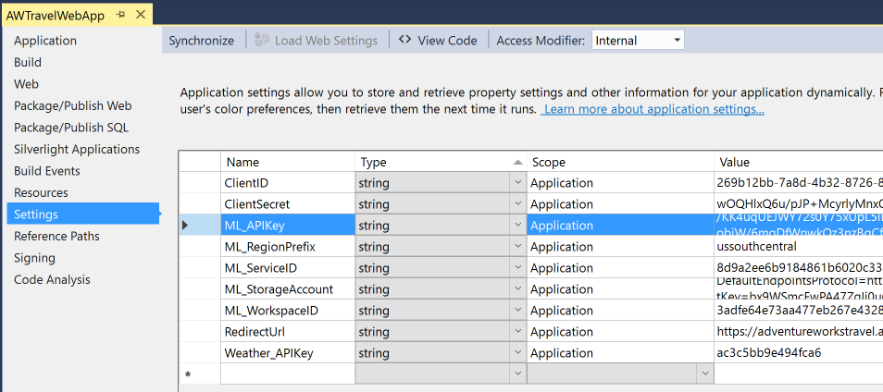

1. Save the solution.
2. Publish the solution.
3. Navigate to your deployed sample in the browser, but instead of going to the homepage go to BatchScore, for example:

http://<yourwebapp>.azurewebsites.net/BatchScore

1. Modify the values of the relative paths for the location of the file to score and the location of scored output to that it is correct for your environment, for example:

Relative location of file to score: **<ContainerName>**/flights/FlightsAndWeather.csv

Relative location of scored output file: **<ContainerName>**/flights/Scored_FlightsAndWeather.csv  
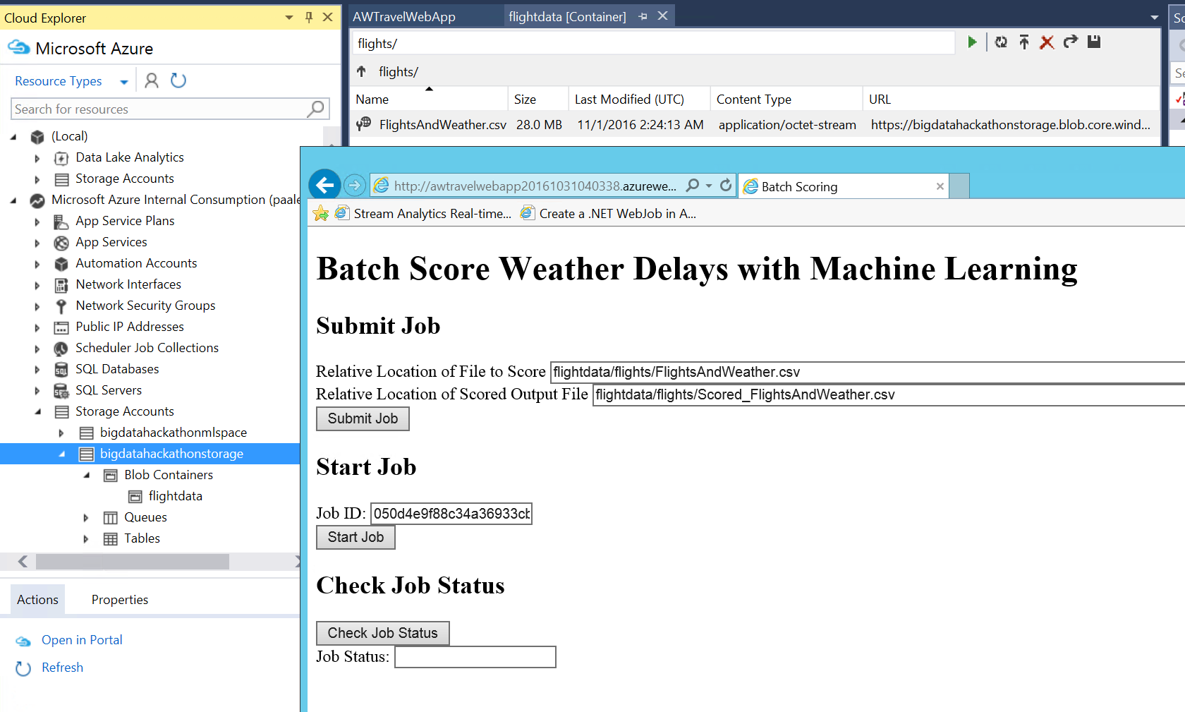

1. Click **Submit Job**.
2. When a Job ID appears, click **Start Job** to begin the batch scoring process.
3. Periodically click check job status until you see the job status of Job is finished. This will take 1-2 minutes. You now have a scored CSV ready for summarization using SQL Data Warehouse.   
   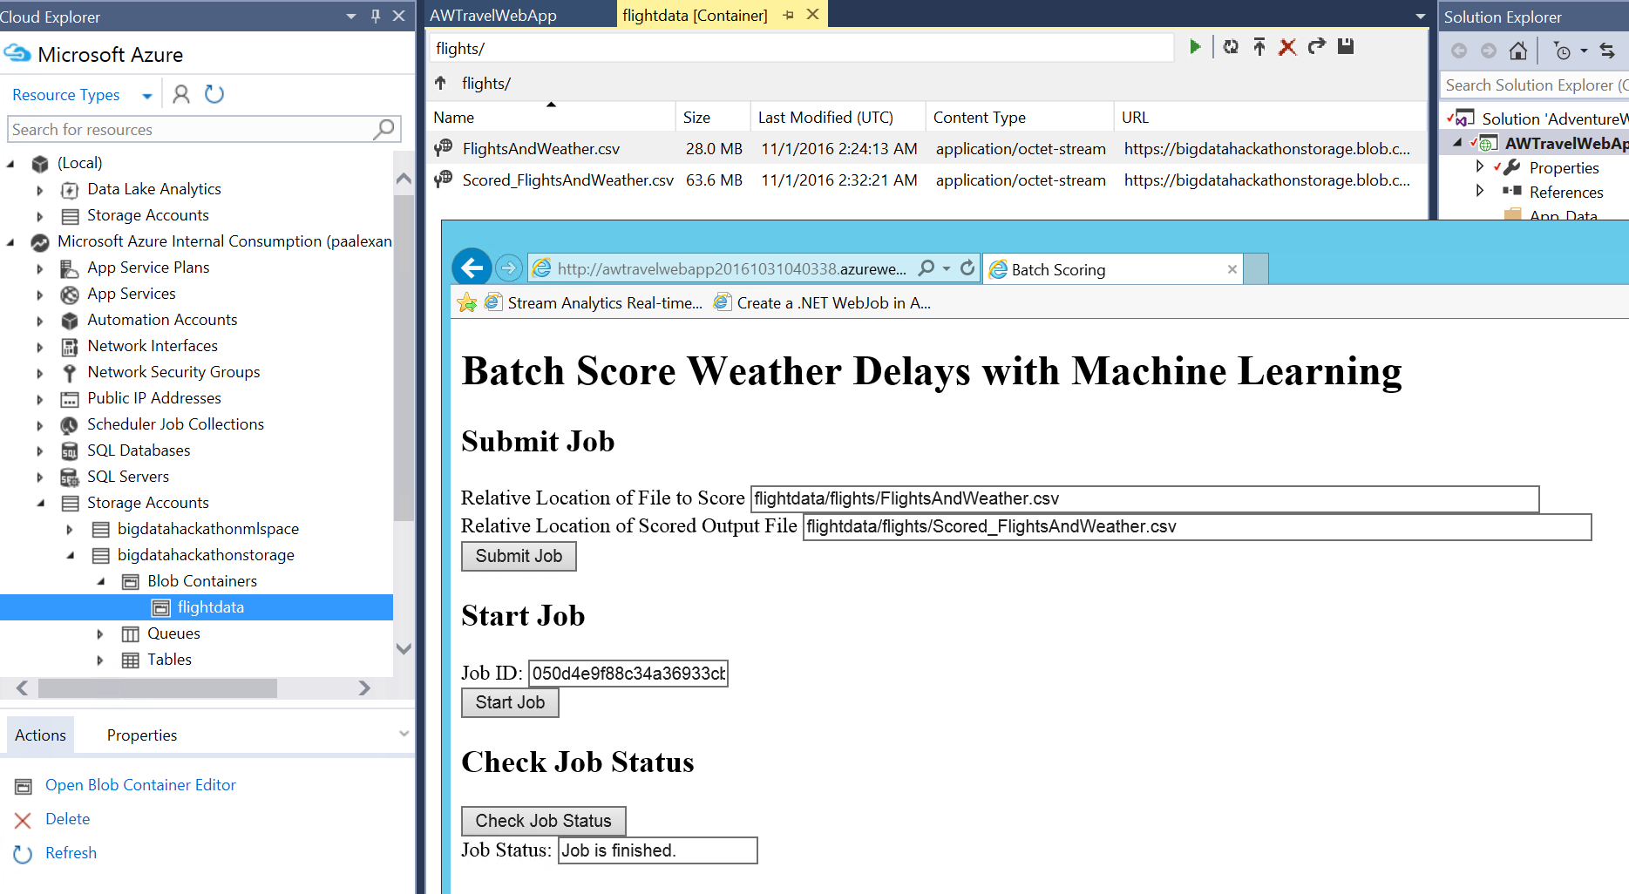

### Task 2: Summarize delays by airport

1. Using Visual Studio, go to Cloud Explorer by selecting **View**, **Cloud Explorer**.



1. Expand SQL Databases  
   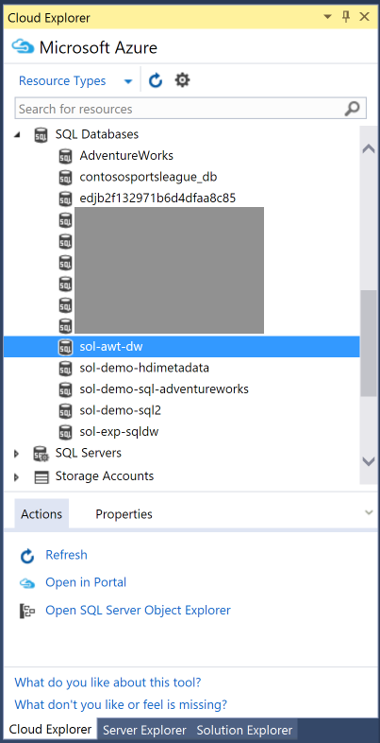
2. Right-click your SQL Data Warehouse and select **Open SQL Server Object Explorer**. If this fails with an error, you can always open SQL Server Object Explorer from the View menu and then add your SQL Server manually.

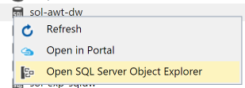  
  
Use the Connect dialog as displayed below to connect to your SQL Server manually if the automatic connection failed:  
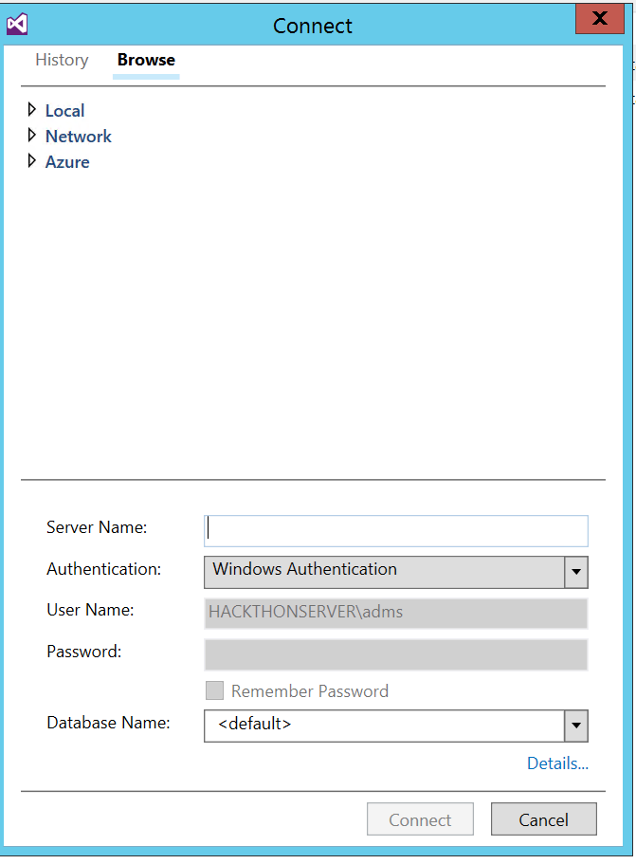

1. In SQL Server Object Explorer, right-click your SQL Data Warehouse database and select **New Query**.  
   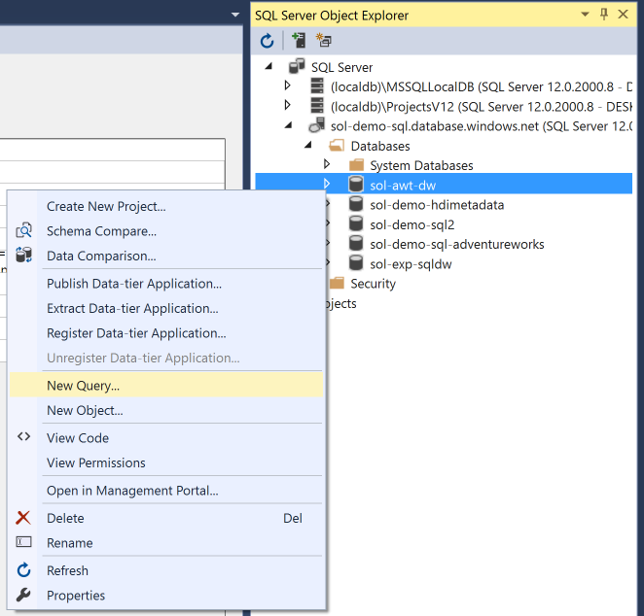
2. In the document that appears, paste the following query, which stores the connection information to your Azure Storage Account (that contains the Scored_FlightAndWeather.csv) and defines a particular container and path as the root for subsequent steps. Substitute in your Storage Account Name and Storage Account Key (replacing the <StorageAccountKey>, <Container>, and <StorageAccountName> in the query with the corresponding values you can get from the Azure Portal).

CREATE MASTER KEY;

CREATE DATABASE SCOPED CREDENTIAL ASBSecret

WITH IDENTITY = 'flightdelaysclient'

, Secret = '<StorageAccountKey>'

;

CREATE EXTERNAL DATA SOURCE azure_storage

WITH

(

TYPE = HADOOP

, LOCATION ='wasbs://<Container>@<StorageAccountName>.blob.core.windows.net/flights'

, CREDENTIAL = ASBSecret

);

CREATE EXTERNAL FILE FORMAT text_file_format

WITH

(

FORMAT_TYPE = DELIMITEDTEXT

, FORMAT_OPTIONS (

FIELD_TERMINATOR =','

, USE_TYPE_DEFAULT = TRUE

)

);

1. Run the Query by clicking the **Execute** icon. The first time you run a query this way, you may get an error dialog box that you can safely ignore. All error messages will be output in the output pane just below the query window.  
   
2. Next, append the following query that creates an external table (e.g., a table structure that is superimposed over the files in Blob storage).   
     
   CREATE EXTERNAL TABLE FlightDelays(OriginAirportCode char(3), Month tinyint, Day tinyint, Hour tinyint, DayOfWeek tinyint, Carrier varchar(4), DestAirportCode char(3), DepDelay15 bit, WindSpeed smallint, SeaLevelPressure decimal(4,2),

HourlyPrecipitation decimal(8,5), DelayPredicted bit, DelayProbability decimal(5,4), OriginLatitude decimal(14,10), OriginLongitude decimal(14,10))

WITH

(

LOCATION = '/Scored_FlightsAndWeather.csv',

DATA_SOURCE = azure_storage,

FILE_FORMAT = text_file_format,

REJECT_TYPE = value,

REJECT_VALUE = 100000  
);

1. Highlight the query you just added and click **Execute**. (By highlighting the query, only the selection is executed.) When this completes, you should have the FlightDelays table you can query using T-SQL.
2. Run the following T-SQL to view a sample of the contents.  
     
   SELECT Top 100 * FROM FlightDelays;
3. You should see output similar to the following:  
   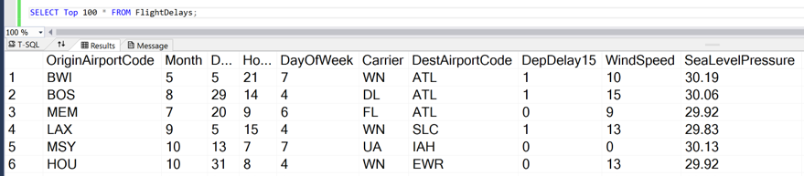
4. Create a View called FlightDelaysSummary by copying and pasting the following SQL and then executing it:

CREATE VIEW FlightDelaysSummary AS

SELECT OriginAirportCode, Cast(OriginLatitude as varchar(15)) + ',' + Cast(OriginLongitude as varchar(15)) OriginLatLong, Month, Day, Hour, Sum(Cast(DelayPredicted as int)) NumDelays, Avg(DelayProbability) AvgDelayProbability

FROM FlightDelays

WHERE Month = 4

GROUP BY OriginAirportCode, Cast(OriginLatitude as varchar(15)) + ',' + Cast(OriginLongitude as varchar(15)) , Month, Day, Hour

Having Sum(Cast(DelayPredicted as int) ) > 1

1. Examine the contents of this view by running the following query.  
     
   SELECT * FROM FlightDelaysSummary
2. You are now ready to visualize this data with PowerBI.

## Exercise 5: Visualizing in Power BI

Duration: 20 mins

Synopsis: In this exercise, attendees will construct a report in Power BI that uses the map visualization to illustrate the predicted delays, using the data originally scored using Machine Learning, but summarized in a View within SQL Data Warehouse.

### Task 1: Connect Power BI to SQL Data Warehouse

1. Log in to Power BI by going to app.powerbi.com and entering your credentials.
2. Click **Get Data** from the bottom-left corner of the navigation bar.



1. In the page that appears, click **Get** located within the Databases tile.

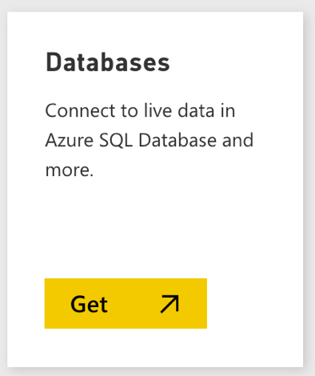

1. In the page of tiles that appears, click the **Azure SQL Data Warehouse** tile.

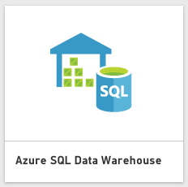

1. Click **Connect**.



If prompted, click on the button to start a free trial of Power BI Pro, which is required for connecting to SQL Data Warehouse.

1. In the dialog box, enter the fully qualified name to the SQL Server hosting your SQL Data Warehouse, and then provide the name of the database.

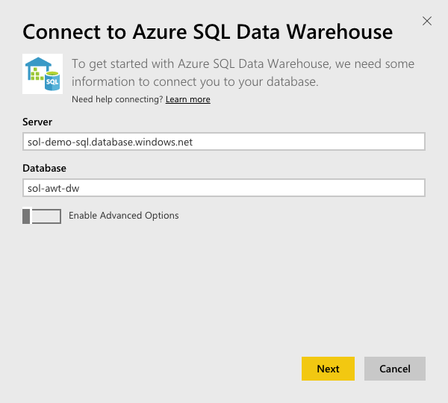

1. Click **Next**.
2. Enter your Username and Password and click **Sign In**.

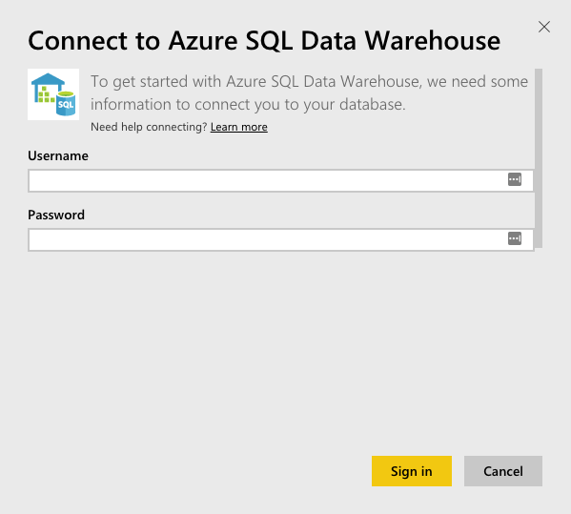

1. Give the system a few moments to connect and load the metadata.

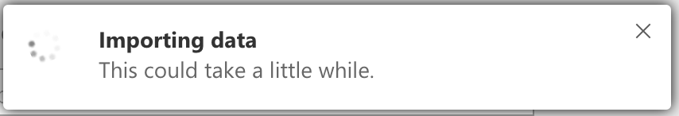

1. When the dialog box disappears, look for the Azure SQL Data Warehouse tile on your dashboard. Select the tile.  
   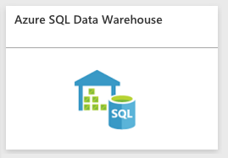
2. In the Visualizations, click the **Globe** icon to add a Map visualization to the report design surface.



1. With the Map visualization still selected, in the Fields area at right, expand the table called FlightDelaysSummary.

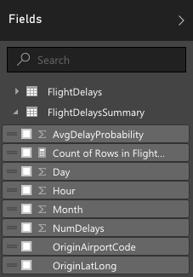

1. Click and drag the field labeled OriginLatLong and drop it into the **Location** field located just below visualizations.

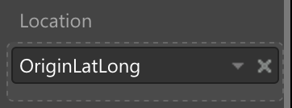

1. Next, drag the field labeled NumDelays and drop it into the **Size** field.

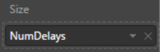

1. Give the map a few moments to update with the new data.

Your map should look something like following:

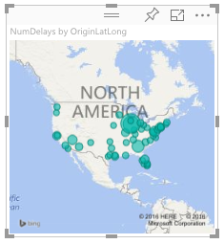

### Task 2: Create a dashboard

1. In order to create a dashboard, you need to save your report first. To give this report a name, click **File** and then click **Save**.
2. Enter FlightDelays in the field and click **Save**.

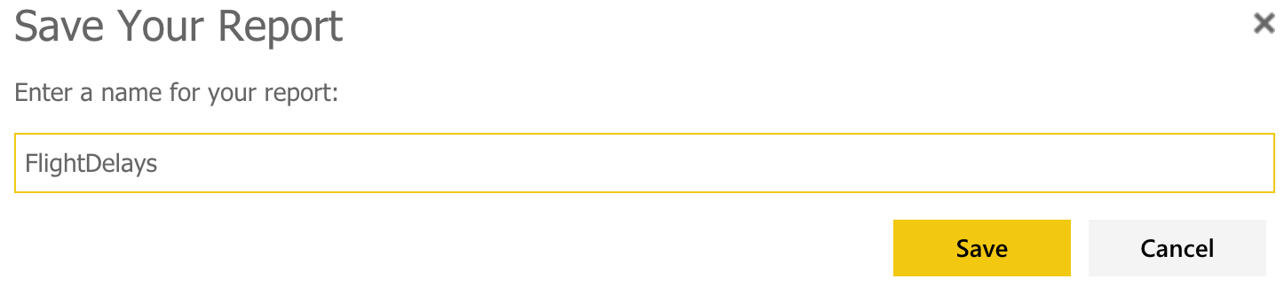

1. Next, you will create a dashboard from this report.
2. Click your newly created FlightDelays report.
3. At the top-right of the map visual, click the **Pin** icon.
4. In the dialog box, select **New dashboard** and name the dashboard AdventureWorks

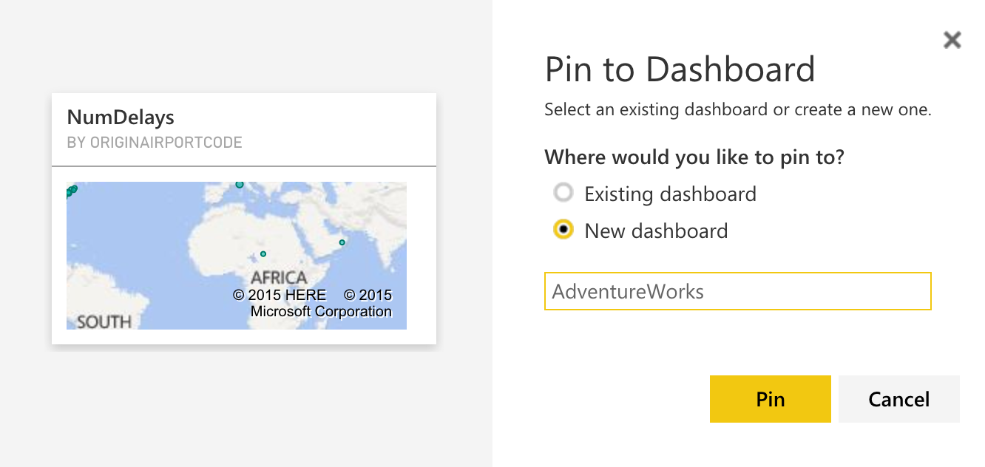

### Task 3: Observe the batch score results

1. Navigate to the deployed sample and click **Sign in to Power BI**.



1. When prompted, sign in to Power BI with your appropriate credentials.

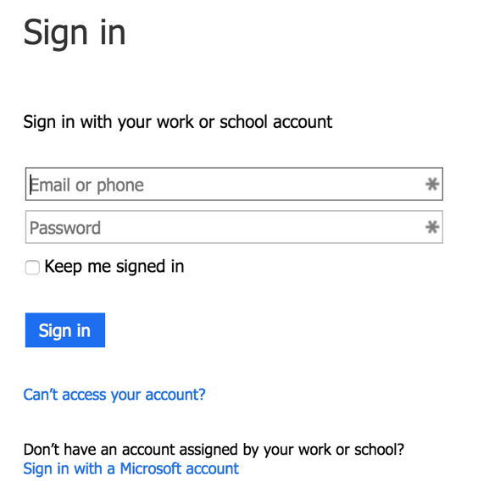

1. Your browser will redirect back to the sample web app and the Power BI tile with the flight delays should appear.



## Exercise 6: Cleanup

Duration: 10 mins

Synopsis: In this exercise, attendees will deprovision any Azure resources that were created in support of the lab.

1. Delete the Resource Group in which you placed your SQL Data Warehouse, Storage Account, and App Services.
   1. From the Portal, navigate to the blade of your Resource Group and click Delete in the command bar at the top.
   2. Confirm the deletion by re-typing the resource group name and clicking Delete.

1. Delete the Machine Learning Workspace
   1. From the Manage Portal, select Machine Learning.
   2. In the list of Workspaces, select the workspace you created.
   3. Click Delete in the command bar at the bottom.
   4. When prompted to confirm the deletion, click Yes.
2. Delete the Power BI reports and dashboard